AzureWebApp

A PROJECT REPORT

Submitted by

Hitesh Kumar

220670131014

In partial fulfillment for the award of the degree of

BACHELOR OF ENGINEERING

in

Bhadaj Circle, Ahmedabad, Gujarat (Affiliated with GTU)



Computer Science & Engineering
SAL Institute of Technology & Engineering Research

Gujarat Technological University, Ahmedabad

Academic Year
(2025-2026)

SAL Institute of Technology & Engineering Research
Bhadaj Circle, Ahmedabad, Gujarat (Affiliated with GTU)

CERTIFICATE

This is to certify that the project report submitted along with the project entitled AzureWebApp has been carried out by Hitesh Kumar under my guidance in partial fulfillment for the degree of Bachelor of Engineering in Computer Science & Engineering, 7th Semester of Gujarat Technological University, Ahmadabad during the academic year 2025-26.

Prof. Hetal Shah Dr. Nimisha Patel

Internal Guide | HoD CE/CSE/ICT
 | SALITER

Completion Certificate
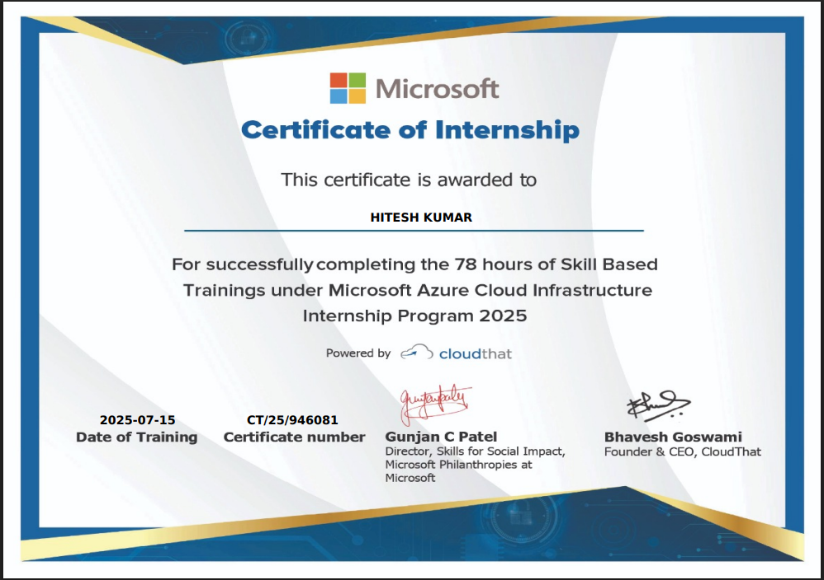

SAL Institute of Technology & Engineering Research
Bhadaj Circle, Ahmedabad, Gujarat (Affiliated with GTU)

DECLARATION

CERTIFICATE

I hereby declare that the Internship report submitted along with the Internship entitled AzureWebApp submitted in partial fulfillment for the degree of Bachelor of Engineering in Computer Science & Engineering to Gujarat Technological University, Ahmedabad, is a bonafide record of original project work carried out by me at Microsoft under the supervision of Prof. Hetal Shah and that no part of this report has been directly copied from any students’ reports or taken from any other source, without providing due reference.

Hitesh Kumar (220670131014) Sign of Student

Acknowledgement

I wish to express my sincere gratitude to my External guide Mr. Ritesh Gupta for continuously guiding me at Microsoft and answering all my doubts with patience. I would also like to thank my Internal Guide Prof. Hetal Shah for helping me through my internship by giving me the necessary suggestions and advice along with valuable coordination in completing this internship.

I also thank our parents, friends and all the members of the family for their precious support and encouragement which they had provided in completion of my work. In addition to that, we would also like to mention the company personals who gave me the permission to use and experience the valuable resources required for the internship.

Thus, In conclusion to the above said, I once again thank the staff members of Microsoft
for their valuable support in completion of the project.

Thank You

Hitesh Kumar

CONTENTS

Title Page |  |  | I
Certificates |  |  | II
Acknowledgement |  |  | III
Content |  |  | IV
List of Figures |  |  | V
1 |  | Introduction | 1
 | 1.1 | Project Summery | 1
 | 1.2 | Aim and Objectives | 3
 | 1.2 | Tools & Technologies | 4
2 |  | Implementation | 6
 | 2.1 | Functional | 6
 | 2.2 | Non Functional | 8
3 |  | Outcomes | 11
 | 3.1 | Conclusion | 11
 | 3.2 | Future Enhancement | 12
 | 3.3 | Progress report with result Pictures | 13
4 |  | Bibliography | 15

LIST OF FIGURES

SR.NO | NAME OF FIGURES | PAGE NO.
1 | Figure 1.1 Architecture Diagram of Azure WebApp Deployment | 2
2 | Figure 1.2 Portfolio Website – Homepage (Deployed on Azure) | 3
3 | Figure 1.3: Portfolio Website | 4
4 | Figure 2.1: Azure Portal – Dashboard View | 5
5 | Figure 2.2: Azure Resource Group Created for Project | 7
6 | Figure 2.3: Custom Domain & SSL Configuration | 8
7 | Figure 2.4: CI/CD Pipeline (GitHub Actions → Azure Deployment) | 9
8 | Figure 2.5: GitHub Repository for Portfolio Website | 10

