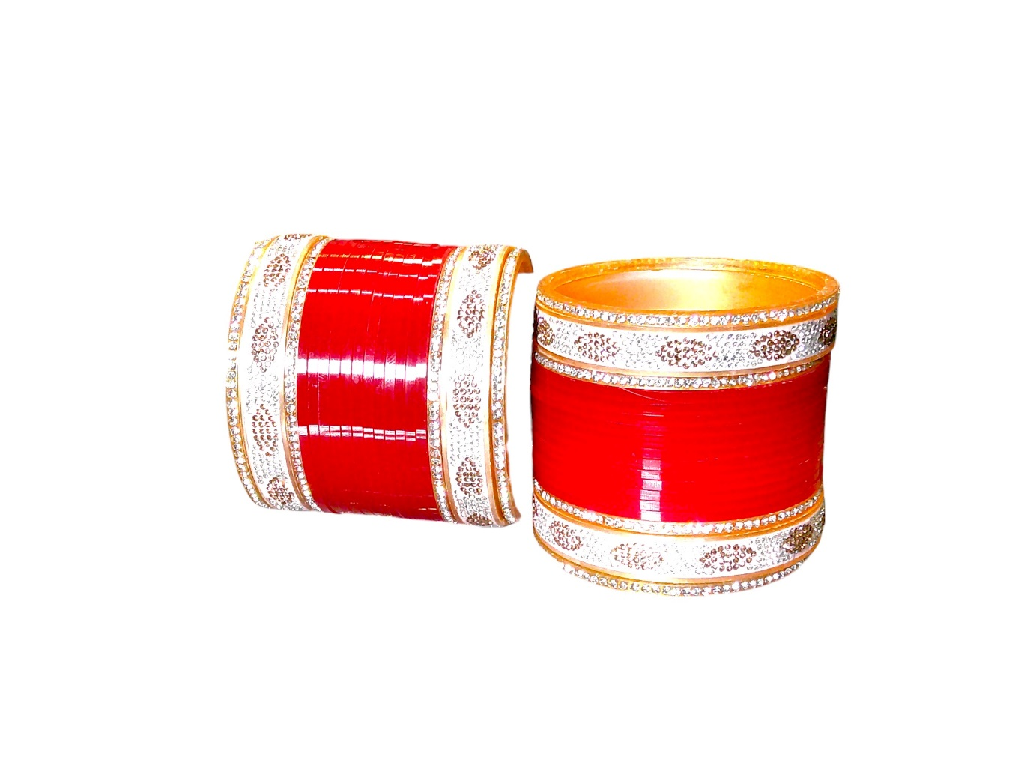

Product Description for Amazon, Flipkart, and Meesho
This Chuda Bridal Bangle Set by "Nari Nakhre, a brand by Mohini Cosmetics" is an elegant combination of tradition and modern style. The set includes 24 premium-quality bangles: 12 red bangles and 12 white stonework bangles, perfect for weddings and special occasions. Crafted from durable plastic material, these lightweight bangles offer comfort without compromising on style. A must-have accessory for brides and women who love traditional ethnic wear.
Product Description for Shopify
This Chuda Bridal Bangle Set by "Nari Nakhre, a brand by Mohini Cosmetics" is an elegant combination of tradition and modern style. The set includes 24 premium-quality bangles: 12 red bangles and 12 white stonework bangles, perfect for weddings and special occasions. Crafted from durable plastic material, these lightweight bangles offer comfort without compromising on style. A must-have accessory for brides and women who love traditional ethnic wear.
For further details, please visit www.narinakhre.com or mail at hello@mohinicosmetics.com.

Key Features
- Bridal Chuda bangle set with 24 bangles.
- Includes 12 red bangles and 12 white stonework bangles.
- Made of durable plastic material for lightweight comfort.
- Elegant design, perfect for weddings and festive occasions.
- Suitable for sizes 2/4, 2/6, and 2/8.
- Vibrant colors and intricate details enhance ethnic wear.

Product Title
Nari Nakhre Elegant Bridal Chuda Set - Red and White Stone Bangles (Pack of 24)

Colour
Red and White

Model Name
Elegant Bridal Chuda Set - Red and White Stone Bangles

SKU IDs
- SKU ID for size 2/4: 012025BNGRE24014
- SKU ID for size 2/6: 012025BNGRE26014
- SKU ID for size 2/8: 012025BNGRE28014

Model Number
NNCHUD014

Product Type
Chuda (Bridal Bangles)

Search Keywords
bridal chuda set, wedding bangles, red and white bangles, traditional bridal accessories, ethnic chuda bangles, stonework bangles, lightweight bangles for brides, Nari Nakhre bangles.

HSN Code
71171910

GST Rate
3%

Manufacturer and Importer Details
Mohini Cosmetics,
136 Darhai Rd, Kotwali,
Jabalpur, Madhya Pradesh, 482001, India
Email: hello@mohinicosmetics.com

