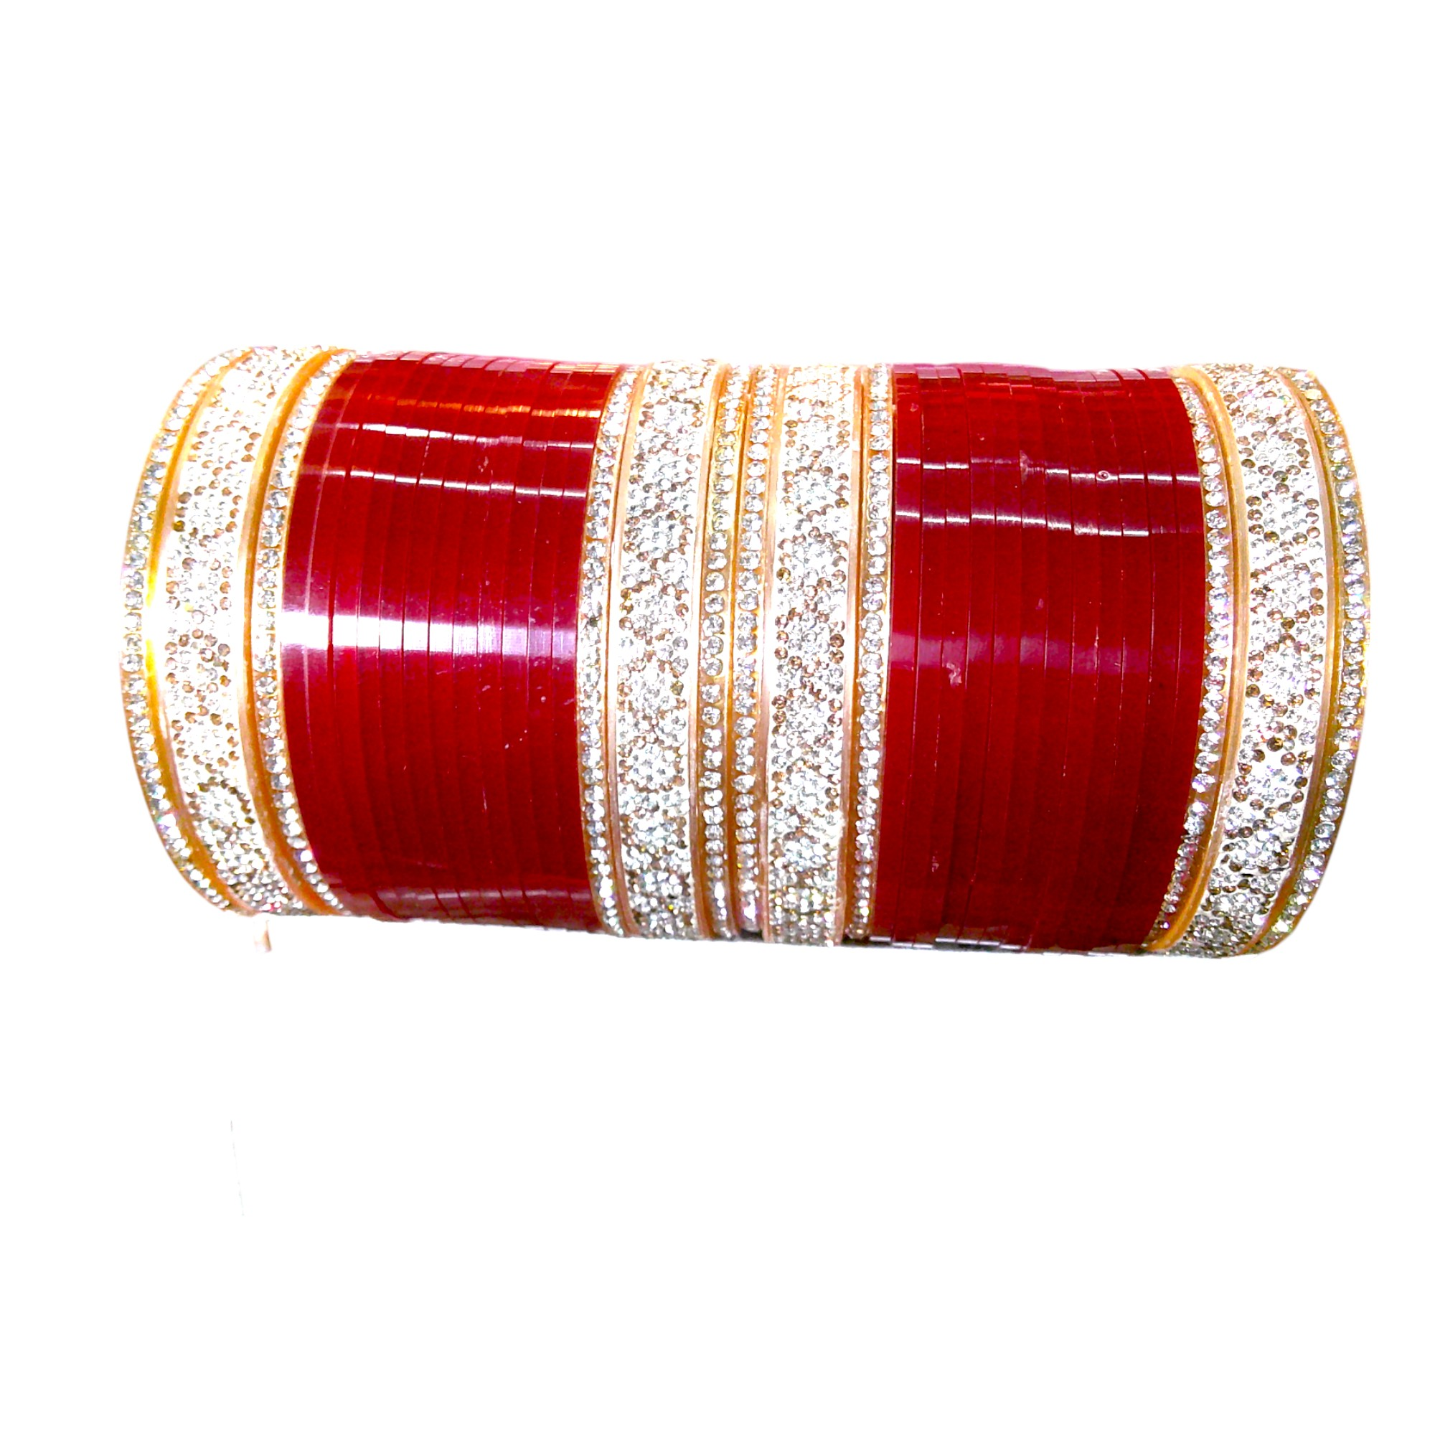
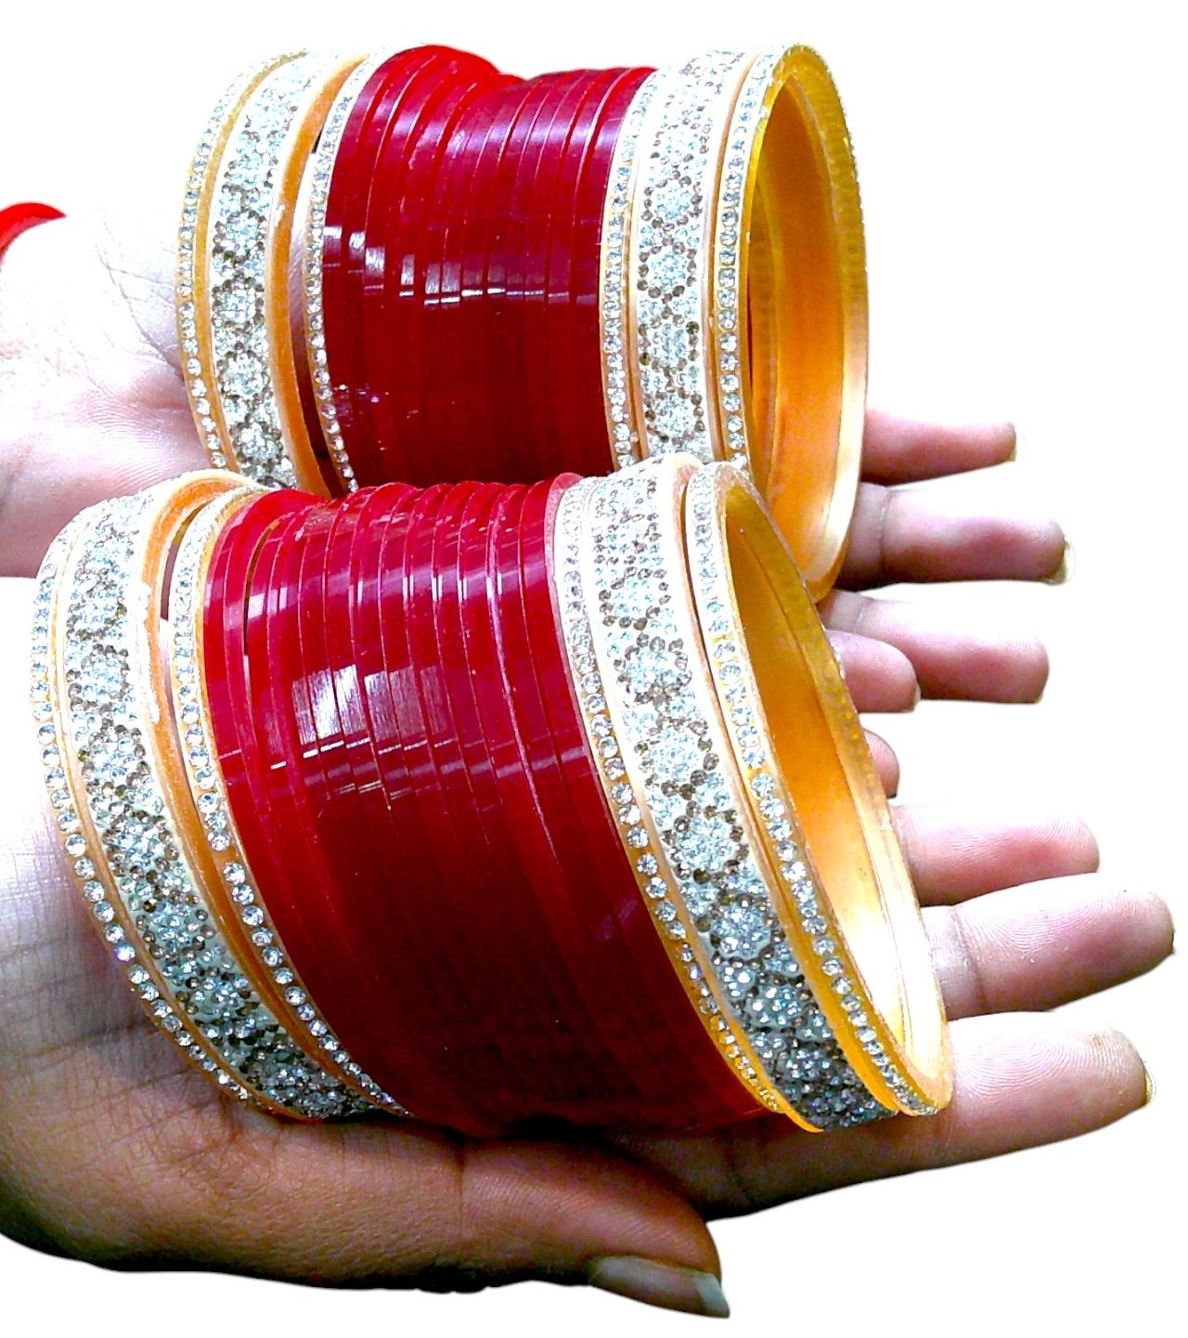

Product Details

Description for Amazon, Flipkart and Meesho
Enhance your bridal look with Nari Nakhre's exquisite Bridal Chuda Set, a brand by Mohini Cosmetics. This set includes 12 white stonework bangles and 24 dark red bangles with intricate designs. Perfectly crafted to add charm and elegance to your special day.

Description for Shopify
Enhance your bridal look with Nari Nakhre's exquisite Bridal Chuda Set, a brand by Mohini Cosmetics. This set includes 12 white stonework bangles and 24 dark red bangles with intricate designs. Perfectly crafted to add charm and elegance to your special day. For further details, please visit www.narinakhre.com or mail at hello@mohinicosmetics.com.

Key Features
- Premium bridal chuda set with 36 bangles.
- Includes 12 white stone bangles and 24 dark red bangles.
- Intricate stonework adds elegance.
- Lightweight and comfortable to wear.
- Perfect accessory for weddings and festive occasions.

Product Title
Nari Nakhre Bridal Chuda Set with White and Red Stonework Bangles - 36 Pieces

Colour
Dark Red and White

Model Name
Bridal Chuda Set with White and Red Stonework

SKU ID
012025BNGRE24015
012025BNGRE26015
012025BNGRE28015

Model Number
NNCHD015

Product Type
Bridal Chuda

Search Keywords
Bridal Chuda, Chuda Bangles, Wedding Bangles, Red Bangles, White Stone Bangles, Bridal Accessories, Elegant Bangles, Traditional Bangles, Nari Nakhre Chuda

HSN Code
71171910

GST Rate
3%

Manufacturer and Importer Details
Mohini Cosmetics, 136 Darhai Rd, Kotwali, Jabalpur, Madhya Pradesh, 482001, India. Email: hello@mohinicosmetics.com

MRP
INR 1899

Selling Price
INR 599

