Copilot Cowork — Quick Reference Card
Getting Things Done with Copilot Cowork for HR Tasks · keep this beside your laptop
1 · Pick the right tool
Tool | Use it when… | HR example
Copilot Chat | You need a quick answer or a rewrite | “Summarize this policy in 3 bullets.”
Copilot Cowork | Several steps that end in a doc, email, deck, report, or schedule | “Draft welcome emails for 4 new hires; save as drafts.”
Agent Builder | Others need a reusable Q&A helper | An HR Policy Agent employees can chat with

2 · Write a good prompt
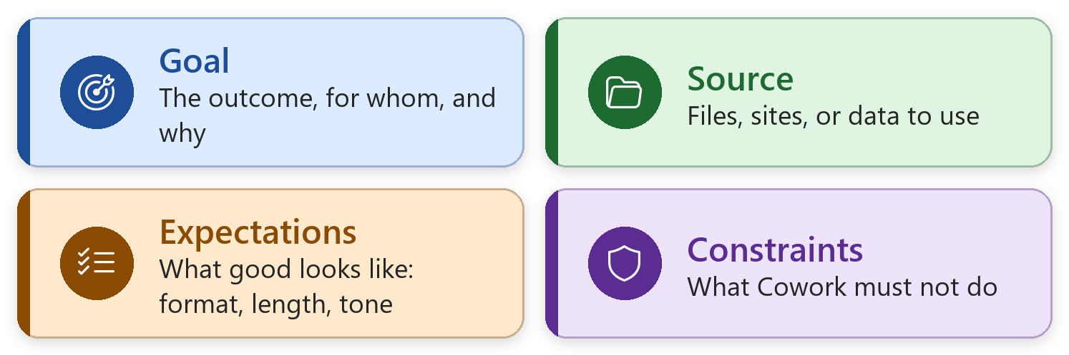
e.g. “Draft a warm welcome email for our new HR Coordinator starting Monday, using onboarding-checklist.docx. Under 200 words. Save as a draft — don’t send.”
- Attach files: + → Attach cloud files, or type / and pick the file.
- Web tasks: “Use Deep Research…” for cited research; “Open {site} in my browser…” runs in your Edge.
- Automations: name the exact file and folder; choose Activate and run now to test.
- Always add: “Save as a draft for me to review — don’t send.”
3 · Approvals — one at a time
Option | What it does | Today?
Send / Post / Create | Approves this one action | ✔ Yes
Cancel | Skips it; Cowork continues | ✔ Yes
Show parameters | Shows recipients and details | ✔ Yes
Approve All (n) | Approves every pending action | ✘ No
More options → Always allow | Stops asking for this session | ✘ No

Clicked one by mistake? Side panel → Permissions → revoke.
4 · Where things are in Cowork
Go to… | To…
New task | Start a task · model picker · reasoning effort · attach · starters
My tasks | Find and resume previous work
Automations | Schedules: Runs tab · Manage schedules (edit, pause, delete)
Customize | Custom instructions · your skills (Share / Re-share) · plugins
Side panel | Progress · Input/Output folder · skill chips · schedule · Permissions
Output folder | Preview · Download · Download All (zip); also in OneDrive → Cowork

5 · Golden rules for HR
- Every output is a draft. Review before you send, share, or file.
- Approve one at a time. Read the preview before you confirm.
- Keep real data private. Ex 8 results stay yours; Zava files for the rest.
- Cite and confirm. Name the source; note “please confirm with HR.”
- People decisions stay with people. Cowork only sees what you’re allowed to see.
6 · Files: which formats work where
Where | Use
Today’s sample files | Word (.docx) and Excel (.xlsx) — work in both tools
Cowork | Word, Excel, PowerPoint, PDF, plus .md, .csv, images, and more
Agent Builder | .docx, .pdf, .pptx, .txt, .xlsx — not .md or .csv

7 · Before you leave today
☐ Pause or delete the schedules from Exercises 8 and 6 (Automations → Manage schedules).
☐ Clean up the training data: follow the last section of your workbook.
☐ Keep your custom skills set to “Only you” unless you meant to share them.
☐ Pick one task to hand to Cowork next week.

