After the Workshop
Send this to attendees the day after the session. It has four parts: a knowledge check to lock in learning, a feedback survey to improve the next session, a 30-day adoption plan to turn one workshop into a habit, and a short read on HR plugins, which the session didn't have time for.

1. Knowledge check (8 questions)
Suggested use: ask 3–4 of these as a quick room poll at wrap-up, or send all 8 as a self-check.
Q1. You need a 3-bullet summary of one policy document. Which tool fits best?
- A. Copilot Cowork
- B. Copilot Chat
- C. Agent Builder
Q2. You want welcome emails for four new hires, grounded in the onboarding checklist and saved as drafts. Which tool fits best?
- A. Copilot Cowork
- B. Copilot Chat
- C. Agent Builder
Q3. Cowork is about to send five emails and shows Approve All (5). What happens if you click it?
- A. It approves only the first action
- B. It approves all five pending actions at once, skipping each individual review
- C. It saves all five as drafts
Q4. You clicked Always allow by mistake. Where do you undo it?
- A. Customize → Skills
- B. The session side panel's Permissions section
- C. Automations → Runs
Q5. Which file types can you add as Agent Builder knowledge?
- A. .md and .csv
- B. .docx, .pdf, .pptx, .txt, .xlsx (and similar Office/PDF formats)
- C. Any file type
Q6. What's the key difference between a custom skill and an Agent Builder agent?
- A. There is no difference
- B. A skill helps you inside Cowork; an agent is a standalone helper others can chat with
- C. Agents are always cheaper
Q7. You create an automation that runs every Monday. Why should the prompt name the exact file and folder?
- A. It makes the run faster
- B. The run happens without you there to clarify which file it should use
- C. Automations can't read OneDrive
Q8. An employee asks the HR Policy skill, "What does my colleague earn?" What's the right behavior?
- A. Look it up in the roster
- B. Politely decline and redirect to HR or payroll
- C. Give an estimated range

Answers
- B — a quick, single-document answer is a Chat job.
- A — multi-step work that ends in deliverables is a Cowork job.
- B — so today's rule is one approval at a time.
- B — side panel → Permissions.
- B — that's why the workshop's sample files are Word and Excel.
- B
- B — scheduled runs can't ask you which file you meant.
- B — individual pay is out of scope; the skill's guardrails should decline it.

2. Feedback survey (paste into Microsoft Forms)
- Overall, how useful was this workshop for your day-to-day work? (Rating 1–5)
- How confident are you using Cowork on your own now? (Rating 1–5: Not at all → Very)
- Which exercise was most valuable? (Choice: Executive Command Center · Deep Research · Navigate websites with the browser · Custom skill · Recruiting + reporting · Onboarding pack · Automate & share · Agent Builder)
- Which exercise was least valuable, or most confusing? (Same choices + "None")
- The pace was… (Choice: Too slow · About right · Too fast)
- Did anything stop you completing an exercise? (Choice: Account/sign-in · Missing data · Cowork error · Ran out of time · Nothing · Other)
- Which HR task will you hand to Cowork first? (Text)
- What would make this workshop better? (Text)
- Would you recommend this workshop to a colleague? (Net Promoter: 0–10)

3. Your 30-day adoption plan
Pick one task per week. Use real work data only in the ways your organization permits for Cowork; when in doubt, practice on the Zava files first.
Week | Focus | Try this
1 | Daily habit | Check your Executive Command Center each morning, or try the Organize my inbox prompt from the prompt library. Approve one action at a time.
2 | Your recurring question | Rebuild your HR Policy Answer skill on your organization's real, approved policy documents, then test in-scope and out-of-scope questions.
3 | Put a report on a schedule | Turn one weekly report you rebuild by hand (ticket volume, open reqs, onboarding status) into an Automation. Use Activate and run now to test it.
4 | Share and measure | Share your best skill with one teammate (with your manager's OK), and note the time saved across the month.

Starter prompts for your first month
- "Summarize what changed in {policy document} compared with last year's version, and list what employees need to do differently. Cite the sections."
- "Draft a first-week schedule for {new hire} starting {date} as {role}, using our onboarding checklist. Show it for approval before creating any meetings."
- "From {ticket export}, show this month's top 5 ticket categories, what's trending up, and one self-service FAQ we could publish to reduce each."
- "Build an interview scorecard in Excel for {role} from its job description, with competencies as rows and a 1–5 anchored scale."

Where to go next
- The kit's prompt library and custom skill guide
- Microsoft Learn: Use Copilot Cowork and Agent Builder overview

4. Go further: extend Cowork with HR plugins
You've packaged your own work as a skill and put it on a schedule. Plugins extend Cowork further, into the HR systems you already use: payroll, recruiting, scheduling, or your HR system. Read this on your own; there's nothing to install.
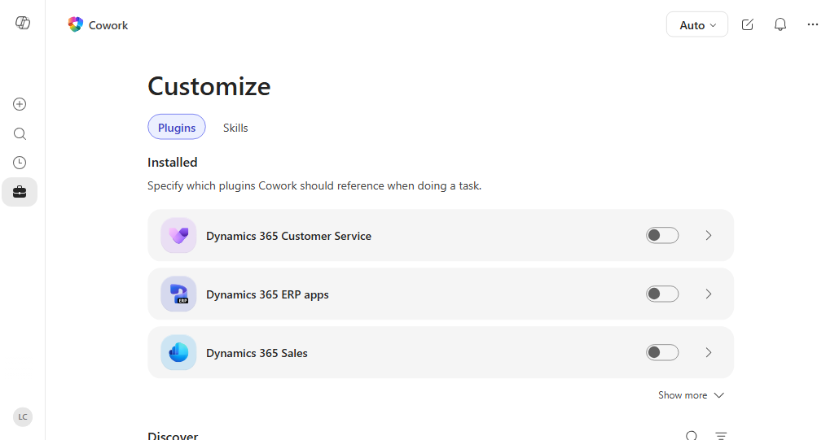
Customize → Plugins (screenshot: Microsoft Learn). HR plugins appear in the same Installed list once your admin adds them.
- What: a plugin adds skills (HR know-how) and/or connectors to systems outside Microsoft 365. Connectors can be MCP servers.
- Where: Customize → Plugins. Installed plugins have on/off toggles; the detail page shows what each one connects to; Discover lists plugins your admin made available.
- HR examples: Gusto (payroll, employee records, benefits enrollment), ZipRecruiter and Dice.com (job listings), Cronofy MCP (interview scheduling across real calendar availability), Articulate (training course outlines), or your organization's own HR system connected through an MCP server. Full list: Available plugins for Copilot Cowork.
- ⭐ SAP SuccessFactors? No SuccessFactors plugin is in the Cowork catalog yet. Today, use the Employee Self-Service agent with its SAP SuccessFactors extension pack, or have IT build a custom plugin with an MCP connector. Details in reference/09-plugins.docx.
- Imagine: "Which open tickets in hr-tickets-sample.xlsx are payroll issues? Check each employee's latest pay run and draft a reply." With a payroll plugin, Cowork answers T-2008 from the spreadsheet and live payroll data, then waits for your approval.
- Why it matters: fewer copy-and-paste hand-offs between systems; consistent answers across the team; governed by IT (approval, deployment, Purview audit logs); and no extra access, because each connector uses your own sign-in.
Don't add or upload plugins without your admin; most plugins need admin approval. Details, the full example, and how IT can build an HR plugin: reference/09-plugins.docx.

Housekeeping (please do this today)
- Pause or delete the schedules from Exercises 1 and 7 (Automations → Manage schedules).
- Check that your custom skills are still "Only you" unless you meant to share them.
- Delete any drafts or test sends you don't need.

