09 · Extend Cowork with HR Plugins (Self-study)
Reference sheet for the "Getting Things Done with Copilot Cowork for HR Tasks" workshop. Self-study, not part of the live session (it's in the after-the-workshop pack). It shows how plugins connect Cowork to the HR systems you already use, and where you manage them on the Customize page.

What a plugin is
A plugin is a package that adds new abilities to Cowork. It can contain:
- Skills: HR know-how that teaches Cowork how to do a type of work. Plugin skills work like built-in skills: Cowork activates them automatically and shows them as chips in the side panel.
- Connectors: links to systems outside Microsoft 365, such as payroll, recruiting, or your HR system, so Cowork can look things up or take actions there. Connectors can be MCP (Model Context Protocol) servers; Cowork discovers the server's tools automatically when they're needed.

Where you manage plugins: Customize → Plugins
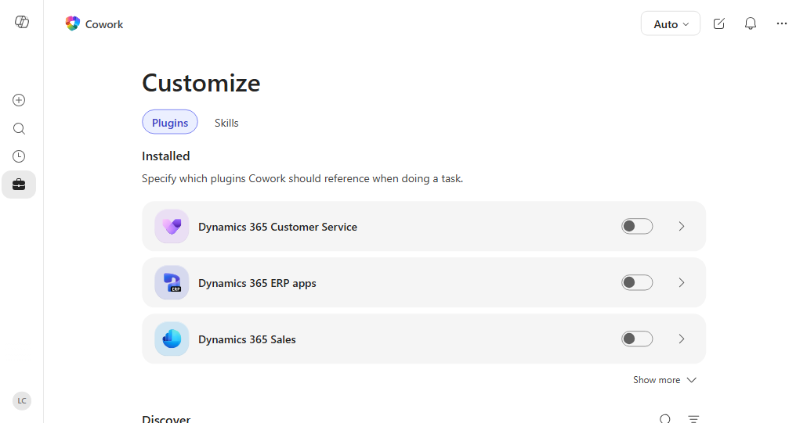
Screenshot: Microsoft Learn, Customize Copilot Cowork. This tenant shows Dynamics 365 plugins; HR plugins such as Gusto or ZipRecruiter appear in the same list once added. Your page may also show a Preferences tab, where custom instructions live.
Area | What it does
Installed | Plugins you or your admin added. Each has an on/off toggle, so you choose which plugins Cowork uses.
Plugin detail page (the arrow) | Shows the publisher, description, the skills and connectors it includes, and what data it connects to. You can remove plugins you added yourself.
Discover | Plugins available from the Microsoft 365 App Store, plus plugins you published or that were shared with you. Select Add to install one.
Upload plugin | Upload your own plugin package (a .zip), then Share it with Only you or specific people in your organization.
Sources & Skills panel (in a conversation) | Turn plugins on or off for the task in front of you, to keep results focused.

HR plugins you can use today
From Microsoft's published list of available plugins for Copilot Cowork (checked October 1, 2026; the catalog keeps growing). What's available to you depends on what your admin has approved; in Cowork, open Add plugins to see the current list for your organization.
Plugin | What it brings to HR work in Cowork
Gusto | Payroll runs, employee records, benefits enrollment, tax filings, and time data
ZipRecruiter | Search job listings, e.g. to benchmark a role you're hiring for
Dice.com | Search tech job listings by keyword, location, and filters
Cronofy MCP | Schedule meetings using real-time, multi-person calendar availability; handy for interview panels
Articulate | Turn training ideas into build-ready course outlines for learning and development
Your own HR plugin | Your organization's HR skills plus an MCP connector to your HR system (HRIS), built and deployed by IT; see below
⭐ Using SAP SuccessFactors? There's no SuccessFactors plugin in the Cowork catalog yet (the only SAP entry, enosix arnold, covers SAP ERP orders and invoices, not HR). Three ways to bring SuccessFactors into your Microsoft 365 Copilot work today:
- Employee Self-Service agent + SAP SuccessFactors extension pack (Microsoft 365 Copilot agent, not a Cowork plugin): employees and managers read and update their own HR data, such as hire date, job info, compensation, emergency contacts, and direct reports' details, in Copilot. Integrate SAP SuccessFactors with Employee Self-Service
- A custom Cowork plugin: IT packages HR skills with an MCP connector to SuccessFactors (for example through an MCP gateway in front of the SuccessFactors APIs), the same pattern as the Zava HRIS example below.
- Ask for one: your admin can request a plugin in the Microsoft 365 admin center, or work with a partner to build it.

Example: payroll questions with an HR plugin
Illustration only. The workshop tenant has no HR plugins installed.
- Your admin deploys a payroll plugin (for example, Gusto) to the HR team. It appears under Customize → Plugins → Installed with a Managed by your organization label; you didn't have to find or add it.
- Open its detail page to see its skills and connectors and what payroll data it reaches.
- Connect once. The first time Cowork uses the connector, select Connect and sign in to the payroll system with your own account.
- Ask Cowork:
- Which open tickets in hr-tickets-sample.xlsx are payroll issues? For each one, check the employee's latest pay run in payroll, explain what happened, and draft a reply for me to review.
- Cowork joins the two sources. For ticket T-2008 ("Overtime hours missing from my paycheck"), it reads the ticket from the spreadsheet, checks the pay run through the plugin, and drafts an answer. It still pauses for your approval before anything is sent.
Without the plugin, you'd look the employee up in payroll, copy the details into the prompt, and check the result by hand.

For IT: your own HR system as an MCP plugin
Organizations can package their own HR skills and an MCP server for their HR system into a custom plugin, upload it in Customize → Plugins → Upload plugin, test it, and then deploy it. A plugin declares its MCP server in its manifest. This trimmed, fictional example follows the format in Microsoft's documentation:
"agentSkills": [ { "folder": "./skills/hr-policy-answer" } ],
"agentConnectors": [
{
"id": "zava-hris",
"displayName": "Zava HR System",
"description": "Remote MCP server for Zava employee, leave, and benefits data",
"toolSource": {
"remoteMcpServer": {
"mcpServerUrl": "https://hris.zava.example/mcp",
"authorization": { "type": "OAuthPluginVault", "referenceId": "<from Teams Dev Center>" }
}
}
}
]
The hr-policy-answer skill you built in Exercise 4 could ship inside a plugin like this, so the whole HR team gets the skill and live HR data together. Details: Build plugins for Cowork.

Benefits for HR
- One task across HR systems and Microsoft 365. Combine payroll, recruiting, scheduling, or HRIS data with your email, calendar, and files in a single request.
- Fewer swivel-chair hand-offs. Cowork looks up and acts in the other system instead of you exporting data and pasting it into a prompt.
- Consistent answers across the team. A plugin can bundle HR skills so everyone follows the same process and format.
- Governed by IT. Admins approve and deploy plugins, decide who gets them, and see plugin activity in Microsoft Purview audit logs.
- No extra access to people data. A connector uses your own sign-in, so it can't reach any employee data you can't already reach, and no one can sign in on your behalf.
- You stay in control. Turn plugins on or off per conversation, and Cowork still asks for approval before sending, posting, or changing anything.

Good to know
- Admin approval: most plugins must be approved by your IT admin before they appear. If you need one, ask your admin; they can request plugins in the Microsoft 365 admin center.
- Admin-deployed plugins appear automatically. You can't remove them, but you can turn them off for your own conversations.
- One sign-in per connector: after the first connection, Cowork remembers it until you or your admin revoke it.
- Sensitive data: payroll and employee records are confidential. Apply the same golden rules: draft, review, approve one action at a time, and only look up what your role allows.
- In this workshop: don't add or upload plugins in the shared attendee tenant. This is a slide or facilitator demo only.
Learn more: Use plugins with Cowork · Available plugins · Manage plugins (admins)

