ODBC Configuration

1.- Go to Control Panel → System and Security → Admin Tools → ODBC Data Sources (64bits)

2.- In User DSN click on Add

3.- Choose SQL Server Native 11

4.- In the next Window enter

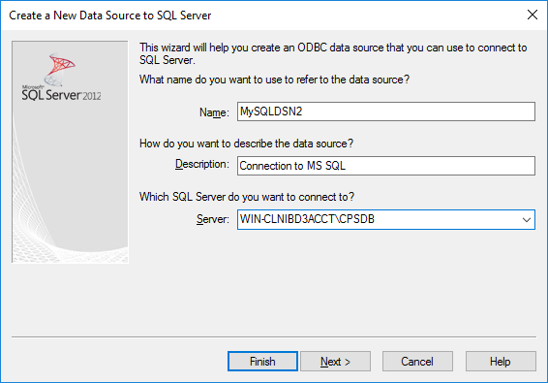
5.- Use Windows Authentication

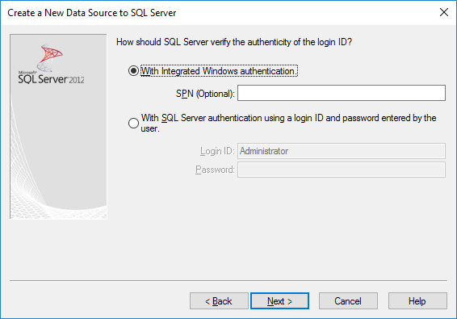
6.- Click Next

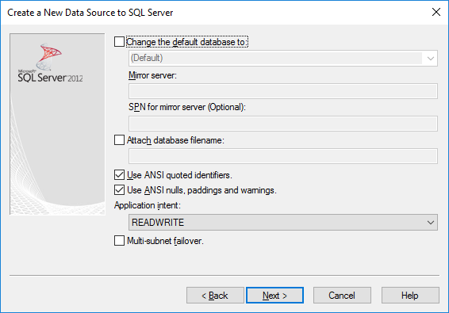

7.- Click Next

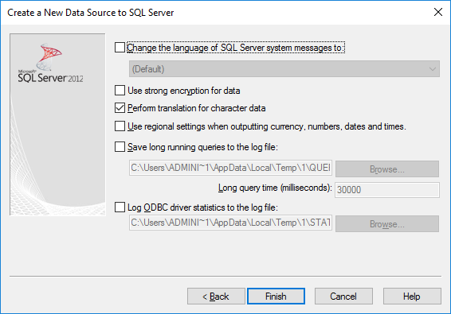
8.- Test Data Source

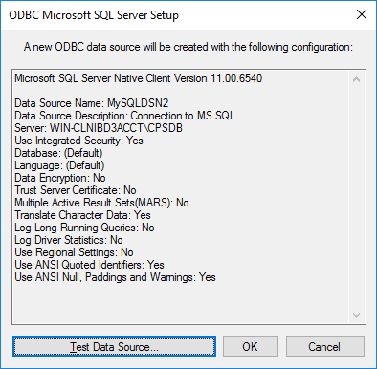

9.- Success
