Health Outcomes Among Children and Youth in Climate-Related Migration: A Scoping Review

Raghav Khanal, Sri Hari Govind, Rachael Barrett, Mahim Eaty, Oumnia Bouaddi, Hasheem Mannan.

INTRODUCTION
In 2020, there were an estimated 281 million international migrants and 55 million internally displaced persons (IDPs) globally.¹ Migrant, refugee, and IDP populations like any population have an irrefutable right to health under the Universal Declaration of Human Rights. Despite this, migration status continues to be a key social determinant of health and migrant populations are made structurally and socially vulnerable to physical and mental ill health throughout the migration process due both to elevated exposure to health risks and barriers to accessing health care.² Furthermore, an increasingly stigmatising rhetoric surrounding migration in many destination countries fuels social exclusion, discrimination, and violence against migrant populations that has detrimental impacts on migrants’ physical and mental health and can directly and indirectly prevent access to healthcare. Particular migrant populations such as refugees, IDPs (who remain within their state of origin), and irregular migrants also face additional and unique barriers to health.² Migrant populations are anticipated to grow as the impacts of climate change forces people to leave their homes due to loss of habitable land and livelihoods as well as acute health risks.³ In 2021, the World Bank projected that without climate action 216 million people could be forced to relocate within states by 2050.⁴ Such climate change migration is already documented in many global regions and the nexus of climate change, migration and health is increasingly explored in peer-reviewed literature.^{5–9}

However, migrant populations are not homogenous- with considerable diversity in terms of gender, age, sexuality, ethnicity, race, country of origin, and length of stay that can also impact individual health. Children, adolescents and youth make up a considerable proportion of migrant populations globally, with an estimated 36 million migrants being under the age of 18 in 2020.¹⁰ Young migrants – especially when unaccompanied- can face increased health risks, including under-nutrition, emotional distress and trauma, and exposure to unsafe substances, sexual behaviours, and employment practices that result in acute and long-term health problems.² Yet, child, adolescent and youth migrants are largely underrepresented in global migration discourse which culminates in a lack of evidence in these vulnerable populations, particularly adolescents and youth.^{2,11} To address this research gap, we seek to assess the health impact and challenges faced as a result of climate change migration on this under-studied population. Previous systematic and scoping reviews have noted the adverse health consequences arising from climate change associated displacement, but failed to focus on this vulnerable population.^{12,13} To fill this gap, with the intention of spurring research and policy adapted to the needs of this young population, we ask:
- According to existing literature, what are the health outcomes of climate change migration on children and youth?
- Where is further research needed to inform meaningful policy to protect the health of young climate migrants?
METHOD
To answer these questions, we will perform a scoping review of peer-reviewed literature based on the framework of Arksey and O’Malley and in alignment with the PRISMA-ScR guidelines.^{14,15}
Definitions
In this work we will utilize the definition of climate change migration submitted by the International Organization for Migration to the Warsaw International Mechanism Executive Committee under the UNFCCC. Specifically, climate change migration is defined as ‘the movement, within a state or across an international border, of a person or a groups of persons, who are obliged or choose to leave their habitual place of residence either temporarily or permanently predominantly for the reasons of sudden or progressive change in the environment due to climate change.’¹⁶ To operationalise this in our method a population will be considered climate change migrants only if their movement is linked to environmental changes associated with or sensitive to climate change.
Similarly, our focus on children, adolescents, and youth refers exclusively to individuals between the ages of 5 to 24 to align with the United Nations’ definition.¹⁷ The decision was taken to exclude children under five, infants and newborns from the purview of this scoping review due to the separate and unique health challenges faced in these early years.

Search strategy and reference selection
We will search in 4 major biomedical databases including Medline, Embase and Psycinfo via OVID platform and CINAHL to identify peer-reviewed primary studies documenting the health outcomes or challenges of children, adolescents, and youth on the move because of climate change. These databases will be searched by using a search strategy that was iteratively refined in accordance with the research objectives, capacity of the research team, with the assistance of a librarian, and by testing using key references. The search will include articles published in any language translation software will be used for articles published in languages other than English. Annex 2 provides an example search. All identified search results from the three databases will be uploaded to Rayyan.ai review management software and de-duplicated. In addition to database searches, we will also conduct manual searches, including screening the reference lists of relevant scoping and systematic reviews to identify additional eligible study.

Articles will be initially screened by title and abstract by four members of the research team according to the inclusion and exclusion criteria (Table 1). Those thought relevant at the title and abstract stage will then undergo a full text screen according to the same criteria. Uncertainties regarding reference relevance at either stage will be resolved through discussion on a case-by-case basis by the research team. Relevant secondary studies will be included in the first stage of screening to allow for reference lists to be searched, but only primary studies will be ultimately eligible for inclusion.

Table 1. Inclusion and exclusion criteria
Inclusion
- Focus on children, adolescents, or youth aged 5–24 years, in alignment with the United Nations definition¹⁷. Studies including broader age ranges will be eligible if results are disaggregated for this age group, if the mean or median age falls within 5–24 years, or if at least 50% of participants are aged 5–24 years.
- Include migrants, refugees, asylum seekers, or internally displaced persons whose movement is explicitly attributed to climate change or climate-related environmental change (e.g., drought, flooding, sea-level rise, heatwaves, desertification, storms), including both long term and short term displacement.
- Any type of health outcomes or challenges reported.
- Peer-reviewed primary research studies with any design (quantitative, qualitative, mixed methods, observational, or interventional, including randomised controlled trials).
- Conducted in any country and at any stage of migration
Exclusion
- Focus exclusively on populations outside the 5–24 age range (e.g., under 5 years or over 24 years) without extractable data for the target group.
- Examine migration not explicitly linked to climate and events classified as geophysical (e.g., earthquakes, tsunami, volcanic eruptions,etc) will be excluded as non-climate-related hazards.
- Studies with multiple cause of displacement will also be excluded.
- Are review articles, commentaries, editorials, opinion pieces, conference abstracts, or other non-primary or non–peer-reviewed studies.

Data extraction
Data will be extracted from all articles included after the final screening stage using an extraction template designed in Excel to capture relevant information. Provisional topics of data extraction include:
- Reference details (Authors, title, year of publication, journal)
- Population (Country and location, type of migrant population, point in migration, age range, length of residence)
- Role of climate change (Driver of migration, details)
- Health outcome (Type of health issue discussed, specific health outcome(s) measured, how were health outcomes measured)
- Study design (Method, control population if any)
- Key findings and conclusions
Extracted information will inform the development of summary tables and the subsequent analysis and conclusions. No quality assessment of included articles will be conducted as is standard for scoping reviews.¹⁴

Methodology
Guiding frameworks of this scoping review will be:
- Arksey and O’Malley framework
- PRISMA-ScR guidelines

1. Definitions

Climate migration: The movement, within a State or across an international border, of a person or groups of persons, who are obliged to leave their habitual place of residence, or choose to do so, either temporarily or permanently, predominantly for reasons of sudden or progressive change in their environment due to climate change¹⁸.
Children: The convention on the Rights of the child defines child as every human being below the age of eighteen years unless under the law applicable to the child, majority is attained earlier¹⁹.
Youth Definition: No children under 5, According to the UN Secretariat, it uses the terms youth and young people interchangeable to mean age 15-24 with the understanding that member states and other entities use different definitions²⁰.
Migrant: A migrant is a person who moves away from their usual residence within a country or across international borders, regardless of legal status, reason for movement, or duration of stay ²¹.
IDP: "Persons or groups of persons who have been forced or obliged to flee or to leave their homes or places of habitual residence, in particular as a result of or in order to avoid the effects of armed conflict, situations of generalized violence, violations of human rights or natural or human-made disasters, and who have not crossed an internationally recognized State border”. (Guiding Principles on Internal Displacement, 1998)²².

2. PCC Framework, General list of terms

Population (two subsets) | ((child* or adolescen* or teen* or youth* or young or minor* or juvenil* or paediatric* or pediatric* or puber* or pre-pubescent or jeune* or *mineur* or “jeune adulte” or pubescen* or “school age*” OR adolescent/ or young adult/ or child/) AND (migr* or immigr* or emigr* or outmigrat* or refugee* or asylum* or undocument* or non-citizen or citizenship* or transient* or displac* or expat* or nationalit* or non-resident* or newly-arrived or newcomer* or new-comer* or foreign-born or country ajd3 origin* or diaspora* or “population movement*” or “border crossing*” or “unaccompanied minor*”or refugi* or asile or etrang* or sans-papiers or transitoire* or citoyen*).ti,ab  or exp human migration/ or exp “transients and migrants”/ or exp refugees/ or exp emigrants and immigrants/ ))
Climate change (context) | exp climate change/ or exp greenhouse effect/ or exp extreme weather/ or exp environmental change/ or exp natural disasters/  or “climate change*” or “global warming” or “climate variability” or “climatic variability” or “sea level*” or “greenhouse effect*” or “extreme weather” or “environmental change*” or “climate disaster*” or “natural disaster*” or “natural hazard*” or drought* or famine* or flood* or heat* or wildfire* or desertification or “ocean acidification” or pollut* or “air quality” or “water scarcity” or “water stress*” or storm* or climat* or environment* or desertif* or “changement climatique” or “réchauffement” or “food production” or “sea level” or “extreme weather events” or “air pollution” or Climate OR Heat waves OR Meteorological factors OR Snow OR Heavy rain OR Flooding OR Extreme weather events OR Weather OR Warming OR Climate change intervention OR Climate change adaptation OR Atmosphere OR Greenhouse effect OR allergens OR Ozone OR Suspended Particulate Matter OR Aeroallergens OR Arid OR Rain OR Climatic factors Or Relative humidity OR Precipitation OR Temperature OR Seasonality
Health outcomes (optional, try with and w/o) (concept) | Morbidity OR Mortality OR Health OR Disease OR Injury OR Death OR Non-communicable diseases OR Cancer OR Cardiovascular disease OR Diabetes OR Hypertension OR Myocardial infarction OR Cerebrovascular disease OR Stroke OR Respiratory OR Mental health OR Depression OR Schizophrenia OR Neurological OR Stress-Related disorders OR Health care OR Health services OR Asthma OR Allergies OR Airway OR Food insecurity OR Food security OR Hunger OR Malnutrition OR Health center OR Hospital OR Infection OR Diarrhea OR Waterborne OR Vector OR Trachoma OR Nutrition OR Cyanide OR Malaria OR Schistosomiasis OR Typhoid fever OR Amoebiasis OR Cholera OR Hepatitis A OR Salmonellosis OR Shigellosis OR Dengue OR Onchocerciasis OR Japanese encephalitis OR Scabies OR Impetigo OR Respiratory OR malnutrition OR Trauma

5. Analysis
Based on extracted data from the included articles we will synthesis the outcomes alligned to the overview of climate-sensitive health risks pathway.
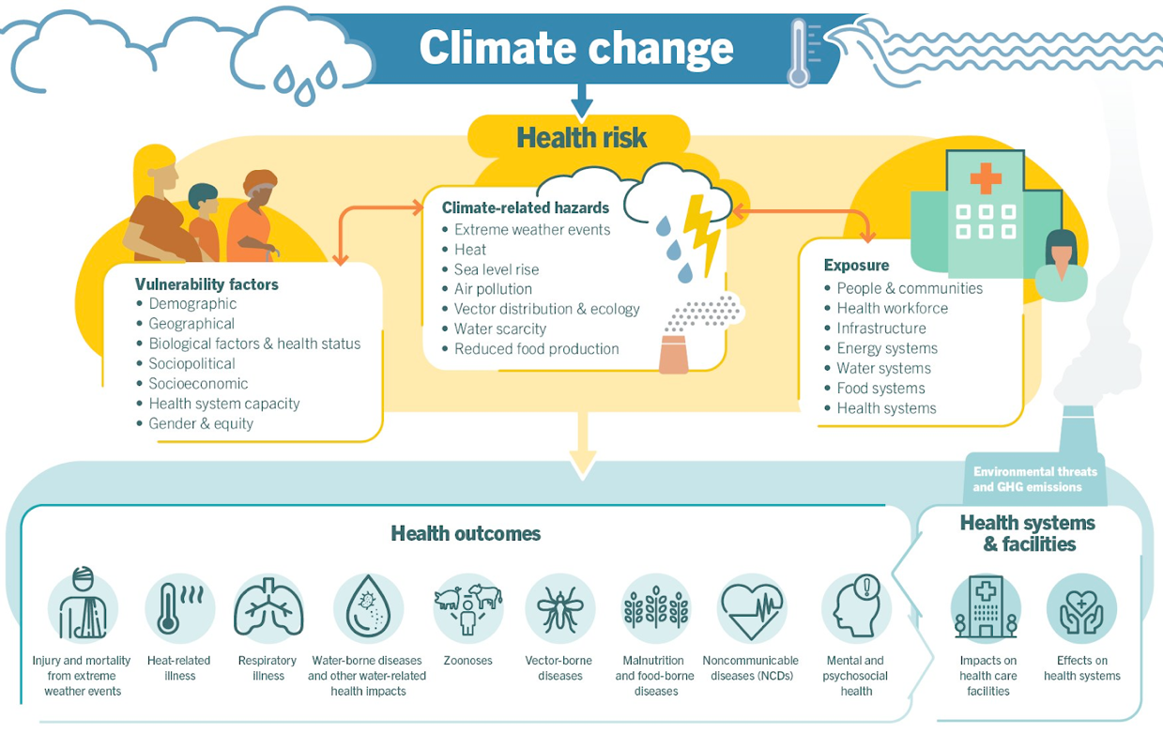
Figure1: WHO framework of Climate Change outcomes
Source: WHO ²³.

Health outcomes may be classified as:
- heat-related illness
- respiratory illness
- water-born diseases
- vector born diseases
- malnutrition and food borne diseases
- non-communicable diseases
- mental health.

Identification of studies via other methods
Identification of studies via databases and registers

Records identified from*:
Medline = 4492
Embase = 6143
PyscInfo = 2055
CINAHL = 960
Total =13650

Records removed before screening:
Duplicate records removed (n =3622)
Duplicate manual removed (n= 497)

Records identified from Manual Screening at Google Scholar = 1
Identification

Records excluded**
(n =9303)
Records screened
(n =9417)

Screening

Reports excluded (n=103):
- Not a peer-review article or only abstract or no full text or review article, commentary, book chapter, weekly report, conference document (n =36)
- Population does not meet population inclusion criteria/outside target age group or does not have stratification to be included in 5-24 categories. (n =32)
- Climate change as cause of movement/displacement (n = 14)
- All Study population are not displaced or in move ( n = 16)
- Multiple cause of displacement ( n = 2)
- Health outcome not assessed (n = 2)
Reports assessed for eligibility
(n = 114)

Studies included in review
(n = 12)

Included

Figure 2: PRISMA: FLOW CHART
Source: Page MJ, et al. BMJ 2021;372:n71. doi: 10.1136/bmj.n71.

Results:

From 4 databases Medline, Embase, PyscInfo and CINAHL 13650 results was obtainted among which 3622 was removed by automation process by using Zotero software whereas extra 497 duplication was resolve manually using Rayyan.ai. Moving on to title and abstract screening, 9303 article were removed while 114 articles remained left for full-text screening. And finally after fulltext screening 11 studies from databases search and 1 article which was already idenfied by manual Googlescholar search resulting 12 studies for final data-extraction. The details of search results can be seen in above PRISMA-Flowchart.

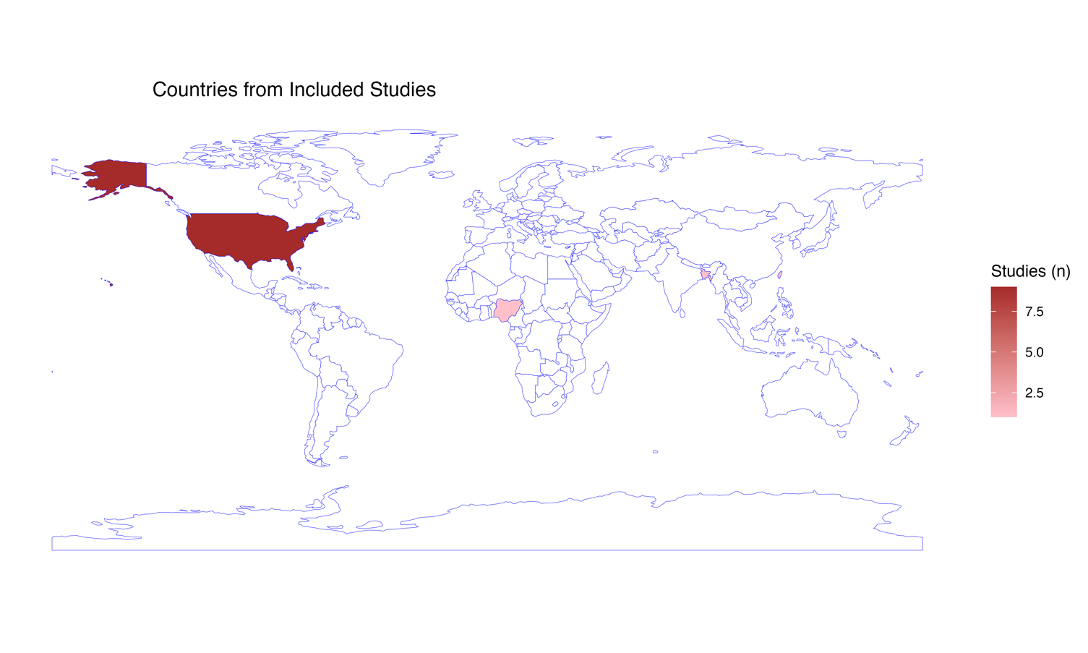
Figure 3: Country from Included Studies

Among 12 included studies, 9 were from United States of America (USA), 1 from Bangladesh, 1 Nigeria and 1 Taiwan.

Descritive table of included study
Characteristic | N = 12¹
YOP
2008 | 3 (25%)
2010 | 1 (8.3%)
2011 | 1 (8.3%)
2012 | 1 (8.3%)
2015 | 3 (25%)
2018 | 2 (17%)
2025 | 1 (8.3%)
Study Design
Cross-sectional | 3 (25%)
Cross-sectional comparative | 4 (33%)
Quasi-Experimental | 5 (42%)
Study Setting
Institutional Setting | 5 (42%)
Online Survey | 1 (8.3%)
Relocation Camps | 3 (25%)
School Based Survey | 1 (8.3%)
Telephone Survey | 1 (8.3%)
Urban Slum | 1 (8.3%)
Country-Economy
HIC | 10 (83%)
LMIC | 2 (17%)
Climatic Events
Flood | 1 (8.3%)
Hurricane | 8 (67%)
Hurricane and Flood | 1 (8.3%)
Multiple (Coastal or Riverbank erosion,Cyclone, Flood) | 1 (8.3%)
Typhoon, mudslides, flooding | 1 (8.3%)
¹n (%)

While exploring the year of publication of article, 3 studies were from 2008 and 3 studies from 2005, 2 from 2018, 1 each studies from 2010, 2011, 2012 and 2025. Among study design, most of the study 42% design were Quasi-Experimental studies (n = 5), followed by 33% Cross-sectional comparative studies (n=4) and 25% Cross-sectional study (n=3). Moving on to study setting, majority of the study 42% were done in an institutional setting (n=5), followed by 3 studies done in relocation camps, 1 study done in urban slum, 1 study done in school based survey and 1 study in telephone survey. While looking Country economy as per World-Bank Category most of the study 83.33% were from High Income Economies (n=10), only few study 16.66% were from Lower middle income economies (n=2). Moreover among 12 studies, hurricane was the most reported climatic events (n=8), whereas Flood (n=1), Hurricane & Flood (n=1), Multiple events (Coastal or Riverbank erosion,Cyclone, Flood) (n=1) and Typhoon, mudslides, flooding (n=1) were the reported cause of displacement of our study population of youth/chidren 5-24.

Health Outcomes:

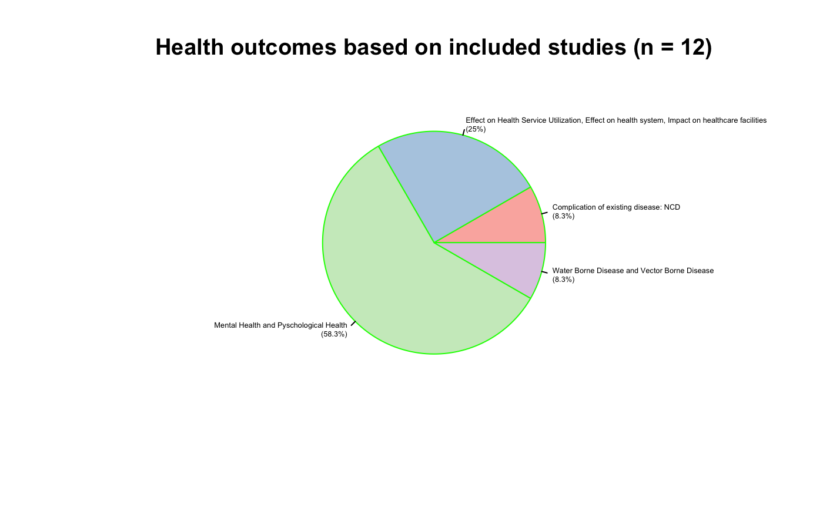

Figure 4: Pie chart showing health outcomes reported in the included studies

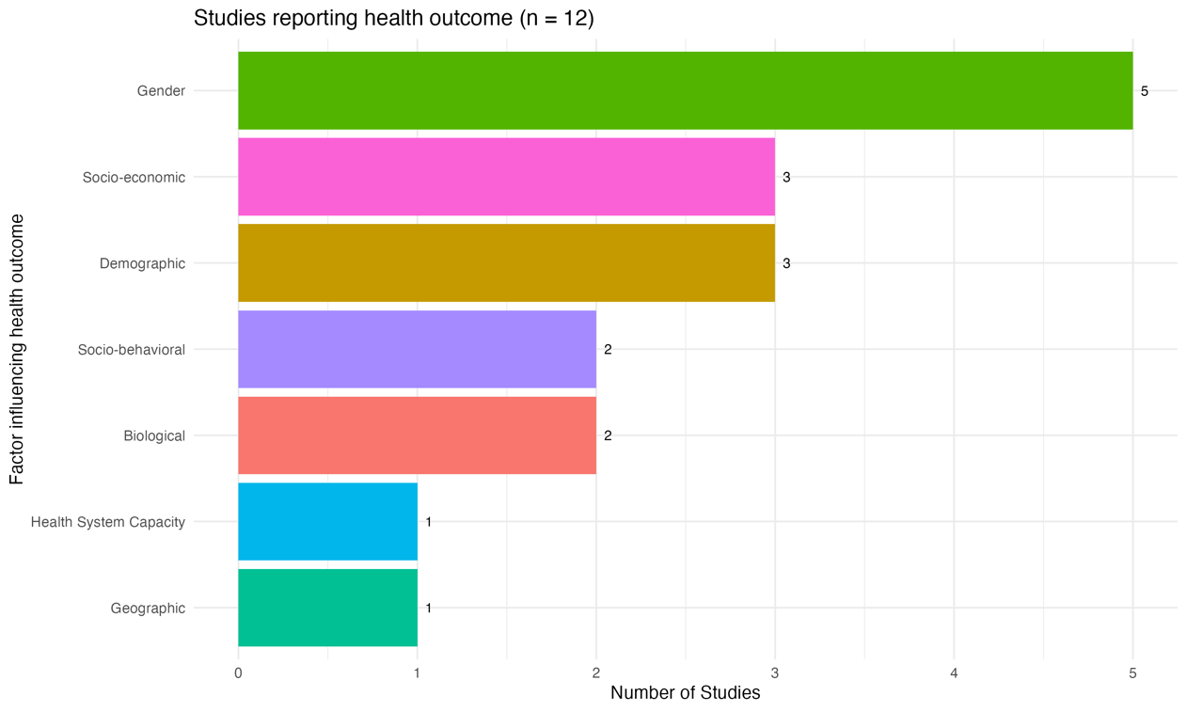

Figure 5: Barchart showing Factor influecing health outcomes in included studies
Among total studies, majority of the study reported Mental Health Outcomes (58.3%), following Effect on health service utilization/effect on health care system, (8.3%) reported complication of existing disease and (8.3%) reported Water-Borne Disease and Vector Borne Disease, which can be seen in Figure 4. Among the studies which also reported the health majority of the outcomes was associated with Gender (n=5) followed by Socio-economic (n=3), Demographic (n=3), Socio-behavioral (n=2), Biological (n=2), Health System (n=1) and Geographic (n=1), this finding can seen in Figure 5.

Discussion and Limitation:
This review to map the exisiting evidence in Health Outcomes Among Children and Youth of in Climate-Related Migration, Out of total 13650 search results from 4 major biomedical databases and 1 result from manual search, we included 12 article after duplication resolving, title and abstract screening, full-text screening processes based on inclusion and exclusion criteria. The details of information extracted from the included article can be found in Annex 1. While looking the geographical distribution based on World Bank Socio-economic classification, majority of the study were conducted in High Income countries (HIC) and only few were done low and middle income countries (LMICs). However , no eligible studies represented Upper Middle Income Country and Middle Income Countries. This results highlights that there is existing geographical evidence gaps and suggest the need of conducting research in to represent the this geography.

Our study also mapped evidence based on climatic events, most of the study were focused on extreme weather events such as Hurricane, Flood, Typhoon, Cyclone, Erosion, Mudslide etc, however research focusing on to study other climatic events like avalance, glacier lake outbrust, heat wave, air pollution, water scarcity, femine were lacking. This also shows future researcher should also focus equally on other climatic events to understand climate change in comprehensive way. When we looked on the health outcomes most of studies health outcomes Mental Health Outcomes, following Effect on health service utilization/effect on health care system, reported complication of existing disease and (8.3%) and Water Borne and Vector Borne Disease disease. This finding highlights the significant burden of mental health outcomes among youth and children. However due to missing evidence futher research should also equally focus on missing health outcomes such as malnutrition, heat related illness, non-communicable diseases, respiratory illnesses,etc.

Our review was done in very limited resources therefore, our study full-text screening and data extraction was performed by single reviewer which reduces however we used generative AI was used to verify the independent review decision. Despite our review included major biomedical data bases only google scholar was used to search for manual literature screening and our study was only limited with peer-review article therefore you could have missed relevent conference abstract, editorial, pre-prints,commentaries etc. Inclusion critieria didnt include pre-planed migration or displacement which are normally done to prevent outcome of climatic events before the happening of events, this is also one of our limitation. In future the researcher should plan considering our study limitation for generating better evide
Annex 1:Data extraction from included studies:
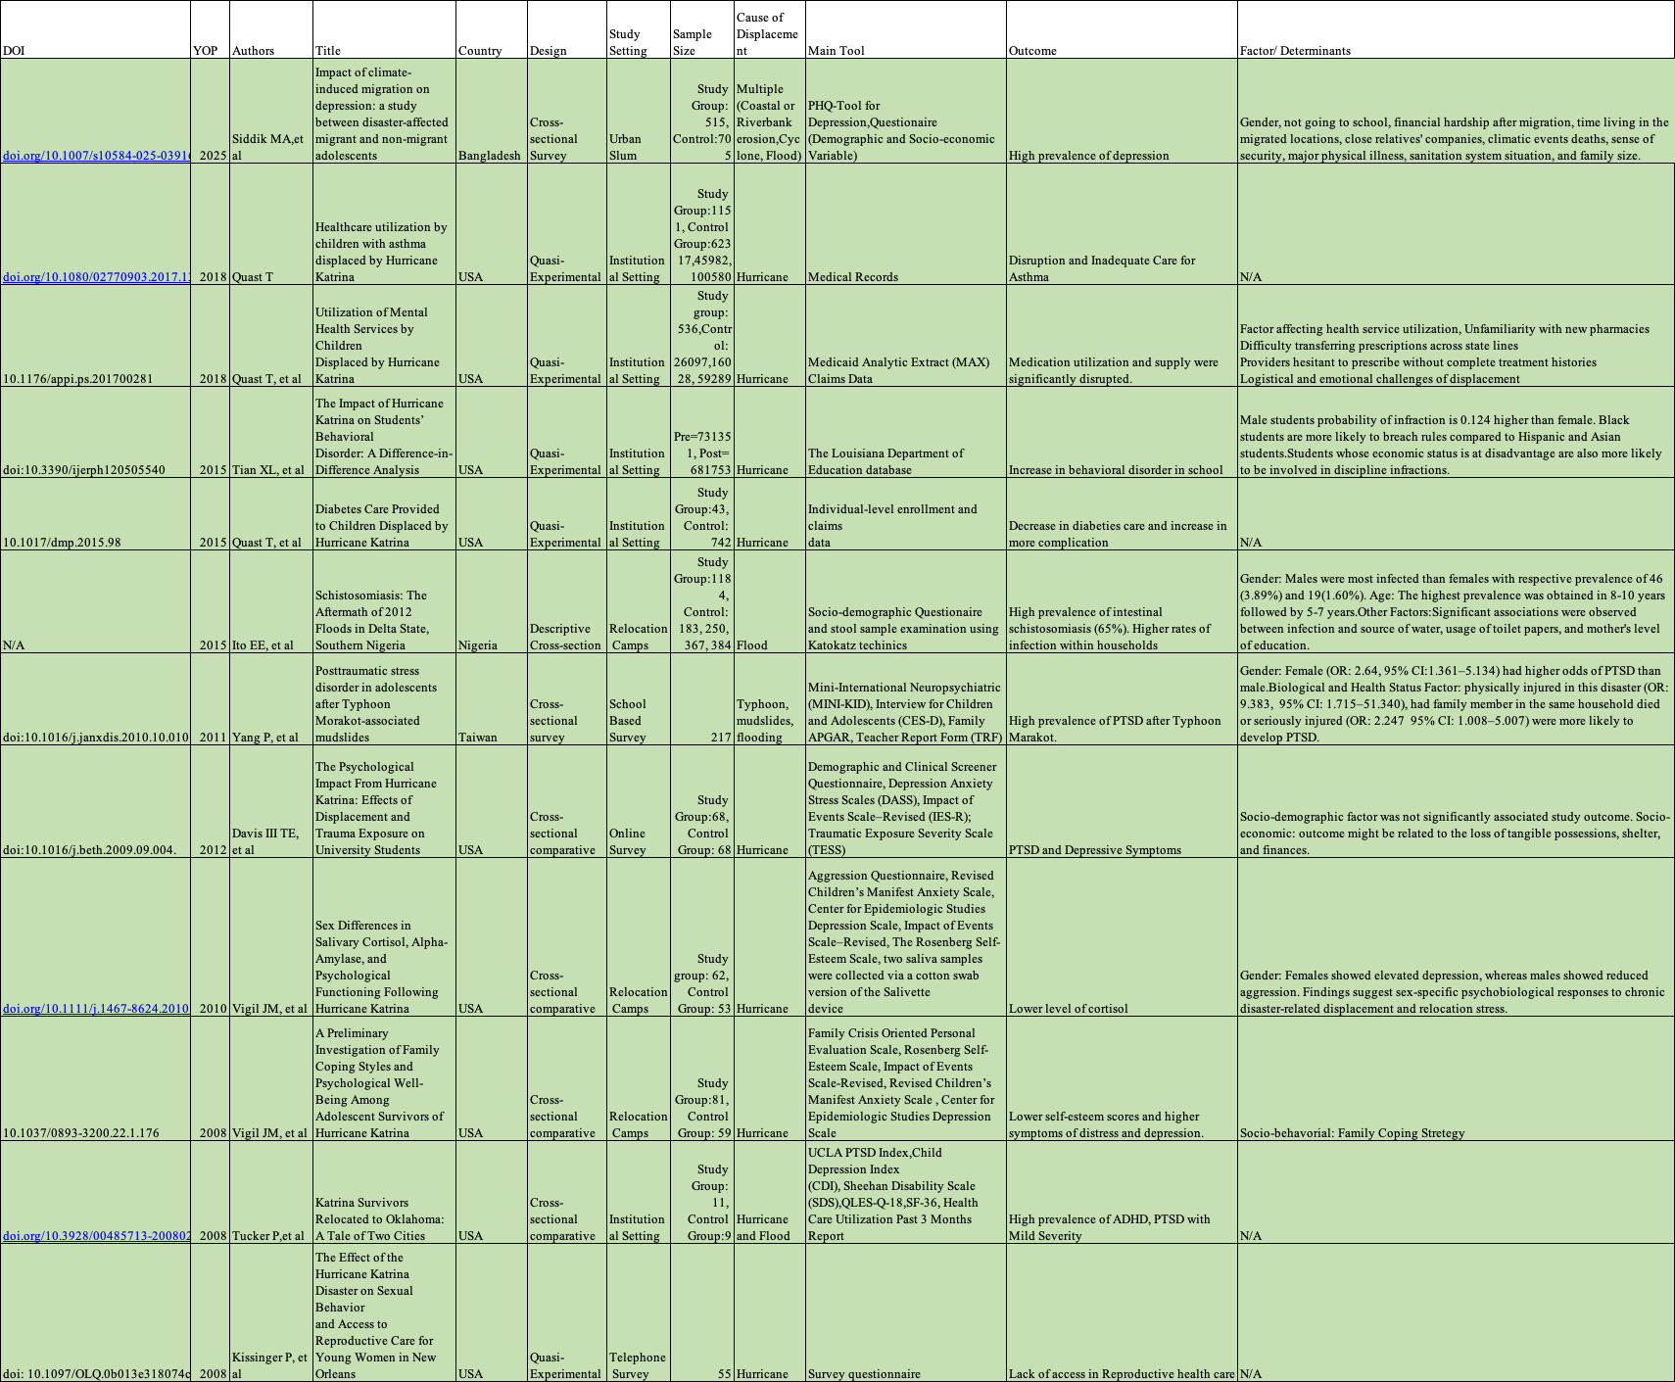

Annex 2: Search terms and results
Search Details:
S.N | CINAHL (18-Oct-2025, 18:26:34) QUERY | Results
1 | IN TEXT ((child* OR adolescen* OR teen* OR youth* OR young OR minor* OR juvenil* OR paediatric* OR pediatric* OR puber* OR pre-pubescent OR jeune* OR mineur OR “jeune adulte” OR pubescen* OR “school age*” OR adolescent/ OR young adult/ OR child/) AND (migr* OR immigr* OR emigr* OR outmigrat* OR refugee* OR asylum* OR undocument* OR non-citizen OR citizenship* OR transient* OR displac* OR expat* OR nationalit* OR non-resident* OR newly-arrived OR newcomer* OR new-comer* OR foreign-born OR country adj3 origin* OR diaspora* OR “population movement*” OR “border crossing*” OR “unaccompanied minor*” OR refugi* OR asile OR etrang* OR sans-papiers OR transitoire* OR citoyen* OR exp human migration/ OR exp “transients and migrants”/ OR exp refugees/ OR exp emigrants and immigrants/)) | 960 (Limit 2000-2025 to get latest articles)
2 | AND TI (exp climate change/ OR exp greenhouse effect/ OR exp extreme weather/ OR exp environmental change/ OR exp natural disasters/ OR "climate change*" or "global warming" or "climate variability" or "climatic variability" or "sea level*" or "greenhouse effect*" or "extreme weather" or "environmental change*" or "climate disaster*" or "natural disaster*" or "natural hazard*" or drought* or famine* or flood* or heat* or wildfire* or desertification or "ocean acidification" or pollut* or "air quality" or "water scarcity" or "water stress*" or storm* or climat* or desertif* or "changement climatique" or "réchauffement" or "food production" or "sea level" or "extreme weather events" or "air pollution" or "Heat waves" or "Meteorological factors" or Snow or "Heavy rain" or Flooding or "Extreme weather events" or Warming or "Greenhouse effect" or allergens or Ozone or "Suspended Particulate Matter" or Aeroallergens or Arid or Rain* or "Climatic factors" or "climactic factors" or "Relative humidity" or Precipitation or Temperature or Seasonal* or environment* or climat*)
3 | TI (Morbidity OR Mortality OR Health OR Disease OR Injury OR Death OR Non-communicable diseases OR Cancer OR Cardiovascular disease OR Diabetes OR Hypertension OR Myocardial infarction OR Cerebrovascular disease OR Stroke OR Respiratory OR Mental health OR Depression OR Schizophrenia OR Neurological OR Stress-Related disorders OR Health care OR Health services OR Asthma OR Allergies OR Airway OR Food insecurity OR Food security OR Hunger OR Malnutrition OR Health center OR Hospital OR Infection OR Diarrhea OR Waterborne OR Vector OR Trachoma OR Nutrition OR Cyanide OR Malaria OR Schistosomiasis OR Typhoid fever OR Amoebiasis OR Cholera OR Hepatitis A OR Salmonellosis OR Shigellosis OR Dengue OR Onchocerciasis OR Japanese encephalitis OR Scabies OR Impetigo OR Respiratory OR malnutrition OR Trauma)

S.N | EMBASE (18-Oct-2025, 20:07) QUERY | Results
1 | exp migration/ | 55653
2 | exp refugee/ | 20903
3 | exp forced migrant/ or exp migrant/ | 59831
4 | exp undocumented immigrant/ or exp immigrant/ | 23581
5 | exp internally displaced person/ | 333
6 | 1 or 2 or 3 or 4 or 5 | 106452
7 | (migr* or immigr* or emigr* or outmigrat* or refugee* or asylum* or undocument* or non-citizen or citizenship* or displac* or expat* or non-resident* or newly-arrived or newcomer* or new-comer* or foreign-born or diaspora* or "population movement*" or "border crossing*" or "unaccompanied minor*" or refugi* or asile or etrang* or sans-papiers or transitoire* or citoyen*).ti,ab. | 945434
8 | 6 or 7 | 968486
9 | exp adolescent/ or exp young adult/ or exp child/ | 4847802
10 | (child* or adolescen* or teen* or youth* or young or minor* or juvenil* or paediatric* or pediatric* or puber* or pre-pubescent or jeune* or mineur* or "jeune adulte" or pubescen* or "school age*").ti,ab. | 4175074
11 | 9 or 10 | 6512808
12 | exp climate/ or exp climate change/ or exp greenhouse effect/ or exp global climate/ | 162926
13 | exp extreme weather/ or exp environmental impact/ | 135756
14 | exp natural disaster/ | 5599
15 | 12 or 13 or 14 | 261234
16 | ("climate change*" or "global warming" or "climate variability" or "climatic variability" or "sea level*" or "greenhouse effect*" or "extreme weather" or "environmental change*" or "climate disaster*" or "natural disaster*" or "natural hazard*" or drought* or famine* or flood* or heat* or wildfire* or desertification or "ocean acidification" or pollut* or "air quality" or "water scarcity" or "water stress*" or storm* or climat* or desertif* or "changement climatique" or "réchauffement" or "food production" or "sea level" or "extreme weather events" or "air pollution" or "Heat waves" or "Meteorological factors" or Snow or "Heavy rain" or Flooding or "Extreme weather events" or Warming or "Greenhouse effect" or allergens or Ozone or "Suspended Particulate Matter" or Aeroallergens or Arid or Rain* or "Climatic factors" or "climactic factors" or "Relative humidity" or Precipitation or Temperature or Seasonal* or environment* or climat*).ti,ab. | 3454041
17 | 15 or 16 | 3507514
18 | (Morbidity or Mortality or Health or Disease or Injury or Death or Non-communicable diseases or Cancer or Cardiovascular disease or Diabetes or Hypertension or Myocardial infarction or Cerebrovascular disease or Stroke or Respiratory or Mental health or Depression or Schizophrenia or Neurological or Stress-Related disorders or Health care or Health services or Asthma or Allergies or Airway or Food insecurity or Food security or Hunger or Malnutrition or Health center or Hospital or Infection or Diarrhea or Waterborne or Vector or Trachoma or Nutrition or Cyanide or Malaria or Schistosomiasis or Typhoid fever or Amoebiasis or Cholera or Hepatitis A or Salmonellosis or Shigellosis or Dengue or Onchocerciasis or Japanese encephalitis or Scabies or Impetigo or Respiratory or malnutrition or Trauma).ti,ab. | 18822523
19 | 8 and 11 and 17 and 18 | 7497
20 | limit 19 to (human and yr="2000 -Current") | 6143

S.N | Ovid MEDLINE(R) (18-Oct-2025, 11:47:00) QUERY | Results
1 | exp Refugees/ | 15014
2 | exp "Transients and Migrants"/ | 15837
3 | exp "Emigrants and Immigrants"/ | 17395
4 | 1 or 2 or 3 | 45187
5 | (migr* or immigr* or emigr* or outmigrat* or refugee* or asylum* or undocument* or non-citizen or citizenship* or displac* or expat* or non-resident* or newly-arrived or newcomer* or new-comer* or foreign-born or diaspora* or "population movement*" or "border crossing*" or "unaccompanied minor*" or refugi* or asile or etrang* or sans-papiers or transitoire* or citoyen*).ti,ab. | 627571
6 | 4 or 5 | 634955
7 | exp Adolescent/ or exp Adolescent Health/ | 2357585
8 | exp Child Health/ or exp Child/ | 2291680
9 | exp Young Adult/ | 1170105
10 | 7 or 8 or 9 | 4113472
11 | (child* or adolescen* or teen* or youth* or young or minor* or juvenil* or paediatric* or pediatric* or puber* or pre-pubescent or jeune* or mineur* or "jeune adulte" or pubescen* or "school age*").ti,ab. | 2726308
12 | 10 or 11 | 5072657
13 | exp Climate Change/ or exp Climate/ | 204910
14 | exp Greenhouse Effect/ | 6341
15 | exp Extreme Weather/ or exp Disasters/ | 119827
16 | exp Natural Disasters/ | 32061
17 | 13 or 14 or 15 or 16 | 322594
18 | ("climate change*" or "global warming" or "climate variability" or "climatic variability" or "sea level*" or "greenhouse effect*" or "extreme weather" or "environmental change*" or "climate disaster*" or "natural disaster*" or "natural hazard*" or drought* or famine* or flood* or heat* or wildfire* or desertification or "ocean acidification" or pollut* or "air quality" or "water scarcity" or "water stress*" or storm* or climat* or desertif* or "changement climatique" or "réchauffement" or "food production" or "sea level" or "extreme weather events" or "air pollution" or "Heat waves" or "Meteorological factors" or Snow or "Heavy rain" or Flooding or "Extreme weather events" or Warming or "Greenhouse effect" or allergens or Ozone or "Suspended Particulate Matter" or Aeroallergens or Arid or Rain* or "Climatic factors" or "climactic factors" or "Relative humidity" or Precipitation or Temperature or Seasonal* or environment* or climat*).ti,ab. | 2249513
19 | 17 or 18 | 2400612
20 | (Morbidity or Mortality or Health or Disease or Injury or Death or Non-communicable diseases or Cancer or Cardiovascular disease or Diabetes or Hypertension or Myocardial infarction or Cerebrovascular disease or Stroke or Respiratory or Mental health or Depression or Schizophrenia or Neurological or Stress-Related disorders or Health care or Health services or Asthma or Allergies or Airway or Food insecurity or Food security or Hunger or Malnutrition or Health center or Hospital or Infection or Diarrhea or Waterborne or Vector or Trachoma or Nutrition or Cyanide or Malaria or Schistosomiasis or Typhoid fever or Amoebiasis or Cholera or Hepatitis A or Salmonellosis or Shigellosis or Dengue or Onchocerciasis or Japanese encephalitis or Scabies or Impetigo or Respiratory or malnutrition or Trauma).ti,ab. | 11684650
21 | 6 and 12 and 19 and 20 | 5436
22 | limit 21 to yr="2000 -Current" | 4492

S.N | APA PsycInfo vid OVID (19-Oct-2025, 16: 28:47) QUERY | Result
1 | exp child/ or exp adolescent/ or exp young adult/ or (child* or adolescen* or teen* or youth* or young or minor* or juvenil* or paediatric* or pediatric* or puber* or pre-pubescent or "school age*" or "jeune*" or mineur* or "jeune adulte" or pubescen*).ti,ab. | 1292061
2 | (exp emigrants/ and immigrants/) or exp refugees/ or exp "transients and migrants"/ or exp human migration/ or (migr* or immigr* or emigr* or outmigrat* or refugee* or asylum* or undocument* or non-citizen or citizenship* or transient* or displac* or expat* or nationalit* or non-resident* or newly-arrived or newcomer* or "new-comer*" or "foreign-born" or (country adj3 origin*) or diaspora* or "population movement*" or "border crossing*" or "unaccompanied minor*" or refugi* or asile or etrang* or sans-papiers or transitoire* or citoyen*).ti,ab. | 171201
3 | exp climate change/ or exp greenhouse effect/ or exp extreme weather/ or exp environmental change/ or exp natural disasters/ or ("climate change*" or "global warming" or "climate variability" or "climatic variability" or "sea level*" or "greenhouse effect*" or "extreme weather" or "environmental change*" or "climate disaster*" or "natural disaster*" or "natural hazard*" or drought* or famine* or flood* or heat* or wildfire* or desertification or "ocean acidification" or pollut* or "air quality" or "water scarcity" or "water stress*" or storm* or climat* or environment* or desertif* or "changement climatique" or "réchauffement" or "food production" or "extreme weather events" or "air pollution" or Climate or "Heat waves" or "Meteorological factors" or Snow or "Heavy rain" or Flooding or "Extreme weather events" or Weather or Warming or "Climate change intervention" or "Climate change adaptation" or Atmosphere or Greenhouse effect or allergens or Ozone or "Suspended Particulate Matter" or Aeroallergens or Arid or Rain or "Climatic factors" or "Relative humidity" or Precipitation or Temperature or Seasonality).ti,ab. | 485425
4 | exp morbidity/ or exp mortality/ or exp health/ or exp disease/ or exp injury/ or exp death/ or exp chronic disease/ or exp mental health/ or exp nutrition disorders/ or exp communicable diseases/ or (Morbidity or Mortality or Health or Disease or Injury or Death or "Non-communicable disease*" or Cancer or "Cardiovascular disease" or Diabetes or Hypertension or "Myocardial infarction" or "Cerebrovascular disease" or Stroke or Respiratory or "Mental health" or Depression or Schizophrenia or Neurological or "Stress-Related disorders" or "Health care" or "Health services" or Asthma or Allergies or Airway or "Food insecurity" or "Food security" or Hunger or Malnutrition or "Health center" or Hospital or Infection or Diarrhea or Waterborne or Vector or Trachoma or Nutrition or Cyanide or Malaria or Schistosomiasis or Typhoid fever or Amoebiasis or Cholera or "Hepatitis A" or Salmonellosis or Shigellosis or Dengue or Onchocerciasis or "Japanese encephalitis" or Scabies or Impetigo or Trauma).ti,ab. | 1839893

