<ParkPilot - AI-Powered Intelligent Parking Space Detection and Navigation Using Computer Vision>

A PROJECT BASED LEARNING (PBL) REPORT

Submitted by
R. Ragav
Tharun K.S.
Submitted in partial fulfilment of the requirements
for the
Project-Based Learning component of Machine Learning

BACHELOR OF ENGINEERING

in

COMPUTER SCIENCE AND ENGINEERING



CHENNAI INSTITUTE OF TECHNOLOGY, CHENNAI


Affiliated to Anna University, Chennai

(Autonomous)

OCTOBER 2026

Vision of the Institute:
To be an eminent centre for Academia, Industry and Research by imparting knowledge, relevant practices and inculcating human values to address global challenges through novelty and sustainability.

Mission of the Institute:

IM1. To creates next generation leaders by effective teaching learning
methodologies and in still Scientifics Park in them to meet the global challenges.
IM2. To transform lives through deployment of emerging technology, novelty and sustainability.
IM3. To inculcate human values and ethical principles to cater the societal needs.
IM4. To contributes towards the research ecosystem by providing a suitable,

DEPARTMENT OF

COMPUTER SCIENCE AND ENGINEERING

Vision of the Department:
To Excel in the emerging areas of Computer Science and Engineering by imparting knowledge, relevant practices and inculcating human values to transform the students as potential resources to contribute innovatively through advanced computing in real time situations.

Mission of the Department:

DM1. To provide strong fundamentals and technical skills for Computer Science
applications through effective teaching learning methodologies.
DM2. To transform lives of the students by nurturing ethical values, creativity and novelty to become Entrepreneurs and establish start-ups.
DM3. To habituate the students to focus on sustainable solutions to improve the
quality of life and the welfare of the society.

BONAFIDE CERTIFICATE

This is to certify that the Project–Based Learning report titled “ParkPilot - AI-Powered Intelligent Parking Space Detection and Navigation Using Computer Vision” is a Bonafide record of work carried out by R. Ragav, Tharun K.S. (2104251040740; 2104251041038) of the Department of Computer Science and Engineering, Chennai Institute of Technology, as part of the continuous, mentor–guided Project-Based Learning (PBL) component of the Machine Learning course during the academic year 2026–2027 under my supervision.

SIGNATURE  Dr. S. Pavithra, M.E., Ph.D.  Professor and Head,  Dept. of Computer Science and Engineering  Chennai Institute of Technology,  Chennai – 69. | SIGNATURE  Pratham Verma  MENTOR  Machine Learning Faculty  Dept. of Computer Science and Engineering  Chennai Institute of Technology,  Chennai – 69.

Submitted for the final review held on …………………….

Internal Examiner

DECLARATION
I/We jointly declare that the PBL report on “ParkPilot - AI-Powered Intelligent Parking Space Detection and Navigation Using Computer Vision” is the result of original work done by us and best of our knowledge, similar work has not been submitted to “ANNA UNIVERSITY, CHENNAI” for the requirement of Degree of BACHELOR OF ENGINEERING. This PBL report is submitted on the partial fulfilment of the requirement of the award of Degree of COMPUTER SCIENCE AND ENGINEERING.

Signature

R. Ragav

R. Ragav

Place: Chennai
Date:

ACKNOWLEDGEMENT
We wish to express our sincere gratitude to our honorable Chairman SHRI. P. SRIRAM for providing immense facilities at our institution.

We are very proudly rendering our thanks to our Principal Dr.A.RAMESH M.E, Ph.D., for the facilities and the encouragement given by him to the progress and completion of our project.
We would like to express special thanks of gratitude to our Dean Dr. V. SRINIVASA RAO, M.E., Ph.D., who has been the key spring of motivation to us throughout the completion of our course and project work.
We proudly render our immense gratitude to the Head of the Department Dr. S. PAVITHRA M.E, Ph.D., for her effective leadership, encouragement and guidance in the project.
We would like to extend our thanks to Pratham Verma, Machine Learning Faculty, Project Coordinator / Faculty Guide, Department of Computer Science and Engineering, for his valuable guidance and suggestions throughout this project.
We wish to acknowledge the support of our Class Advisors, Prasanna (Design and Analysis of Algorithms Faculty) and Lavanya (Java Faculty), for their academic guidance and encouragement.

NAME 1 (REG.NO)
NAME 2 (REG.NO)

ABSTRACT

ParkPilot is a Machine Learning and Computer Vision based system designed to detect vacant and occupied parking spaces from camera feeds and guide drivers toward the nearest available slot. The project addresses the difficulty of finding parking in crowded urban areas, malls, and office complexes, where drivers may waste time and fuel searching for free spaces. The proposed system uses Python, OpenCV, and the YOLOv8 object-detection model to identify vehicles and determine parking-slot occupancy. A custom slot-grid mapping module is used to associate detected vehicles with marked parking slots and identify the nearest available slot from the entry point. The intended workflow includes live video capture, vehicle detection, vacancy classification, real-time status tracking, slot selection, and navigation display. The zeroth-review material specifies the expected outcome as a user-friendly system capable of real-time parking availability detection and navigation. Quantitative model-performance results are not yet provided in the supplied project material, so the final report should insert the measured accuracy/precision/recall or other evaluation values after experimentation.
Keywords: Computer Vision, YOLOv8, Parking Detection, Machine Learning, Navigation

TABLE OF CONTENTS
Team Roles and Responsibilities i
CHAPTER 1: INTRODUCTION 1
1.1 Background 1
1.2 Driving Question 1
1.3 Objectives 1
1.4 Scope and Limitations 1
CHAPTER 2: CONCEPT EXPLORATION 1
2.1 Related Approaches 1
2.2 Summary Table 1
2.3 What This Told Us 1
CHAPTER 3: PROJECT PLANNING AND TEAM ORGANISATION 1
3.1 Weekly PBL Progress Log 1
3.2 Requirements 1
3.3 Feasibility 1
CHAPTER 4: ITERATIVE DESIGN AND DEVELOPMENT 1
4.1 System Architecture 1
4.2 Iteration 1 — Baseline 1
4.3 Iteration 2 — Refinement 1
4.4 Final Approach 1
4.5 Training Procedure 1
CHAPTER 5: IMPLEMENTATION 1
5.1 Module Description 1
5.2 Key Code Snippets 1
5.3 User Interface / Demo (if applicable) 1
CHAPTER 6: RESULTS AND DISCUSSION 1
6.1 Evaluation Metrics 1
6.2 Results Across Iterations 1
6.3 Discussion 1
6.4 Limitations 1
CHAPTER 7: TEAM REFLECTION AND LEARNING OUTCOMES 1
7.1 Individual Reflections 1
7.2 Team Learning 1
7.3 Course Outcomes — Evidence Summary 1
CHAPTER 8: CONCLUSION AND FUTURE SCOPE 1
8.1 Conclusion 1
8.2 Future Scope 1
REFERENCES 1
APPENDIX 1
A.3 Self and Peer Assessment 1

LIST OF FIGURES

Figure 1.1 ParkPilot problem context and workflow ........................................
Figure 4.1 ParkPilot system architecture ...............................................
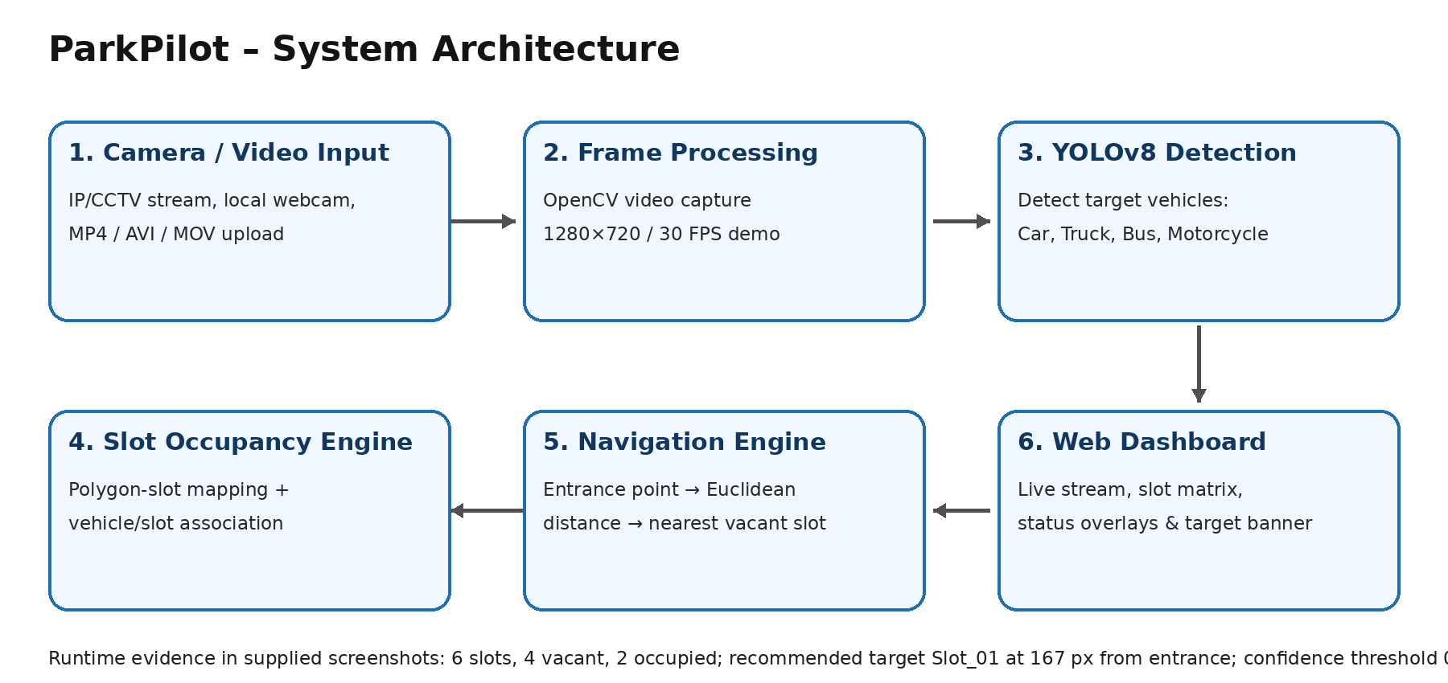
Figure 4.1: ParkPilot end-to-end system architecture.
Figure 6.1 Runtime occupancy and navigation evidence ................................

LIST OF TABLES

Table 3.1 Weekly PBL progress log ........................................................
Table 3.2 Hardware and software requirements ..........................................
Table 6.1 Observed runtime evaluation results ........................................

LIST OF ABBREVIATIONS

Eg.
ML — Machine Learning
CNN — Convolutional Neural Network
PBL — Project-Based Learning
CV — Computer Vision
YOLO — You Only Look Once
FPS — Frames Per Second
RTSP — Real Time Streaming Protocol
API — Application Programming Interface
JSON — JavaScript Object Notation

TEAM ROLES AND RESPONSIBILITIES
R. Ragav (2104251040740) — Project implementation, machine-learning integration, system integration and documentation.
Tharun K.S. (2104251041038) — Working-model development, interface integration and testing.
Pratham Verma — Machine Learning Faculty; Mentor / Faculty Guide and Project Coordinator.
Prasanna — Design and Analysis of Algorithms Faculty; Class Advisor.
Lavanya — Java Faculty; Class Advisor.

CHAPTER 1

INTRODUCTION

1.1 Background
Set the real-world context. What problem area does this sit in, and why does it matter? 2–3 short paragraphs, no citations dump — save the detailed literature for Chapter 2.

1.2 Driving Question

Driving Question: Can a real-time camera-based computer-vision system reliably identify vacant parking slots and guide a driver to a nearby available slot? The project narrows this to YOLOv8 vehicle detection, polygon-based slot definitions, occupancy determination, entrance-to-slot distance calculation and live navigation display.

1.3 Objectives

- • To configure camera/video inputs and prepare parking-scene frames for real-time processing.
• To define and persist parking-slot polygons and an entrance/start point.
• To integrate YOLOv8 vehicle detection with slot-occupancy logic.
• To compute and display the nearest available parking slot.
• To evaluate the working system using runtime occupancy and navigation evidence.
• To document the PBL development process, implementation decisions and learning outcomes.

1.4 Scope and Limitations
Scope: real-time or uploaded parking video, polygon-defined parking slots, YOLOv8 vehicle detection, live occupancy status, nearest-slot navigation and a browser dashboard. Limitations include dependence on camera placement, scene quality and slot configuration, plus the absence of supplied training logs and held-out-set metrics.

CHAPTER 2

CONCEPT EXPLORATION

2.1 Related Approaches
Classical parking systems may use dedicated sensors at individual spaces. ParkPilot uses camera-based computer vision so one video source can support multiple slot definitions. The project material selects YOLOv8 for vehicle detection and OpenCV for video processing. The exact YOLOv8 checkpoint variant is not visible in the supplied evidence.

2.2 Summary Table
Ref. | Approach / Model | Dataset | Reported Result
[1] | YOLOv8 object detection | Dataset source/size not supplied in the provided project material. | Runtime evidence: 6 total slots, 4 vacant, 2 occupied; nearest target Slot_01; displayed distance 167 px from entrance.
[2] | [Additional source/approach details to be provided] | [Additional source/approach details to be provided] | [Additional source/approach details to be provided]

2.3 What This Told Us
The team selected a YOLOv8-based detection pipeline because the application requires vehicle detection from camera/video streams. The detector is combined with user-defined parking-slot polygons so detections can be converted into occupancy states and navigation decisions.

CHAPTER 3

PROJECT PLANNING AND TEAM ORGANISATION

3.1 Weekly PBL Progress Log

Week | Milestone / Task | Work Done | Mentor Remarks
1–2 | [Problem framing, dataset search] | [Work completed/details to be provided] | [Mentor remarks to be provided]
3–4 | [Concept exploration, baseline plan] | [Work completed/details to be provided] | [Mentor remarks to be provided]
5–7 | [Iteration 1 — baseline model] | [Work completed/details to be provided] | [Mentor remarks to be provided]
8–10 | [Iteration 2 — refinement] | [Work completed/details to be provided] | [Mentor remarks to be provided]
11–12 | [Final evaluation, report, demo] | [Work completed/details to be provided] | [Mentor remarks to be provided]

3.2 Requirements
The supplied project material does not specify the dataset source, dataset size, or class counts. These should be added once the training/evaluation dataset is confirmed.
Category | Requirement
Processor / RAM | [e.g. Intel i5 / 8 GB RAM (minimum)]
Programming language | [Python 3.x]
Libraries / frameworks | [e.g. scikit-learn, TensorFlow/PyTorch, pandas, NumPy]
Development environment | [e.g. Jupyter Notebook / Google Colab / VS Code]
Version control | [e.g. Git/GitHub repository link]

3.3 Feasibility
The proposed system is designed around standard camera/IP-CCTV hardware and commonly used Python computer-vision tools. The project can be developed incrementally through problem framing, concept exploration, baseline detection, refinement, evaluation, and demonstration. Final feasibility depends on the actual dataset, available compute resources, and the measured performance obtained during implementation.

CHAPTER 4

ITERATIVE DESIGN AND DEVELOPMENT

4.1 System Architecture
Figure 4.1 presents the implemented pipeline: camera/video input → frame processing → YOLOv8 vehicle detection → polygon-slot occupancy logic → entrance-to-slot distance calculation → nearest-slot selection → browser dashboard.
Figure 4.1 — Proposed pipeline: Camera Feed → Vehicle/Slot Detection (YOLOv8) → Occupancy Classification → Real-Time Tracking → Nearest Slot Selection → Navigation Display/Dashboard.

4.2 Iteration 1 — Baseline
Iteration 1 should establish a baseline using YOLOv8 for vehicle detection and a simple parking-slot occupancy decision rule. The supplied material does not contain measured baseline results or mentor feedback, so those values and observations should be inserted from the team's actual experiments.

4.3 Iteration 2 — Refinement
The working model adds an interactive polygon editor, automatic grid generation, video-source management, adjustable YOLOv8 confidence and vehicle-class selection, live occupancy cards, nearest-slot recommendation and API endpoints. The demonstrated state contains 6 slots, with 4 vacant and 2 occupied.

4.4 Final Approach
The proposed final approach uses YOLOv8 for real-time object detection, combined with OpenCV-based video processing and a custom slot-grid mapping module. YOLOv8 is intended to identify vehicles in the camera feed; the system then associates detections with predefined parking slots to classify each slot as vacant or occupied. The supplied material does not specify the final trained model variant or hyperparameter values, so these should be added after implementation.

4.5 Training Procedure
The supplied project material does not specify the train/validation/test split, final hyperparameters, epochs, loss function, optimizer, or cross-validation strategy. These details should be recorded from the actual training run.

CHAPTER 5

IMPLEMENTATION

5.1 Module Description
The implementation can be organized into: (1) Data/Video Ingestion for live camera feeds; (2) Computer Vision Processing using OpenCV; (3) YOLOv8 Vehicle Detection; (4) Parking-Slot Occupancy Classification; (5) Real-Time Status Tracking; (6) Nearest-Slot Selection using the custom slot-grid mapping module; and (7) Navigation/Dashboard display. The exact code structure should be aligned with the team's implementation.

5.2 Key Code Snippets

# Representative implementation area: insert the actual YOLOv8 inference,
# parking-slot occupancy logic, and nearest-slot selection snippets here.

5.3 User Interface / Demo (if applicable)
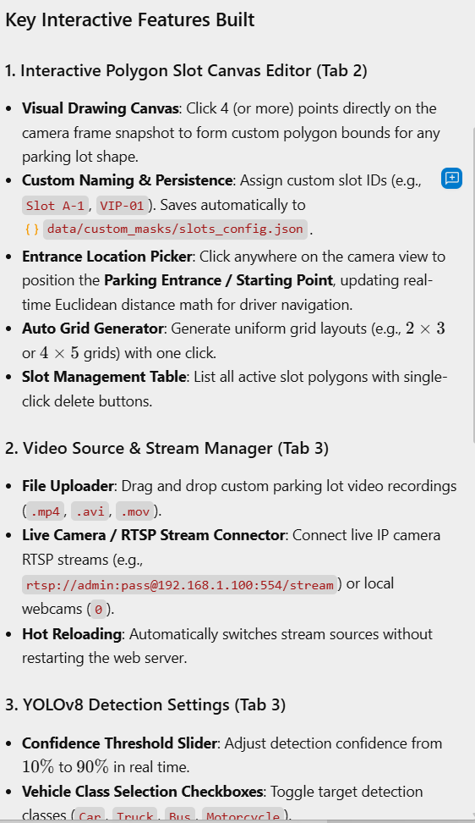
Figure 5.1: Interactive feature set and configuration capabilities.
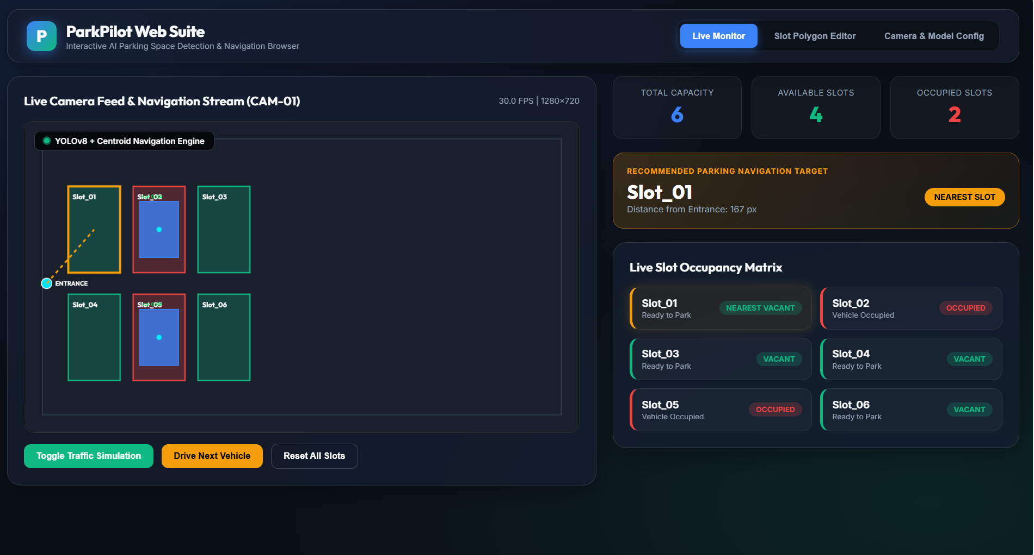
Figure 5.2: Live Monitor showing 6 slots, 4 vacant, 2 occupied and Slot_01 as nearest target.
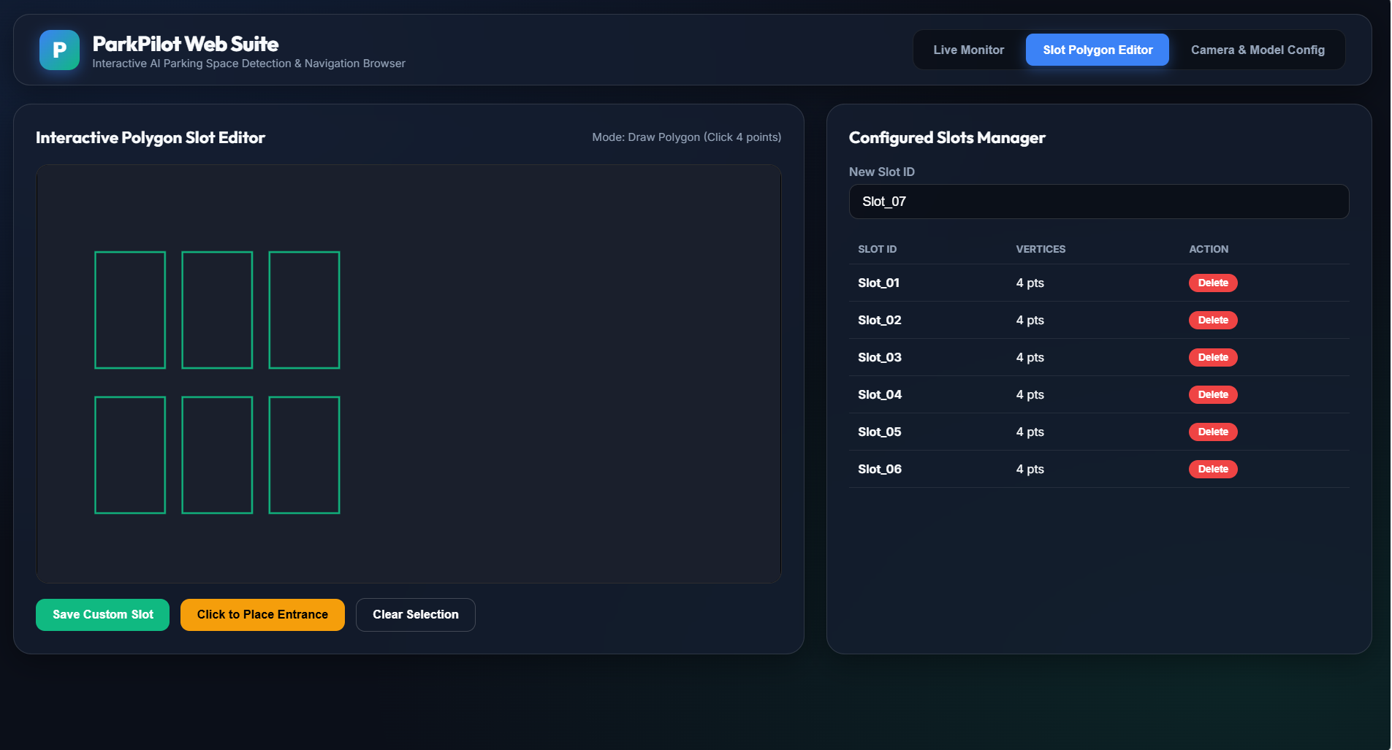
Figure 5.3: Interactive polygon slot editor with six configured slots.
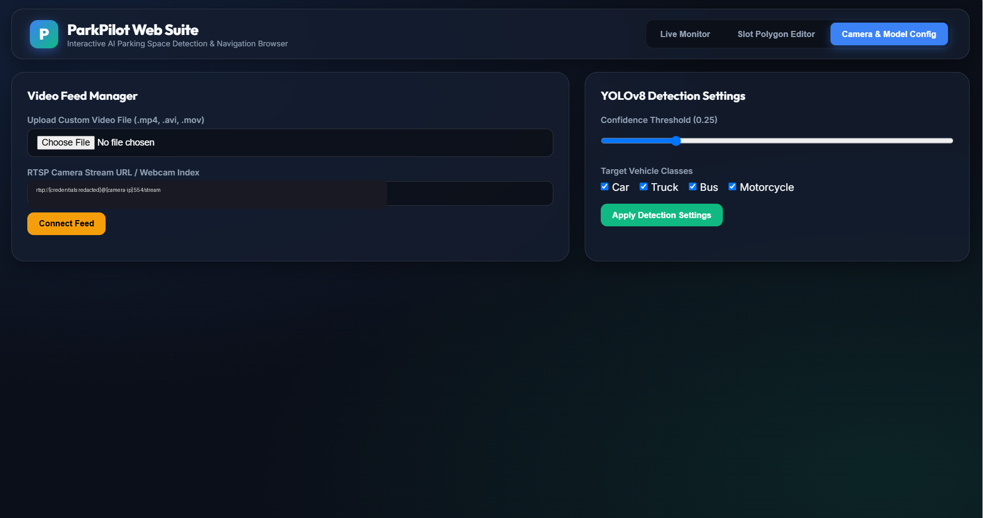
Figure 5.4: Video source and YOLOv8 detection settings; camera credentials redacted.
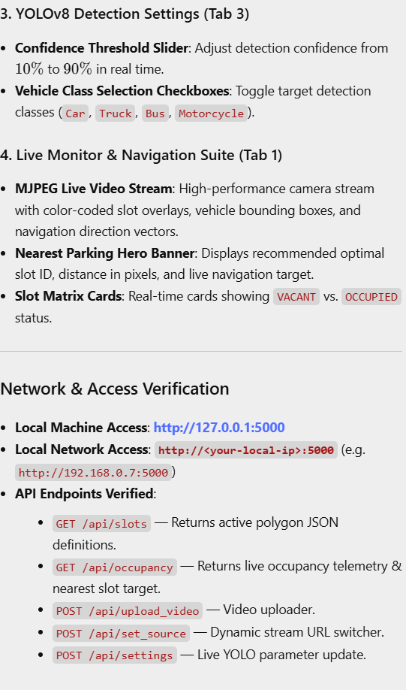
Figure 5.5: Network/API access verification and local application endpoint.
Figures 5.1–5.5 document the supplied working ParkPilot Web Suite and its major interactive features.

CHAPTER 6

RESULTS AND DISCUSSION

6.1 Evaluation Metrics
For the final evaluation, report the object-detection and occupancy-classification metrics actually used by the team, such as precision, recall, F1-score, and/or accuracy where applicable. The supplied project material does not provide measured values yet.

6.2 Results Across Iterations
Figure 6.1: Runtime occupancy and navigation evidence.

Version | Accuracy | Precision | Recall / F1
Runtime demonstration | Not applicable | Not applicable | 6 total slots; 4 vacant; 2 occupied
Nearest-slot selection | Not applicable | Not applicable | Slot_01; displayed distance 167 px
Video stream | Not applicable | Not applicable | 1280×720 at 30.0 FPS

Formal confusion-matrix, mAP, precision, recall and F1 results were not supplied. The report therefore presents the actual runtime evidence available from the working model rather than fabricating training metrics.

6.3 Discussion
The final discussion should relate measured detection and occupancy results to lighting, camera angle, vehicle overlap, occlusion, slot markings, and other conditions observed in the actual test data. Because no measured results are included in the supplied project material, this section should be completed after experimentation.

6.4 Limitations
Potential limitations to verify during implementation include dependence on camera placement and image quality, changes in lighting and weather, vehicle occlusion, dataset coverage, computational resources, and generalisation to different parking layouts. Only limitations actually observed should be retained in the final report.

CHAPTER 7

TEAM REFLECTION AND LEARNING OUTCOMES

7.1 Individual Reflections

R. Ragav: [reflection]
Tharun K.S.: [reflection]
: [reflection]

7.2 Team Learning
[Add team reflection based on actual work division, decisions, mentor feedback, and lessons learned.]

7.3 Course Outcomes — Evidence Summary
[For each CO listed in the front matter, give one line of concrete evidence from this project — e.g. (teamwork): weekly log in Table 3.1 shows task rotation across all three iterations.”]

CHAPTER 8

CONCLUSION AND FUTURE SCOPE

8.1 Conclusion
ParkPilot proposes a real-time camera-based system for detecting vacant and occupied parking spaces and guiding drivers to the nearest available slot. The supplied project material establishes the proposed architecture and expected outcome, but it does not yet provide final measured model results; those results should be inserted after implementation to complete the conclusion.

8.2 Future Scope
- Scale evaluation to a larger and more diverse parking dataset.
- Evaluate alternative or improved object-detection models and tuning strategies.
- Extend the navigation and occupancy dashboard to a web/mobile application.

REFERENCES

[1] Ultralytics, “YOLO Documentation,” [Online]. Available: official documentation source. [Add exact access details used by the team.]
[2] Dataset source: Not specified in the supplied project material; insert the actual dataset/repository used for training and evaluation.
[3] ParkPilot working-model screenshots and feature documentation supplied by the authors, 2026.

APPENDIX

A.1 Full source code: [GitHub/Colab link]
A.2 Complete weekly PBL log (if longer than Table 3.1) and mentor sign-offs.

A.3 Self and Peer Assessment

Team Member | Self-Rated Contribution (%) | Peer-Rated Contribution (%) | Remarks
R. Ragav | [%] | [%] | [Mentor remarks to be provided]
Tharun K.S. | [%] | [%] | [Mentor remarks to be provided]

