1. Show how to create and drop a database.

Ans.

A. create database movies;

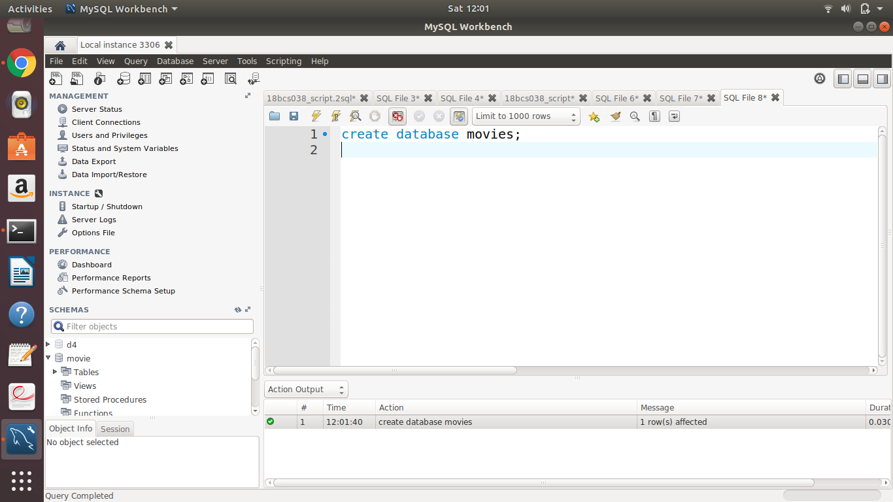

B. drop database movies;

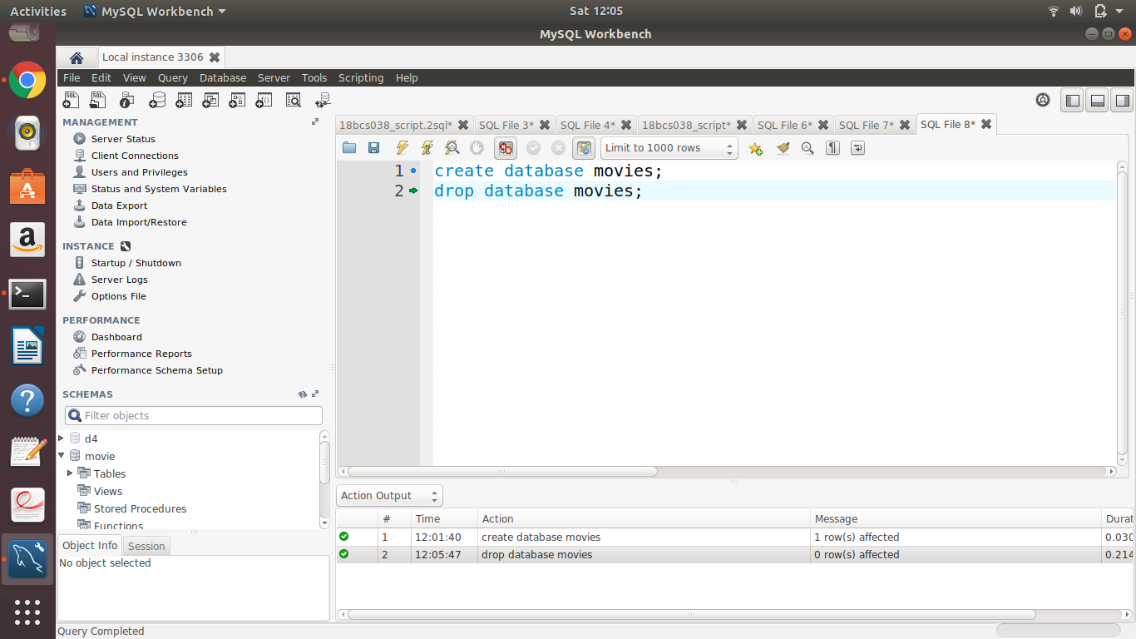

1. Show all the databases that are there in the system.

Ans. show databases;

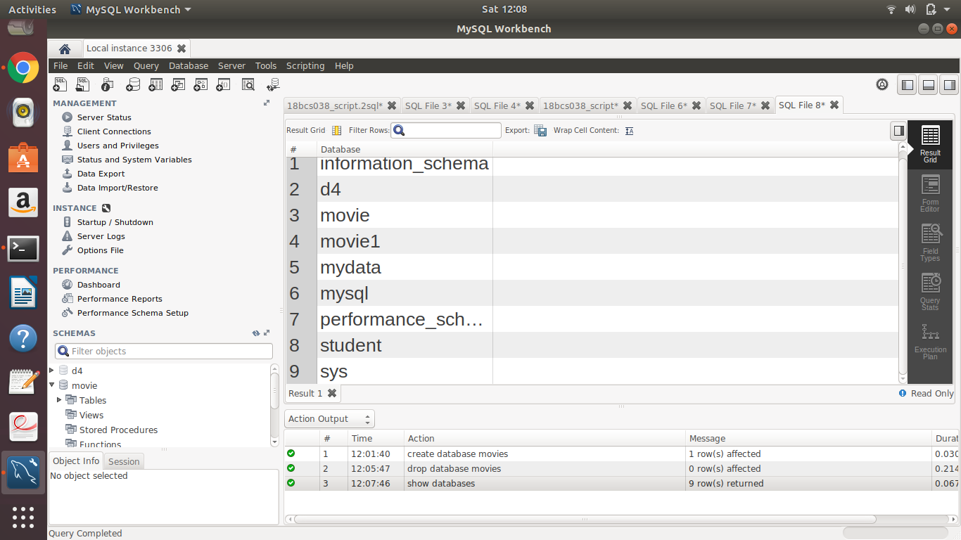

1. Create Table for your database.

Ans. create table movies1(movie_id INT primary key,title VARCHAR(45),date1 DATE, genre VARCHAR(45), rating INT);

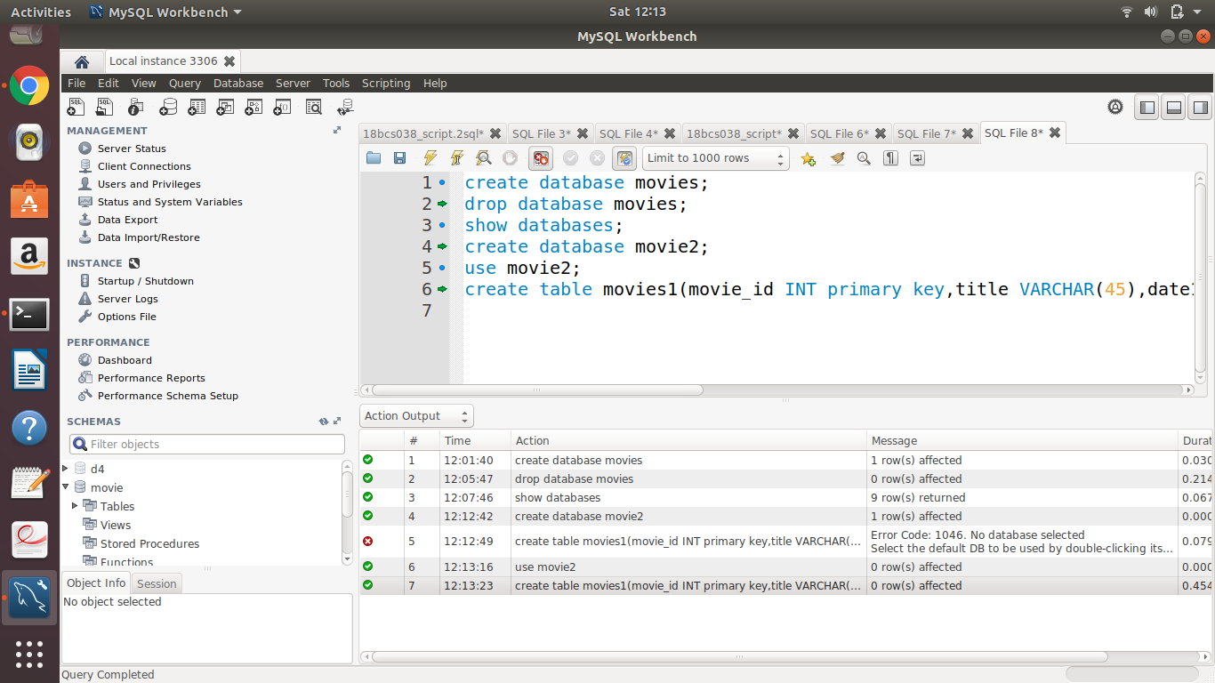

1. Show how select can be used for creating table.

Ans. create table movie_info as select title, date1, genre from movies1;

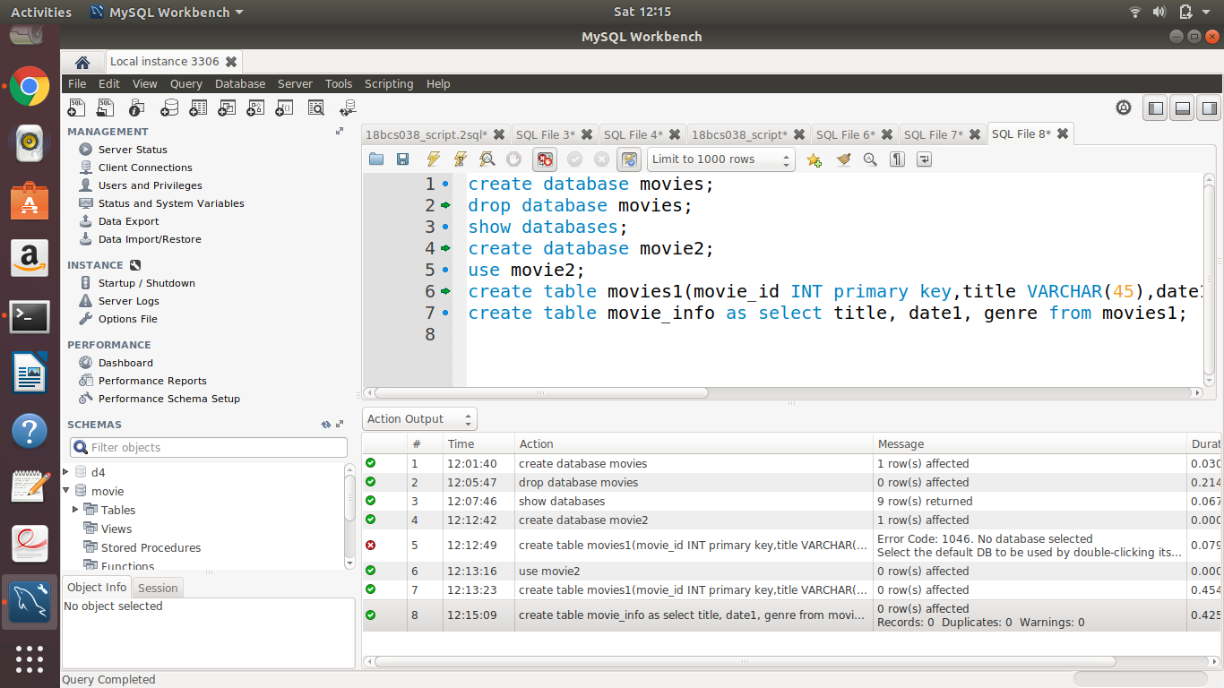

1. Drop table

Ans. drop table movie_info;

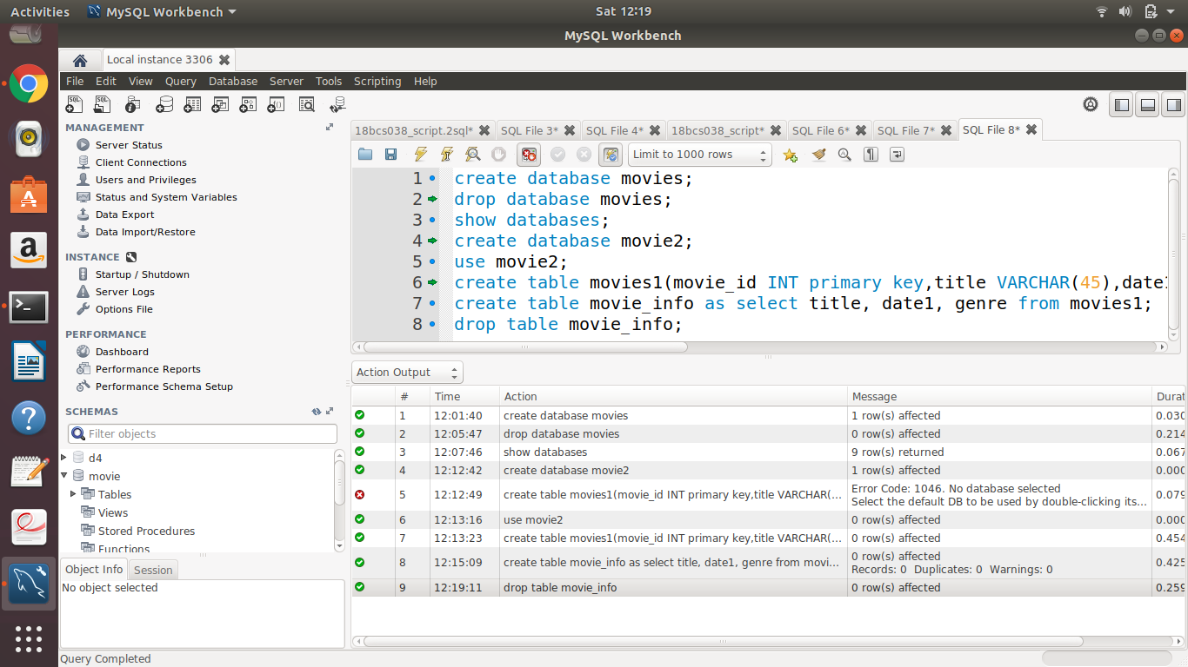

1. Show how to check the schema of the tables.

Ans. desc movies1;

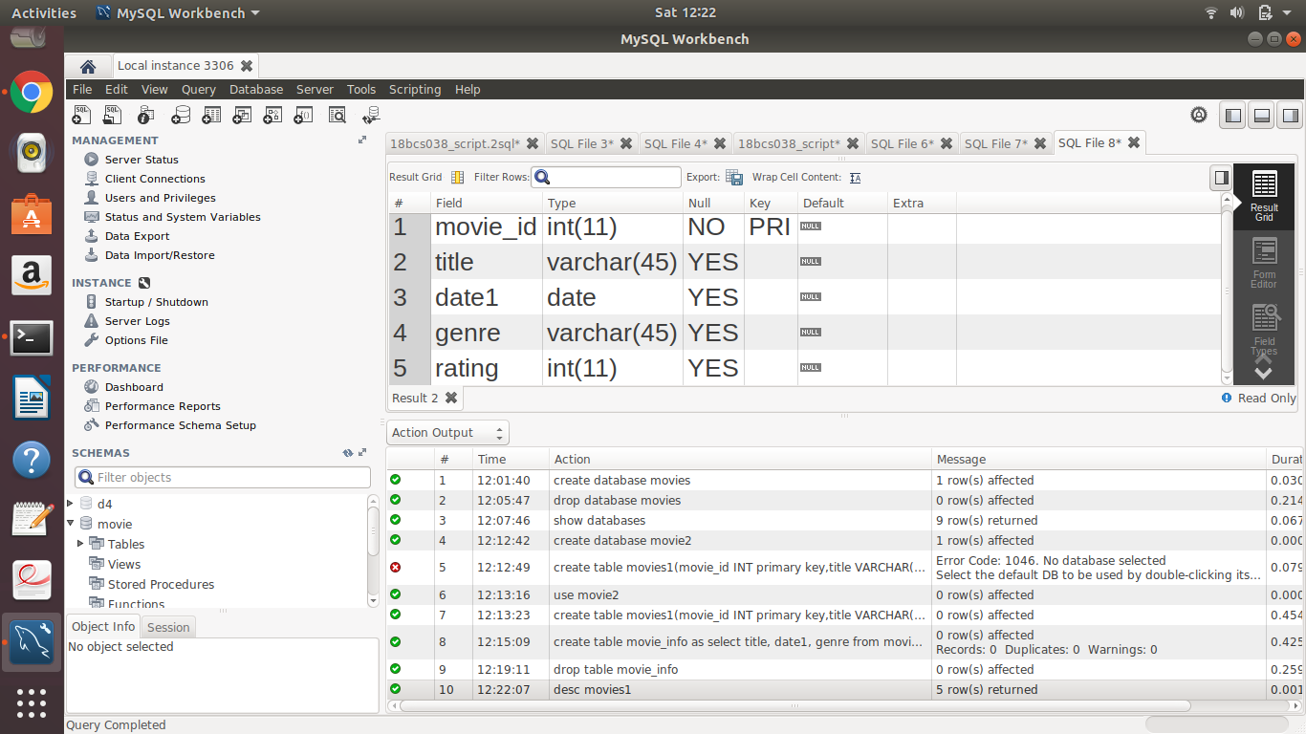

1. Show all the tables from the database.

Ans. a. create table songs(movie_id int, song_name varchar(45), singer varchar(45), composer varchar(45));

b. show tables;

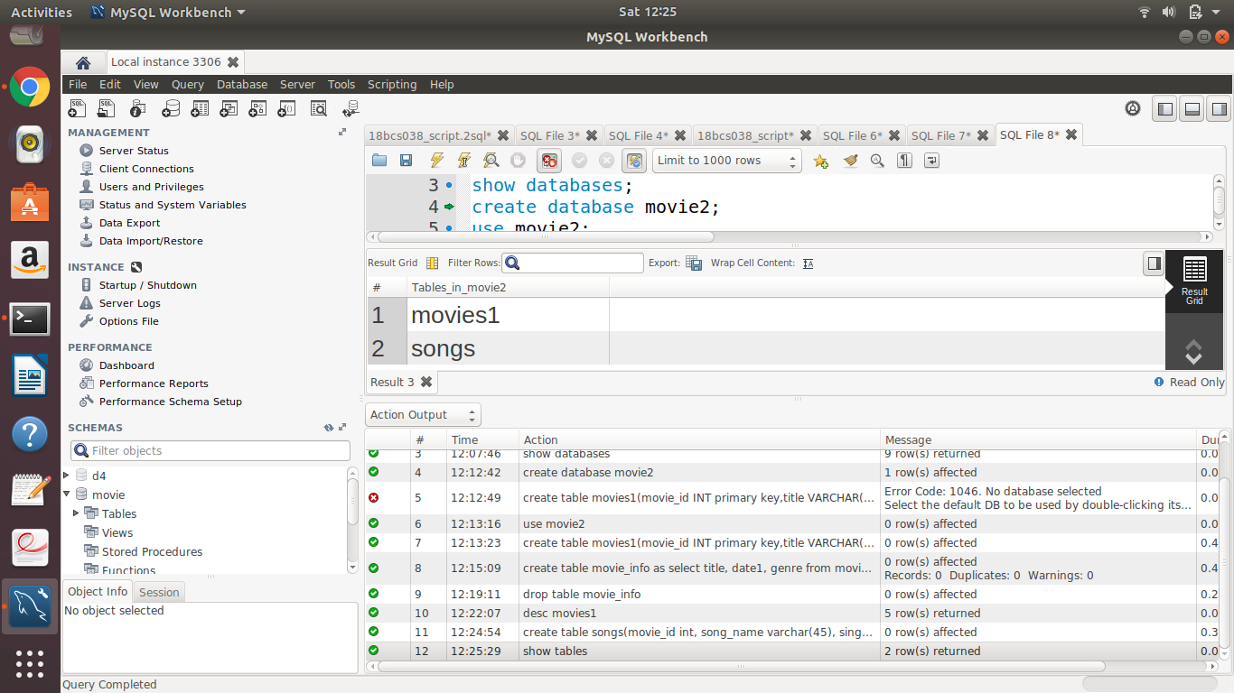

1. Insert 5 to 10 rows in each of the tables of your database.

Ans.

insert into movies1 values(128, "Valimai", "2020-04-24", "Adventure", 4);

insert into movies1 values(125, "Soorarai_potru", "2020-05-23", "Action", 3);

insert into movies1 values(134, "Tenet", "2020-06-27", "Action", 4);

insert into movies1 values(129, "3_idiots", "2019-08-26", "Comedy", 4);

insert into movies1 values(131, "Thupakki", "208-05-09", "Thriller", 5);

insert into songs values(123, "Vaathi_coming", "Anirudh", "Thanu");

insert into songs values(128, "Sigaram_todu", "Sid_sriram", "Anirudh");

insert into songs values(125, "Veyyon_silli", "Harish", "Vivek");

insert into songs values(134, "inceptor", "Jackie", "Rocky");

insert into songs values(129, "Jo_tum", "Taruk", "Shakib");

insert into songs values(131, "Google_google", "Vijay", "Harris");

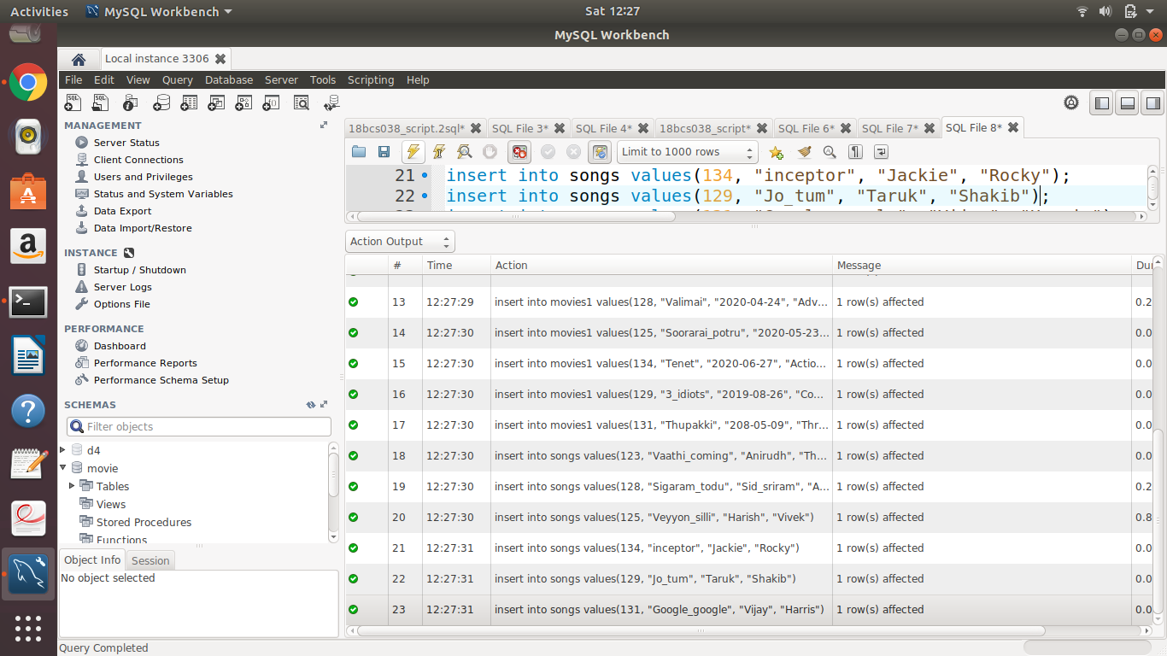

1. Show usage of a simple select statement.

Ans. select * from movies1;

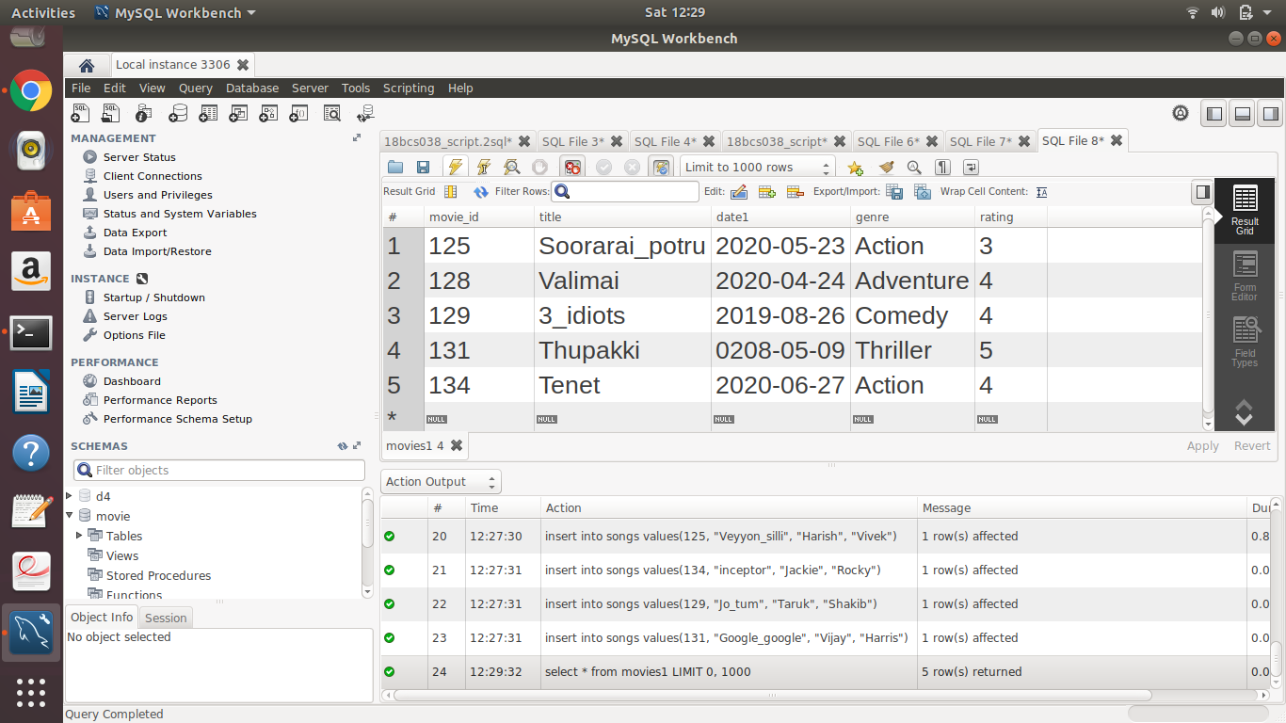

1. Select statement using relational and logical operators.

Ans. select * from movies1 where rating >=4 and genre = "Action";

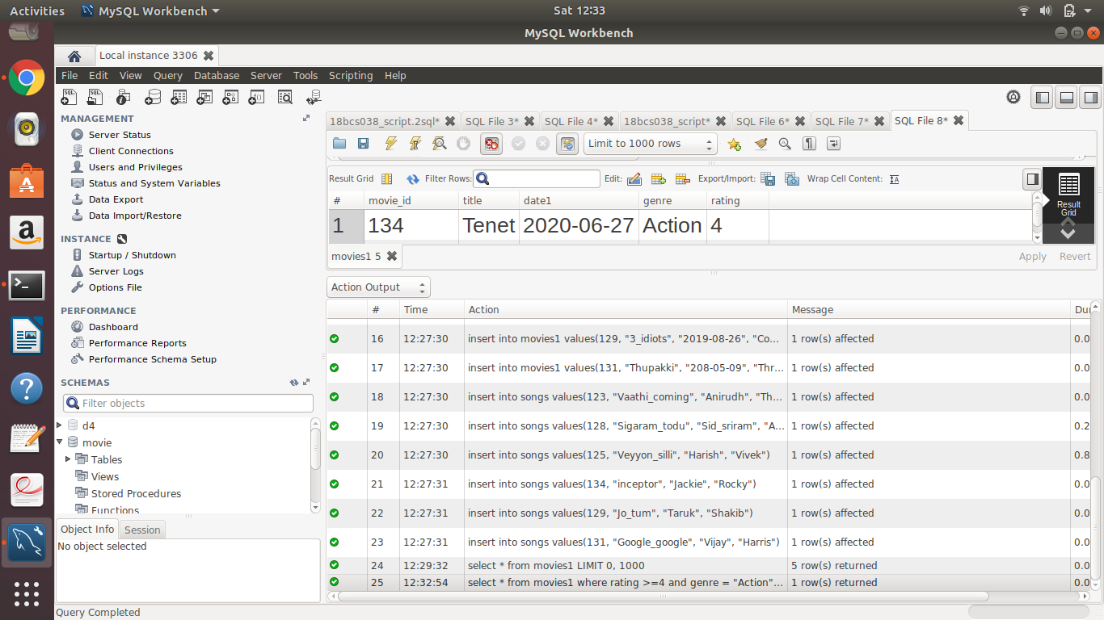

1. One simple subquery using select.

Ans. select * from movies1 where movie_id > 130 and title IN(select title from movies1 where title = "Thuppakki" );

