E-Commerce Database Analysis using PostgreSQL

Internship Report  
By: RAGAVARSHINI ALAGARSAMY  
Company: ELEVATE LABS  
Date: 08th AUG 2025

# 1. Introduction

This report documents the analysis of an e-commerce database using PostgreSQL. The database contains tables such as customers, categories, products, orders, and order_items. The objective of this project is to execute SQL queries for retrieving, analyzing, and optimizing business data.

# 2. Tools Used

- PostgreSQL 17

- pgAdmin 4

- Dataset provided by the company

# 3. Dataset Preparation

Before importing the dataset, existing data was truncated to avoid primary key conflicts. The CSV files were then imported using the following commands:

**TRUNCATE TABLE table_name RESTART IDENTITY CASCADE;  
\copy table_name FROM 'file_path.csv' DELIMITER ',' CSV HEADER;**

**Data was verified using:  
SELECT * FROM table_name LIMIT 5;**

# 4. Queries and Outputs

Each query is presented with its SQL code and the corresponding output screenshot.

## Query 1

1. List all customers from a specific city

SELECT *

FROM customers

WHERE city = 'Kimborough';

OUTPUT:

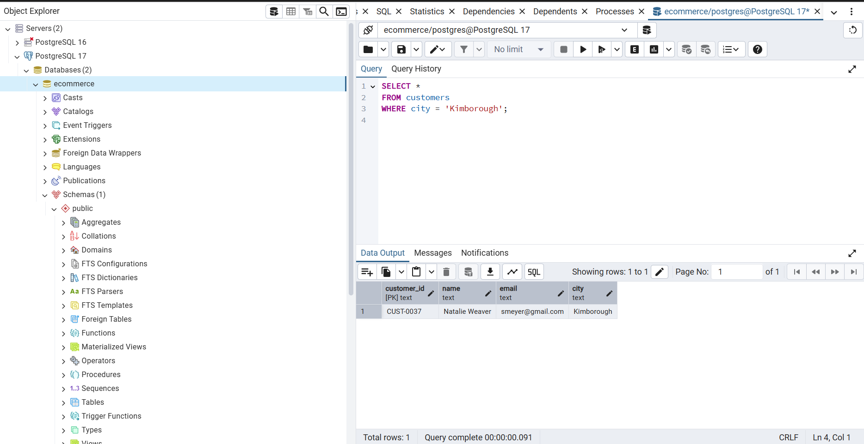

## Query 2

1. Top 10 most expensive products

SELECT product_id, product_name, price

FROM products

ORDER BY price DESC

LIMIT ;

OUTPUT:

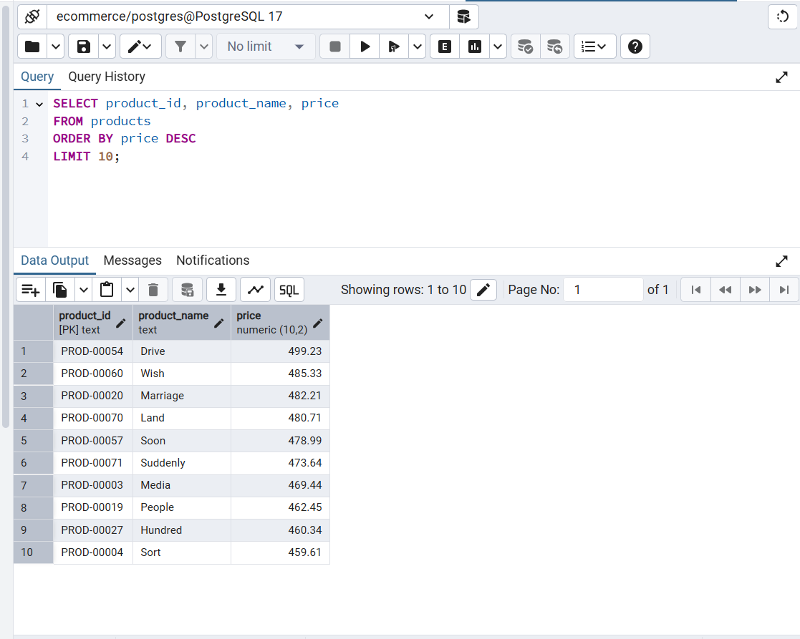

## Query 3

1. Total revenue per category

SELECT c.category_id, c.category_name, SUM(oi.price * oi.quantity) AS total_revenue

FROM order_items oi

JOIN products p ON oi.product_id = p.product_id

JOIN categories c ON p.category_id = c.category_id

GROUP BY c.category_id, c.category_name

ORDER BY total_revenue DESC;

OUTPUT:

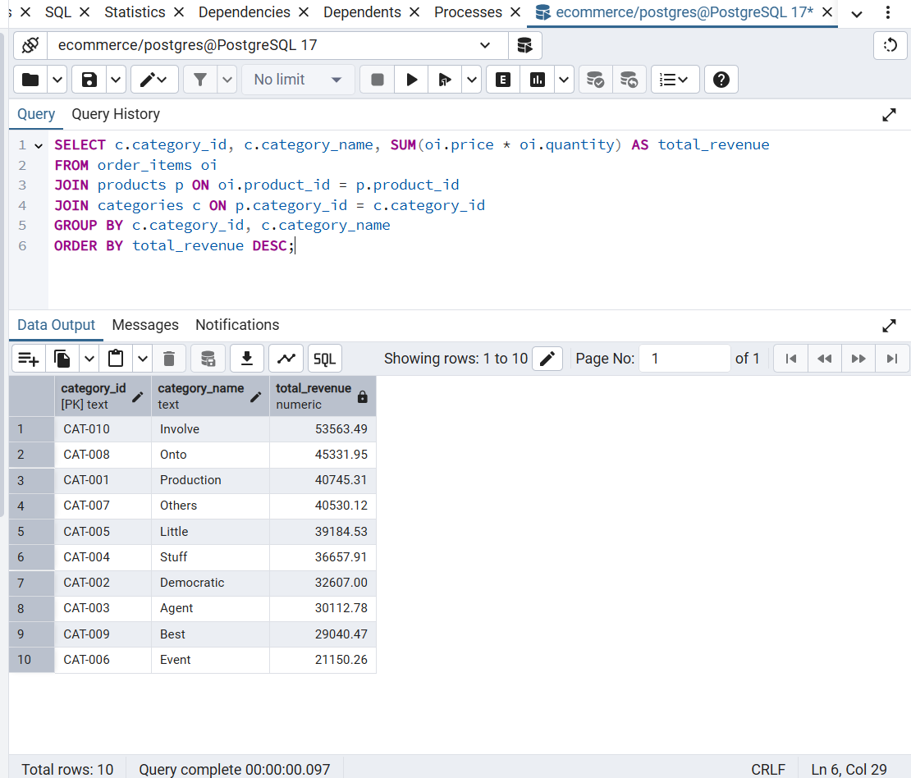

## Query 4

1. Customers with more than 5 orders

SELECT customer_id, COUNT(order_id) AS total_orders

FROM orders

GROUP BY customer_id

HAVING COUNT(order_id) > 5

ORDER BY total_orders DESC;

OUTPUT:

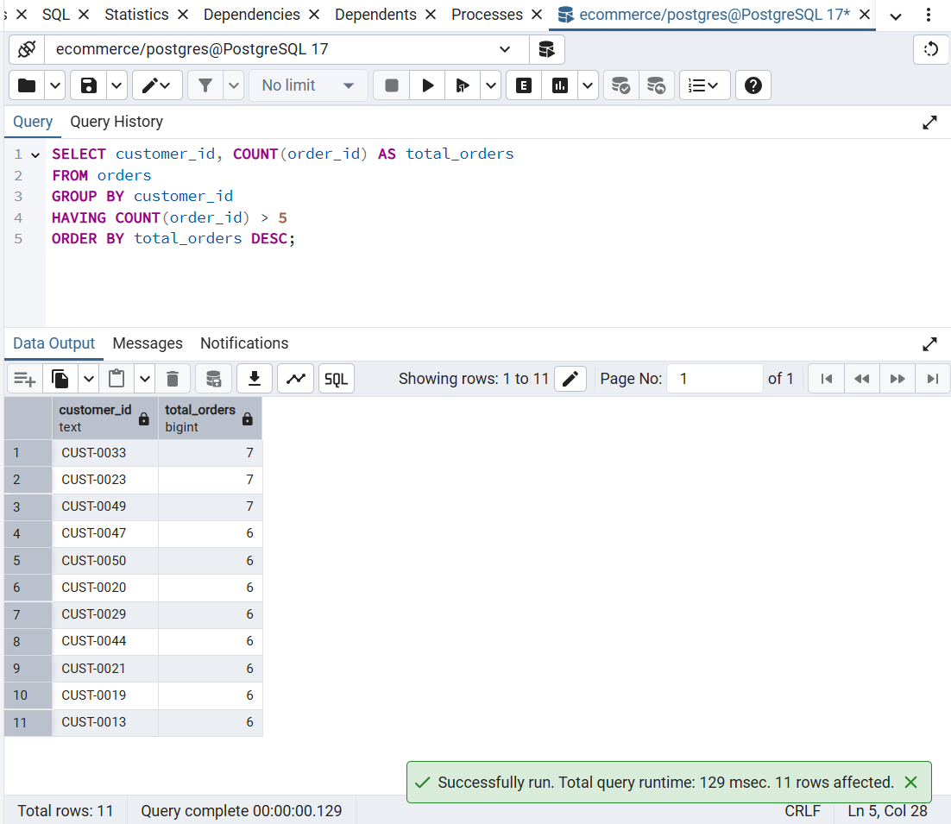

## Query 5

1. Order details (INNER JOIN example)

SELECT o.order_id, o.order_date, c.name AS customer_name, p.product_name, oi.quantity, oi.price

FROM orders o

JOIN customers c ON o.customer_id = c.customer_id

JOIN order_items oi ON o.order_id = oi.order_id

JOIN products p ON oi.product_id = p.product_id

ORDER BY o.order_date DESC

LIMIT 20;

OUTPUT:

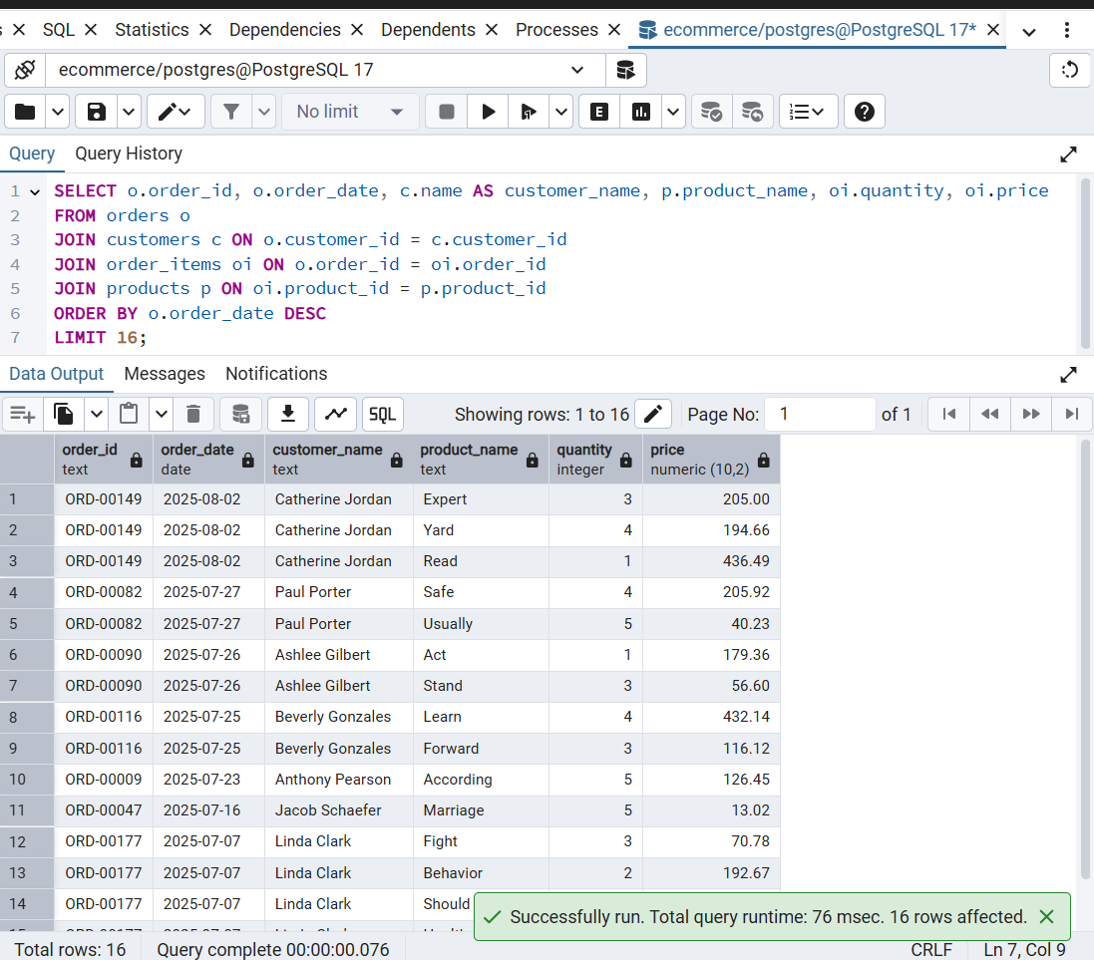

## Query 6

1. All customers and their orders (LEFT JOIN example)

SELECT c.customer_id, c.name, o.order_id, o.total_amount

FROM customers c

LEFT JOIN orders o ON c.customer_id = o.customer_id

ORDER BY c.customer_id;

OUTPUT:

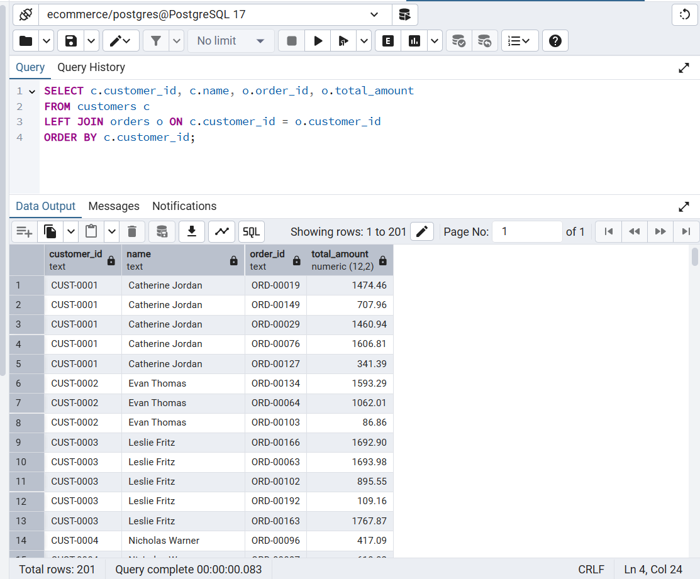

## Query 7

1. Products that have never been ordered (RIGHT JOIN example)

SELECT p.product_id, p.product_name

FROM products p

LEFT JOIN order_items oi ON p.product_id = oi.product_id

WHERE oi.order_item_id IS NULL;

OUTPUT: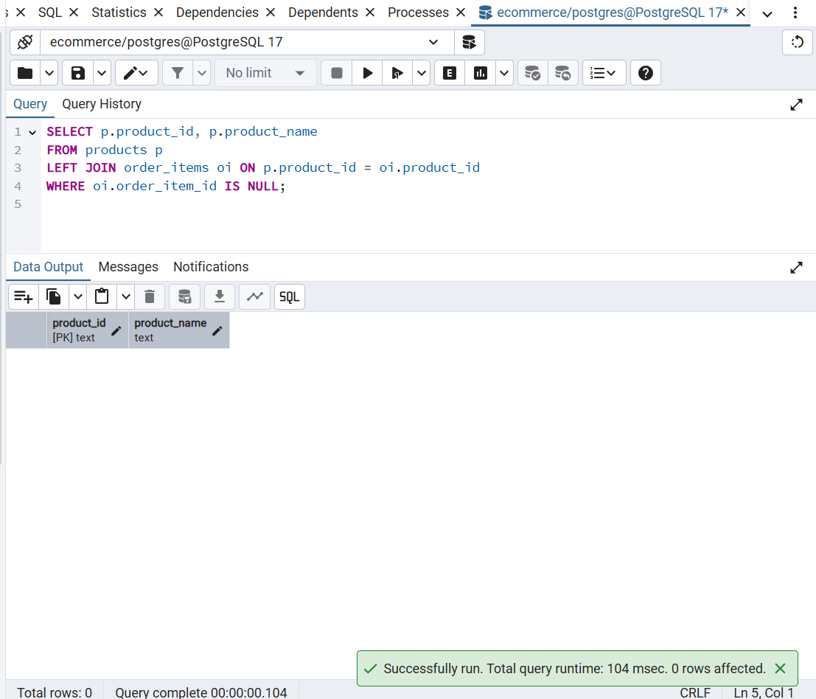

## Query 8

1. Subquery – Top 5 customers by total spend

SELECT customer_id, total_spent

FROM (

SELECT customer_id, SUM(total_amount) AS total_spent

FROM orders

GROUP BY customer_id

) t

ORDER BY total_spent DESC

LIMIT 5;

OUTPUT:

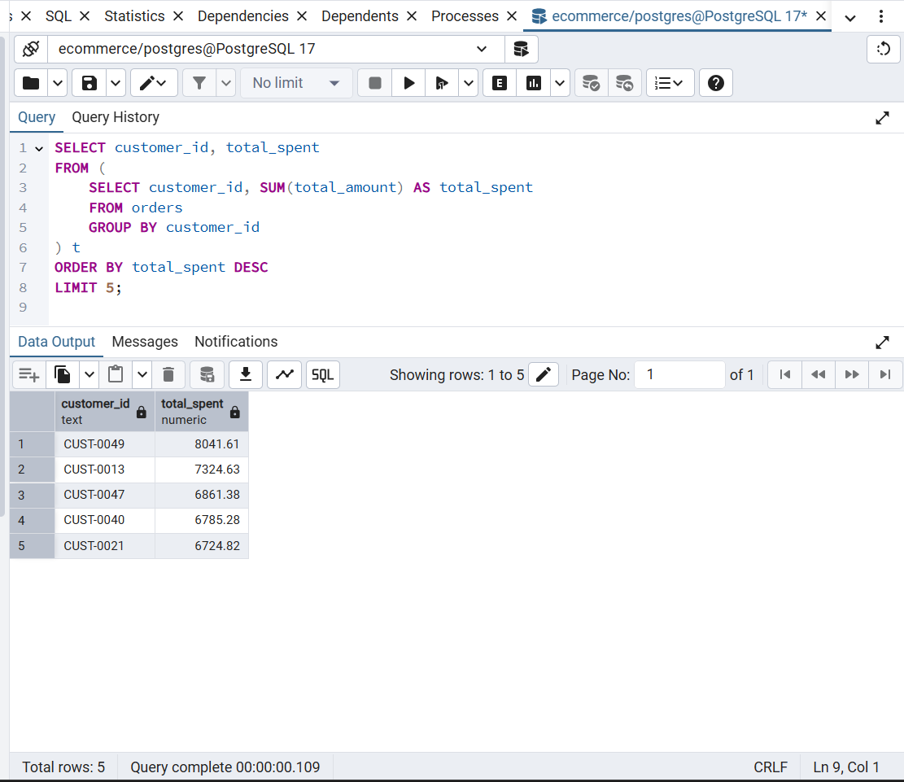

## Query 9

1. Create a view for monthly revenue

CREATE OR REPLACE VIEW monthly_revenue AS

SELECT DATE_TRUNC('month', order_date) AS month, SUM(total_amount) AS revenue

FROM orders

GROUP BY month

ORDER BY month;

-- To see the view:

SELECT * FROM monthly_revenue;

OUTPUT: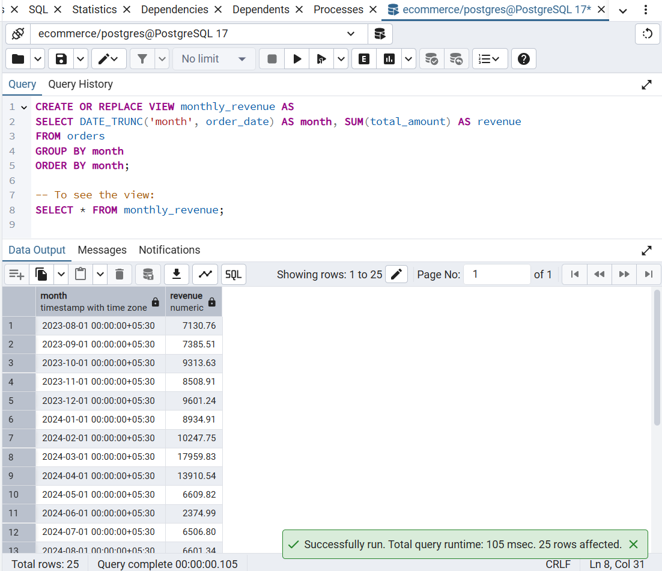

## Query 10

1. Index + EXPLAIN ANALYZE

-- Create index on orders table

CREATE INDEX idx_orders_customer_date ON orders(customer_id, order_date);

-- Analyze query performance

EXPLAIN ANALYZE

SELECT * FROM orders

WHERE customer_id = 'CUST-0005'

AND order_date > '2024-01-01';

OUTPUT:

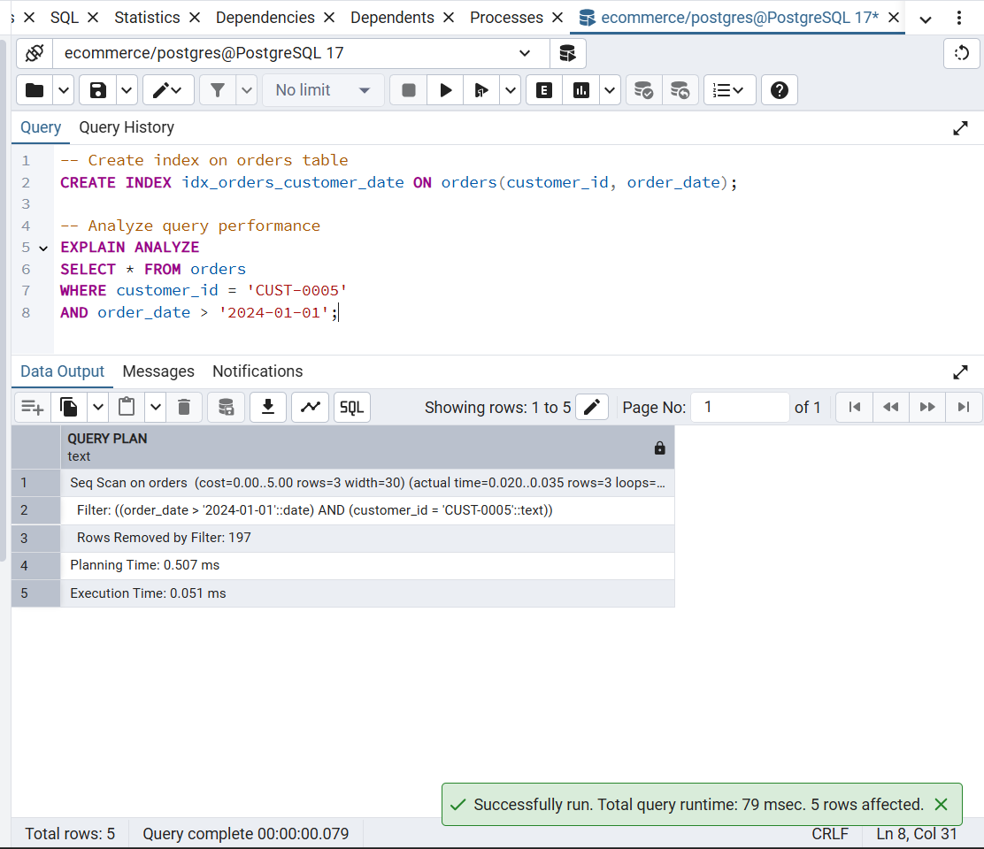

## Query 11

1. Top 5 Customers by Lifetime Value

SELECT customer_id, SUM(total_amount) AS total_spent

FROM orders

GROUP BY customer_id

ORDER BY total_spent DESC

LIMIT 5;

OUTPUT: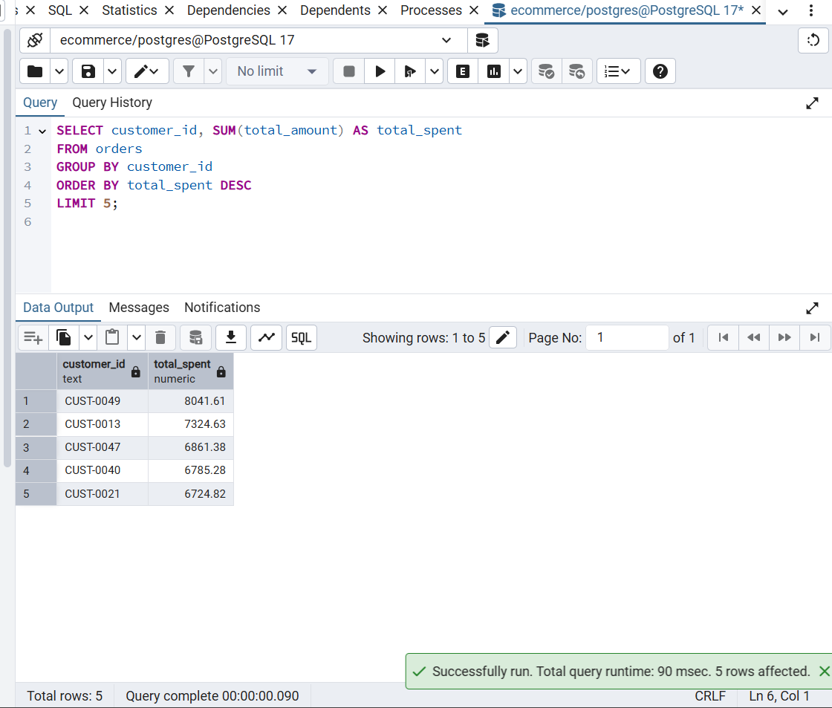

## Query 12

1. **Monthly Revenue Trend** (shows business growth)

SELECT DATE_TRUNC('month', order_date) AS month, SUM(total_amount) AS revenue

FROM orders

GROUP BY month

ORDER BY month;

OUTPUT:

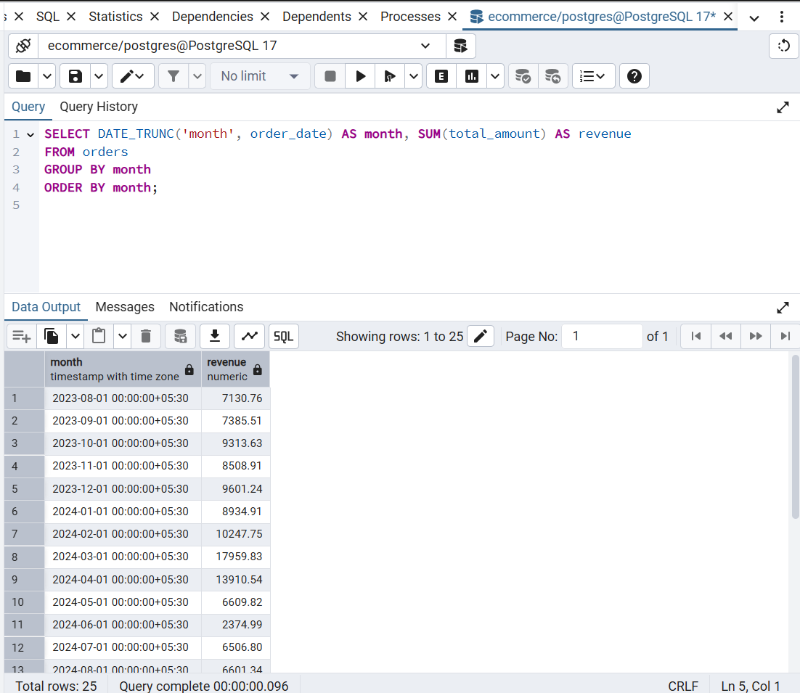

## Query 13

13 Most Profitable Category

SELECT c.category_name, SUM(oi.price * oi.quantity) AS profit

FROM order_items oi

JOIN products p ON oi.product_id = p.product_id

JOIN categories c ON p.category_id = c.category_id

GROUP BY c.category_name

ORDER BY profit DESC

LIMIT 1;

OUTPUT:

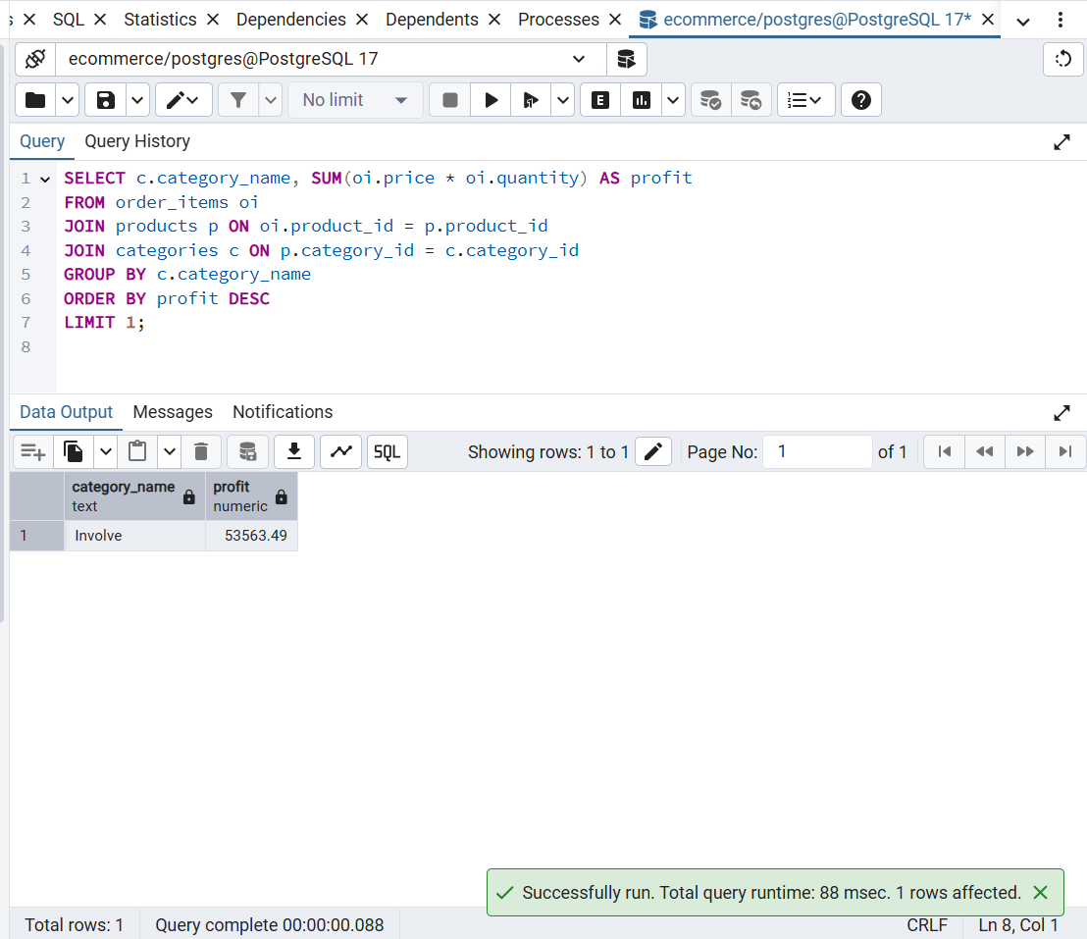

# 5. Observations

From the analysis, we observed trends in customer purchasing patterns, monthly revenues, and top spenders. For example, certain months such as March and April showed higher revenues, and a few customers contributed to a large percentage of sales.

# 6. Conclusion

Through this project, I gained hands-on experience in SQL queries, joins, views, indexing, and data analysis in PostgreSQL. These skills are essential for real-world database management and business intelligence.