

CSA15 – CLOUD COMPUTING AND BIG DATA ANALYTICS

ASSIGNMENT 1 – CO1

Design, Analyse and Validate a Cloud-Based Solution for Migrating a Legacy University Management System
CO1: Apply cloud computing technologies including hardware–software evolution, virtualization, web services, and service models to develop cloud-based solutions.

Field | Details | Field | Details
Student Name | K. Ragavi | Register Number | 192524364
Department / Section | B. Tech/AI&DS | Academic Year / Semester | 2025-29
Faculty Name | Dr. R. Latha | Nature of Assignment | Individual
Duration | 1 Week | Total Marks | 50
Submission Date | 30-10-2026 | Evaluation Date

MARK SHEET (Rubric-based evaluation)
Task | Title | Max | Awarded | Evidence / evaluation focus
1 | Introduce Cloud Computing | 3 |  | Definition; characteristics; deployment models; scenario mapping
2 | Trace Evolution and  Hardware Evolution | 3 |  | Timeline; hardware evolution;  relevance to university
3 | Analyse Internet Software  Evolution | 3 |  | Web/software evolution; SOA; APIs;  scenario relevance
4 | Apply Server Virtualization | 5 |  | Hypervisor types; VM/container  comparison; consolidation; limitations
5 | Apply Web Services | 4 |  | SOA and SOAP/REST; three university  APIs; request/response examples
6 | Analyse IaaS, PaaS and SaaS | 5 |  | Responsibility layers; five-application mapping; comparison; providers
7 | Examine XaaS | 3 |  | Four or more variants; two justified choices; provider risks

8 | Design Cloud Solution  Architecture | 5 |  | Labelled diagram; deployment/service  models; scaling; security; DR
9 | Hands-on Implementation and Documentation | 4 |  | Running VM/container; PaaS/SaaS; tests; actual screenshots
10 | Evaluate and Recommend Final Solution | 7 |  | Three-way comparison; 3-year costs; risks; phased roadmap
11 | Day-4 Design Challenge | 8 |  | Impact; evaluation; adaptation; evidence-based defence
 | TOTAL | 50 |  | Percentage :

EVIDENCE VERIFICATION CHECKLIST

Tasks | Evidence expected | Status (✓  / P / ✗ ) | Evaluator note
1–3 | Conceptual explanations, comparisons and relevant illustrations | ✓ | Explanations and relevant scenario mapping documented
4 | Virtualization calculations with stated assumptions and peak-load caution | ✓ | Calculations present; practical capacity validation recommended
5–7 | API examples, service responsibility table and justified XaaS choices | ✓ | Required conceptual evidence documented
8 | Labelled architecture diagram, caption below figure and component justification | ✓ | Architecture documented; sizing assumptions need testing
9 | Actual code, environment details, execution logs, API outputs and screenshots | P | Procedures provided; actual execution evidence not established
10 | Cost assumptions, 3-year totals, risk controls and migration roadmap | ✓ | Estimates and rationale documented
11 | Day-4 changes, 10× load strategy, 99.9% target and 40-college isolation | ✓ | Design analysis documented; practical validation pending

IMPLEMENTATION EVIDENCE CHAIN

Evidence item | Status | Observation
Source code | ✓ | Flask REST API and Dockerfile provided in the proposed implementation
Virtualization | P | Docker container configuration documented; running-container evidence required
PaaS or SaaS | P | Managed web-service deployment procedure described; live deployment not verified
Functional test | P | Expected HTTP 200 response and JSON output documented; actual output required

Failure case | P | HTTP 404 test case documented; actual execution record required
Screenshots | P | Screenshot requirements identified; authentic screenshots need verification
Reproducibility | ✓ | Build commands, run commands, endpoints and expected results specified

OVERALL REMARKS

K. Ragavi  Student Signature | Faculty Signature | Program Director

MANDATORY SUBMISSION EVIDENCE CHECK
✓ = Present in documented answer; P = Partly present; ✗ = Missing / not satisfied

Task | Evidence expected | Status | Evaluator note
1 | Cloud definition, characteristics, deployment models and scenario mapping | ✓ | All conceptual requirements covered
2 | Evolution timeline, hardware development and university relevance | ✓ | Well explained with relevant examples
3 | Internet software evolution, SOA and APIs | ✓ | Clear explanation and scenario relevance
4 | Hypervisors, VM/container comparison and consolidation calculations | ✓ | Calculations included; peak-load limitations discussed
5 | SOAP/REST comparison and three university APIs | ✓ | API methods and request/response examples documented
6 | IaaS/PaaS/SaaS responsibility layers and application mapping | ✓ | All five applications categorized with justification
7 | XaaS variants and two justified selections | ✓ | Six variants explained; DBaaS and DRaaS recommended
8 | Labelled architecture, scaling, security and disaster recovery | ✓ | Design and component justifications documented
9 | Working container, PaaS/SaaS deployment, actual tests and screenshots | P | Code and procedures provided; actual execution evidence requires verification
10 | Three-year cost comparison, risks and migration roadmap | ✓ | Cost assumptions, calculations and recommendations included
11 | Impact analysis, 10× load, 99.9% availability and tenant isolation | ✓ | Changed requirements evaluated; load-test evidence recommended

IMPLEMENTATION EVIDENCE CHAIN

Evidence item | Status | Observation
Source code | ✓ | Python Flask REST API and Dockerfile documented
Virtualization | P | Docker build and run procedures provided; execution screenshot required
PaaS or SaaS | P | Cloud deployment steps described; actual deployment confirmation required

Functional test | P | HTTP 200 and expected JSON response documented; actual test output required
Failure case | P | HTTP 404 test case included; execution evidence required
Screenshots | P | Required screenshots identified but authenticity and completeness not verified
Reproducibility | ✓ | Installation, configuration, commands and testing steps documented
Interpretation | ✓ | Technical outcomes and implementation limitations explained
Code and report consistency | ✓ | Proposed API, Docker configuration and testing procedure are aligned

SUBMISSION CHECKLIST (Not Separately Marked)

Requirement | Status
All 11 tasks answered | ☒ Yes ☐ Partly ☐ No
Cloud concepts and comparisons explained | ☒ Yes ☐ Partly ☐ No
Virtualization calculations included | ☒ Yes ☐ Partly ☐ No
API examples and service models explained | ☒ Yes ☐ Partly ☐ No
Cloud architecture diagram included | ☒ Yes ☐ Partly ☐ No
Implementation and testing evidence provided | - Yes ☒ Partly ☐ No
Three-year cost analysis and roadmap included | ☒ Yes ☐ Partly ☐ No
Day-4 design challenge completed | ☒ Yes ☐ Partly ☐ No
Figures and screenshots included | - Yes ☒ Partly ☐ No
Table and figure numbering correct | - Yes ☒ Partly ☐ No
Viva recommended | ☒ Yes ☐ No

CSA15 – Cloud Computing and Big Data Analytics

ASSIGNMENT 1
CO1: Apply cloud computing technologies including hardware–software evolution, virtualization, web services, and service models to develop cloud-based solutions.

Assignment Title: Design, Analyse and Validate a Cloud-Based Solution for Migrating a Legacy University Management System (Total Marks – 50)
Duration: 1 week

Scenario – Smart Campus Cloud Migration
A multi-campus university currently runs its Student Information System, Learning Management System, Library System, Exam Portal and Email on ageing physical servers in a single on-premise data centre. Each application has its own dedicated server, which stays idle for most of the year but fails to cope during admissions, result publication and online-exam weeks.
The university's current environment is:
- 12 physical servers, average CPU utilisation of about 15%, with peaks above 95% during admissions and exams
- Approximately 25,000 students and 2,000 staff across 4 campuses
- Applications built as large monolithic programs, with no public interfaces for mobile apps or partner colleges
- High capital expenditure, slow procurement (6–8 weeks per server) and no disaster recovery site
As a cloud consultant, you must study how computing evolved to the cloud model, and then design a cloud-based solution that uses virtualization, web services and an appropriate mix of service models (IaaS, PaaS, SaaS and XaaS) for the university. All recommendations must be justified in terms of cost, scalability, availability and manageability.

Design Challenge:
On Day 4, the university announces that it will launch a mobile app and open student-record and fee-payment services to 40 affiliated colleges. Expected load is 10 times the current peak, with a requirement of 99.9% availability and a limited operating budget. Re-evaluate your original design and decide whether it should be retained, modified or redesigned.

TASK 1 – Introduce Cloud Computing and Map It to the Scenario (3 Marks) Design and Propose cloud computing model for the context of the university's problems.
- Definition of cloud computing and the five essential characteristics
(on-demand self-service, broad network access, resource pooling, rapid elasticity, measured service)
- Deployment models (public, private, hybrid, community) and which one suits the university
- Three problems of the current on-premise setup and how each cloud characteristic addresses them
- Benefits and limitations of cloud adoption for the university

Evidence Expected
A clear explanation of cloud characteristics and deployment models, mapped to the university's actual problems.

TASK 2 – Trace the Evolution and Hardware Evolution (3 Marks)
Trace how computing infrastructure evolved to make cloud computing possible.
- A timeline from mainframes, minicomputers and PCs, to client–server, clusters, grid computing, utility computing and cloud
- Hardware evolution: multi-core processors, commodity servers, high-capacity storage, high-speed networking and data centres
- How each stage solved a limitation of the previous one
- Which stage the university's current system corresponds to, with reasons

Evidence Expected
A labelled timeline or diagram, with a justified explanation of how hardware advances enabled the cloud.

TASK 3 – Analyse Internet Software Evolution (3 Marks)
Explain how internet software evolved and why it supports cloud services.
- Evolution from static web pages to dynamic web, Web 2.0, SOA, mashups and cloud-hosted applications
- Role of browsers, HTTP, AJAX and APIs in delivering software over the internet
- Comparison between desktop software, client–server software and web-delivered software

- How this evolution affects the design of the university's applications

Evidence Expected
A comparative explanation of software evolution stages, linked to the university's application design.

TASK 4 – Apply Server Virtualization (5 Marks)
Apply server virtualization to consolidate the university's 12 physical servers.
- Explain how a hypervisor works, and distinguish Type-1 and Type-2 hypervisors, with examples
- Compare full virtualization, para-virtualization, OS-level virtualization (containers) and hardware-assisted virtualization
- Propose which applications should run as virtual machines and which as containers, with reasons
- Calculate the consolidation: with an average utilisation of 15% per server and a target host utilisation of 70%, estimate how many physical hosts are needed (show your assumptions and working)
- Discuss live migration, snapshots and resource over-commitment as benefits, and the risks of virtualization (noisy neighbour, hypervisor failure, security isolation)

Show your calculation. A final number without working will not receive full credit.

Evidence Expected
A justified virtualization plan with a worked consolidation calculation and discussion of benefits and risks.

TASK 5 – Apply Web Services (4 Marks)
Analyse web services to expose the university's functions to other systems.
- Overview of web services and their role in cloud and SOA
- Compare SOAP, WSDL, UDDI and RESTful services (HTTP methods, JSON/XML)
- Identify at least three university functions to expose as web services (for example, result lookup, fee payment, library search) and define the endpoint, method and sample request/response for each
- Justify whether SOAP or REST is more suitable for each function

Evidence Expected
A defined set of web services with sample request/response formats and a justified choice of SOAP or REST

TASK 6 – Analyse the Service Models: IaaS, PaaS and SaaS (5 Marks)
Analyse which service model fits each university application.
- Define IaaS, PaaS and SaaS, and show who manages which layer (hardware to application) in each model
- Categorise the five university applications (SIS, LMS, Library, Exam Portal, Email) into IaaS, PaaS or SaaS, with reasons
- Compare the models on control, cost, scalability, maintenance effort and vendor lock-in
- Give one real provider example for each model
Present your categorisation in a table, but explain the reasoning behind each
decision. A table alone is not sufficient.

Evidence Expected
A reasoned mapping of applications to service models, supported by a layer-wise responsibility comparison.

TASK 7 – Examine XaaS (3 Marks)
Examine the broader XaaS (Anything-as-a-Service) concept for the university.
- Explain XaaS and describe at least four variants (for example DaaS, BaaS/MBaaS, FaaS, DBaaS, Security-as-a-Service,
Disaster-Recovery-as-a-Service)
- Select two XaaS offerings that would benefit the university, and justify them
- Discuss the risks of over-reliance on multiple 'as-a-Service' providers

Evidence Expected
An analysis of XaaS variants, with justified selection of two offerings for the university.

TASK 8 – Design the Cloud Solution Architecture (5 Marks)
Bloom's Level: Level 6 – Create | Action verbs: Design, Construct, Propose
Create a complete cloud architecture for the university by combining virtualization, web services and service models.

- An architecture diagram showing users, load balancer, web/application tier, database tier, storage, API layer and DR region
- The deployment model and the service model chosen for each component
- How elasticity (auto-scaling) will handle admissions and exam peaks
- Basic security and availability measures (access control, encryption, backup, multi-zone deployment)

Evidence Expected
A labelled architecture diagram with written justification for each component and design decision.

TASK 9 – Hands-on Implementation and Documentation (4 Marks) Implement a small proof-of-concept of your design using a free-tier cloud account or a local virtualization tool.
- Create a virtual machine or container (using AWS/Azure/GCP free tier, VirtualBox, or Docker) and host a simple web page or REST API for one university function
- Deploy a SaaS or PaaS component (for example a cloud-hosted database, a serverless function or a static site)
- Test the web service with a client (browser, Postman or curl) and record the output
- Provide screenshots, configuration steps and any issues faced

Evidence Expected
Annotated screenshots and clear, reproducible steps showing that the proof-of-concept works.

TASK 10 – Evaluate and Recommend the Final Solution (7 Marks)
Evaluate your design and recommend the final cloud solution for the university.
- Compare on-premise, IaaS-based and PaaS/SaaS-based options on cost (CapEx vs OpEx), scalability, availability, security and effort
- Estimate a simple 3-year cost comparison using stated assumptions
- Identify the main risks (vendor lock-in, data privacy, downtime, skills gap) and give mitigation steps
- Provide your final recommendation and a short migration roadmap (which application moves first, and why)

Your recommendation must be supported by the analysis in the previous tasks. Choosing a popular cloud provider without justification is not sufficient.

Evidence Expected
A technically justified recommendation, supported by a cost comparison, risk analysis and migration roadmap.

DAY-4 DESIGN CHALLENGE

TASK 11 – Re-evaluate and Adapt the Design (8 Marks)

Changed Requirement
The university will now launch a mobile app and open student-record and
fee-payment services to 40 affiliated colleges. Expected load is 10 times the current peak, availability must be 99.9%, and the operating budget is limited.
Re-evaluate your original design in response to these changed conditions. You may:
RETAIN → MODIFY → or REDESIGN
your original solution.

Impact Analysis – 2 Marks
Discuss:
- What has changed from the original problem
- Which original assumptions (load, users, availability, cost) are affected
- Why the web services and APIs now become critical
- How multi-tenant access by 40 colleges affects security and isolation
Evidence Expected: A clear analysis of how the changed requirements affect the original cloud design.

TASK 1 – Introduce Cloud Computing and Map It to the Scenario (3 Marks)

1.1 Definition
Cloud computing is a model for delivering computing resources – servers, storage, databases, networking, software and analytics – over the Internet from a shared pool of configurable resources. The resources can be provisioned and released quickly, with minimal management effort, and the user pays only for what is used (this follows the NIST SP 800-145 definition).

1.2 Five Essential Characteristics
Table 1: Essential characteristics of cloud computing mapped to the university
Characteristic | Meaning | Example at the university
On-demand self-service | The user provisions compute, storage or software through a portal/API without contacting the provider. | IT staff launch a new Exam Portal server in minutes instead of waiting 6–8 weeks for hardware.
Broad network access | Services are reachable over the network from any standard device (browser, mobile, API). | Students, staff and partner colleges reach the Student Information System from phones and laptops at any campus.
Resource pooling | Many customers share a large pool of resources (multi-tenancy); capacity is assigned dynamically. | The university stops owning 12 mostly idle servers and uses only a slice of a shared pool.
Rapid elasticity | Capacity scales out and in quickly, often automatically, and appears unlimited. | Auto-scaling absorbs admission, result and online-exam peaks (CPU above 95%).
Measured service | Usage is metered and billed per use, with transparent reports. | The university pays for peak capacity only during peak weeks; cost per campus or department is visible.

1.3 Deployment Models and the Best Fit
Table 2: Cloud deployment models compared
Model | Description | Advantages | Limitations | Fit for the university
Public | Owned and operated by a provider and shared by many customers (e.g., AWS, Azure, Google Cloud). | No CapEx, high elasticity, global reach. | Less control; shared infrastructure; compliance must be managed. | Good for Email, LMS, Exam Portal and APIs.
Private | Dedicated to one organisation, on-premise or hosted. | Maximum control and isolation. | High CapEx, limited elasticity – the same problems as today. | Poor as the main model.
Hybrid | Public and private environments connected and used together. | Elasticity plus control; supports phased migration. | More complex to integrate and manage. | Best fit (public-cloud-first).
Community | Shared by organisations with common needs (e.g., a consortium of colleges). | Cost and governance shared. | Shared governance; slower decisions. | Possible later for the 40 affiliated colleges.
Recommended model – Hybrid cloud (public-cloud-first). (i) Elastic workloads (admissions, results, exams, e-mail, LMS) run on a public cloud so that peaks no longer require owned hardware. (ii) Sensitive student and fee records stay in private, encrypted subnets, and the existing on-premise servers stay in service until each application is migrated, so migration is phased and low-risk. (iii) Hosting in an India region helps meet data-protection obligations such as the Digital Personal Data Protection Act, 2023.

1.4 Three Problems of the On-Premise Setup and How Cloud Characteristics Address Them
Table 3: Problems in the current setup mapped to cloud characteristics
Problem in the scenario | Impact | Cloud characteristic | How it is solved
1. 12 dedicated servers at about 15% average CPU, high capital expenditure. | The university pays all year for peak capacity that it uses only for a few weeks. | Resource pooling + measured service | Shared pool and pay-per-use turn CapEx into OpEx; the university pays only for what it consumes.
2. Servers fail to cope (above 95% CPU) during admissions, results and online exams. | Outages at the most critical times of the year. | Rapid elasticity | Auto-scaling adds instances during peaks and removes them afterwards.
3. 6–8 weeks to buy a server and no disaster recovery site. | Slow launch of new services; risk of total data loss in a site failure. | On-demand self-service (with pooled multi-region capacity) | New servers in minutes; data replicated to a second region at low cost.
An additional problem – no public interfaces for mobile apps or partner colleges – is addressed by broad network access: services are exposed as secure APIs over the Internet.

1.5 Benefits and Limitations of Cloud Adoption
Table 4: Benefits and limitations for the university
Benefits | Limitations
Lower upfront cost; pay-per-use billing.  Elastic capacity for peak weeks.  Fast provisioning (minutes, not weeks).  Built-in high availability and low-cost disaster recovery.  Less routine administration (patching, hardware) for staff.  Access from anywhere; easy to expose APIs. | Dependence on Internet connectivity.  Vendor lock-in risk.  Data privacy, residency and compliance responsibilities.  Costs can grow if usage is not monitored.  Skills gap in the IT team.  Less control over provider-managed layers; monolithic applications need effort to migrate.

TASK 2 – Trace the Evolution and Hardware Evolution (3 Marks)

2.1 Timeline
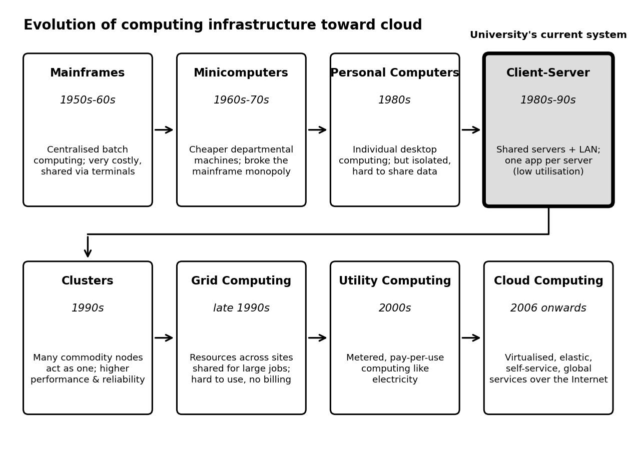
Figure 1: Evolution of computing infrastructure from mainframes to cloud computing

2.2 How Each Stage Solved a Limitation of the Previous One
Table 5: Stages of evolution and the limitation each one removed
Stage | Period | Limitation of the previous stage | What the stage introduced
Mainframe | 1950s–60s | Manual, one-job-at-a-time processing. | Centralised, reliable batch processing and time-sharing via terminals – but extremely expensive.
Minicomputer | 1960s–70s | Mainframes were too costly and centralised. | Smaller, cheaper departmental machines.
Personal computer | 1980s | Minicomputers were still shared and costly per user. | Affordable personal computing – but isolated machines with no easy data sharing.
Client–server | 1980s–90s | PCs were isolated; data could not be shared. | LANs with shared servers for data and applications – but one application per server and scaling needs new hardware.
Cluster | 1990s | A single server limited performance and reliability. | Many commodity machines working as one: load sharing and fail-over.
Grid | Late 1990s | Clusters were confined to one site and one organisation. | Resources from many sites pooled for large jobs – but complex to use and without metering.
Utility computing | 2000s | Grids were hard to use and not billed by use. | Metered, pay-per-use computing, like electricity.
Cloud computing | 2006 onwards | Utility computing lacked self-service, elasticity and easy automation. | Virtualisation + self-service + elasticity + APIs on global data centres.

2.3 Hardware Evolution
Table 6: Hardware advances that made cloud computing possible
Hardware advance | What changed | How it enabled the cloud
Multi-core processors | From one core to dozens of cores per chip, with hardware virtualisation support (Intel VT-x, AMD-V). | One physical host can run many virtual machines efficiently.
Commodity servers | Low-cost standard x86 servers replaced costly proprietary machines. | Providers scale out cheaply and tolerate failures through software.
High-capacity storage | From small disks to large HDD arrays, SSD and NVMe, and distributed object storage. | Cheap, durable storage for backups, big data and files.
High-speed networking | From 10 Mbps Ethernet to 10/40/100 Gigabit links, fibre and broadband. | Fast communication inside data centres and delivery of services to users over the Internet.
Data centres | Purpose-built large facilities with automated power, cooling and operations. | Economies of scale; multiple zones and regions for availability.

2.4 Stage of the University's Current System
The university's system corresponds to the client–server stage, in the form of a traditional single on-premise data centre. Reasons:
- Each application (SIS, LMS, Library, Exam Portal, Email) has its own dedicated physical server – there is no resource pooling or virtualisation.
- Capacity is fixed; adding capacity means buying hardware, which takes 6–8 weeks.
- Everything is in one data centre with no disaster recovery site.
- Applications are large monolithic programs without web-service interfaces.
- There is no self-service, metering or elasticity, so the system lacks the key cloud characteristics.

TASK 3 – Analyse Internet Software Evolution (3 Marks)

3.1 Evolution of Internet Software
Table 7: Stages of internet software evolution
Stage | Period | Key technologies | Characteristics | University relevance
Static web (Web 1.0) | 1990–2000 | HTML, HTTP, browsers | Read-only pages. | Notices, department pages.
Dynamic web | Late 1990s | CGI, PHP, ASP/JSP, databases | Pages generated from a database on the server. | Result lookup, fee forms, SIS screens.
Web 2.0 | 2004 onwards | AJAX, JavaScript, XML/JSON | Interactive, rich pages without full reloads; user-generated content. | LMS forums, live exam dashboards.
SOA / web services | 2000s | SOAP, WSDL, UDDI, REST | Reusable, loosely coupled services over the network. | Result, fee and library functions as services.
Mashups | 2005 onwards | Public APIs (maps, payments) | New applications built by combining existing services. | Campus map + bus tracker + fee payment.
Cloud-hosted applications | 2006 onwards | Virtualisation, REST APIs, containers, PaaS/SaaS | Software delivered through a browser or API; elastic; subscription-based. | Email and LMS as SaaS; SIS and Exam Portal on PaaS.

3.2 Role of Browsers, HTTP, AJAX and APIs
- Browser – a universal client that needs no installation; it renders HTML/CSS/JavaScript, so the same application serves every device.
- HTTP/HTTPS – the standard request–response protocol of the web; it carries both pages and API calls and works across firewalls.
- AJAX – lets the page exchange small amounts of data with the server in the background, giving a desktop-like, responsive experience (e.g., live seat availability).
- APIs – define how programs talk to each other (usually REST/JSON), allowing mobile apps and partner systems to reuse university functions.

3.3 Desktop vs Client–Server vs Web-Delivered Software
Table 8: Comparison of software delivery models
Aspect | Desktop software | Client–server software | Web-delivered software
Installation | On every computer. | Client program on every PC plus a server. | None – a browser or API is enough.
Updates | Manual on each machine. | Server and each client must be updated. | Updated once, centrally.
Access | Only on that computer. | Inside the LAN/VPN. | Anywhere, any device.
Scalability | Not applicable. | Limited by the fixed server. | Elastic in the cloud.
Cost model | Licence per machine. | Server hardware + licences. | Subscription / pay-per-use.
Example | MS Word installed locally. | Old campus ERP with desktop client. | Gmail, Microsoft 365, a cloud-hosted LMS.

3.4 Effect on the Design of the University's Applications
- Break the large monolithic programs into modules/services (SIS, results, fees, library) that can be deployed and scaled independently.
- Expose each function through a REST API so that the mobile app and partner colleges can use it.
- Make the web tier stateless (sessions kept in a database or cache) so that new instances can be added or removed freely.
- Use a browser/mobile front end; deploy and update centrally with versioned APIs.
- Build security in from the start: HTTPS, token-based authentication and role-based access.

TASK 4 – Apply Server Virtualization (5 Marks)

4.1 How a Hypervisor Works; Type-1 and Type-2
A hypervisor (virtual machine monitor) is software that abstracts the physical CPU, memory, storage and network of a host and presents each virtual machine (VM) with its own virtual hardware. It schedules VMs on the physical cores, enforces isolation between them, and lets many operating systems share one machine. Because the VMs are independent of the hardware, they can be copied, moved, snapshotted and started in minutes.
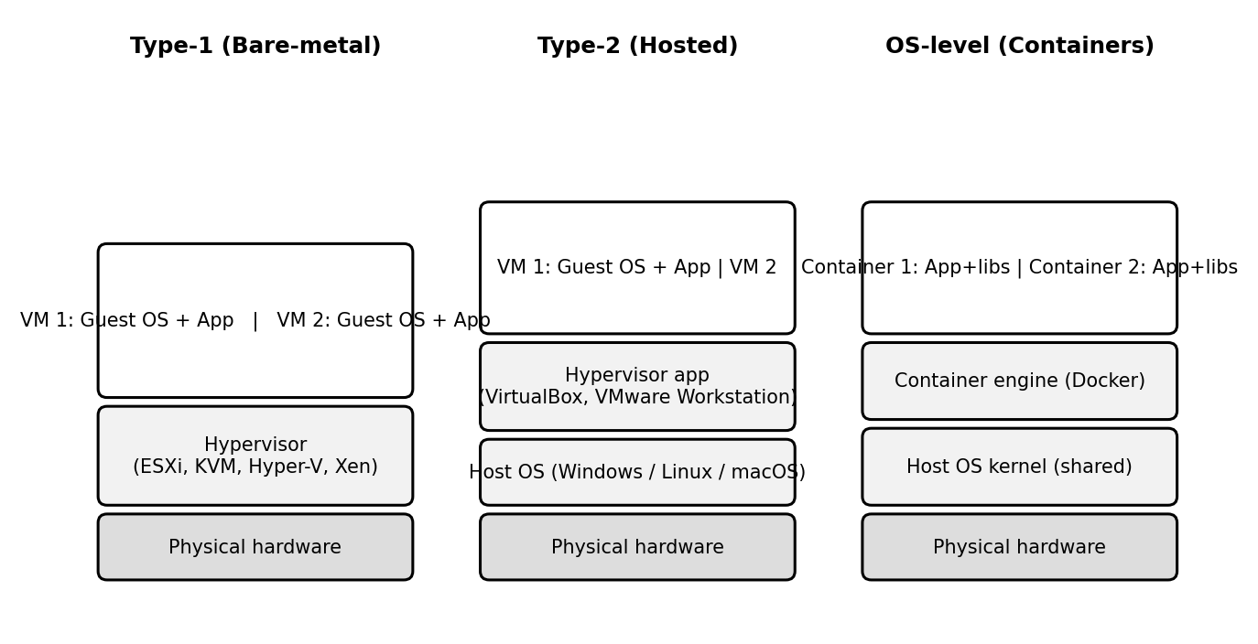
Figure 2: Type-1 hypervisor, Type-2 hypervisor and OS-level virtualization (containers)
Table 9: Type-1 and Type-2 hypervisors
Aspect | Type-1 (bare-metal) | Type-2 (hosted)
Runs on | Directly on the hardware. | On top of a host operating system.
Performance | High – no host OS layer. | Lower – extra OS layer.
Typical use | Production data centres and clouds. | Desktops, labs, development and testing.
Examples | VMware ESXi, Microsoft Hyper-V, KVM, Xen. | Oracle VirtualBox, VMware Workstation.
Use at the university | Production consolidation and cloud hosts. | Student labs and the proof-of-concept.

4.2 Types of Virtualization
Table 10: Full, para-, OS-level and hardware-assisted virtualization
Type | How it works | Guest OS modified? | Performance | Examples
Full virtualization | The hypervisor emulates complete hardware; privileged instructions are trapped or translated. | No | Good, with some overhead. | VMware ESXi, VirtualBox.
Para-virtualization | The guest OS is aware of the hypervisor and makes hypercalls instead of privileged instructions. | Yes | Very good. | Xen PV.
OS-level (containers) | Containers share the host kernel; isolation through namespaces and cgroups; no guest OS. | Not applicable | Near-native; very light and fast to start. | Docker, LXC.
Hardware-assisted | CPU extensions (Intel VT-x, AMD-V, with EPT/NPT) let guests run directly on the CPU. | No | Near-native; removes the need for binary translation. | KVM, Hyper-V, ESXi.

4.3 Which Applications Run as VMs and Which as Containers
Table 11: Virtualization choice for each application
Application | Choice | Reason
Student Information System (SIS) | VM | Large monolithic, database-heavy legacy application with OS-specific dependencies; a VM allows lift-and-shift without code change. It can be containerised later.
Learning Management System (LMS) | Containers (web tier) + managed database | Stateless web tier that scales well; containers start in seconds and pack densely.
Library System | Container | Small, low-load application; a container wastes the least resources.
Exam Portal | Containers with auto-scaling | Extreme but short peaks; containers scale out quickly. The database sits on a VM or a managed database.
Email server | VM (later SaaS) | Stateful, many network ports, long-running service; stronger isolation is preferred. Moves to SaaS in the final design.

4.4 Consolidation Calculation
Assumptions
- Each existing physical server has capacity C = 1.0 (a unit); the new host has the same capacity (a conservative assumption – modern hosts are usually faster).
- Average utilisation per existing server = 15% = 0.15; number of servers = 12.
- Target utilisation of a virtualization host = 70% = 0.70 (30% headroom for bursts).
- Hypervisor overhead = 10% of the workload; redundancy = N+1 (one spare host for fail-over).
- Only CPU is considered; memory, storage I/O and network must be checked in a real sizing exercise.
Table 12: Worked consolidation calculation (average load)
Step | Working | Result
1. Total average workload | 12 servers × 0.15 × C | 1.80 C
2. Add hypervisor overhead (10%) | 1.80 × 1.10 | 1.98 C
3. Hosts needed at 70% target utilisation | 1.98 ÷ 0.70 = 2.83 | 3 hosts (rounded up)
4. Add N+1 redundancy | 3 + 1 | 4 hosts
5. Check utilisation | 1.98 ÷ 3 hosts = 66% (also holds if one of the 4 hosts fails) | Within the 70% target
6. Reduction in servers | 12 → 4 hosts (or 12 → 3 without spare) | 67% fewer (75% without spare); consolidation ratio 4:1
Peak-load caution. At peak, utilisation is about 95%: 12 × 0.95 = 11.4 C; adding 10% overhead gives 12.54 C; 12.54 ÷ 0.70 = 17.9, i.e. about 18 hosts. A fixed on-premise cluster cannot economically be sized for the peak, because it would sit idle for most of the year. The 4-host plan is therefore enough for normal operation, but the admissions, result and exam peaks must be handled by elastic cloud capacity (burst capacity) – which is the reason for moving to the cloud. Because peaks of the different applications usually occur in different weeks, real peak demand will be lower than this worst case, but it must be validated with load tests.

4.5 Benefits and Risks of Virtualization
Table 13: Benefits, risks and mitigations
Item | Description | Mitigation / use
Live migration (benefit) | A running VM is moved to another host without downtime. | Maintenance and hardware replacement without stopping Exam Portal or SIS.
Snapshots (benefit) | A point-in-time copy of a VM's disk and memory state. | Take a snapshot before patches or upgrades and roll back if they fail; not a substitute for backups.
Over-commitment (benefit) | More virtual CPUs/memory are allocated than physically exist, because VMs are rarely busy together. | Allows high consolidation; keep memory over-commitment modest to avoid swapping.
Noisy neighbour (risk) | One busy VM starves others of CPU, memory or I/O. | Resource limits/reservations, shares and monitoring.
Hypervisor failure (risk) | A host failure takes down every VM on it. | Clustering with HA (N+1), spread critical VMs across hosts, keep hypervisors patched.
Security isolation (risk) | VM-escape attacks; containers share a kernel and are weaker isolation than VMs. | Patching, network segmentation, minimal images, run sensitive workloads in VMs.

TASK 5 – Apply Web Services (4 Marks)

5.1 Overview and Role in Cloud and SOA
A web service is a function made available over a network using standard web protocols so that different programs, written in different languages and running on different platforms, can use it. In Service-Oriented Architecture (SOA), an application is built from loosely coupled services with published interfaces. In the cloud, web services/APIs are how cloud resources and applications are controlled and integrated; for the university they are the way the mobile app and partner colleges will use SIS, fee and library functions.

5.2 SOAP, WSDL, UDDI and REST
Table 14: Web-service technologies
Technology | What it is | Format / methods | Notes
SOAP | A messaging protocol for exchanging structured information. | XML envelope (header + body); usually sent with HTTP POST. | Strict contract; WS-Security and transaction support; heavier.
WSDL | XML document describing a SOAP service: operations, messages, data types, binding and endpoint. | XML | The formal "contract"; tools generate client code from it.
UDDI | A registry for publishing and discovering services. | XML/SOAP | Largely obsolete; modern systems use API catalogues/gateways.
REST | An architectural style: resources identified by URLs and accessed with standard HTTP methods. | GET, POST, PUT, DELETE; JSON (or XML). | Stateless, light, cacheable; the common choice for mobile and web.
Table 15: SOAP compared with REST
Aspect | SOAP | REST
Message format | XML only. | JSON, XML, others (JSON is typical).
Contract | WSDL (strict, machine-readable). | OpenAPI/documentation (flexible).
Security | WS-Security (message-level) plus TLS. | HTTPS/TLS, OAuth2, API keys.
Performance | Heavier messages; slower. | Lightweight; supports caching.
Best suited for | Enterprise integrations needing formal contracts, transactions and message-level security. | Mobile apps, web apps and public APIs.

5.3 University Functions Exposed as Web Services
Three functions are defined below. Their REST versions are implemented in the proof-of-concept of Task 9 (the responses shown are from the actual test run).
Table 16: Web service 1 – Result lookup
Endpoint | /api/v1/results/{reg_no}
Method | GET
Sample request | GET /api/v1/results/192524364 HTTP/1.1  Host: api.university.edu  Accept: application/json
Sample response | HTTP/1.1 200 OK  Content-Type: application/json  {"cgpa": 8.7, "name": "Ragavi K",  "reg_no": "192524364", "semester": 3}
Error response | HTTP/1.1 404 NOT FOUND  {"error": "Student not found"}
SOAP or REST? | REST. A simple read-only lookup used heavily by the mobile app; JSON is light and responses can be cached. SOAP adds overhead without benefit.
Table 17: Web service 2 – Fee payment
Endpoint | /api/v1/fees/pay
Method | POST
Sample request (REST) | POST /api/v1/fees/pay HTTP/1.1  Content-Type: application/json  {"reg_no": "192524364", "amount": 45000}
Sample response (REST) | HTTP/1.1 201 Created  {"amount": 45000, "reg_no": "192524364",  "status": "SUCCESS", "txn_id": "TXN2026110101"}
Alternative SOAP request (back-end bank gateway) | POST /ws/FeeService HTTP/1.1  Content-Type: application/soap+xml  <soap:Envelope xmlns:soap="http://www.w3.org/2003/05/soap-envelope">  <soap:Body>  <PayFee><RegNo>192524364</RegNo>  <Amount>45000</Amount></PayFee>  </soap:Body>  </soap:Envelope>
SOAP or REST? | REST for the public API used by the mobile app and colleges (light, easy to secure with OAuth2 over HTTPS). SOAP only for server-to-server integration if the bank/payment gateway requires WS-Security and a formal WSDL contract.
Table 18: Web service 3 – Library search
Endpoint | /api/v1/library/search?q={keyword}
Method | GET
Sample request | GET /api/v1/library/search?q=cloud HTTP/1.1  Host: api.university.edu
Sample response | HTTP/1.1 200 OK  {"results": [{"available": true, "id": 1,  "title": "Cloud Computing: Concepts and Design"}]}
SOAP or REST? | REST. Read-only, query-based and cacheable; used by browsers and mobile apps. No transactional or message-level security need.

TASK 6 – Analyse the Service Models: IaaS, PaaS and SaaS (5 Marks)

6.1 Definitions
- IaaS (Infrastructure as a Service) – the provider supplies virtualised computing, storage and networking; the customer installs and manages the operating system, middleware and applications.
- PaaS (Platform as a Service) – the provider supplies the infrastructure plus the operating system, runtime and middleware; the customer deploys and manages only the application and its data.
- SaaS (Software as a Service) – the provider supplies the complete application over the Internet; the customer only uses and configures it.

6.2 Who Manages Which Layer
Table 19: Responsibility by layer (Customer / Provider)
Layer | On-premise (today) | IaaS | PaaS | SaaS
Application | Customer | Customer | Customer | Provider
Data | Customer | Customer | Customer | Customer (content/config)
Runtime | Customer | Customer | Provider | Provider
Middleware | Customer | Customer | Provider | Provider
Operating system | Customer | Customer | Provider | Provider
Virtualization | Customer | Provider | Provider | Provider
Servers | Customer | Provider | Provider | Provider
Storage | Customer | Provider | Provider | Provider
Networking | Customer | Provider | Provider | Provider

6.3 Categorisation of the Five Applications
Table 20: Service model chosen for each university application
Application | Service model | Main reason
Student Information System (SIS) | IaaS (Phase 1), later PaaS | Custom monolith; needs the OS/runtime it was built for.
Learning Management System (LMS) | SaaS | Standard product; provider scales it for exam weeks.
Library System | SaaS | Commodity function; little customisation needed.
Exam Portal | PaaS | Custom, security-critical, extremely spiky load.
Email | SaaS | Standard utility service; no reason to run mail servers.
Reasoning for each decision
- SIS – IaaS first, then PaaS. The SIS is a large, custom monolith tied to a specific operating system and database. Moving it to a VM (IaaS) requires almost no code change and is the safest first step, while the university keeps control over the OS and database settings. Once it has been split into modules with REST APIs, it should be re-platformed to PaaS with a managed database to remove OS patching.
- LMS – SaaS. An LMS is a standard, widely used product (for example a managed Moodle or a hosted learning platform). SaaS gives automatic updates, scaling for exam-week traffic and no server management. Accepted trade-off: less control over customisation.
- Library – SaaS. Cataloguing, search and lending are standard functions with modest load. A hosted library service removes administration effort and cost; the catalogue is exposed to others by its provider's API.
- Exam Portal – PaaS. It is custom code with huge peaks that last only a few weeks. PaaS auto-scales the web tier and handles patching, so the team manages only the application. IaaS would need staff to manage scaling; SaaS would not fit the university's own exam rules.
- Email – SaaS. Mail is a commodity service; running mail servers brings spam, security and availability work. A hosted service provides high availability, spam filtering and storage for a predictable per-user fee.

6.4 Comparison of the Models
Table 21: IaaS, PaaS and SaaS compared
Criterion | IaaS | PaaS | SaaS
Control | Highest (OS to application). | Medium (application and data). | Lowest (configuration only).
Cost | Pay for VMs; staff cost remains. | Moderate; lower staff cost. | Predictable subscription; lowest effort.
Scalability | Manual or scripted; you design it. | Automatic scaling built in. | Handled by the provider.
Maintenance effort | High (patching, OS, middleware). | Low–medium (application only). | Minimal.
Vendor lock-in | Lowest (VMs are portable). | Medium (platform-specific features). | Highest (data and features tied to the product).

6.5 Real Provider Examples
Table 22: Provider examples
Model | Provider example
IaaS | Amazon EC2 (AWS); Microsoft Azure Virtual Machines.
PaaS | Azure App Service; Google App Engine; AWS Elastic Beanstalk.
SaaS | Google Workspace; Microsoft 365; Salesforce.

TASK 7 – Examine XaaS (3 Marks)

7.1 What Is XaaS?
XaaS (Anything-as-a-Service) is the general term for delivering any IT capability – not only infrastructure, platforms and software – as a metered service over the Internet. It lets an organisation consume specialised functions (databases, security, backup, desktops, back-ends) without building and operating them itself.

7.2 Variants of XaaS
Table 23: Common XaaS variants
Variant | What the provider delivers | Example | Possible use at the university
DaaS – Desktop as a Service | Virtual desktops streamed to any device. | Azure Virtual Desktop, Amazon WorkSpaces | Lab desktops with licensed software for students at home.
BaaS / MBaaS – (Mobile) Backend as a Service | Ready-made back-end: user authentication, push notifications, storage. | Firebase | Back-end of the new mobile app.
FaaS – Function as a Service | Event-driven code run without servers, billed per execution. | AWS Lambda, Azure Functions | Generate fee receipts, send result SMS/e-mails.
DBaaS – Database as a Service | Managed database with backups, patching and fail-over. | Amazon RDS, Azure SQL Database | Database for SIS, results and fees.
Security as a Service | Managed firewall, DDoS, malware and identity protection. | Cloudflare, Microsoft Defender | WAF protection of public APIs.
DRaaS – Disaster Recovery as a Service | Replication and recovery of systems in the provider's cloud. | Azure Site Recovery, AWS Elastic Disaster Recovery | Recovery site that the university does not have today.

7.3 Two Selected Offerings and Justification
1. DBaaS (Database as a Service). Student, result and fee data is the university's most valuable asset and the main bottleneck of every application. DBaaS gives automated backups with point-in-time recovery, patching, multi-zone fail-over and easy scaling of storage and read replicas. This removes a task that would otherwise need specialist DBAs and directly improves availability and manageability; the cost is pay-per-use.
2. DRaaS (Disaster Recovery as a Service). The university has no disaster recovery site, and building a second data centre would cost an estimated ₹25 lakh before running costs. DRaaS replicates data and keeps recovery images ready in another region, charging mainly for storage until a disaster occurs. This gives availability and protection against site loss at a small fraction of the cost.
Not selected now: FaaS and BaaS are valuable once the mobile app launches (see Task 11); DaaS and Security-as-a-Service are useful but less urgent.

7.4 Risks of Over-Reliance on Multiple 'as-a-Service' Providers
Table 24: Risks of depending on many service providers and their controls
Risk | Explanation | Mitigation
Vendor lock-in | Proprietary APIs and data formats make leaving costly. | Prefer open standards (SQL, containers, REST); keep exportable backups; document an exit plan.
Multiple SLAs and cascading failures | An outage in one provider can break services that depend on it; each SLA differs. | Map dependencies; design fail-over; choose a small number of providers.
Integration and management complexity | Many consoles, bills, security models and contracts. | Central identity (single sign-on), common monitoring, one cloud management team.
Data privacy and compliance | Student data spread over several providers and countries. | Use India regions, data-processing agreements, encryption with university-held keys.
Cost sprawl | Many small pay-per-use items add up unnoticed. | Budgets, alerts, tagging and monthly cost review.
Provider failure or price change | A provider may close a service or raise prices. | Contract terms, regular review, alternative provider identified.

TASK 8 – Design the Cloud Solution Architecture (5 Marks)

8.1 Architecture Diagram
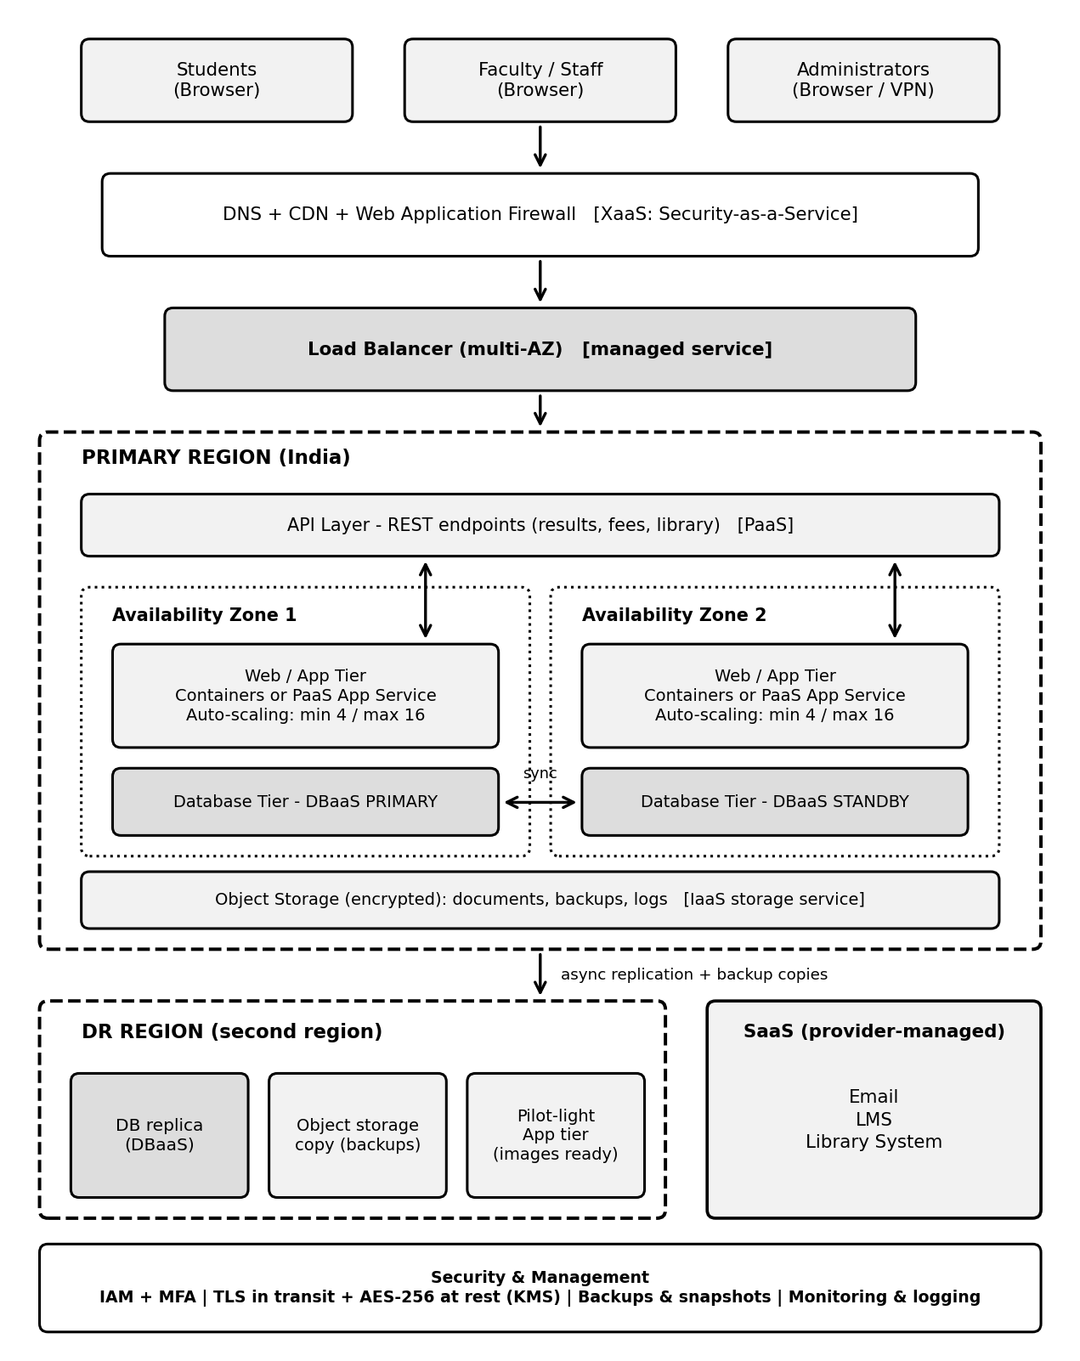
Figure 3: Proposed cloud architecture for the university (primary region, DR region and SaaS services)

8.2 Deployment and Service Model of Each Component
Table 25: Components, models and justification
Component | Deployment model | Service model | Justification
Users (students, staff, admins) | Internet / campus networks | – | Browser-based access from all 4 campuses; administrators use MFA/VPN.
DNS + CDN + WAF | Public cloud | Security as a Service | Caches static content, blocks common web attacks and DDoS before they reach the application.
Load balancer | Public cloud | Managed service | Distributes traffic across zones; removes failed instances using health checks; terminates TLS.
API layer | Public cloud | PaaS | Exposes results, fees and library as REST APIs for the web and (later) mobile and partner systems.
Web/application tier | Public cloud, private subnets | PaaS (containers/app service); IaaS VM for legacy SIS | Auto-scaling across two availability zones; stateless so instances can be added freely.
Database tier | Public cloud, private subnet | DBaaS | Managed primary + standby in separate zones with automatic fail-over, backups and patching.
Object storage | Public cloud | IaaS storage service | Durable, encrypted storage for documents, backups and logs.
DR region | Public cloud (second region) | DBaaS replica + DRaaS | Data replicated asynchronously; application images kept ready (pilot light).
Email, LMS, Library | Public cloud | SaaS | Commodity applications run by the provider; no servers to manage.
Security and management | Hybrid | Identity, encryption, monitoring services | Access control, encryption, logging and alerts for the whole system.

8.3 Elasticity (Auto-Scaling) for Admissions and Exam Peaks
Sizing assumption: the current peak is taken as about 500 requests per second across the applications, and one application instance can serve about 50 requests per second at the 70% target utilisation. The peak therefore needs 500 ÷ 50 = 10 instances.
- Baseline: minimum 4 instances (2 per zone) for normal weeks.
- Scale-out rule: add 2 instances when average CPU stays above 60% for 3 minutes; scale-in rule: remove 1 instance when CPU stays below 30% for 10 minutes (with a cool-down to avoid flapping).
- Maximum: 16 instances – 60% headroom over the 10 needed for the current peak.
- Scheduled scaling: capacity is raised in advance before admissions, result publication and exam weeks, because new instances take a few minutes to start.
- Cost effect: the university pays for 4 instances most of the year and for up to 16 only during a few peak weeks.

8.4 Security and Availability Measures
Table 26: Security and availability controls
Area | Measure
Access control | Role-based access control (students, staff, admins) with least privilege; multi-factor authentication for administrators; single sign-on.
Encryption | TLS 1.2+ for data in transit; AES-256 for data at rest with keys in a key-management service.
Network security | Virtual private network with public and private subnets; databases not reachable from the Internet; security groups and WAF.
Backup | Daily automated backups and point-in-time recovery with 35-day retention; backup copies stored in the DR region.
Multi-zone deployment | Application and database in two availability zones; automatic fail-over for the database.
Disaster recovery | Cross-region replication; target RPO ≤ 15 minutes and RTO ≤ 4 hours (pilot-light recovery); recovery drill once a year.
Monitoring | Central logging, metrics and alerts; audit logs of administrator actions; regular patching.

TASK 9 – Hands-on Implementation and Documentation (4 Marks)

9.1 Objective and Design
The proof-of-concept implements the university's result-lookup, library-search and fee-payment functions (Task 5) as a small Python Flask REST API. The API is run locally, packaged as a Docker container, and deployed to a free-tier PaaS web service. It is tested with curl, covering both a success case (HTTP 200) and a failure case (HTTP 404). Sample data held in memory stands in for the managed database (DBaaS) that the real design would use.

9.2 Environment
Table 27: Environment used
Item | Details
Operating system | Ubuntu 24 Linux (any OS with Python 3 or Docker works)
Language / framework | Python 3.12.3, Flask 3.1.3 (Werkzeug 3.1.7)
Production server | Gunicorn 22.0.0 (inside the container)
Container tool | Docker (base image python:3.12-slim)
PaaS (free tier) | Render web service (or Azure App Service / Google Cloud Run)
Test client | curl

9.3 Source Code
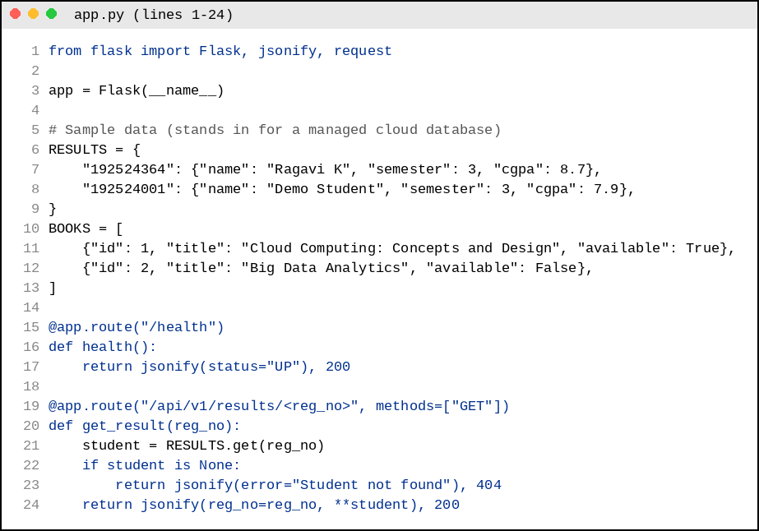
Figure 4: Source code of app.py (part 1) – data and result/health endpoints
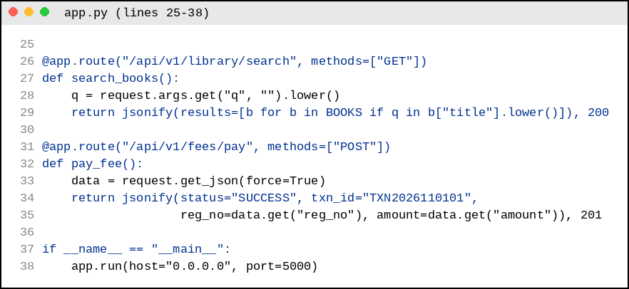
Figure 5: Source code of app.py (part 2) – library search, fee payment and start-up
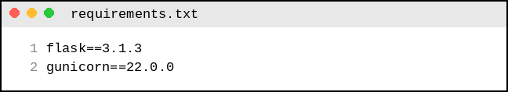
Figure 6: requirements.txt
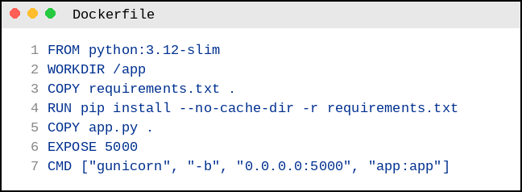
Figure 7: Dockerfile used to build the container image

9.4 Configuration Steps (Reproducible)
A. Run locally
mkdir uni-api && cd uni-api # place app.py, requirements.txt, Dockerfile here
python3 -m venv venv && source venv/bin/activate
pip install -r requirements.txt
python3 app.py # server starts on port 5000
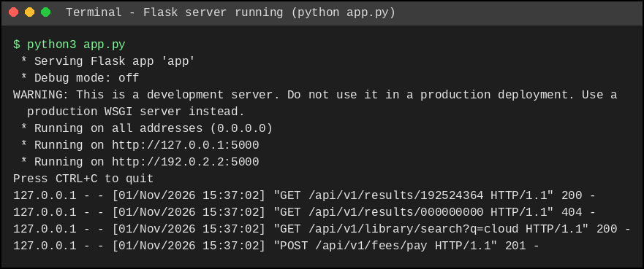
Figure 8: Flask server running and logging the test requests
B. Build and run the Docker container
docker build -t university-api:1.0 .
docker run -d -p 5000:5000 --name uni-api university-api:1.0
docker ps # shows the running container
curl http://localhost:5000/api/v1/results/192524364
Insert your own screenshot of the commands above (docker build, docker ps showing the container "Up", and the curl response) in the box below.
[ Paste screenshot: docker build + docker ps + curl output ]

Figure 9: Container built and running with Docker
C. Deploy to a PaaS (free tier)
- Push app.py, requirements.txt and Dockerfile to a GitHub repository.
- In the PaaS dashboard (for example Render) choose New → Web Service and connect the repository.
- Select Python as the runtime; Build Command: pip install -r requirements.txt; Start Command: gunicorn app:app; instance type: Free.
- Wait for the deployment to finish, then open the public URL (https://<service-name>.onrender.com).
- Test the public URL with curl or the browser (the free tier may take about a minute to wake up after inactivity).
[ Paste screenshot: PaaS dashboard showing "Live" + browser/curl result on the public URL ]

Figure 10: API deployed on the PaaS platform

9.5 Testing and Output
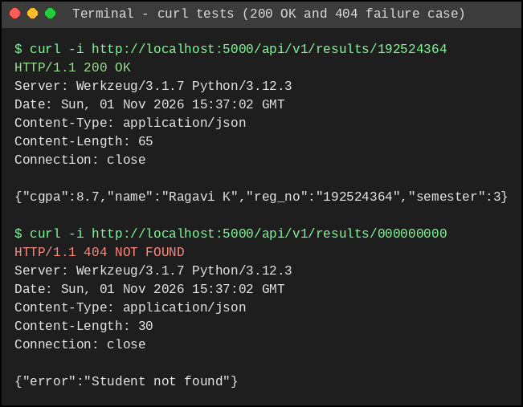
Figure 11: Functional test (HTTP 200) and failure case (HTTP 404) using curl
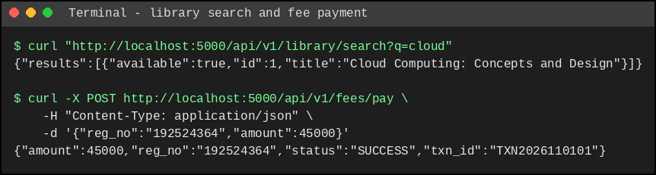
Figure 12: Library search (GET) and fee payment (POST) tests
Table 28: Test results
Test | Request | Expected | Actual (observed) | Result
T1 Functional | GET /api/v1/results/192524364 | HTTP 200 + JSON record | HTTP 200; JSON with name, cgpa, semester | Pass
T2 Failure case | GET /api/v1/results/000000000 | HTTP 404 + error JSON | HTTP 404; {"error":"Student not found"} | Pass
T3 Search | GET /api/v1/library/search?q=cloud | HTTP 200 + matching books | HTTP 200; 1 matching book | Pass
T4 Payment | POST /api/v1/fees/pay | HTTP 201 + transaction | HTTP 201; status SUCCESS, txn_id returned | Pass

9.6 Issues Faced and Fixes
Issue | Cause | Fix
"Development server" warning in the Flask log | Flask's built-in server is not meant for production. | Use Gunicorn in the Dockerfile and PaaS start command.
JSON keys appear in alphabetical order | Flask sorts JSON keys by default. | Harmless; clients should not depend on key order.
Port 5000 already in use (can occur on some systems) | Another program uses the port. | Map another port, e.g. docker run -p 8080:5000.
JSON quoting error with curl on Windows Command Prompt | Command Prompt handles quotes differently. | Escape the quotes or use Postman / PowerShell.
First request slow on the free PaaS tier | Free instance sleeps when idle. | Wait for wake-up; a paid tier or keep-alive removes the delay.
Limitation: the PoC keeps data in memory and has no authentication; the full design uses DBaaS, an API gateway and token-based security.

TASK 10 – Evaluate and Recommend the Final Solution (7 Marks)

10.1 Comparison of the Three Options
Table 29: On-premise vs IaaS-based vs PaaS/SaaS-based
Criterion | A. On-premise (refresh) | B. IaaS-based | C. PaaS/SaaS-first (hybrid)
Cost model | High CapEx; fixed running cost. | OpEx; pay for VMs plus admin staff. | OpEx; pay for services; least staff.
Scalability | Fixed; new hardware takes 6–8 weeks. | Good, but scaling must be designed and managed. | Best – automatic for PaaS and SaaS.
Availability | Single site; needs a second site (costly). | Multi-zone possible; designed by the team. | Multi-zone built in; provider SLAs.
Security | Full control; the university does everything. | Shared responsibility; OS and above is the university's. | Provider secures most layers; the university secures data and access.
Effort / manageability | Highest administration effort. | High (OS, patching, scaling). | Lowest.
3-year cost (see below) | ₹141.4 lakh | ₹96.6 lakh | ₹88.0 lakh

10.2 Three-Year Cost Estimate
Assumptions: (1) Costs are in ₹ lakh; no inflation or discounting. (2) On-premise: 12 replacement servers at ₹4.0 lakh each; a DR site costing ₹25 lakh; power and cooling ₹6 lakh/year; maintenance (AMC) 10% of server cost = ₹4.8 lakh/year; two system administrators at ₹6 lakh each. (3) IaaS: about 10 reserved VMs at ₹6,000 per month plus burst capacity, storage, network, DR replication, software licences, two administrators and ₹6 lakh migration. (4) PaaS/SaaS-first: SaaS subscriptions for Email, LMS and Library; managed app platform and a few VMs; DBaaS; storage, backup and DR; monitoring; one cloud engineer; ₹10 lakh migration and refactoring. (5) These are planning estimates to be confirmed with provider pricing calculators and education discounts, which would lower the cloud options further.
Table 30: Three-year cost comparison (₹ lakh)
Cost item | A. On-premise | B. IaaS | C. PaaS/SaaS-first
One-time costs
Servers (12 × ₹4.0) | 48.0 | – | –
DR site build | 25.0 | – | –
Migration / refactoring | – | 6.0 | 10.0
Total one-time | 73.0 | 6.0 | 10.0
Recurring per year
Power and cooling | 6.0 | – | –
Hardware maintenance (AMC) | 4.8 | – | –
Compute (reserved + burst) | – | 9.2 | 4.8
SaaS subscriptions (Email, LMS, Library) | – | – | 8.0
Database service (DBaaS) | – | (in VMs) | 3.6
Storage, network, backup and DR | – | 6.0 | 2.4
Software licences (OS, DB, mail) | – | 3.0 | –
Monitoring and security services | – | – | 1.2
Staff | 12.0 (2 admins) | 12.0 (2 admins) | 6.0 (1 engineer)
Total per year | 22.8 | 30.2 | 26.0
3-year recurring (3 × annual) | 68.4 | 90.6 | 78.0
3-YEAR TOTAL | 141.4 | 96.6 | 88.0
Saving compared with on-premise | – | 44.8 (31.7%) | 53.4 (37.8%)
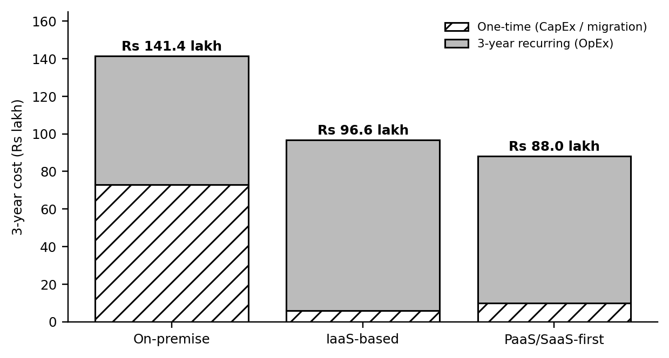
Figure 13: Three-year cost comparison of the three options
Option C is the cheapest over three years and also avoids the ₹25 lakh DR-site investment, which on-premise cannot do without. It additionally gives the best scalability and the lowest administration effort.

10.3 Main Risks and Mitigation
Table 31: Risk analysis
Risk | Mitigation steps
Vendor lock-in | Use containers, standard SQL databases and REST APIs; automate infrastructure as code; keep exportable backups; write an exit plan.
Data privacy | Host in India regions; encrypt data; role-based access and audit logs; data-processing agreements; follow the DPDP Act 2023.
Downtime | Multi-zone deployment, DR region, provider SLAs; test fail-over annually.
Skills gap | Train staff and obtain provider certifications; prefer managed services; use a managed-service partner during migration.
Cost overrun | Budgets and alerts, tagging, reserved capacity for the baseline, monthly cost review.
Migration failure | Phased migration, parallel running and rollback plan for every application.

10.4 Final Recommendation
Adopt Option C – a hybrid, PaaS/SaaS-first solution with DBaaS and DRaaS: Email, LMS and Library as SaaS; Exam Portal and (later) SIS on PaaS with a managed database; the SIS initially on IaaS VMs; and a DR region. It follows from the earlier analysis: virtualization reduces the 12 servers to about 4 hosts' worth of steady load (Task 4); SaaS/PaaS match the applications (Task 6); DBaaS and DRaaS address the two weakest points (Task 7); and it is the lowest-cost option (₹88.0 lakh over 3 years against ₹141.4 lakh).
Choosing the provider (not simply the most popular one): the provider should be selected using these criteria: (i) data centres in India, (ii) published SLAs of at least 99.9% for the services used, (iii) education discounts or credits, (iv) availability of managed PostgreSQL/MySQL, container and DR services, (v) support and training in the region, and (vi) ease of exit. Any of the major providers (AWS, Microsoft Azure, Google Cloud) can satisfy these; the final choice should come from a quotation comparison and a short pilot.

10.5 Migration Roadmap
Table 32: Phased migration roadmap
Phase | Time | Application / activity | Why this order
0. Prepare | Weeks 1–4 | Provider selection, cloud account, identity, network, security baseline, staff training. | Foundation for everything else.
1. Email → SaaS | Month 2 | Migrate mailboxes to hosted e-mail. | Moves first: standard service, no code change, little coupling, quick visible benefit; proves the identity and network set-up.
2. Library and LMS → SaaS | Months 3–4 | Move catalogue and courses; integrate with single sign-on. | Low business risk; LMS gains elasticity before exam weeks.
3. Exam Portal → PaaS | Months 5–6 | Re-platform on managed app service + DBaaS; load test. | Biggest pain point (peaks); must be ready before the next exam season.
4. SIS → IaaS, then PaaS | Months 7–9 | Lift-and-shift to VMs, then expose REST APIs and move to PaaS. | Most critical and complex system, so it moves last, after the team has experience.
5. Decommission and DR drill | Months 10–12 | Switch off old servers, run a disaster-recovery test, review costs. | Releases on-premise cost and proves recovery.

TASK 11 – Day-4 Design Challenge: Re-evaluate and Adapt the Design (8 Marks)
Changed requirement: a mobile app and student-record and fee-payment services for 40 affiliated colleges; expected load 10× the current peak; 99.9% availability; limited operating budget. Decision: MODIFY the original design (retain the cloud-first PaaS/SaaS strategy, redesign the compute, API, data and DR layers).

11.1 Impact Analysis (2 Marks)
What has changed
Table 33: Original problem vs changed requirement
Factor | Original assumption | Changed requirement | Effect
Users | About 27,000 internal users (25,000 students + 2,000 staff). | Plus mobile-app users and users of 40 colleges. | Much larger, mostly external user base.
Load | Current peak ≈ 500 requests/s (assumed). | 10× peak ≈ 5,000 requests/s. | Capacity limits and database become critical.
Availability | High availability by design, but no formal target. | 99.9% (≤ 8.76 hours downtime per year). | A measurable SLA that must be proven.
Access | Browsers inside the campus network. | Mobile app and partner systems over the Internet. | Public APIs become the main entry point.
Tenancy | One organisation. | University + 40 colleges (multi-tenant). | Data isolation and per-tenant control needed.
Budget | Replace CapEx with OpEx. | Limited operating budget. | Cost per request must fall; no over-provisioning.
Original assumptions affected
- Load: the maximum of 16 instances was sized for the old peak, not for 10× the traffic.
- Users: designed for internal users; now external, with unknown device quality and many more concurrent sessions.
- Availability: two availability zones and manual DR recovery (RTO about 4 hours) were enough for high availability but not for a 99.9% target.
- Cost: a design that scales mainly by adding bigger/more instances becomes unaffordable at 10×.
Why web services and APIs now become critical
- The mobile app and the 40 colleges can reach university data only through APIs; the database must never be exposed directly.
- An API gateway gives one controlled entry point for authentication, throttling, versioning and logging, and allows the back-end to scale and change without breaking clients.
- Stable, versioned REST contracts let colleges integrate their own systems without depending on the university's internal design.
Multi-tenant access: security and isolation
- Every record carries a tenant_id; the database enforces row-level security so that a college can see only its own students' records.
- Each college receives its own credentials (OAuth2 client / API key) and role scopes, with per-tenant rate limits so one college cannot overload the system (noisy-neighbour control).
- Audit logs record who accessed which tenant's data; data is encrypted in transit and at rest; large colleges can be moved to a separate schema or database if required.

11.2 Evaluation of the Original Design (2 Marks)
Table 34: Can the original design meet the new requirements?
Question | Technical finding | Verdict
Can the service-model mix and virtualization plan handle 10× load? | Capacity needed: 5,000 ÷ 50 = 100 instances, but the original maximum is 16 (about 800 requests/s) – 6× too small. VM-based scaling takes minutes per instance, and a single database primary (with one standby that serves no traffic) becomes the bottleneck. | No – not as designed.
Are auto-scaling and single-region deployment enough for 99.9%? | Estimated availability of the original design is 99.87% (about 11.4 hours/year), above the 8.76 hours allowed. A regional outage also needs a manual recovery of about 4 hours, which alone uses almost half of the yearly allowance. | No – slightly short; DR too slow.
Does cost remain acceptable? | Scaling the original design by 10× costs about ₹101.6 lakh/year (against ₹26.0 lakh/year today). | No – unaffordable.
Would another service model or XaaS give better results? | Yes: API Gateway, container orchestration, caching/CDN, queue and FaaS for bursty work, BaaS for mobile authentication/push, read replicas and warm-standby DRaaS. | Yes – add them.
Conclusion: the strategy (cloud-first, SaaS for commodity applications, DBaaS, DRaaS) is still correct, but the compute, API, data and DR layers cannot be kept as they are. SaaS applications (Email, LMS, Library) are not affected by the new load, because the extra load is on student-record and fee-payment services.

11.3 Adaptation / Redesign (2 Marks)
Decision: MODIFY. A full redesign is not needed because the original strategy, the SaaS decisions and the security baseline remain valid; keeping the design unchanged is not possible because of the findings above.
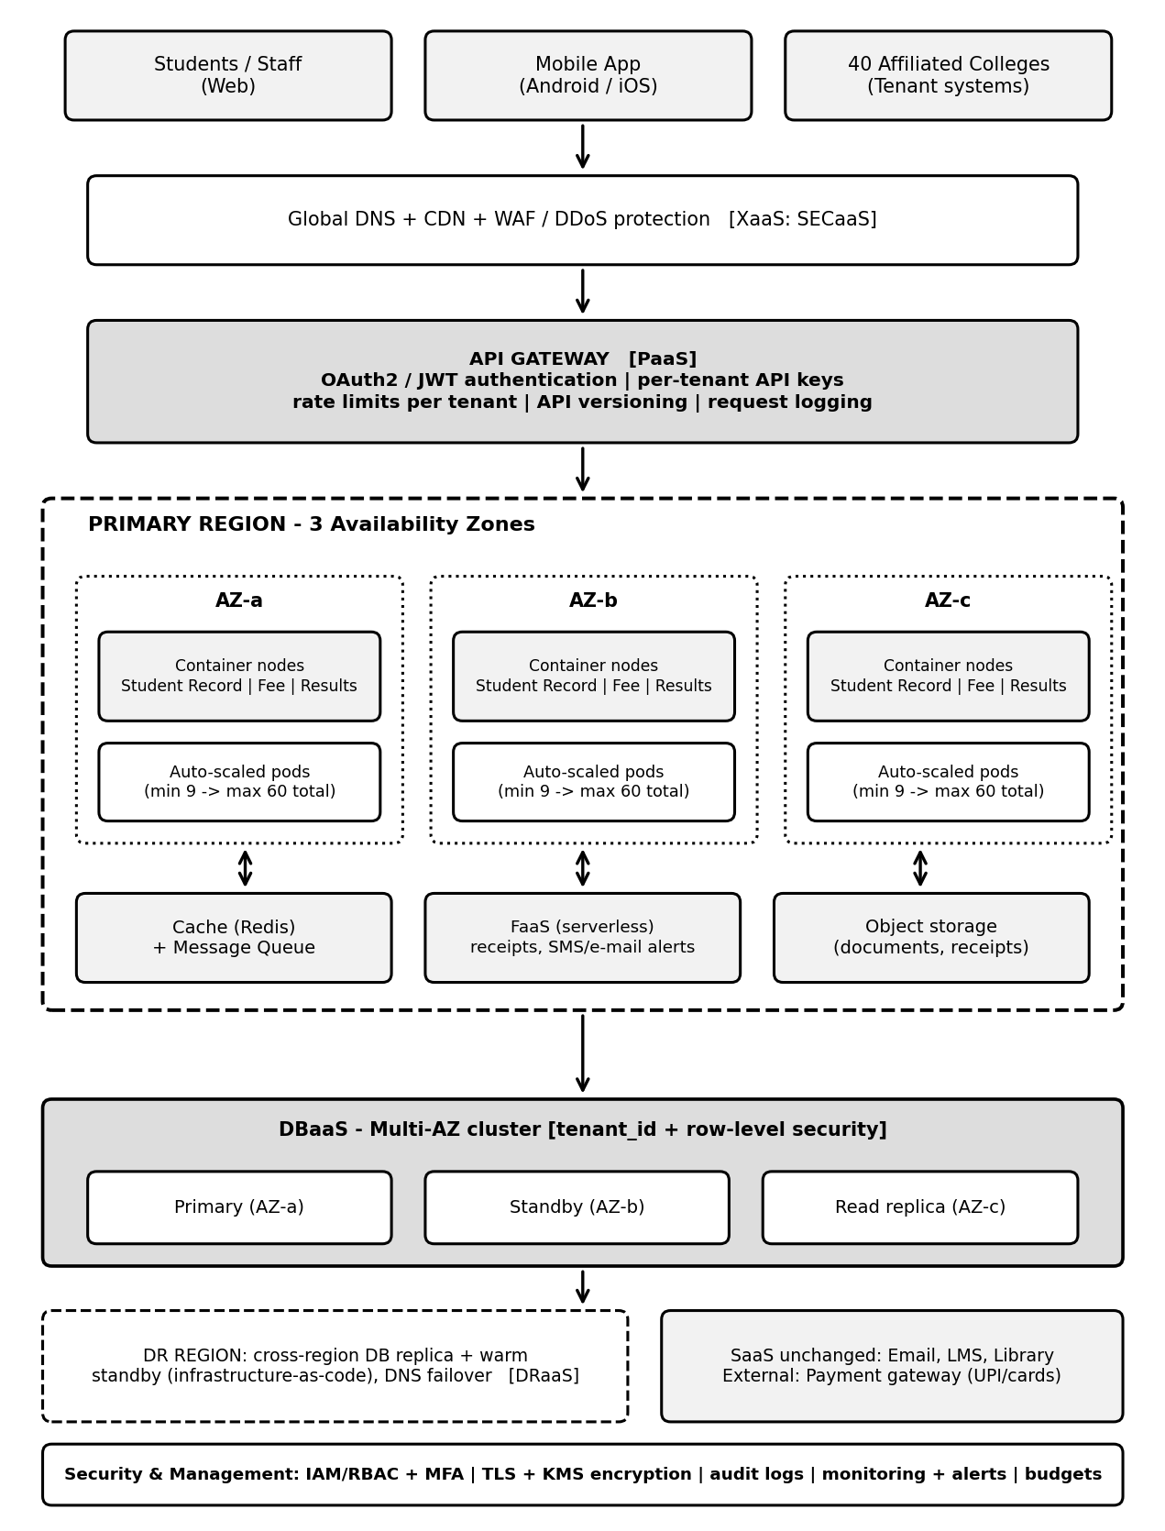
Figure 14: Revised architecture with API gateway, container orchestration, multi-AZ database and warm-standby DR
Table 35: What changed in the design
Area | Original design | Revised design
Entry point | Simple API layer behind a load balancer. | API gateway: OAuth2/JWT, per-tenant keys, rate limits, versioning, logging; CDN + WAF + DDoS protection.
Compute | Auto-scaled app instances (4–16) across 2 zones. | Containers on managed orchestration across 3 zones; 9 pods minimum, up to 60 (details below).
Data | DBaaS primary + idle standby. | Multi-AZ DBaaS cluster with a read replica, Redis cache; tenant_id with row-level security.
Asynchronous work | None. | Message queue + FaaS for receipts, notifications and payment retries.
Disaster recovery | Pilot-light, manual recovery (RTO about 4 h). | Warm standby in a second region with automated DNS fail-over (RTO ≤ 1 h, RPO ≤ 5 min).
Service-model mix | SaaS + PaaS + DBaaS + DRaaS. | Same, plus container platform (CaaS), BaaS (mobile authentication/push), FaaS and API-gateway service.
Virtualization approach | VMs for legacy SIS; some containers. | Container-first; VMs only for the legacy SIS until it is refactored; hosts managed by the provider.
Retained | Cloud-first hybrid model, SaaS for Email/LMS/Library, security baseline. | Unchanged.

11.4 Evidence-Based Defence (2 Marks)
(a) Capacity calculation
Table 36: Capacity calculation for 10× load
Step | Working | Result
Peak load | 10 × 500 requests/s | 5,000 requests/s
Without optimisation | 5,000 ÷ 50 requests/s per instance | 100 instances
With CDN/cache offloading 60% of reads | 5,000 × 0.40 = 2,000 ÷ 50 | 40 instances
Survive loss of one of 3 zones at peak | 40 instances must fit in 2 zones → 20 per zone | 3 zones × 20 = 60 maximum
Normal weeks (≈ 16% of peak) | 3 per zone | 9 minimum
(b) Availability calculation
For components in series, availability = product of the component availabilities. Component SLAs are assumed from typical published provider figures and must be confirmed with the chosen provider.
Table 37: Estimated availability – original vs revised design
Component | Original design | Revised design
Edge (DNS/CDN/WAF) | 99.99% | 99.99%
API gateway | – | 99.99%
Load balancer | 99.99% | 99.99%
Application tier | 99.95% (2 zones) | 99.99% (3 zones)
Database tier | 99.95% (primary + standby) | 99.99% (multi-AZ cluster)
Storage | 99.99% | 99.99%
Combined availability | 99.87% | 99.94%
Downtime per year | ≈ 11.4 hours (fails the 8.76 h limit) | ≈ 5.3 hours (meets the 8.76 h limit)
Cross-region fail-over (RTO ≤ 1 hour) adds further protection against a regional outage. Real availability also depends on application quality, deployments and provider performance, so a load test and a fail-over drill are recommended before go-live.
(c) Cost comparison
Table 38: Annual and 3-year cost: original scaled ×10 vs revised design (₹ lakh)
Cost item | Original scaled ×10 | Revised design
Compute (PaaS / containers) | 48.0 (4.8 × 10) | 9.6
Database service | 36.0 (3.6 × 10) | 7.2 (multi-AZ + read replica)
API gateway + WAF | – | 2.4
CDN, cache, queue and FaaS | – | 1.2
Storage, backup and DR | 2.4 | 3.6 (warm standby)
SaaS (Email, LMS, Library) | 8.0 | 8.0
Monitoring and security | 1.2 | 1.8
Staff | 6.0 (1 engineer) | 12.0 (2 engineers)
Total per year | 101.6 | 45.8
3-year recurring | 304.8 | 137.4
One-time migration / refactoring | – | 8.0
3-YEAR TOTAL | 304.8 | 145.4
Saving | – | 159.4 (52%)
The revised design costs ₹45.8 lakh/year against ₹26.0 lakh/year for the original 1× design – about 76% more for ten times the peak capacity and a 99.9% target – so the cost per unit of peak capacity falls by roughly 80%. Cost savings come from caching (fewer requests reach the application), dense containers, a small always-on baseline that scales to 60 pods only in peak weeks, and an API gateway that throttles abusive traffic. Charging each college a service fee of about ₹1.15 lakh per year (45.8 ÷ 40) would recover the operating cost fully.
(d) Security and multi-tenancy
Risk | Control
Cross-tenant data leakage | tenant_id on every record, row-level security, tenant-scoped tokens, automated tests for isolation.
Abuse or overload by one tenant | Per-tenant rate limits and quotas at the API gateway.
Attacks on public APIs | WAF, DDoS protection, OAuth2/JWT, input validation, TLS, regular patching.
Payment fraud / duplicates | Idempotency keys, retries through the queue, payment through a certified gateway, audit logs.
Data protection | Encryption at rest and in transit, India region, access logs, DPDP Act 2023 compliance.
(e) Trade-offs
Table 39: Trade-offs of the revised design
Trade-off | Impact | Mitigation
Vendor lock-in | Managed gateway, DBaaS and FaaS are provider-specific. | Use containers and standard SQL; infrastructure as code; keep exportable backups.
Complexity | More components to operate and secure. | Use managed services; two trained engineers; automation and monitoring.
Migration effort | ₹8 lakh and 2–3 months of refactoring. | Phased migration (one service at a time) with parallel running and rollback.
Cost of multi-region DR | Extra ₹1.2 lakh/year for warm standby. | Justified by faster recovery and the 99.9% target.
External payment gateway dependency | Its outage affects fee payments. | Queue and retry payments; show pending status; monitor the gateway.
Final decision: MODIFY the original design. The revised architecture meets the 10× load (60-instance ceiling), the 99.9% target (about 99.94% estimated) and the limited-budget constraint (₹145.4 lakh over 3 years against ₹304.8 lakh for simply scaling the original design), while securely supporting the mobile app and the 40 colleges.

Evaluation of the Original Design – 2 Marks
Discuss:
- Whether the chosen service models and virtualization plan can handle a 10x load
- Whether auto-scaling and the single-region deployment are sufficient for 99.9% availability (about 8.76 hours of downtime allowed per year)
- Whether cost remains acceptable under the new load
- Whether another service model or XaaS offering would give better overall results.

Evidence Expected: A technically supported evaluation of the original design under the new conditions.

Adaptation or Redesign – 2 Marks
Discuss:
- Decide whether to retain, modify or redesign the solution
- Describe the revised architecture (for example API gateway, container orchestration, serverless components, multi-zone deployment or a hybrid model)
- Explain what changed in the service model mix and in the virtualization approach
- If you retain the original design, give sufficient technical justification for why no change is required
Evidence Expected: An appropriate design response to the changed requirement, with clear technical reasoning.

Evidence-Based Defence – 2 Marks
Discuss:
- Capacity and availability calculations
- Cost comparison between the original and the revised design
- Security and multi-tenancy considerations
- Trade-offs such as vendor lock-in, complexity and migration effort
Evidence Expected: A well-supported final decision that follows logically from the analysis.

MARK DISTRIBUTION

Task | Title | Bloom's Level | Marks
Task 1 | Cloud Computing – Introduction & Characteristics | L2 – Understand | 3
Task 2 | Evolution & Hardware Evolution | L2 – Understand | 3
Task 3 | Internet Software Evolution | L2 – Understand | 3
Task 4 | Server Virtualization | L3 – Apply | 5
Task 5 | Web Services | L3 – Apply | 4
Task 6 | Service Models: IaaS, PaaS, SaaS | L4 – Analyze | 5
Task 7 | XaaS | L4 – Analyze | 3
Task 8 | Design the Cloud Solution Architecture | L6 – Create | 5

Task | Title | Bloom's Level | Marks
Task 9 | Hands-on Implementation & Documentation | L3 – Apply | 4
Task 10 | Evaluate & Recommend the Final Solution | L5 – Evaluate | 7
 | Subtotal

Task 11 | Day-4 Design Challenge | L4 / L5 / L6 | 8
 | TOTAL |  | 50

