**Task3: DBSCAN Clustering:**

Minpts:3

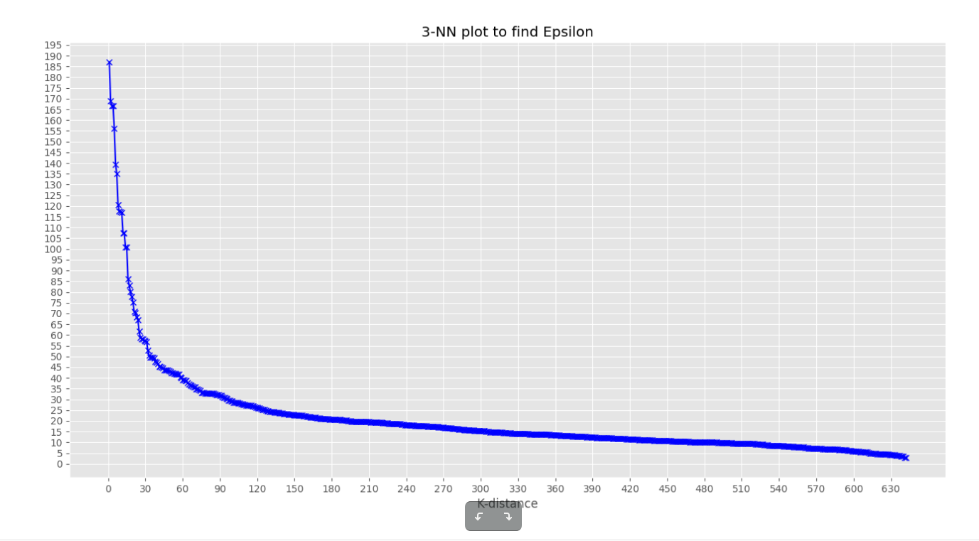

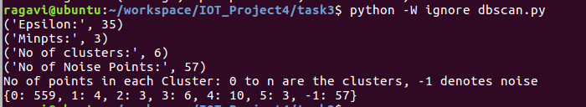

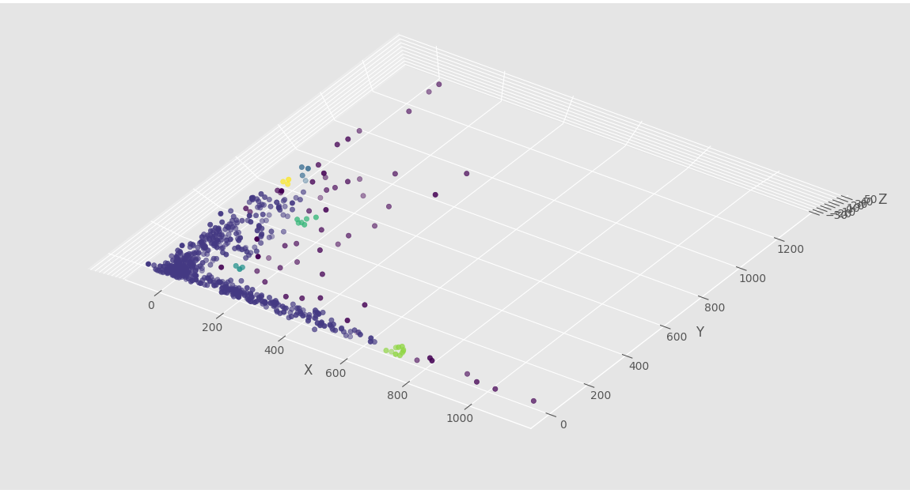

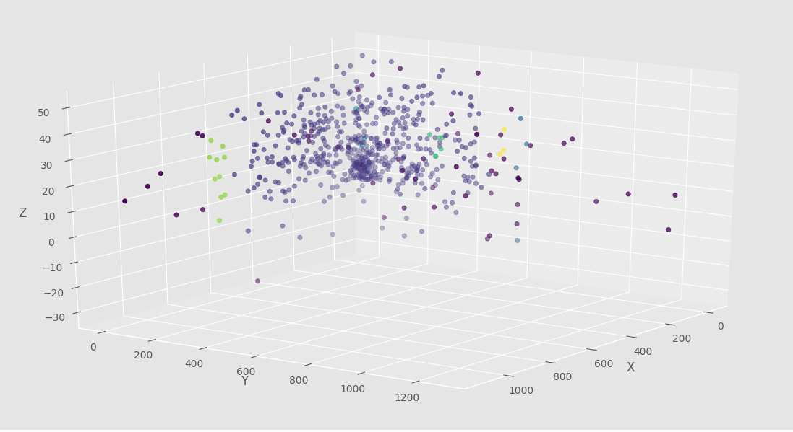

Some clusters are not even properly visible in the 3d scatter plot as the other clusters are sparsely populated and do not contain a lot of data points under its label.

Minpts:4

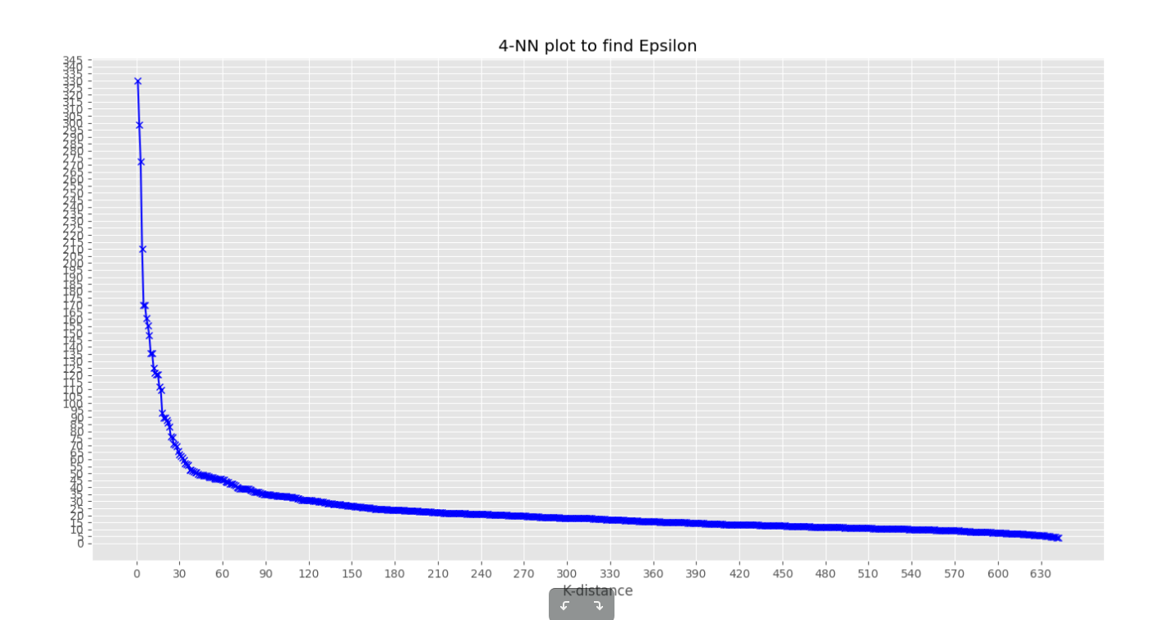

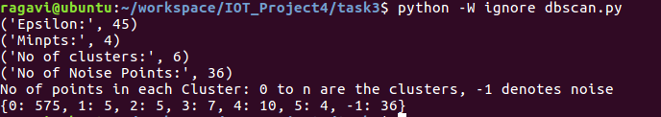

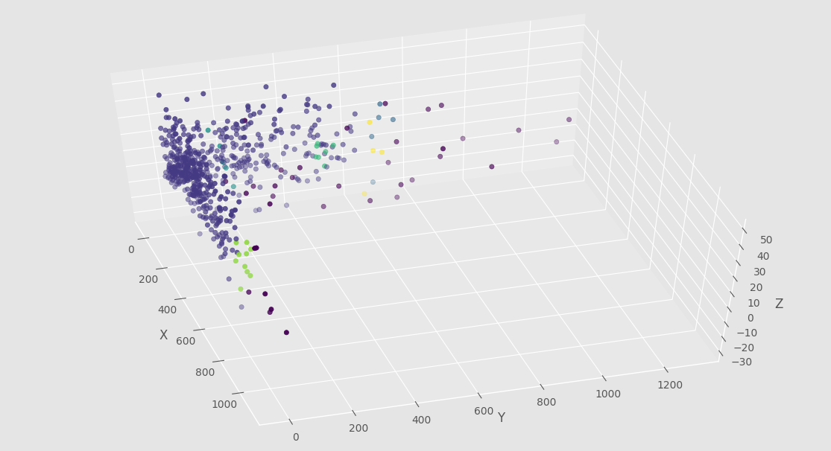

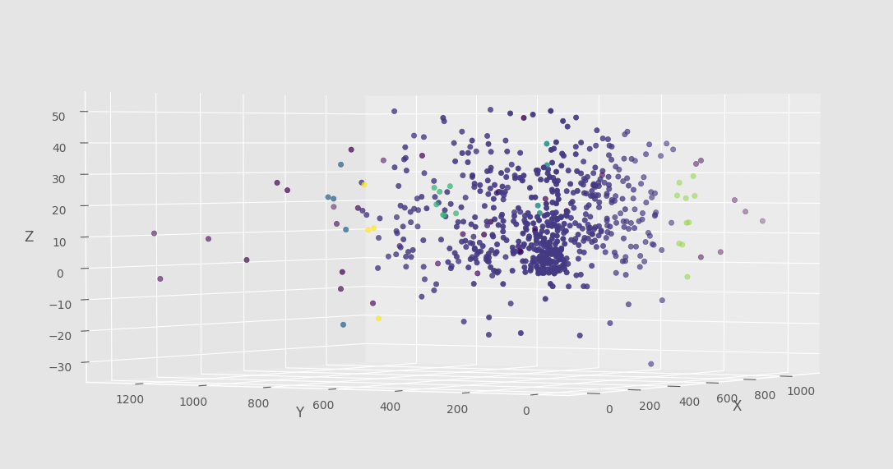

Even though there are only 4 clusters, they are not even properly visible in the 3d scatter plot as the groups are sparsely populated and do not contain a lot of data points under its label.

We identify minpts=5 as the best case and stop with that as it gives only 1 cluster. All higher minpts would give the same number of clusters with varied noise points.