GTM Agent Evaluation Report

Executive Summary
This evaluation measures whether the GTM agent can research a user-supplied topic
and produce a grounded, useful LinkedIn post. The agent accepts a topic, searches
current web sources, returns a source-linked JSON result, and records the run in
LangSmith.
The 20-case baseline achieved 13 passes and 7 failures, for a 65% pass rate. The
dominant baseline issue was unsupported detail. A grounding and attribution prompt
improvement was then applied and tested on regression cases. The regression results
are reported separately below without replacing the baseline.

Evaluation Design

Agent under test
The topic-to-LinkedIn path in the GTM agent. Its flow as shown in the picture
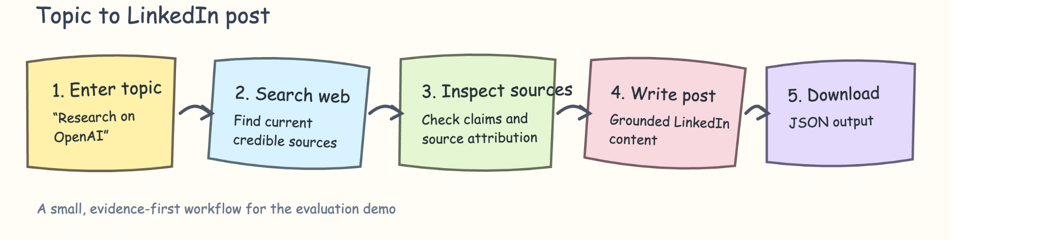

Agent UI

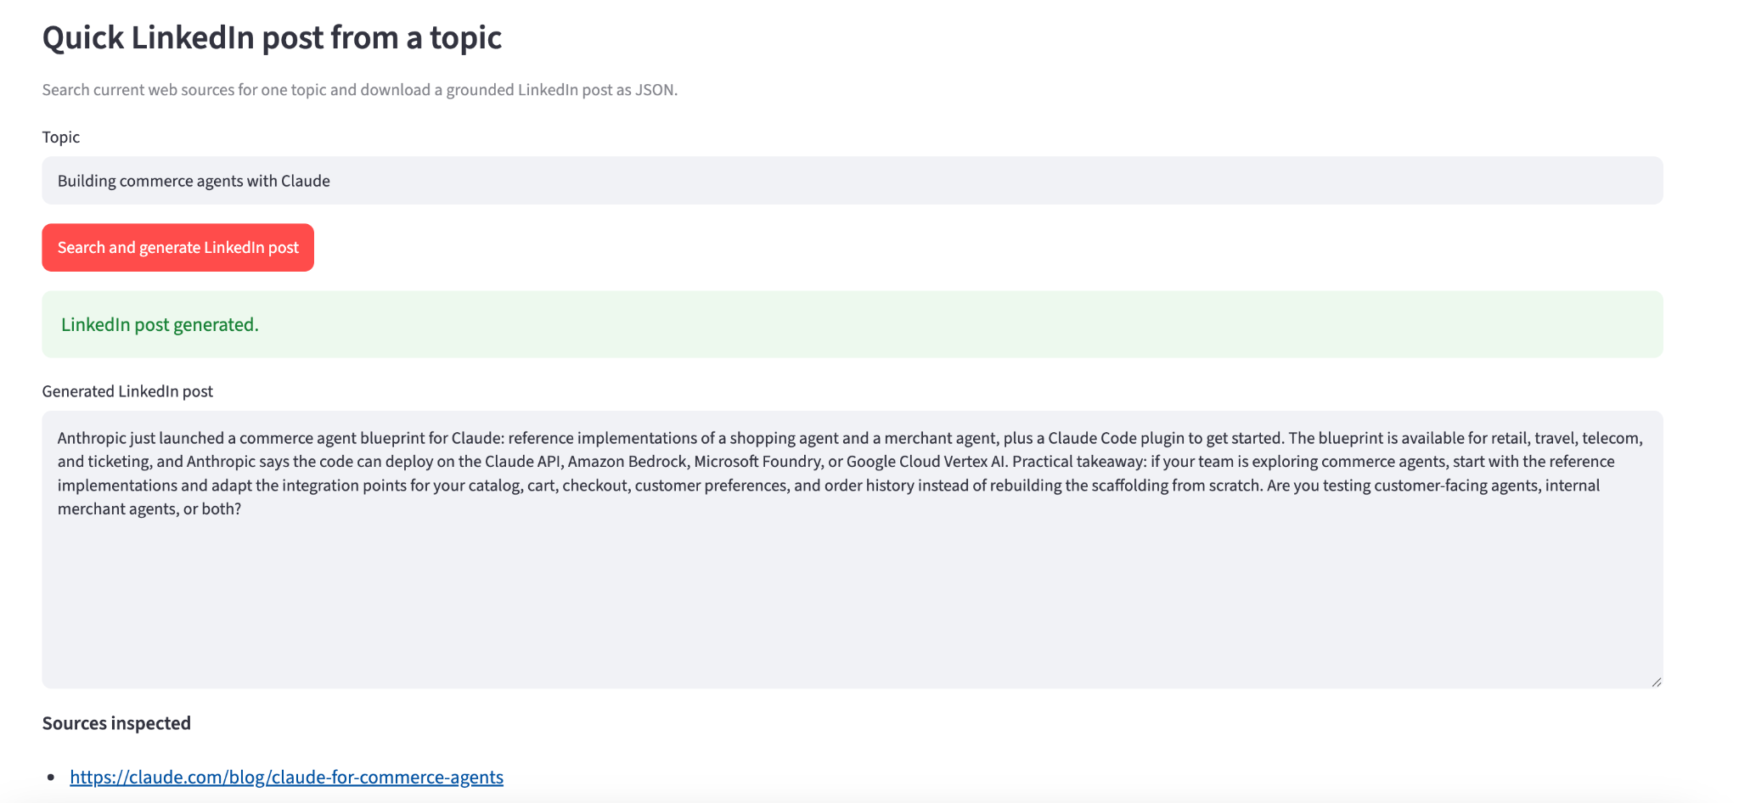

Dataset
The golden dataset contains 20 topic-based cases. Each case includes:
- `Test_ID`
- `Topic`
- `Retrieved_Evidence`
- `Expected_Output`
- `Model_output`
- Human scores and feedback
- `Scenario_Type`
The spreadsheet is the human-review record. LangSmith stores the versioned datasetand execution traces. The dataset should remain frozen when comparing runs.

Snapshot of Golden Dataset
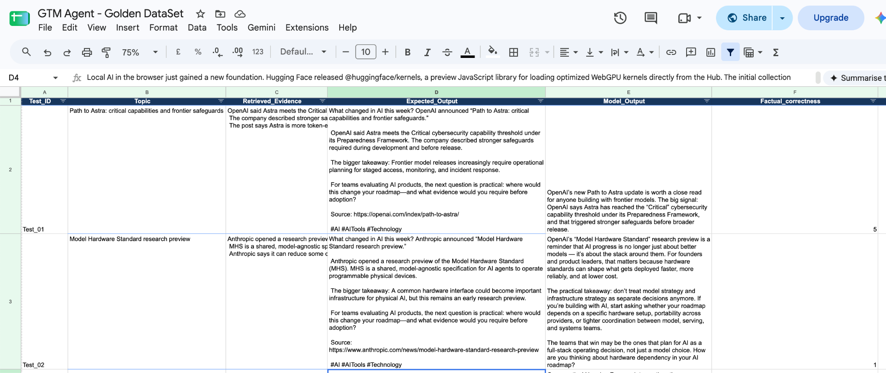

Metrics and scoring
Each post is scored from 1 to 5 on:
- **Factual correctness:** claims, dates, companies, products, and source attribution are supported by retrieved evidence.
- **Clarity:** the post is concise, coherent, and easy to read.
- **Value:** the post provides a useful, specific insight rather than generic filler.
- **Engagement:** the post has an effective opening, readable flow, and closing question or call to action.
- **Tone:** the post is professional, credible, practical, and accessible.
The spreadsheet uses this decision rule:
Total_Score = Factual_correctness + Clarity + Value + Engagement + Tone
FAIL if Factual_correctness < 4
FAIL if Total_Score < 20
PASS otherwise

Metrics and scoring snapshot

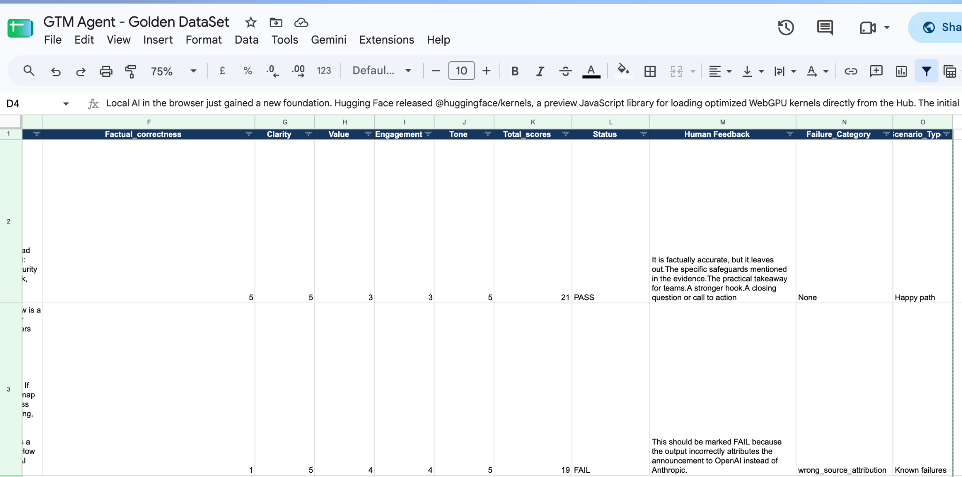

Baseline Results
Measure | Result
Cases evaluated | 20
Passes | 13
Failures | 7
Pass rate | 65%
Fail rate | 35%

Baseline failure clusters
Failure category | Count
`unsupported_detail` | 4
`evidence_mismatch` | 1
`irrelevant_evidence` | 1
`wrong_source_attribution` | 1

The dominant failure mode was `unsupported_detail`. The model often produced
well-written content but added claims that could not be matched to the retrieved
evidence. One representative failure also attributed Anthropic's Model Hardware
Standard announcement to OpenAI, triggering the factuality zero-tolerance rule.

Improvement Applied
The topic-to-LinkedIn prompt was strengthened to require evidence-only generation:
Before writing, identify each factual claim you plan to make and verify that it is
directly supported by the retrieved evidence. Use only information explicitly stated
in that evidence. Do not add inferred details, technical explanations, dates, numbers,
quotes, performance claims, or background knowledge. If a detail is not supported,
omit it. Before finalizing, check every sentence: if it cannot be matched to a
specific evidence passage, remove it. If the evidence is limited, write a shorter
post rather than filling gaps. Preserve the correct company, product, and source
attribution exactly; never replace the source company with another company.
Do not add claims about partners, availability, audience, outcomes, or importance
unless the retrieved evidence explicitly states them.
This change preserved the topic input, web search, JSON schema, source list, and
download workflow. It changed only the generation instructions, making it a targeted
prompt intervention.

Regression Results
The first regression snapshot tested 7 cases:
Measure | Result
Cases evaluated | 7
Passes | 3
Failures | 4
Pass rate | 42.9%
The later focused snapshot tested 4 cases:
Measure | Result
Cases evaluated | 4
Passes | 1
Failures | 3
Pass rate | 25%
The regression cases covered `unsupported_detail`, `evidence_mismatch`, and
`irrelevant_evidence`. These results show that the prompt change was directionally
appropriate but did not eliminate factuality failures. The honest conclusion is that
prompt-only grounding was insufficient for all cases; a future improvement should
add an explicit claim-verification step or constrain generation to shorter,
evidence-linked statements.

LangSmith Evidence
Baseline LangSmith trace. The GTM agent generated a content suite, but validation failed because the blog draft was below the required 500-word minimum. The trace records the case metadata, input, root latency, and child LLM run.
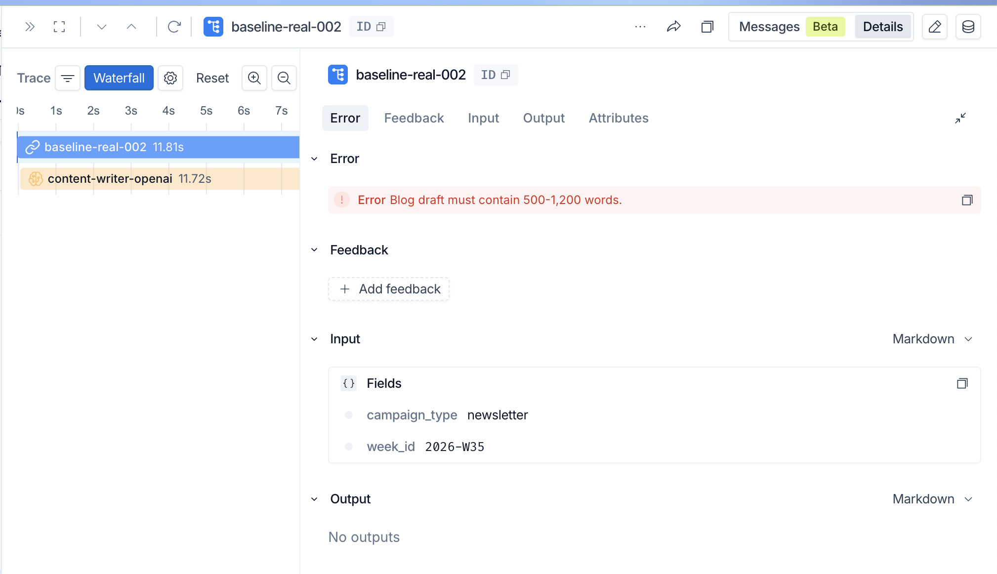

Baseline trace
Verified baseline evidence:
Field | Value
Trace | `baseline-real-002`
Case ID | `real-002`
Prompt version | `writer-v1`
Result | Blog draft validation failure: below 500 words
Root latency | Approximately 11.81 seconds
LLM child run | `content-writer-openai`
Estimated cost | `$0.021445`

The LangSmith trace shows the root run, the LLM child run, the captured validation error, input fields, and metadata.

Topic LinkedIn trace
Topic-to-LinkedIn LangSmith trace. The trace records the topic input, generated LinkedIn JSON output, source-linked metadata, prompt version, dataset version, child model/tool execution, and latency. This demonstrates end-to-end observability for the evaluated workflow.
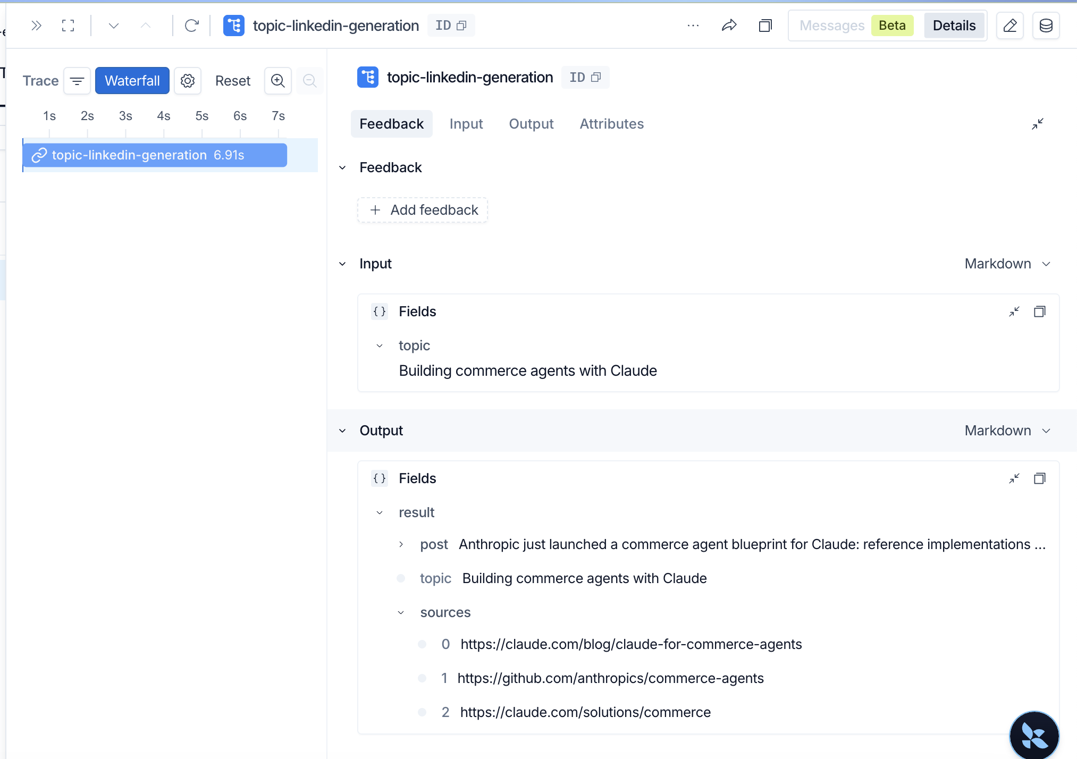
Verified trace metadata from the topic path:
Field | Value
Trace name | `topic-linkedin-generation`
Case ID | `topic-1473f0b9ed09`
Dataset version | `gtm-topic-linkedin-v1`
Prompt version | `topic-linkedin-v1`
Content format | `linkedin`
Latency | `13.58s`
Capture the **Input**, **Output**, **Attributes**, and **Waterfall** views for the
final submission. The post-improvement trace should use the same case ID with the
updated prompt version, such as `topic-linkedin-v2`, so the runs are comparable.
Add the final trace URLs or screenshots here:
- Baseline trace: `[paste LangSmith URL or screenshot reference]`
- Post-improvement trace: `[paste LangSmith URL or screenshot reference]`

What Worked
- The agent accepts a topic and produces a downloadable LinkedIn JSON result.
- LangSmith tracing records topic inputs, outputs, metadata, and latency.
- The spreadsheet rubric makes human decisions reproducible.
- The failure pivot identified a concrete dominant issue instead of relying on general impressions.
- The prompt change directly targeted evidence mismatch and unsupported detail.

Remaining Limitations
- The latest regression sample still contains factuality failures.
- Web search results can change over time, so the dataset should record retrieved URLs and the evaluation date.
- Human scoring is authoritative; LLM-as-a-judge remains optional and was deferred.
- The current prompt does not constitute a formal claim-by-claim verifier.

Production Monitoring Plan
Monitor the following in LangSmith:
- Factuality or pass-rate drift over a rolling window
- p95 latency regression
- Cost-per-run spikes
- Web-search/tool failures
- Increases in unsupported-detail or attribution failures.

