[Building a Full Stack App with React and Express](https://app.pluralsight.com/courses/7244dcfa-7016-4a25-b419-e32471617101/table-of-contents)

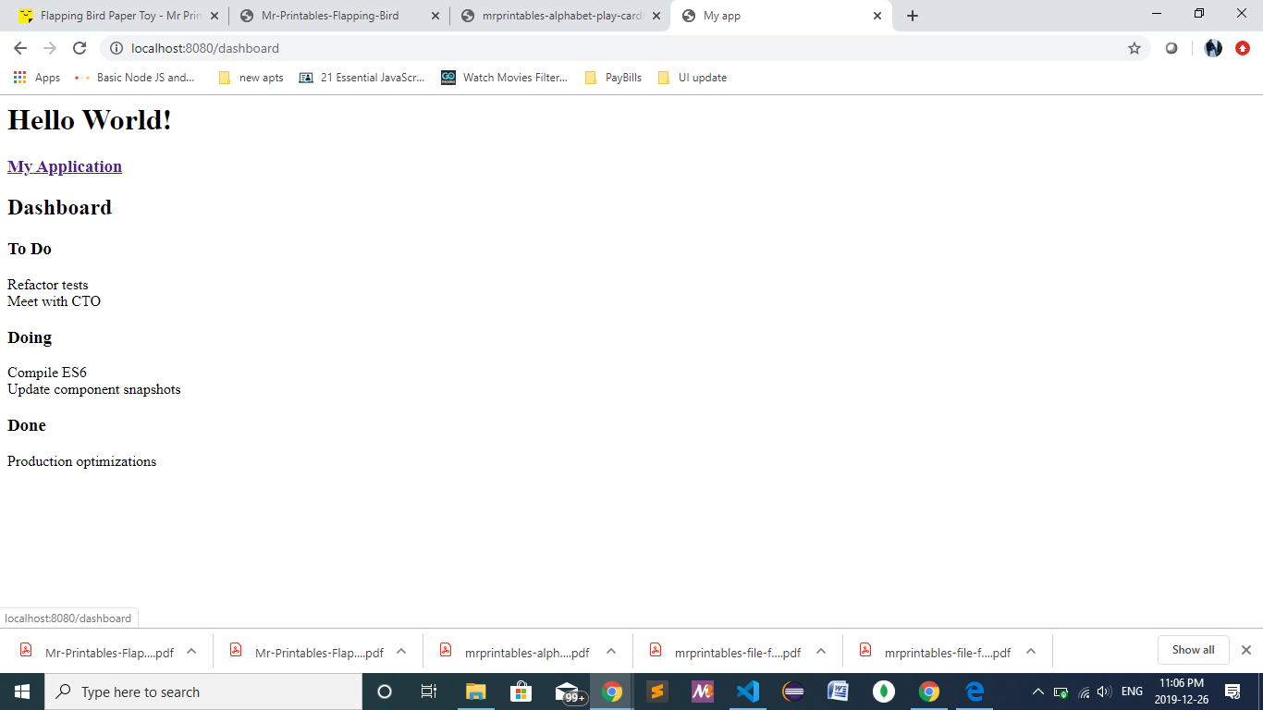

4**.4Router and navigation:**

History.js

import { createBrowserHistory } from 'history';

export const history = createBrowserHistory();

React-router-dom : {Router,Route}

Route properties:

Path

Component/render

import { Router, Route } from "react-router-dom";

 import { history } from "../store/history";

<Router history={history}>

    <Provider store={store}>

      <div>

        <ConnectedNavigation />

        <Route exact path="/dashboard" render={() => <ConnectedDashboard />} />

      </div>

    </Provider>

  </Router>

Link:

React-router-dom

Similar to <a>

Properies:

To

import { Link } from "react-router-dom";

<Link to="/dashboard">

    <h3>My Application</h3>

  </Link>

4.5Adding new tasks: