**CSS(Cascading Style Sheets):**

Used to attach style to structured documents.

Separate style from content of the document.

**CSS3**:

It has feature based modules.

**Implementation basics of css:**

**Inline Syntax:**

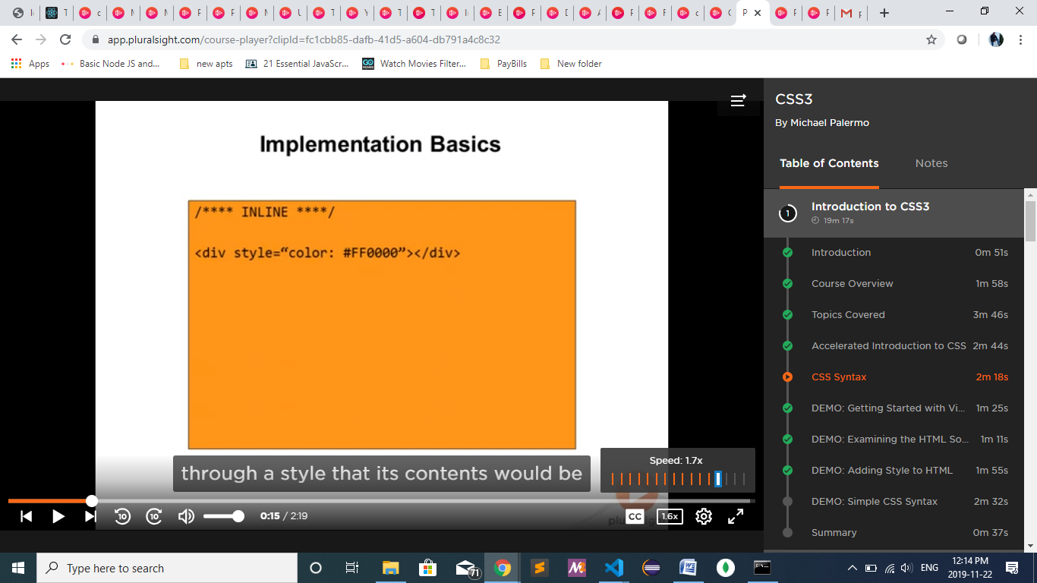

**Internal css:**

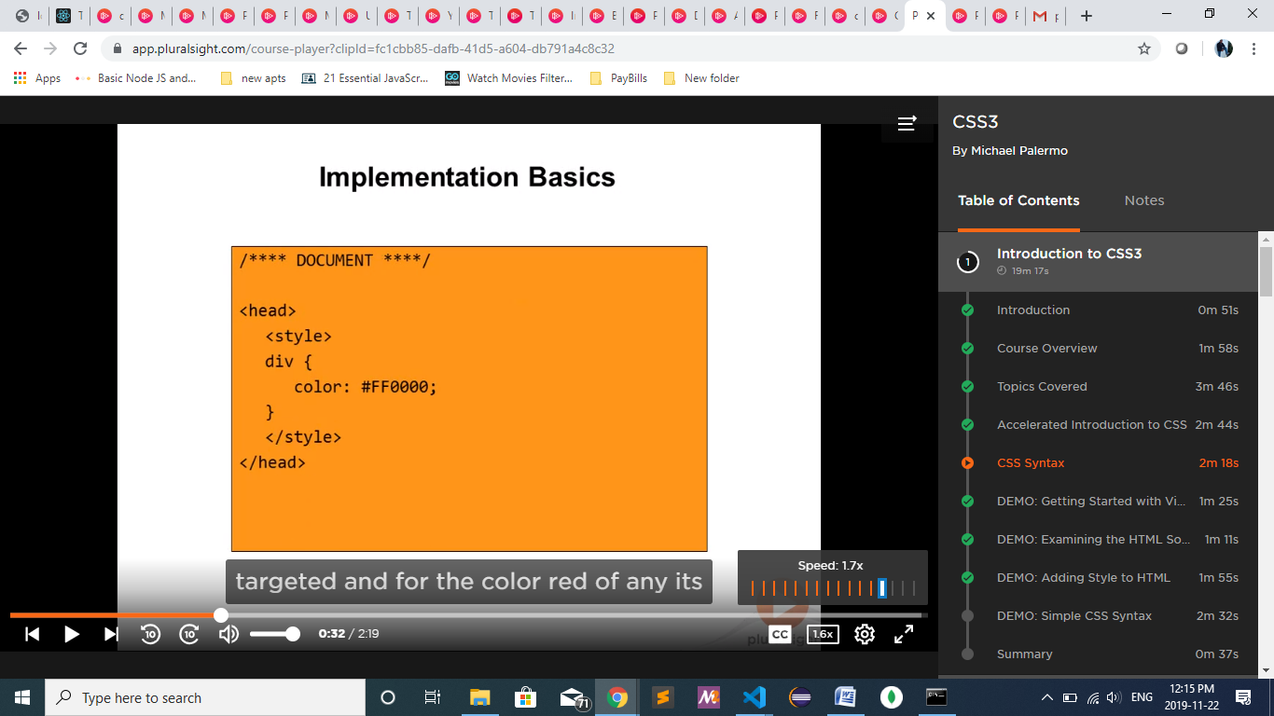

**External CSS file:**

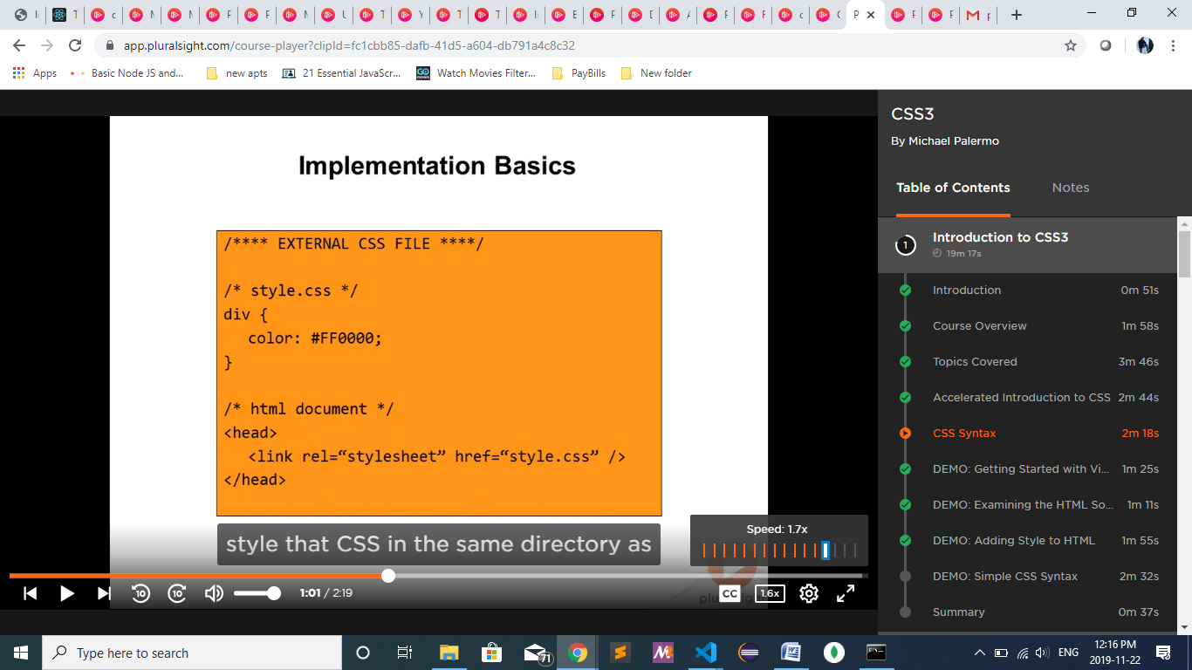

**Selectors:**

Fine tuned control over what you target for styling.

By Id:

#id{},

By class:

.classname{}

**Fonts:**

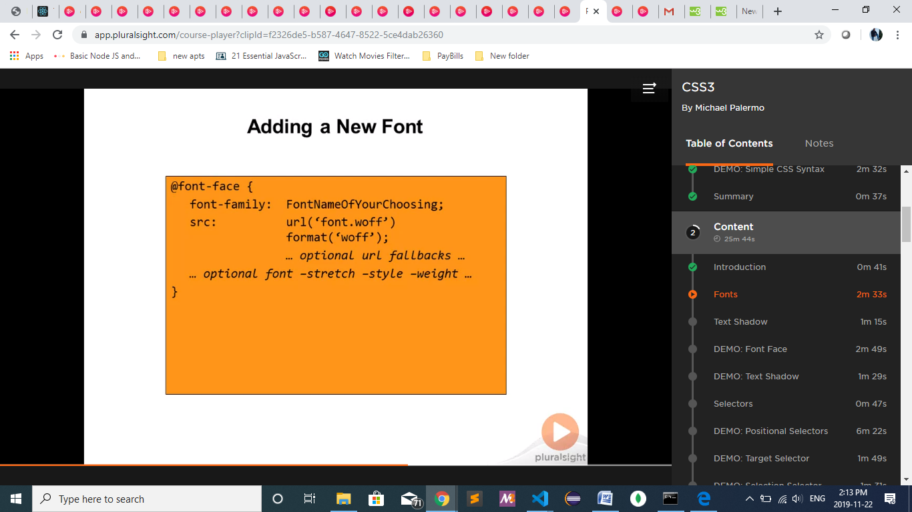

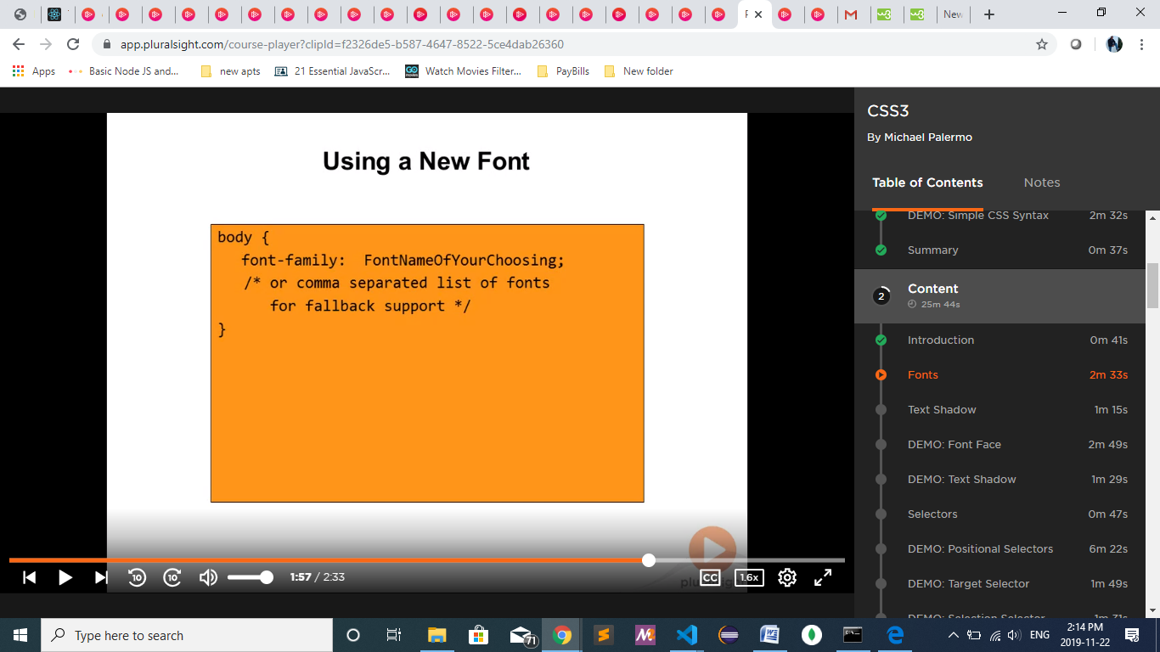

**Fonts :fontsquirrel.com**

**Text-shadow:**

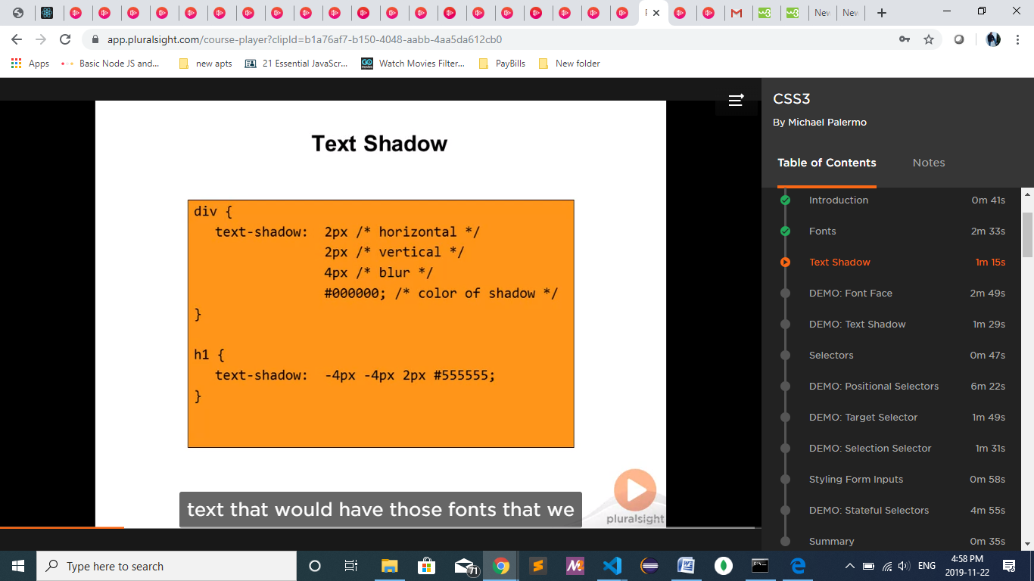

Selectors:

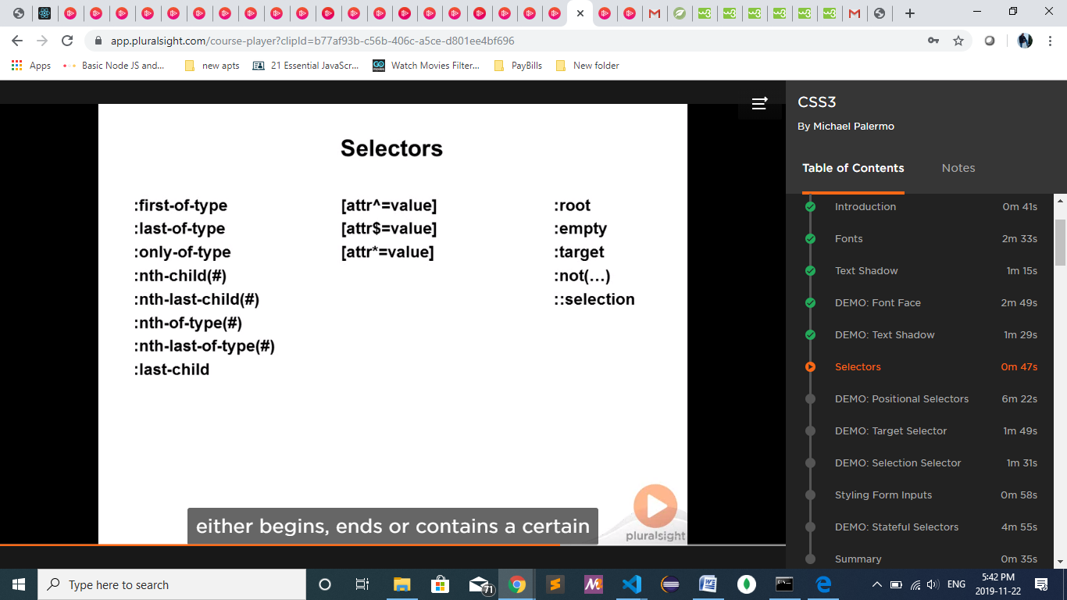

Based on its type or position/ positional selectors

Whether it starts with or ends with or contains the value

**Layout:**

Way to put all the content where you want them to go.

**Background :**

Ex: One single background with multiple images and placing the images where you exactly want them to go.

**Colors:**

Ex:transaparency, gradience , opacity

**Shadowing:**

Providing depth to what you present.

**Borders:**

Ex:round the borders , boxed borders

**Transformation:**

When you need to tweak things the way you like it.

Ex: rotate , skew or scale any element on page

**Animations:**

**Media Queries:**

Change the styles based on the device or ambient container or screen size.

**Scripting:**

To work in multiple browsers.