NAME: RAGAVI V REG NO: 192511212
COURSE NAME: JAVA COURSE CODE: CSA0924

CO2-AT1

1. A customer database needs to return the top five highest-value customers from an ArrayList. Propose an algorithm using collection utilities and explain whether sorting the original list is acceptable. [Collection Algorithms]

AIM:
To develop a Java program that uses an ArrayList and Collections.sort() to identify and display the top five highest-value customers.

PSEUDOCODE:
START
Create an ArrayList of customers
Input number of customers (N)
FOR each customer
Input name
Input value
Add customer to ArrayList
END FOR
Sort ArrayList in descending order of customer value
FOR first 5 customers (or N if N < 5)
Display name and value
END FOR
STOP

CODE:
import java.util.*;

class Customer {
String name;
double value;

Customer(String name, double value) {
this.name = name;
this.value = value;
}
}

public class Main {
public static void main(String[] args) {
Scanner sc = new Scanner(System.in);

ArrayList<Customer> customers = new ArrayList<>();

System.out.print("Enter number of customers: ");
int n = sc.nextInt();
sc.nextLine();

for (int i = 0; i < n; i++) {
System.out.print("Enter customer name: ");
String name = sc.nextLine();

System.out.print("Enter customer value: ");
double value = sc.nextDouble();
sc.nextLine();

customers.add(new Customer(name, value));
}

Collections.sort(customers, (c1, c2) -> Double.compare(c2.value, c1.value));

System.out.println("\nTop 5 Highest-Value Customers:");

int limit = Math.min(5, customers.size());

for (int i = 0; i < limit; i++) {
Customer c = customers.get(i);
System.out.println((i + 1) + ". " + c.name + " - " + c.value);
}

sc.close();
}
}

INPUT:
Enter number of customers: 6
Enter customer name: Alice
Enter customer value: 4500
Enter customer name: Bob
Enter customer value: 7000
Enter customer name: Charlie
Enter customer value: 6000
Enter customer name: David
Enter customer value: 9000
Enter customer name: Eva
Enter customer value: 8000
Enter customer name: Frank
Enter customer value: 5000

OUTPUT:

Top 5 Highest-Value Customers:
1. David - 9000.0
2. Eva - 8000.0
3. Bob - 7000.0
4. Charlie - 6000.0
5. Frank - 5000.0

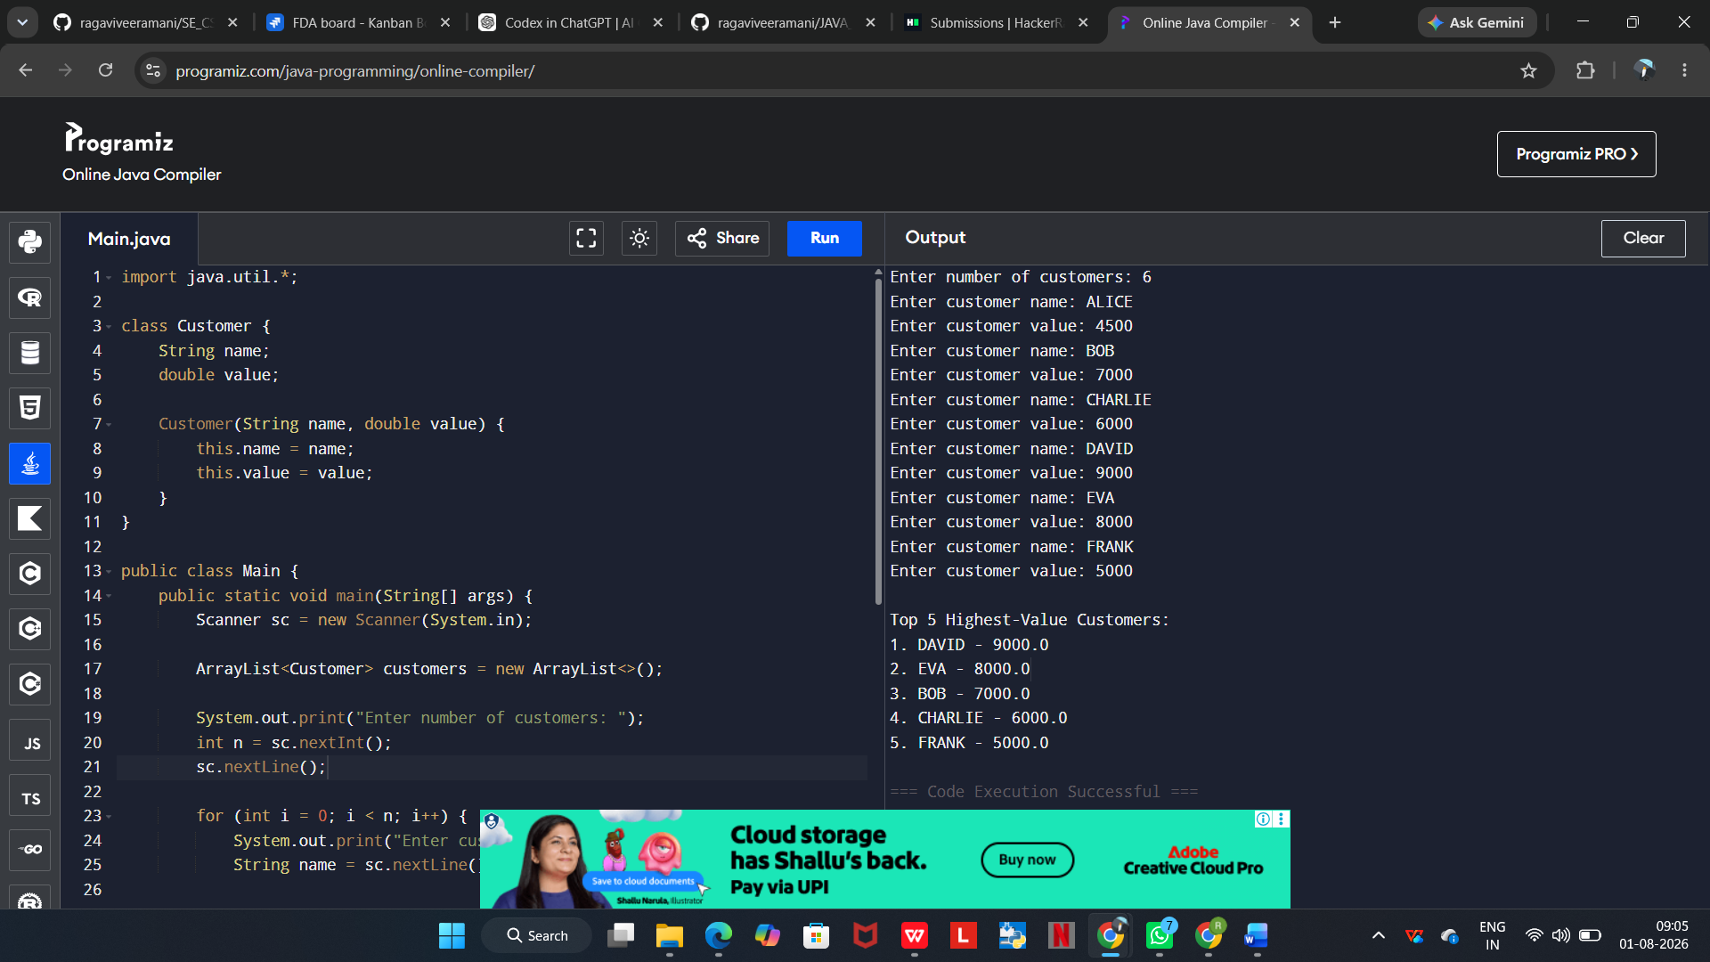
EXECUTED PROGRAM:
