Step 1

#Installed Docker desktop and ran docker engine and checked the version

Created a Docker hub account and pulled image from the hub.

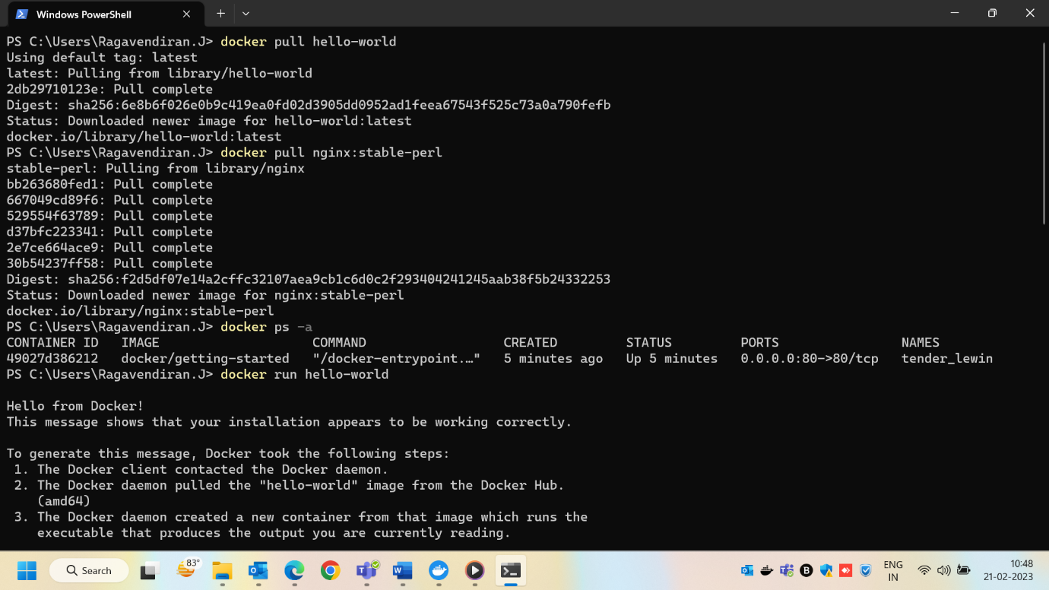

Ran Hello-world container and listed the containers.

