Auto Ticket Classification using FLOW
DESIGNER
Phase 1: Brainstorming & Ideation Phase

Introduction
The Auto Ticket Classification project aims to design an automated solution for categorizing support or service tickets using FLOW DESIGNER. The system is intended to reduce manual classification effort, improve routing accuracy, and help teams respond to tickets more efficiently. During Phase 1, the team focuses on understanding the problem, identifying users and challenges, brainstorming possible solutions, and defining the initial project direction.

Problem Statement
In many organizations, incoming support tickets are manually reviewed and assigned to categories or responsible teams. This process can consume time, create inconsistent classifications, and delay ticket resolution. A flow-based automated classification process can analyze ticket information and assign an appropriate category or destination according to predefined rules and decision logic.

Objectives
- Automate the initial classification of incoming tickets.
- Reduce the time required for manual ticket sorting.
- Improve consistency in ticket categorization and routing.
- Create a clear FLOW DESIGNER process that can be understood and maintained by the team.
- Support faster assignment of tickets to the appropriate team or workflow.
- Provide a foundation for future improvements such as analytics, feedback, and smarterclassification.

Brainstorming & Ideation
The team brainstormed the major stages required for an automated ticket-classification workflow. The initial ideas focus on collecting ticket details, identifying relevant keywords or attributes, applying classification logic, assigning a category, routing the ticket, and recording the result for monitoring and improvement. 4.1 Key Ideas Generated
Idea | Purpose
Ticket Intake | Capture incoming ticket details such as subject, description, priority, and requester information.
Data Validation | Check whether the ticket contains sufficient information for classification.
Classification Rules | Use keywords, ticket fields, and decision rules to identify the appropriate category.
Automatic Routing | Send the classified ticket to the relevant team, queue, or workflow.
Idea | Purpose
Exception Handling | Send unclear or unmatched tickets for manual review.
Audit & Tracking | Store classification and routing outcomes for monitoring and improvement.
Figure 1. Initial ideas for the automated ticket-classification workflow

Proposed FLOW DESIGNER Concept
Step | Flow Activity | Expected Outcome
1 | Ticket received | New ticket enters the workflow.
2 | Read ticket information | Subject, description, priority, and relevant fields are available.
3 | Validate data | Required information is checked.
4 | Apply classification logic | Ticket is matched to a suitable category.
5 | Decision point | Classified / needs manual review.
6 | Route ticket | Ticket is assigned to the relevant team or queue.
7 | Record result | Classification and routing details are logged.
Figure 2. Proposed high-level FLOW DESIGNER process

Stakeholders and Users
- End users or customers who submit support tickets.
- Support agents who receive and resolve categorized tickets.
- Team leads or administrators who manage categories and routing rules.
- Process owners who monitor workflow performance and update the design.

Expected Benefits
- Faster ticket triage and assignment.
- Reduced repetitive manual work.
- More consistent categorization.
- Improved visibility of ticket-routing decisions.
- Easier maintenance through a structured flow-based design.
- A scalable base for future automation and intelligent classification.

Initial Challenges Identified
- Tickets may contain incomplete or ambiguous information.
- The same issue may be described using different words.
- Classification rules may need regular updates.
- Some tickets may not match any predefined category.
- Incorrect classification could route a ticket to the wrong team.

Phase 1 Outcome
At the end of the brainstorming and ideation phase, the team has identified the core problem, target users, major workflow stages, initial classification ideas, expected benefits, and key challenges. These findings provide the foundation for the next project phase, where the proposed flow can be designed in greater detail and translated into an implementable FLOW DESIGNER workflow.

10.Screenshots
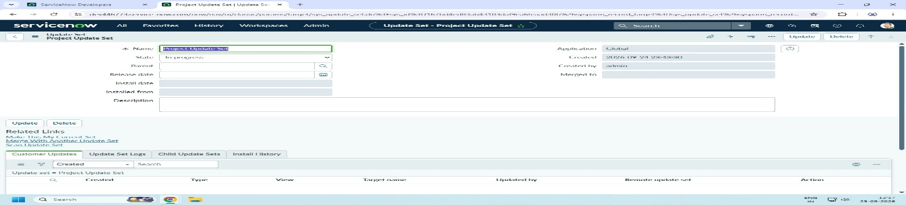
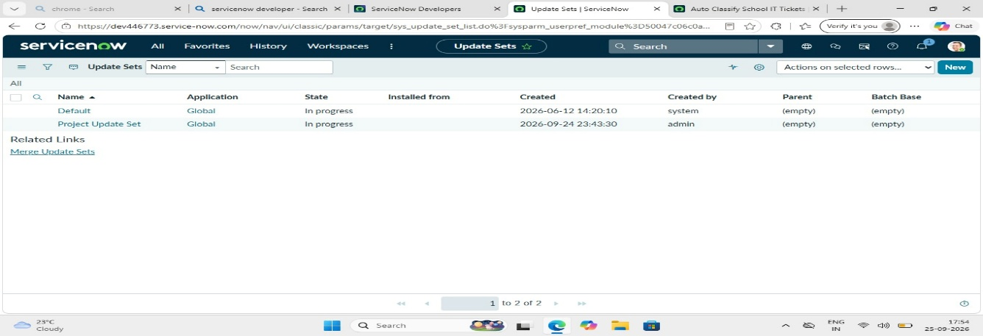

11.Conclusion
Auto Ticket Classification using FLOW DESIGNER can provide a structured approach to automating ticket categorization and routing. The Phase 1 brainstorming activity establishes a common understanding among team members and defines the initial solution concept. The next stages can build on this concept by refining classification rules, designing the workflow, testing different scenarios, and evaluating the results.

