Auto Ticket Classification using FLOW
DESIGNER
Phase 2: Requirement Analysis Phase

Introduction
Requirement Analysis is the second phase of the Auto Ticket Classification using FLOW
DESIGNER project. This phase converts the initial ideas identified during brainstorming into clear, measurable, and implementable requirements. The purpose is to understand what the system must do, who will use it, what information it needs, and what conditions it must satisfy.

Purpose of the System
The proposed system will automatically analyze incoming support tickets and classify them into predefined categories using a FLOW DESIGNER workflow. After classification, the ticket can be routed to the appropriate team or queue. Tickets that cannot be confidently classified should be directed to a manual-review process.

Stakeholder Requirements
Stakeholder | Requirement / Expectation
Ticket Submitter | Ticket should be accepted with the necessary information and receive appropriate acknowledgement
Support Agent | Tickets should arrive in the correct category or queue with relevant information visible.
Team Lead | The workflow should support consistent routing and provide useful status information.
Administrator | Classification categories and routing rules should be maintainable.
Process Owner | The workflow should support monitoring and future improvement.
Figure 1. Stakeholders and their high-level requirements

Functional Requirements
ID | Functional Requirement
FR-01 | The system shall receive a new support ticket as input.
FR-02 | The system shall read relevant ticket fields such as subject, description, priority, and other available attributes.
FR-03 | The workflow shall validate required ticket information before classification.
FR-04 | The workflow shall apply predefined classification rules or decision logic.
FR-05 | The system shall assign the ticket to an appropriate category when a valid match is found.
FR-06 | The system shall route the classified ticket to the appropriate team or queue.
FR-07 | The system shall identify tickets that cannot be classified automatically.
ID | Functional Requirement
FR-08 | Unclassified or ambiguous tickets shall be routed for manual review.
FR-09 | The workflow shall record the classification and routing outcome.
FR-10 | The workflow shall support error handling when required data or processing steps fail.
Figure 2. Functional requirements of the proposed system

Non-Functional Requirements
Category | Requirement
Performance | The workflow should process tickets within an acceptable time for normal operational use.
Reliability | The workflow should handle failures without losing important ticket information.
Usability | The flow should be clear and understandable for administrators and support teams.
Maintainability | Classification and routing rules should be easy to review and update.
Scalability | The design should allow additional ticket categories and rules to be added.
Security | Ticket information should be handled according to organizational access and data-protection requirem
Auditability | Important classification and routing actions should be traceable.
Figure 3. Non-functional requirements

Input Requirements
- Ticket subject or title.
- Ticket description or issue details.
- Priority or urgency, when available.
- Requester or source information, where required.
- Existing category, service, product, or issue-related fields, when available.

Output Requirements
- Assigned ticket category.
- Routing destination such as team or queue.
- Classification status such as Classified or Manual Review.
- Processing or classification result for tracking.
- Error or exception information when processing cannot be completed.

Classification Rules – Initial Requirement
The first version of the workflow can use rule-based classification. Keywords and ticket attributes may be mapped to predefined categories. For example, tickets containing terms related to password access can be assigned to an account or access category, while tickets describing a system outage can be assigned to a technical-support category. The actual categories and keywords should be finalized with the project stakeholders before implementation.

Exception and Manual Review Requirements
- If mandatory ticket information is missing, the workflow should flag the ticket for correction ormanual handling.
- If multiple categories match with no clear decision, the ticket should be sent for manual review.
- If no classification rule matches the ticket, it should be routed to a predefined fallback queue.
- Workflow errors should be recorded so that administrators can investigate and correct them.

Assumptions and Constraints
- Ticket data is available to the workflow through the selected ticketing system or integration.
- Initial categories and routing destinations are defined by the project team or process owner.
- Users have appropriate permissions to submit, view, classify, and route tickets.
- The accuracy of rule-based classification depends on the quality and completeness of ticketinformation.
- The first release may require periodic review and refinement of classification rules.

Requirement Traceability – Initial View
Requirement Area | FLOW DESIGNER Activity | Expected Result
Ticket Intake | Trigger / input handling | New ticket enters the workflow.
Validation | Condition / decision | Required information is checked.
Classification | Rules / decision logic | Category is identified.
Routing | Assignment / action | Ticket reaches the correct queue.
Exception | Fallback branch | Ambiguous tickets go to manual review.
Audit | Record / update action | Result can be tracked.
Figure 4. Initial requirement-to-workflow traceability

Acceptance Criteria
- A valid ticket can enter the workflow successfully.
- Required ticket information is checked before classification.
- A ticket matching a defined rule receives the expected category.
- A classified ticket is routed to the configured destination.
- An unmatched or ambiguous ticket follows the manual-review path.
- The workflow records the classification and routing outcome.
- Errors are handled without silently losing the ticket.

Phase 2 Outcome
The Requirement Analysis Phase establishes the functional and non-functional requirements for Auto Ticket Classification using FLOW DESIGNER. It defines the expected inputs, outputs, classification behavior, routing process, exception handling, stakeholder needs, and acceptance criteria. These requirements provide a structured baseline for the next phase, where the detailed workflow design and implementation approach can be developed.

14.Screenshots

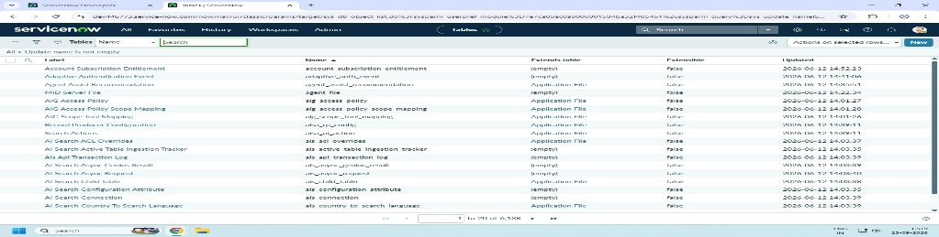
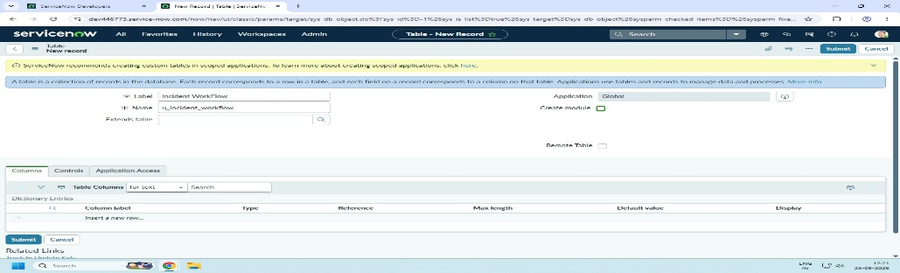
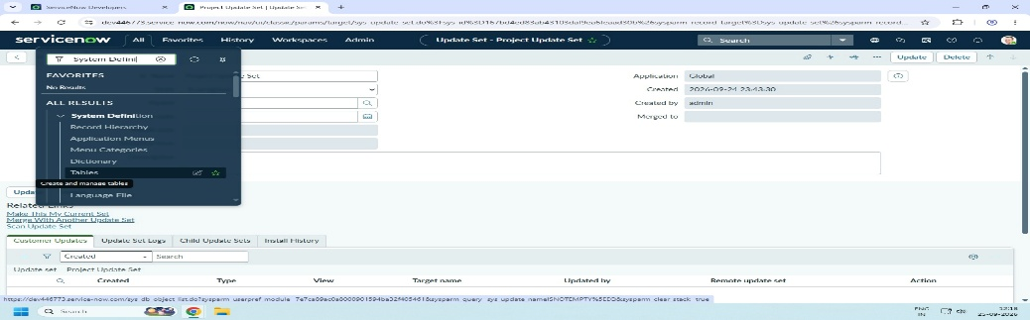
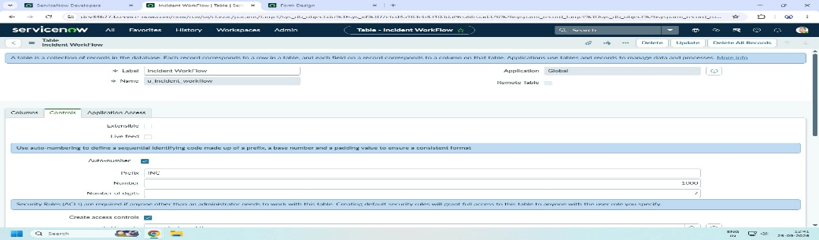
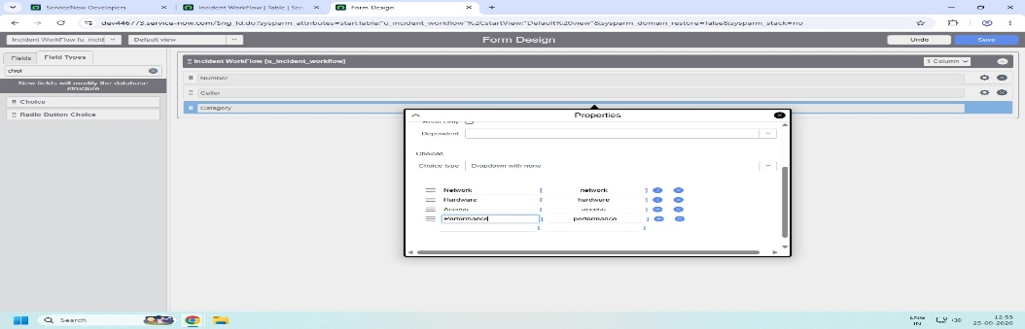
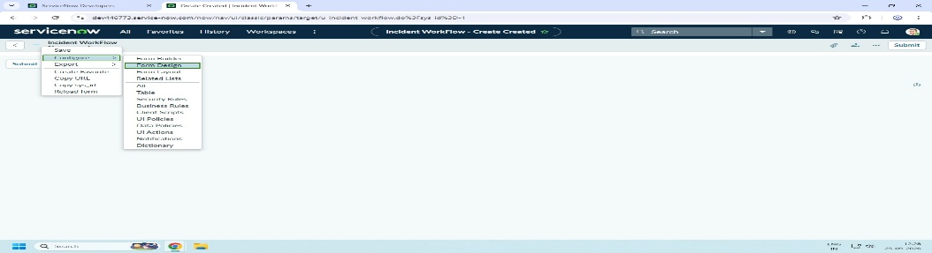
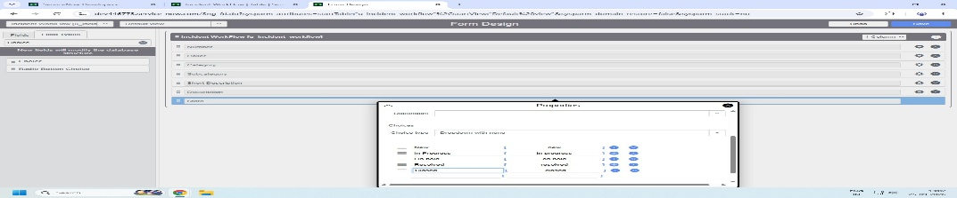
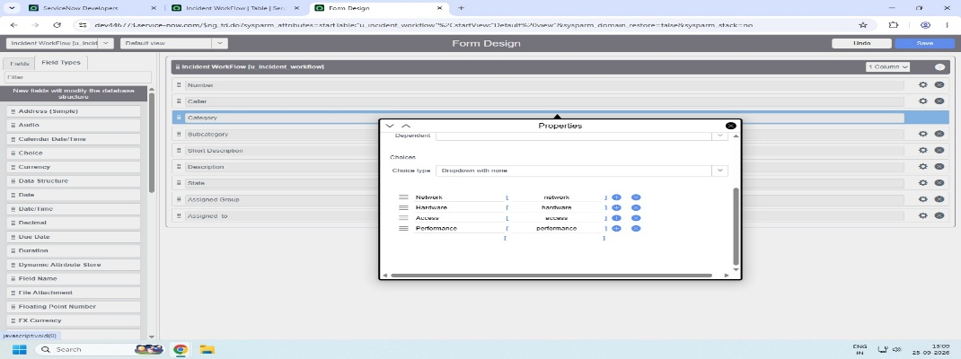
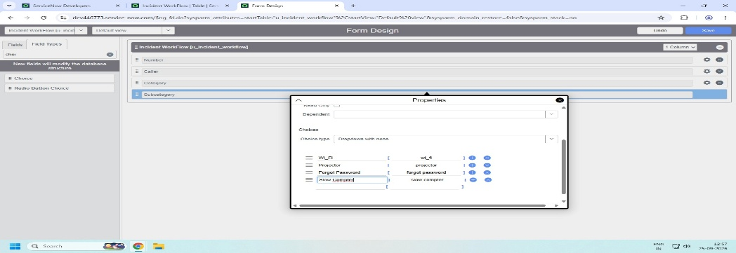
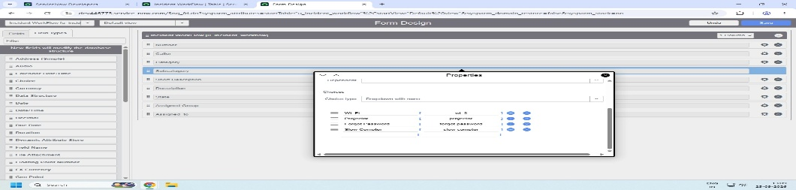

15.Conclusion
A clear requirement specification is essential for building a reliable automated ticket-classification workflow. By defining what the system should do before implementation, the project team can reduce ambiguity, align stakeholder expectations, and create a workflow that is easier to test and maintain.

