

Department of Systemics

School Of Computer Science

UNIVERSITY OF PETROLEUM & ENERGY STUDIES,

Dehradun, Uttarakhand - 248007

Name- Raghav Goyal

SAP ID- 500086815

Roll No.- R2142201713

Batch- B3 (CCVT) [Non-Hons.]

Subject- Cloud Application Development

Submitted To- Mr. Saurabh Shanu

**Github link-** [ragha1v (github.com)](https://github.com/ragha1v) (code to be deployed of application)

**Problem Statement-** Design an E-voting system on a public cloud and describe the need of the public cloud for its deployment of it.

**Language on which application is based?**

Application will be based on the web language so, it can be integrated with the public cloud. Application will be based public cloud which will require different setups like gateways, vpn so, it can be a pre-requisite for the deployment of our application on public cloud which will be accessible by all the users so, web based language will be best suited as per needs.Till it is to be made on python(web or tkinter).

**Literature Review-**

What about Online voting system I could understand is about the application that is to be made consists of different users who want to vote and that requires all over functunalities to be deployed on the cloud so, that all the users could take benefit of the application deployed upon AWS based on the gui framework. It requires all the people to connect for a period of time to vote. It will require cloud deployment also due to various factors like scalability, flexibility to work and cost saving etc factors as discussed below about the necessity to deploy our appn to cloud.

**About my understanding of the application to be deployed?**

Designing the e-voting system which consists of many forms with different functionalities of voting in the country. As, many polling crimes are reported these days about the force voting, not much awareness about the voting and the outcomes which can lead to harness in the whole country. So, we will be desigining an application to solve all these issues. It will be consisting of two functionalities i.e : 1. user 2. Admin Users profiles will be access to all the public for the common voting accessed and voted for the respective representative they want to choose. The Application will be consisting of different functionalities like creating an account for voting, if already registered one functionality will provide them with the voting rights, an info page which will guide them all about how to vote as many users are not aware of the concept of online or voting for the first time so they will not be much aware about the party choosing. So to clarify about the rules and regulations of that application that page will work that will also be accessible to all of the users so that they can gain knowledge about all the related info’s. Admin protal will be giving the admin functionality of to access about the management process of application and the database storage like to manage the user’s if voilated any of the action can be removed or the rights of him can be restricted from voting. Then the application will be having a security mecahnisms which will help the application to be more secure.

**Need of application to be deployed on the cloud?**

The application has some functunalities which needs to be on public cloud like on public cloud because it needs to be accessible to all the user’s for their voting and polling rights that’s why all user’s functunalities need to be deployed on the public cloud as mentioned in the description of the application mentioned there are two functunalities the application will be having one id the user actions i.e motive is to vote for a party they want it needs to be deployed on the public cloud as it will be accessible to all the users who want’s to vote, other which requires to be on the public cloud is of user profile i.e an internal organization or a group of some people will be handling all the management process of the application database and releasing the polling results that can be accessible to all users and users can be able to see the result. Public cloud can be best suited for our application that we are thinking to deploy on public cloud as all the functionalities required are satisified by the public cloud for the process we are inheriting to implement upon. Cost to implement, Scaling, Flexibility could be also the factors that could help us satify our requirements as once at a time users could be more for the voting then ehat we expected to have the traffic so, scalability could all manage that issues. Rest apis could be used for the allow of public cloud to your web application so, all users could access it and poll for the right one.

**Requirements Analysis**

Deployment of application could be possible through the EC2 instances, git etc services or tools which could possibly be the best option for the deployment of it to a public cloud.

AWS Amplify could help them with the manual deployment of code if we have to do it with git provider, GitHub.

**Flow Chart**

It depicts the flow of process how we will procees the project including what services, timelines(pert chart) and the flow of moving ahead in the project.

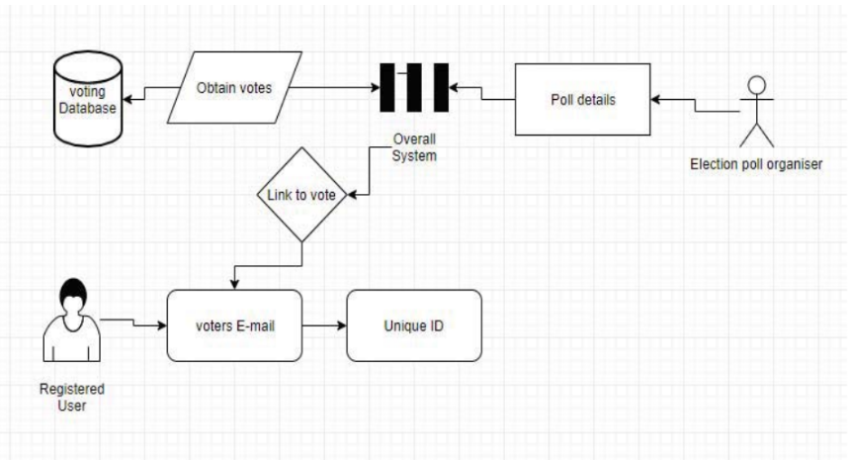

**Pert chart-**

|  |  |  |  |  |  |  |  |  |  |  |  |  |
| --- | --- | --- | --- | --- | --- | --- | --- | --- | --- | --- | --- | --- |
| Planning | **STUDY PERIOD**   |  |  | | --- | --- | | 001 | 2 DAYS | | 26-January 2022 | 3-February 2022 | | **REQUIREMENTS GATHERING**   |  |  | | --- | --- | | 002 | 2 DAYS | | 4- February 2022 | 10- February 2022 | |  |  |
| Design |  | **DESIGN**   |  |  | | --- | --- | | 003 | 1 DAY | | 12- February 2022 | 22- February 2022 | |  |  |
| Development  &  Testing |  | **CODING &**  **IMPLEMENTATION**   |  |  | | --- | --- | | 004 | 13 DAYS | | 23-February 2022 | 15-March-2022 | | **TESTING**   |  |  | | --- | --- | | 005 | 8 DAYS | | 16- March 2022 | 25- March 2022 | | **DEBUGGING**   |  |  | | --- | --- | | 006 | 10 DAY | | 26- March 2022 | 1- April 2022 | |
| Documentation |  |  |  | **REPORT MAKING**   |  |  | | --- | --- | | 007 | 1 DAY | | 2- April -2022 | 5- April 2022 | |