
Faculty of Engineering & Technology
Electrical & Computer Engineering Department
Machine Learning & Data Science
ENCS5341
Data Preprocessing & Exploratory Data Analysis Report

Prepared by:
Raghad Jamhour 1220212
Layal Hajji 1220871

Instructor: Yazan Abu Farha

Section: 2
Table of Contents
Introduction 3
Data Loading and Initial Inspection 3
Handling Missing Data 3
Handling Outliers 3
Feature Scaling 3
Exploratory Data Analysis (EDA) 3
Univariate Analysis 3
Bivariate Analysis 3
Correlation Analysis: 3
Data Visualizations 3
Conclusion 3

Table of Figures
Figure 1: Histogram of income 9
Figure 2: Histogram of SupportCalls 9
Figure 3: Histogram of Age 10
Figure 4: Histogram of Tenure 10
Figure 5: Bar Plot of ProductType 11
Figure 6: Bar Plot of ChurnStatus 12
Figure 7: Bar Plot of Gender 12
Figure 8: SuppotCalls vs ChurnStatus 14
Figure 9: Tenure vs ChurnStatus 14
Figure 10: Income ve ChurnStatus 15
Figure 11: Age vs ChurnStatus 16
Figure 12: Gender vs ChurnStatus 17
Figure 13: ProductType vs ChurnStatus 18
Figure 14: Correlation Matrix 19
Figure 15: Churn Status by Income Range 20
Figure 16: Churn Status by Product Type 21
Figure 17: Churn Status by Tenure Range 22

Introduction

This report focuses on analyzing a synthetic customer dataset to understand factors influencing customer churn. The dataset contains customer demographics, product subscriptions, usage patterns, and churn status. To prepare the data for analysis, preprocessing steps such as handling missing values, detecting outliers, and scaling numerical features are applied. Exploratory data analysis (EDA) is then performed to reveal patterns, relationships, and insights that can help predict churn and improve customer retention strategies.

Data Loading and Initial Inspection

The dataset was loaded into a pandas DataFrame from a CSV file. The first five rows of the dataset were inspected to get an overview of the data structure, including both numeric and categorical features. This preview allows us to understand the types of data present and check for obvious inconsistencies.

General information about the dataset was obtained using .info(), which confirmed the number of rows and columns, data types of each feature, and the presence of missing values. Summary statistics generated via .describe() provided insights into the numeric features such as Age, Income, Tenure, and SupportCalls, showing their mean, median, standard deviation, and range.
This initial inspection helps to identify potential issues such as skewed distributions, extreme values, or missing entries that need to be addressed in the preprocessing steps. It also sets the foundation for further analysis and visualization of the dataset.

Handling Missing Data

Initial inspection revealed that several numeric columns contained missing values:
Age: 175 missing entries
Income: 172 missing entries
Tenure: 175 missing entries
SupportCalls: 171 missing entries
To address missing values, the median of each column was used for imputation. The median was chosen over the mean or mode because it is robust to outliers and better represents the typical value of a feature when the distribution is skewed. For instance, Income and SupportCalls had a notable number of outliers (70 each). Using the mean could have been influenced by these extreme values, producing unrealistic imputations. Age and Tenure, despite having no outliers, still had many missing values, median imputation ensures that central tendencies are preserved without introducing bias from skewed distributions.
Deletion of rows with missing values was not used, as it would have resulted in the removal of a large portion of the dataset (over 170 missing values in some columns). This would significantly reduce the dataset size, potentially discarding valuable information and weakening the analysis. Median imputation allows us to retain all observations while maintaining data integrity.
After applying median imputation, all missing values were resolved, preparing the dataset for further preprocessing steps and exploratory analysis. This approach ensures that subsequent analyses are reliable and not distorted by missing or extreme values.

Handling Outliers

Outliers in the numeric columns were identified using the Interquartile Range (IQR) method. The IQR method calculates the first quartile (Q1) and third quartile (Q3) for each feature, then determines values that fall below Q1 - 1.5*IQR or above Q3 + 1.5*IQR as outliers.
Using this approach, the outlier counts in the dataset were as follows:
Age: 0 outliers
Income: 70 outliers
Tenure: 0 outliers
SupportCalls: 70 outliers
To reduce the influence of these extreme values without removing any data points, IQR capping was applied. Values below the lower bound were set to the lower bound, and values above the upper bound were capped at the upper bound. This method maintains the overall data distribution while minimizing the effect of extreme observations, which is especially important for features like Income and SupportCalls, where extreme values could skew analysis or modeling.
After handling outliers, boxplots were generated to visually confirm that extreme values were properly adjusted, ensuring the dataset is clean and suitable for further analysis.

Feature Scaling

To ensure that numeric features are comparable and suitable for analysis, feature scaling was applied to the numeric columns: Age, Income, Tenure, and SupportCalls.
Z-score standardization (using StandardScaler) was used, which transforms each feature to have a mean of 0 and a standard deviation of 1. This method was chosen because it is robust to outliers that have already been capped and preserves the shape of the original distributions while bringing all features onto a common scale.
Scaling is particularly important for this project because some features, such as Income and SupportCalls, have values on very different scales. Without scaling, features with larger numeric ranges could dominate distance-based relationships or model learning, leading to biased results. Z-score standardization ensures that each feature contributes equally to the analysis and predictive modeling, making it the most appropriate choice for comparing features and detecting patterns related to customer churn.
After standardization, histograms confirmed that the distributions of the numeric features remained consistent while the values were normalized, ensuring the dataset is ready for exploratory data analysis (EDA) and subsequent machine learning tasks.

Exploratory Data Analysis (EDA)

Univariate Analysis
In this step, the distribution of both numerical and categorical variables was examined to understand the general characteristics of the dataset.
For the numerical features such as Age, Income, Tenure, and SupportCalls histograms were used to visualize their frequency distributions. These plots helped identify how the data is spread, detect any skewness, and confirm that the feature scaling process standardized their ranges appropriately.
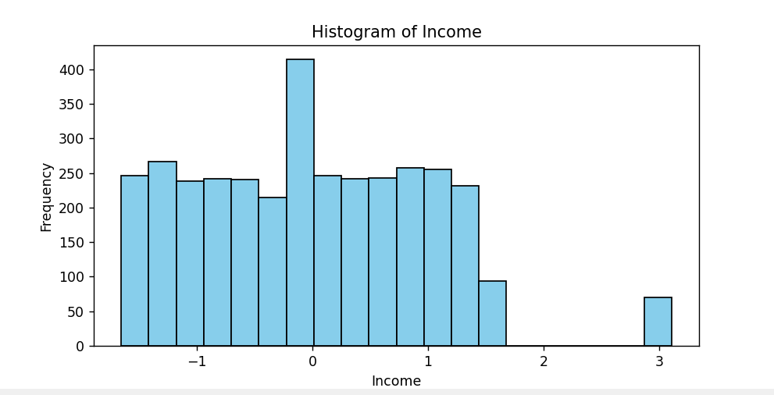
Figure 1: Histogram of income

The Income distribution looks fairly spread out but slightly concentrated around the center. Most values are near the mean (around 0), with fewer at the extremes. Since the feature was standardized after capping outliers, there are no extreme spikes, and the range is consistent
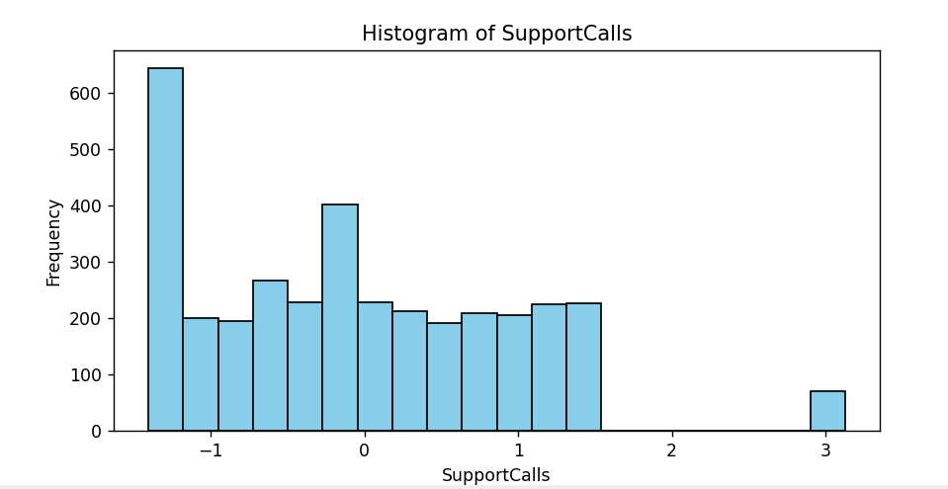
Figure 2: Histogram of SupportCalls
SupportCalls shows a noticeable skew toward lower values meaning most customers made relatively few support calls. The distribution slowly decreases as the number of calls increases.
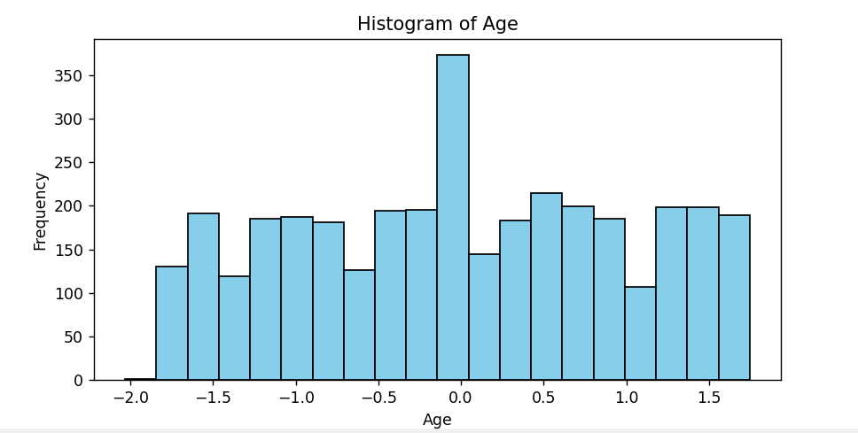
Figure 3: Histogram of Age
The Age feature is evenly distributed, with most values clustered near the middle and balanced across the range.
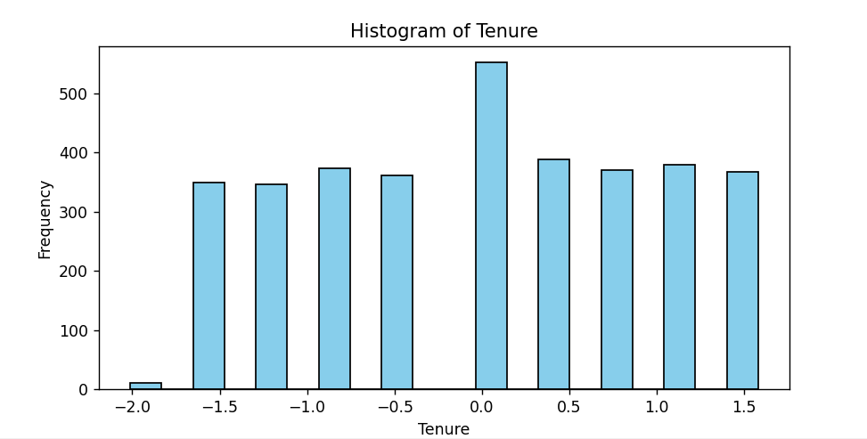
Figure 4: Histogram of Tenure
Tenure is fairly uniform but with a mild peak near the center. This suggests that many customers fall around an average tenure, while fewer are at the shorter or longer ends.

For the categorical variables such as Gender, ProductType, and ChurnStatus. Bar plots were used to show how often each category appeared in the dataset. This allowed us to see whether one category was more common than others (for example, if there were more males than females, or if most customers used the Basic product type). It also showed the overall proportion of customers who churned compared to those who stayed.

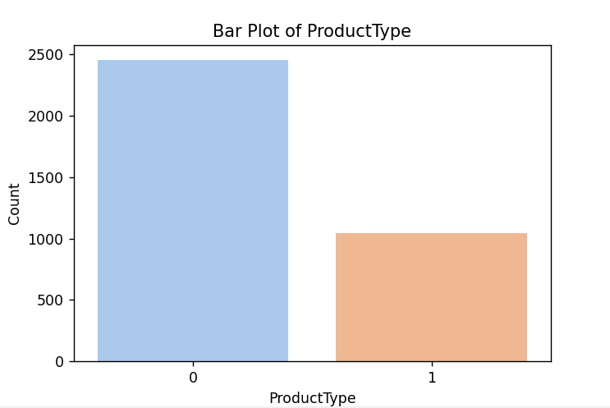
Figure 5: Bar Plot of ProductType
The ProductType distribution shows that category 0 has a noticeably higher count than category 1. This suggests that the basic subscription is more common among customers than the premium one, which may influence churn or engagement patterns later in the analysis.
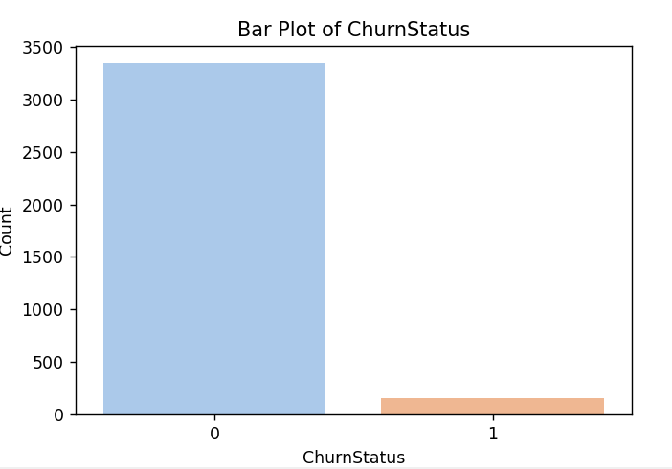
Figure 6: Bar Plot of ChurnStatus
The ChurnStatus variable is highly imbalanced the majority of customers did not churn (0), while only a small portion did (1).
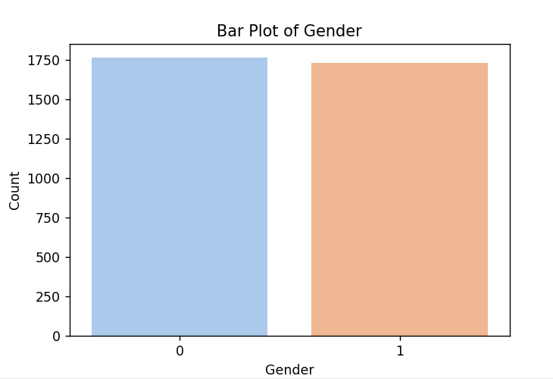
Figure 7: Bar Plot of Gender
The Gender variable is nearly balanced, with both categories (0 and 1) having similar counts. This indicates that the dataset has an almost equal representation of both genders, minimizing potential bias related to gender imbalance.

Overall, the univariate analysis provided a clear understanding of the data’s composition and distribution before exploring relationships between variables.

Bivariate Analysis
To explore relationships between numerical features and the target variable (ChurnStatus), box plots were used. These plots display how the distributions of Age, Income, Tenure, and SupportCalls differ between customers who churned and those who did not. The box plots helped identify whether certain numerical characteristics are associated with higher churn likelihood.
Even after removing outliers using the IQR method, a few still appear in the box plot. This happens because the data was later standardized, which slightly changed its scale and spread. When the box plot is drawn, it recalculates the quartiles and whisker limits based on the standardized values, so some points that were previously within range now fall outside the new boundaries. These points are not actual errors, they simply appear as mild outliers due to the changes in data distribution after standardization.
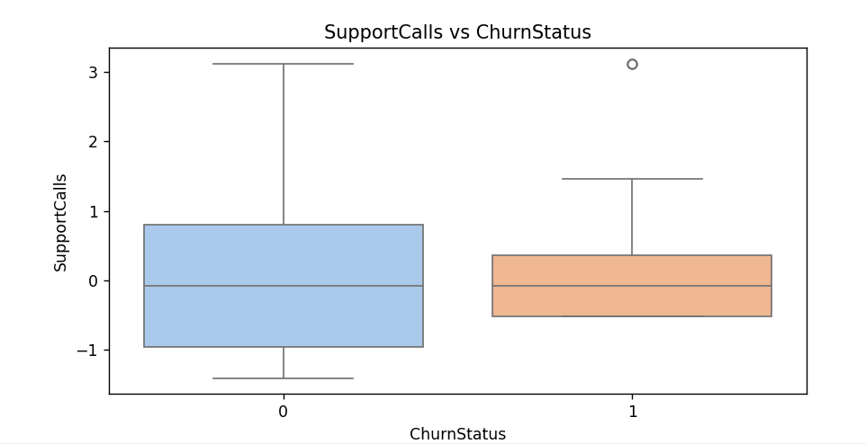
Figure 8: SuppotCalls vs ChurnStatus
The box plot shows that the median number of support calls is identical for both churned and non-churned customers. This indicates that support call frequency does not have an apparent influence on churn. The slight variation in spread suggests minor differences in call behavior, but overall, the number of support calls made by customers seems unrelated to whether they stay or leave.
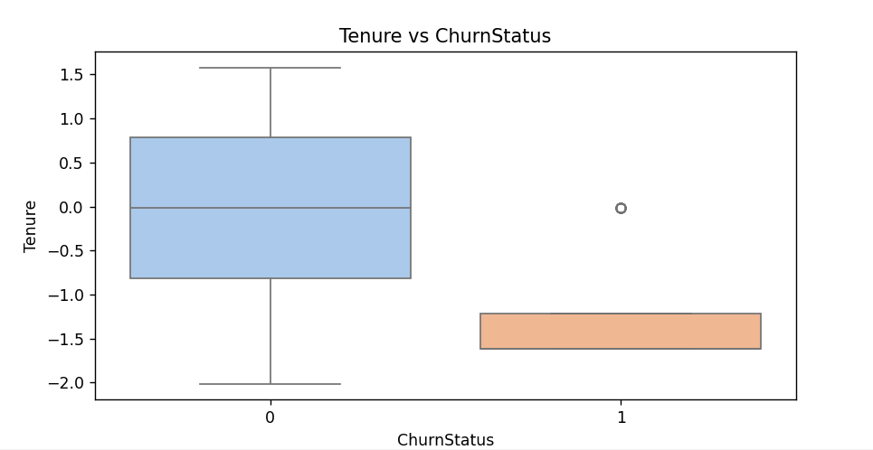
Figure 9: Tenure vs ChurnStatus

In this plot, churned customers have a noticeably lower median tenure, with their box concentrated near smaller values. The wider range and higher median of the stayed group indicate that customers who have been with the company longer are less likely to churn. Thus, tenure shows a clear negative relationship with churn.

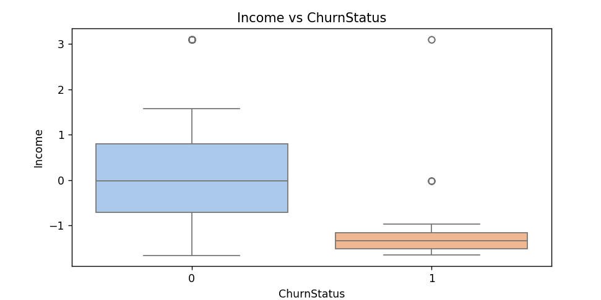
Figure 10: Income ve ChurnStatus
The median income for churned customers is lower than that of those who stayed, as seen from the lower placement of the orange box. The stayed group’s distribution extends to higher values, meaning that higher-income customers are more likely to remain.
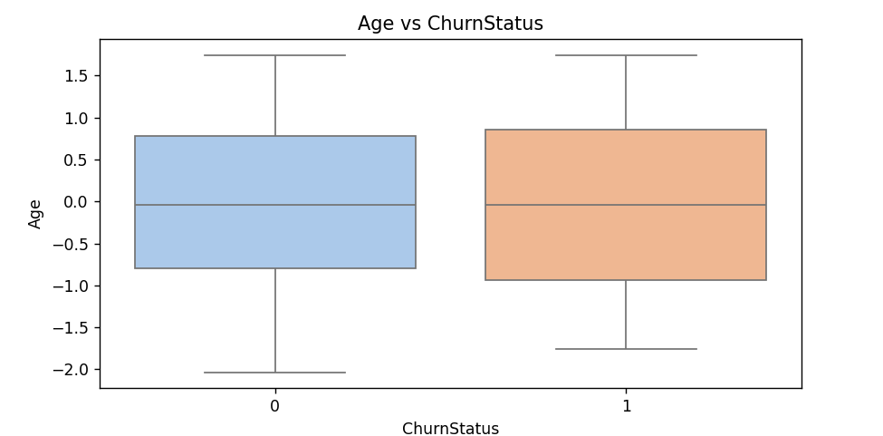
Figure 11: Age vs ChurnStatus
Both groups have nearly identical medians and overlapping interquartile ranges. This similarity indicates that there is no significant difference in age between churned and non-churned customers. Therefore, age does not appear to influence churn behavior.
For categorical variables (Gender and ProductType), bar plots were created with ChurnStatus represented by color categories. These visualizations provided insight into how churn rates vary across different groups. They allowed for an easy comparison of proportions between churned and non-churned customers within each category, helping identify possible categorical factors related to churn tendencies.
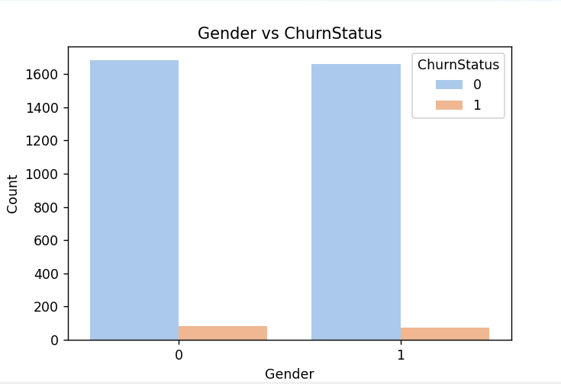
Figure 12: Gender vs ChurnStatus
The bar heights for both genders are almost equal, showing little variation between male and female customers. This means that gender has no clear impact on churn, as the proportion of churned customers is nearly the same across both categories.

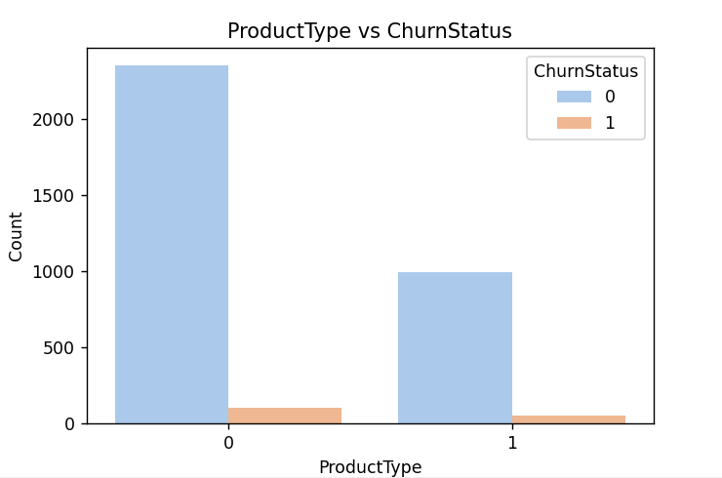
Figure 13: ProductType vs ChurnStatus

The bar plot shows that the churn bar is noticeably larger for Basic (0) customers compared to Premium (1) customers. This indicates that a higher proportion of Basic subscribers tend to leave the service, while Premium users are more likely to stay. Although the number of non-churned Basic customers appears high, this is mainly because the total number of Basic subscribers is much larger than that of Premium users. When considering proportions, Basic customers show a higher churn rate overall, suggesting that Premium plans help improve customer retention.

Correlation Analysis
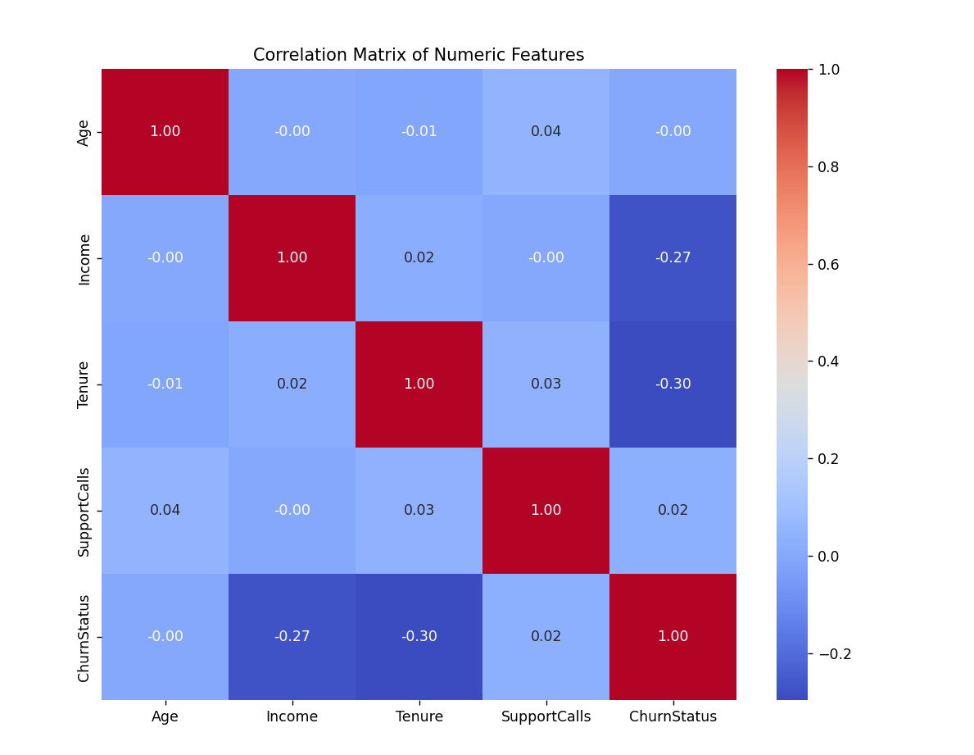
Figure 14: Correlation Matrix

The Figure displays a correlation heatmap illustrating the relationships between numerical variables and the target variable (ChurnStatus). The matrix shows that Income and Tenure have a weak negative correlation with churn (-0.27 and -0.30 respectively), suggesting that customers with higher income or longer tenure are less likely to churn. Other features such as Age and SupportCalls show almost no correlation with churn, indicating minimal influence. Overall, this visualization helps confirm which numerical attributes are most related to customer retention.

Data Visualizations

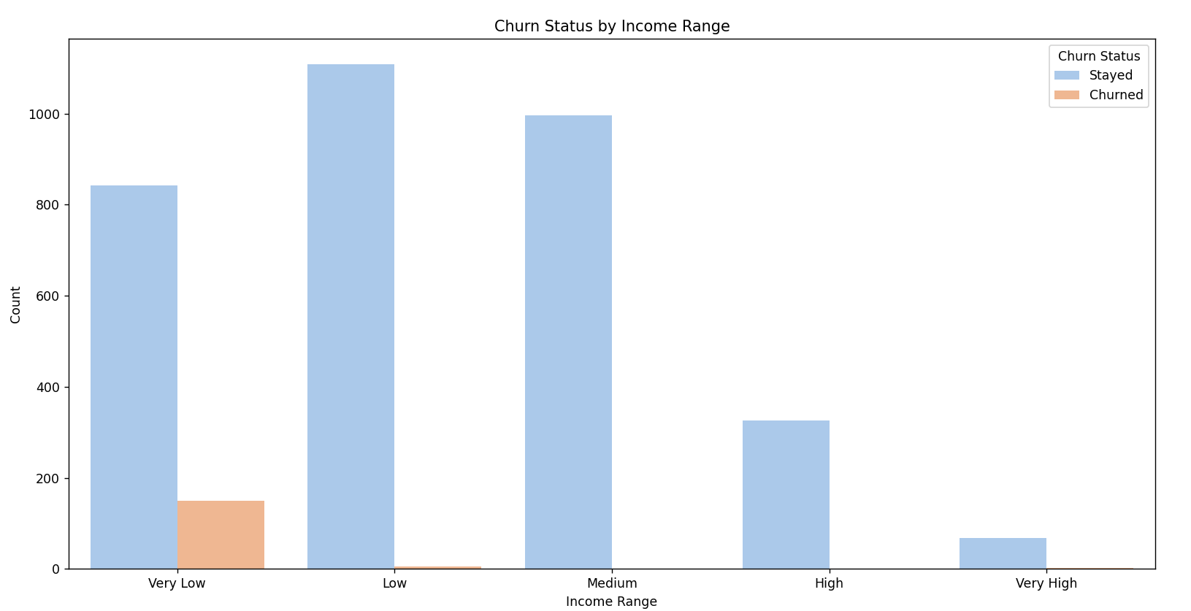
Figure 15: Churn Status by Income Range

The plot shows that churn is most common among customers with very low and low income ranges. As income increases, the number of churned customers decreases sharply, with almost no churn among high and very high income groups. This pattern suggests that customers with higher income levels are more financially stable and less likely to leave the service, possibly due to fewer price-related concerns or greater satisfaction with the product’s value.

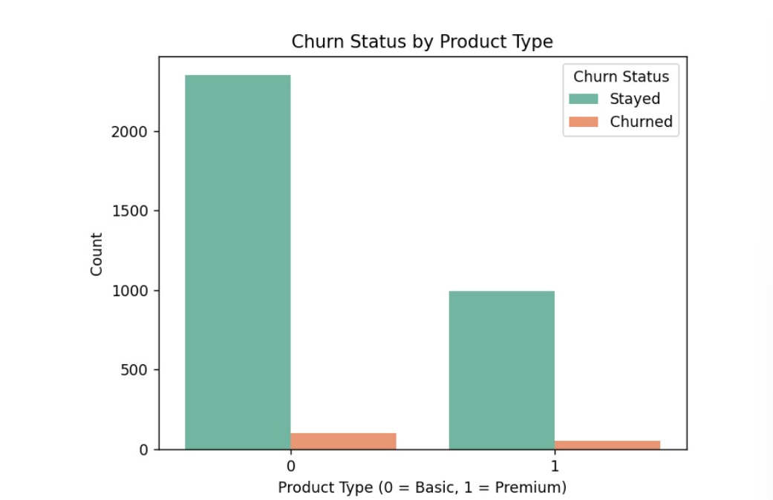
Figure 16: Churn Status by Product Type

This figure indicates that Basic plan (0) users have a noticeably larger churn count compared to Premium plan (1) users. While there are more Basic subscribers overall, the proportion of churned customers within this group is still higher. This suggests that Premium plans may offer better features or benefits that improve customer satisfaction and retention, while Basic users are more likely to switch or cancel their subscriptions.
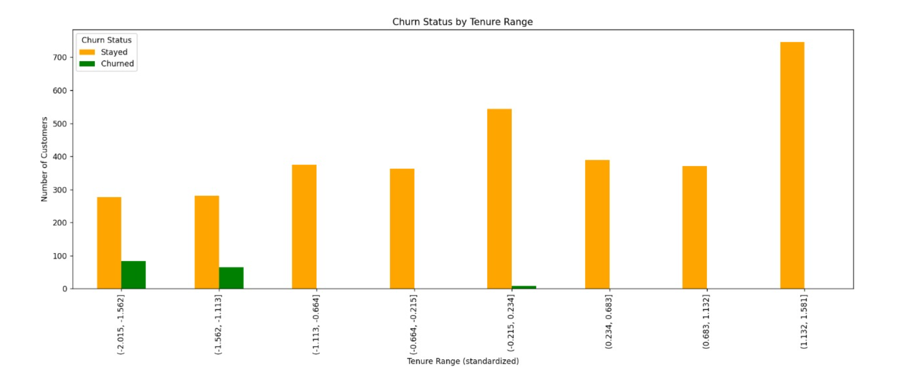
Figure 17: Churn Status by Tenure Range
The visualization shows that churn is most frequent among customers with shorter tenures, while those with longer tenures tend to stay. The bars on the right side of the chart, representing higher tenure ranges, have very few churned customers. This relationship highlights that newer customers are more likely to leave, whereas long-term users have built loyalty and are less likely to churn.
The observations seen in Figures 15 to 17 align with the correlation results shown in Figure 14, which is presented as a heatmap. In this heatmap, the blue shades represent negative correlations, while the red shades indicate positive correlations, and the intensity of the color shows how strong the relationship is. The dark blue cells between ChurnStatus and both Income (-0.27) and Tenure (-0.30) highlight moderate negative correlations, meaning customers with lower income or shorter tenure are more likely to churn. On the other hand, Age and SupportCalls appear in light blue tones, showing almost no correlation with churn. Overall, the heatmap visually confirms that income and tenure have the strongest relationships with customer churn.

Conclusion

The analysis provided valuable insights into the factors influencing customer churn. Through visualizations and correlation analysis, it became clear that income, tenure, and subscription type play key roles in determining whether a customer stays or leaves. Customers with lower income and shorter tenure show higher churn rates, suggesting that financial constraints and lack of long-term engagement contribute to customer loss. Additionally, Basic plan users are more likely to churn compared to Premium users, indicating that offering enhanced value or benefits can improve retention. Other factors, such as age, gender, and support calls, showed minimal relationship with churn, implying they are less significant in predicting customer behavior.
Overall, these findings highlight the importance of focusing retention strategies on newer, lower-income, and Basic plan customers by giving them more attention, better service, or small rewards to help them stay longer and reduce churn.

