For Boost Solutions Company :

Note: This test was completed in 20 hours

1. Port:localhost:3000
2. Db design must be like the following Erd to be more efficient and flexible

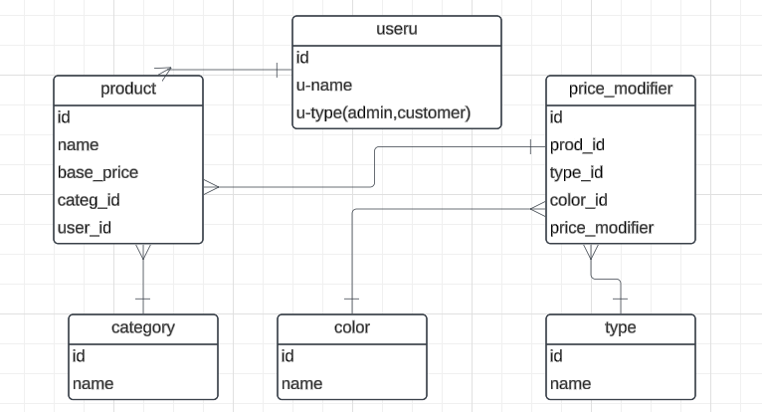

But instead the following was relied upon to exploit more time

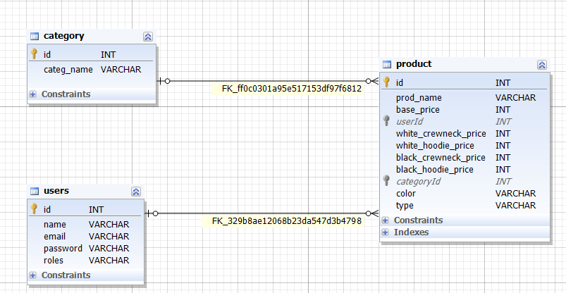

Base price computed by sum the base price and the rest prices column

For example : base price = 5000 and white_hoodie_price =2000 because the admin will add price only to the column that meets product requirements and the rest columns(white_crwneck_price, black_hoodie_price, black_crewneck_price) set to zero

1. Justify Using TypeOrm : for its ease of use, TypeScript support, database agnosticism, and features that simplify database interactions and improve the overall development experience when working with relational databases in TypeScript or JavaScript projects.
2. Security:
3. project architecture:

Folder Structure:

**src/**: This directory typically contains all the source code of your application.

* **controllers/**: Contains controller classes that handle incoming HTTP requests.
* **services/**: Contains service classes that encapsulate business logic.
* **entities/**: Contains entity classes that represent database tables.
* **repositories/**: Contains repository classes that interact with the database using TypeORM.
* **modules/**: Contains modules that encapsulate related functionality.
* **config/**: Contains configuration files.
* **utils/**: Contains utility classes and functions.
* **app.module.ts**: The main module file that bootstraps the application.
* **main.ts**: The entry point of the application.

6-user Mananagment: add all CRUD opertaions and auth using jwt , login and logout

7- Add all API to manage Product: add all CRUD opertaions and make pagination api and search api for products

8- Add all API to category.

9-Add Swagger API :the UI url is :localhost:3000/api

10- Add logger for API :first I create logger and call it in specific controller then I make a global logger in and import it in the app file

11- Apply all validation and transformation needed :each entity contain a DTO file(Data Transfer Objec),

And use whitelist validation in dto.