**Destructuring**

**Video[115-122]**

**#Destructuring array**

**Array so using []**

#If the variables initialized before destructing ,the variable data will update with the new value .

#If I need destructiung only the first 3 value from array

#If the array has 4 element but I declare 5 variable in the destructing

Then e variable will has undefined value .

#i can add default value to the variables A computer screen with text

AI-generated content may be incorrect.

Destructuring

بتسهل علينا الوصول لعناصر الاريه وخاصة اذا كان في اريه متداخلات

Note:لما احط فراغ مكان العنصر معناها ما بدي استخرج هاد العنصر ما بلزمني فبعمله skip

#swapping variables using destructuring

**#Destructuring with objects**

**Object so using {}**

Note :

If I want skip the title in the array to skip it we must put space in the destructor but in the object destructiring to sjip any object property we delete it only

الترتيب غير مهم بالاوبجكت لهيك اذا بدي اعمله سكب بس بحذفه اما الاريه الترتيب مهم لهيك لازم احط فراغ مكانه

##Naming the variable in destucturing object

##add new property

the color is anew property with default value .

##Nested Object

Ex: this nested object ,how destructuring nested object

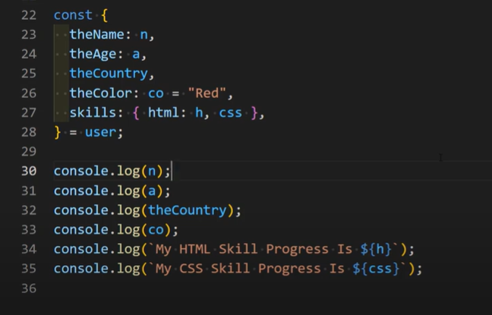

## if we want destructuring only the nested object (inner object ) .

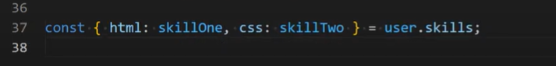

#Destructiring with function Parameters

بدنا نعمل دالة تستقبل كائن وتطبع معلومات عنه

1-function without Destructiring

#Destructuring Mixed Content

Ex: apply Destructuring in this object

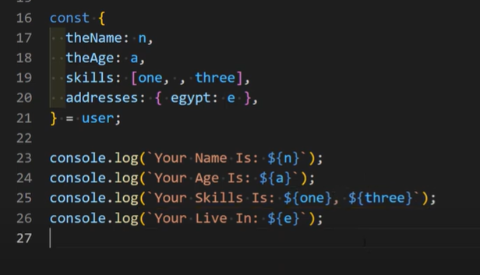

Challenge: if the chosen is 1 it must print the first values in the array if 2 the second values if 3 the third values with using destructuring .

First solution

second solution

