Js

Todos is array of objects

Stringify is method convert the array of obect to json file

This is json format (key with "" and the string value with "" not ' '

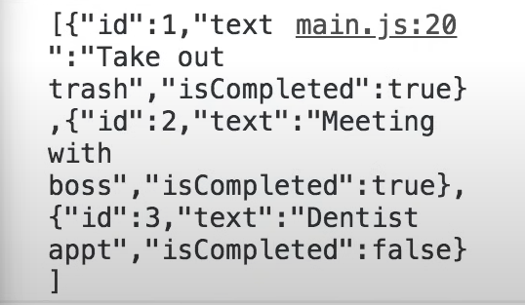

Dom:

