

**Department of Computer Science and Engineering**

**Batch 2018 - 2022**

**School Of Engineering and Technology Sharda University**

Project Diary

**Project Title:** Trip – A complete Tourism Solution



| **Sr. No.** | **Name of student** | **University Roll No.** | **Email** |
| --- | --- | --- | --- |
| **1** | Raghav Gupta | 180101241 | 2018004539.raghav@ug.shardaa.ac.in |
| **2** | Aman Chauhan | 180101041 | 2018001310.aman@ug.sharda.ac.in |
| **3** | Satyam Singh | 180101282 | 2018002681.satyam@ug.sharda.ac.in |
| **4** | Arun Kumar | 180101075 | 2018004636.arun@ug.shardaa.ac.in |

**Supervisors Name:** Dr. Danish Ather

**Department HOD:** Dr. Nitin Rakesh

**Group No.** 10

**Panel No.** 06

**Project No.** 64

Raghav Gupta

180101241

| **Sr. No.** | **Activity Description** | **Date of Meeting** | **Work Done/ Remark** | **Sign of Guide** |
| --- | --- | --- | --- | --- |
| **01** | To finalize the project title.   * Discussion regarding the field and knowledge of project domain * Discussion about the area of project * Guidance for synopsis | 19 March 2021 | Approved |  |
| **02** | To make comparison of project   * To prepare a detailed comparison of our project with other existing ones. * To read research papers on food sites. * To write a research paper * Discussion for evaluation 0. | 05 June 2021 | Synopsis submitted  2 papers read |  |
| **03** | To make some corrections   * Read some more research papers * Make corrections in writings * Make flowcharts and diagram * Find a suitable journal or conference for paper submission * Start learning languages. | 26 June 2021 | Written paper |  |
| **04** | Paper Submission   * Submit the paper. * Start making front-end for e-commerce | 19 July 2021 | Submitted Correct paper  Learned node |  |
| **05** | Evaluation 1   * Review from journal. * Review of project modules completed till now. * Guidance for evaluation 1 * Module 1 should be completed by 20 Aug 2021. | 11 Aug 2021 | Pending response from Journal  Module 1 in progress |  |
| **06** | SDLC   * Analysis of the project. * Designing of General workflow diagram. * Read about Agile workflow. * SDLC model for project. | 25 Oct 2021 |  |  |
| **07** | Project Design   * Worked on PayPal integration for payment gateway in e-commerce. * Helped in maintaining software combining. * Maintaining project synchronization. | 20 Nov 2021 |  |  |

Aman Chauhan

180101041

| **Sr. No.** | **Activity Description** | **Date of Meeting** | **Work Done/ Remark** | **Sign of Guide** |
| --- | --- | --- | --- | --- |
| **01** | To finalize the project title.   * Discussion regarding the field and knowledge of project domain * Discussion about the area of project * Guidance for synopsis | 19 March 2021 | Approved |  |
| **02** | To make comparison of project   * To prepare a detailed comparison of our project with other existing ones. * To read research paper on e-commerce * To write a research paper * Discussion for evaluation 0. | 05 June 2021 | Synopsis submitted  2 papers read |  |
| **03** | To make some corrections   * Read some more research papers * Make corrections in writings * Make flowcharts and diagram * Find a suitable journal or conference for paper submission * Start learning languages. | 26 June 2021 | Written paper |  |
| **04** | Paper Submission   * Submit the paper. * Start making front-end for e-commerce | 19 July 2021 | Submitted Correct paper  Learned node |  |
| **05** | Evaluation 1   * Review from journal. * Review of project modules completed till now. * Guidance for evaluation 1 * Module 1 should be completed by 20 Aug 2021. | 11 Aug 2021 | Pending response from Journal  Module 1 in progress |  |
| **06** | SDLC   * Analysis of the project. * Designing of General workflow diagram. * Read about Agile workflow. * SDLC model for project. | 25 Oct 2021 |  |  |
| **07** | Project Design   * Worked on node for making server side connections in e-commerce. * Helped in maintaining software combining. * Maintaining project synchronization. | 20 Nov 2021 |  |  |

Satyam Singh

180101282

| **Sr. No.** | **Activity Description** | **Date of Meeting** | **Work Done/ Remark** | **Sign of Guide** |
| --- | --- | --- | --- | --- |
| **01** | To finalize the project title.   * Discussion regarding the field and knowledge of project domain * Discussion about the area of project * Guidance for synopsis | 19 March 2021 | Approved |  |
| **02** | To make comparison of project   * To prepare a detailed comparison of our project with other existing ones. * To read research paper on travel * To write a research paper * Discussion for evaluation 0. | 05 June 2021 | Synopsis submitted  2 papers read |  |
| **03** | To make some corrections   * Read some more research papers * Make corrections in writings * Make flowcharts and diagram * Find a suitable journal or conference for paper submission * Start learning languages. | 26 June 2021 | Written paper |  |
| **04** | Paper Submission   * Submit the paper. * Start making front-end for e-commerce | 19 July 2021 | Submitted Correct paper  Learned node |  |
| **05** | Evaluation 1   * Review from journal. * Review of project modules completed till now. * Guidance for evaluation 1 * Module 1 should be completed by 20 Aug 2021. | 11 Aug 2021 | Pending response from Journal  Module 1 in progress |  |
| **06** | SDLC   * Analysis of the project. * Designing of General workflow diagram. * Read about Agile workflow. * SDLC model for project. | 25 Oct 2021 |  |  |
| **07** | Project Design   * Designing of Database with MongoDB for e-commerce. * Helped in maintaining documents. * Maintaining the project synchronization. | 20 Nov 2021 |  |  |

Arun Kumar

180101075

| **Sr. No.** | **Activity Discussion** | **Date of Meeting** | **Work Done/ Remark** | **Sign of Guide** |
| --- | --- | --- | --- | --- |
| **01** | To finalize the project title.   * Discussion regarding the field and knowledge of project domain * Discussion about the area of project * Guidance for synopsis | 19 March 2021 | Approved |  |
| **02** | To make comparison of project   * To prepare a detail comparison of our project with other existing ones. * To read research paper on hotel * To write a research paper * Discussion for evaluation 0. | 05 June 2021 | Synopsis submitted  2 papers read |  |
| **03** | To make some corrections   * Read some more research papers * Make corrections in writings * Make flowcharts and diagram * Find a suitable journal or conference for paper submission * Start learning languages. | 26 June 2021 | Written paper |  |
| **04** | Paper Submission   * Submit the paper. * Start making front-end for e-commerce | 19 July 2021 | Submitted Correct paper  Learned node |  |
| **05** | Evaluation 1   * Review from journal. * Review of project module completed till now. * Guidance for evaluation 1 * Module 1 should be completed by 20 Aug 2021. | 11 Aug 2021 | Pending response from Journal  Module 1 in progress |  |
| **06** | SDLC   * Analysis of the project. * Designing of General workflow diagram. * Read about Agile workflow. * SDLC model for project. | 25 Oct 2021 |  |  |
| **07** | Project Design   * Designing of Frontend with HTML for e-commerce. * Helped in maintaining documents. * Maintaining the project synchronization. | 20 Nov 2021 |  |  |

OUTCOME OF OUR PROJECT

1. Secured Register/Login: The owner will have to register him/her and then him/she can login into the application, by filling up the form, and we would also try to provide a feature for forgot password.

2. Easy UI: The UI of all the pages will be user friendly and easy to navigate, according to Indian users.

3. Payroll Management Feature: The owner can have a full record of all its staff members and their payrolls.

4. Inventory Management Feature: According to their need, the owner can have a full record of all the inventory of its business.

5. Bill Generator Feature: This feature will help the owner to generate a digital bill for the customer, and we will also try to add a QR code which can directly be sent to the customer, for their convenience.

SELECTION OF PROJECT

Flow Chart of Selecting a project.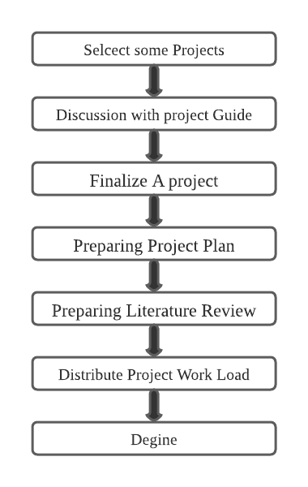

PROJECT SUPERVISON

Meeting Schedule with project Guide: -

| Date | Time | Meeting Link |
| --- | --- | --- |
| 19/03/2021 | 1pm-2pm | In college |
| 05/06/2021 | 4pm-4.35pm | <https://meet.google.com/eco-jbty-tzz> |
| 26/06/2021 | 1pm-1.30pm | [https://meet.google.com/sfs-faoh-zov](https://meet.google.com/sfs-faoh-zov%20) |
| 19/07/2021 | 4pm-4.45pm | <https://meet.google.com/cyg-xoej-zdw> |
| 11/08/2021 | 4pm-4.15pm | [https://meet.google.com/kbk-errt-tsp](https://meet.google.com/eco-jbty-tzz) |

PROOF OF SUPERVISON

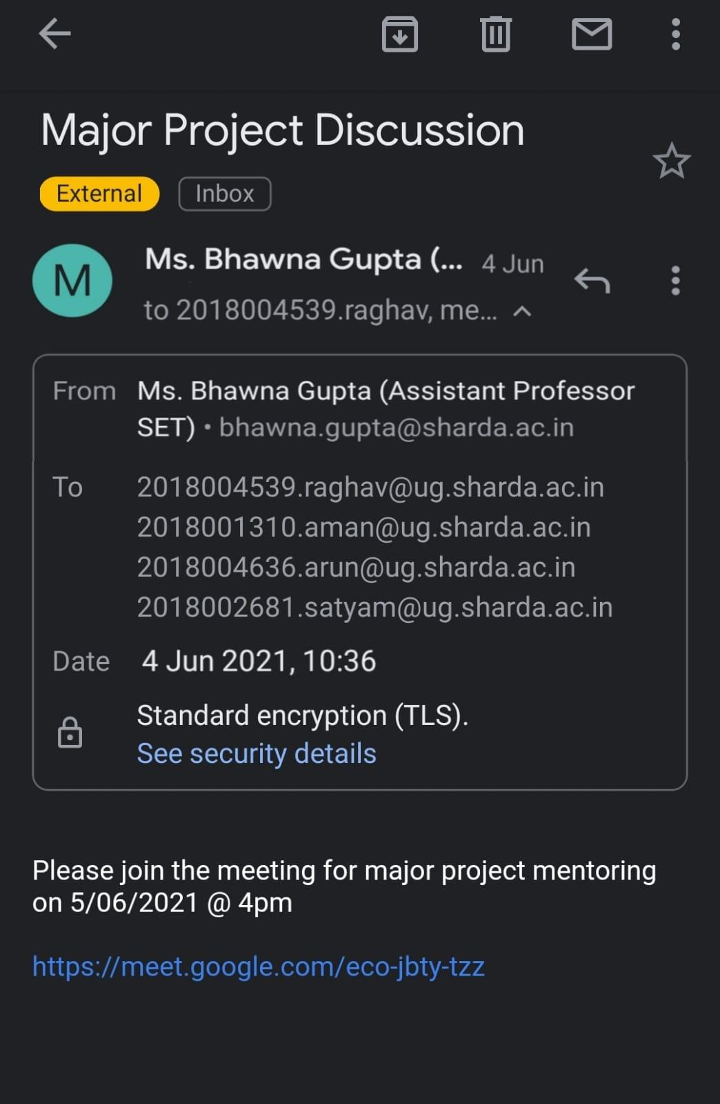 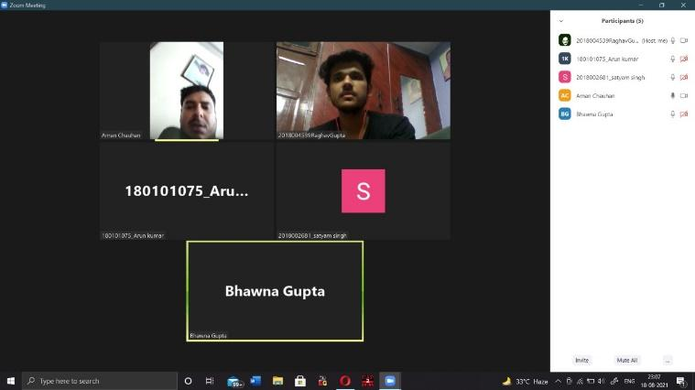

**05/06/2021**

**26/06/2021**

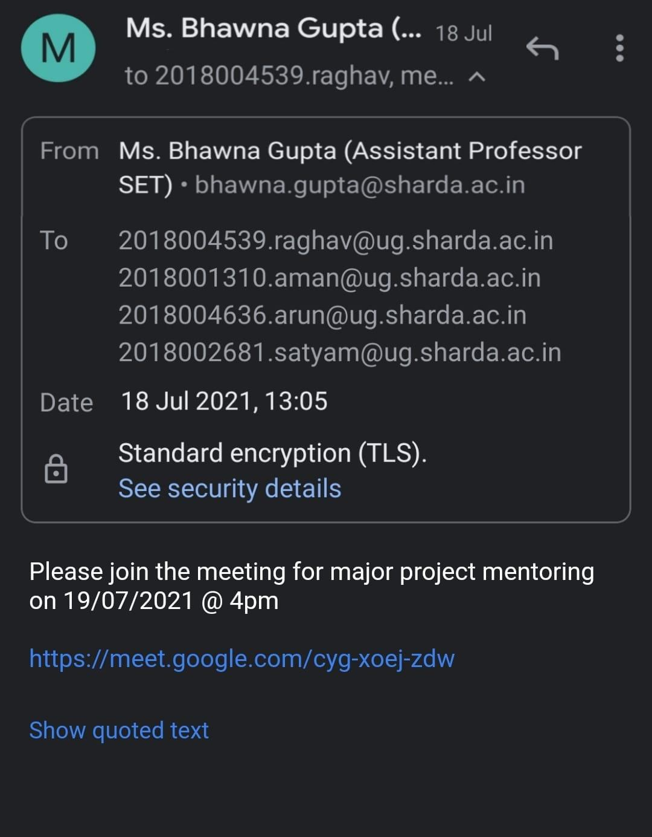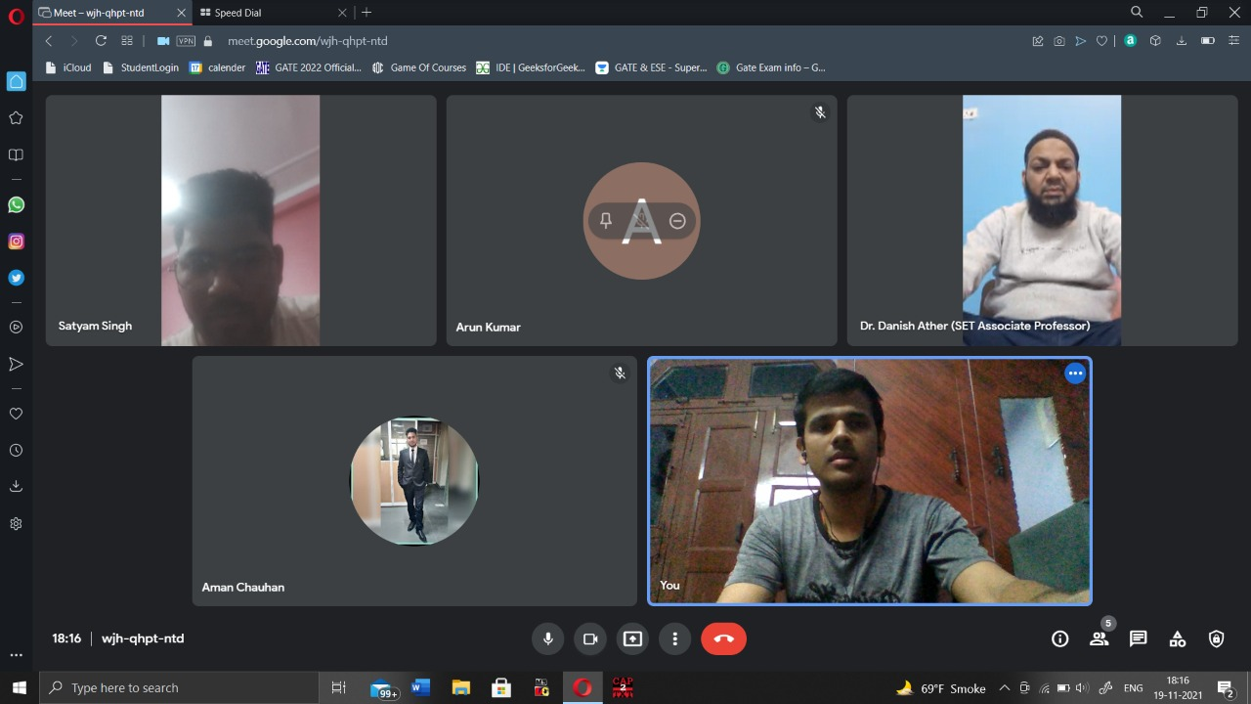

**19/07/2021 15/11/2021**

Project Review details

|  | | Date: | Time: From to | No of hours: |
| --- | --- | --- | --- | --- |
| Attendance: | | | | |
| Sr.  No. | Roll No | | Name of Student | Signature |
|  |  | |  |  |
|  |  | |  |  |
|  |  | |  |  |
|  |  | |  |  |
| Work Done by students: | | | | |
| Comments of Supervisor: | | | | |
| Sr | | Name | Remarks | Signature |
| 1 | | Supervisor |  |  |
| 2 | | Project Coordinator |  |  |
| 3 | | HOD |  |  |