**04-REACTJS-HANDSON**

1. Create a new react application using *create-react-app* tool with the name as “blogapp”
2. Open the application using VS Code
3. Create a new file named as **Post.js** in **src folder** with following properties

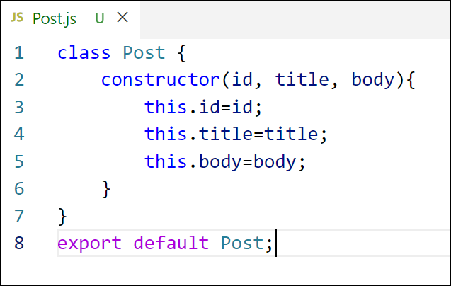

Figure 2: Post class

1. Create a new class based component named as **Posts** inside **Posts.js** file

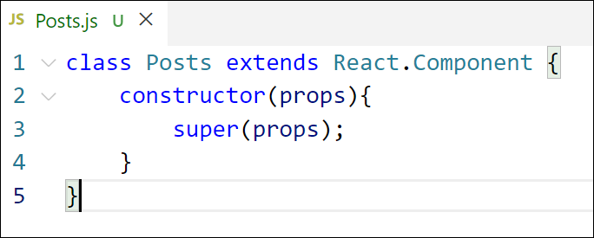

Figure 3: Posts Component

1. Initialize the component with a list of Post in state of the component using the constructor
2. Create a new method in component with the name as **loadPosts()** which will be responsible for using Fetch API and assign it to the component state created earlier. To get the posts use the url (<https://jsonplaceholder.typicode.com/posts>)
3. Implement the **componentDidMount()** hook to make calls to **loadPosts()** which will fetch the posts

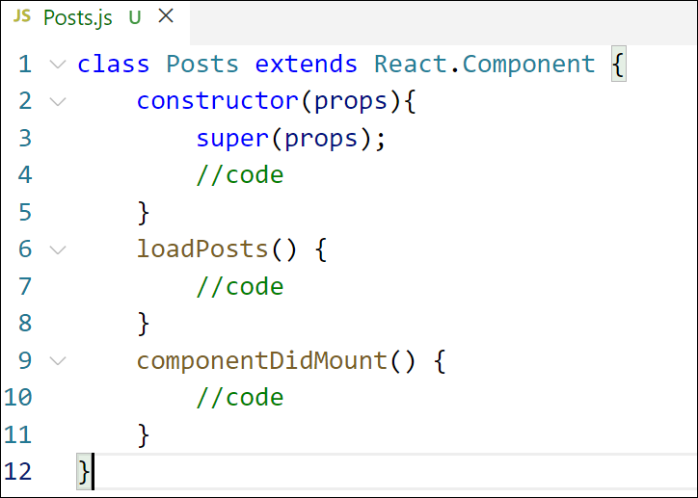

Figure 5: componentDidMount() hook

1. Implement the **render()** which will display the title and post of posts in html page using heading and paragraphs respectively.

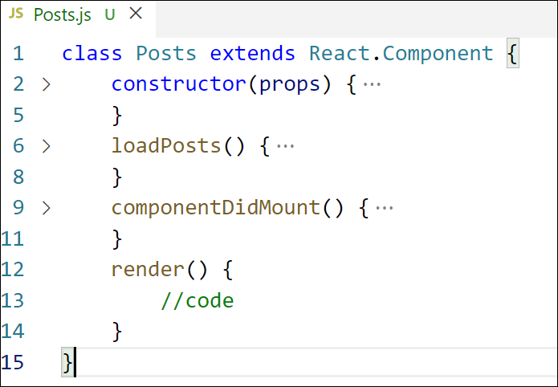

Figure 6: render() method

Define a **componentDidCatch()** method which will be responsible for displaying

Figure 6: render() method

1. Define a **componentDidCatch()** method which will be responsible for displaying any error happing in the component as alert messages.

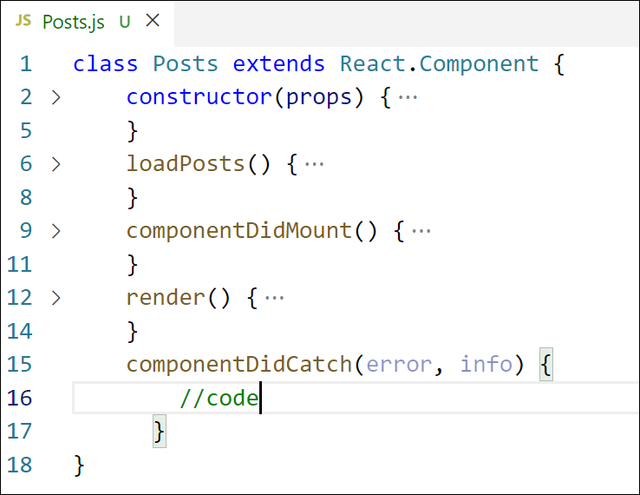

Figure 7: componentDidCatch() hook

1. Add the Posts component to App component.
2. Build and Run the application using *npm start* command.

**Code:**

**App.js  
import** React **from** 'react';

**import** Posts **from** './Posts';

**function** App() {

**return** (

    <div *className***=**"App">

      <Posts />

    </div>

  );

}

**export** **default** App;

**Posts.js  
class** Post {

**constructor**(userId, id, title, body) {

    this.userId **=** userId;

    this.id **=** id;

    this.title **=** title;

    this.body **=** body;

  }

}

**export** **default** Post;

**Post.js  
import** React, { Component } **from** 'react';

**import** Post **from** './Post';

**class** Posts **extends** Component {

**constructor**(props) {

    super(props);

    this.state **=** {

      posts: [],

      hasError: **false**,

    };

  }

  loadPosts **=** () **=>** {

    fetch('https://jsonplaceholder.typicode.com/posts')

      .then(response **=>** response.json())

      .then(data **=>** {

**const** postObjects **=** data.map(p **=>** **new** Post(p.userId, p.id, p.title, p.body));

        this.setState({ posts: postObjects });

      })

      .catch(error **=>** {

        this.setState({ hasError: **true** });

        console.error("Error fetching posts:", error);

      });

  };

  componentDidMount() {

    this.loadPosts();

  }

  componentDidCatch(error, info) {

    alert("Something went wrong: " **+** error.toString());

    this.setState({ hasError: **true** });

  }

  render() {

**if** (this.state.hasError) {

**return** <h2>Unable to load posts. Please try again later.</h2>;

    }

**return** (

      <div>

        <h1>Blog Posts</h1>

        {this.state.posts.map(post **=>** (

          <div *key***=**{post.id} *style***=**{{ marginBottom: '20px' }}>

            <h3>{post.title}</h3>

            <p>{post.body}</p>

          </div>

        ))}

      </div>

    );

  }

}

**export** **default** Posts;

**Output:**

