**09) REACTJS-HOL**

Create a React Application named “cricketapp” with the following components:

1. ListofPlayers

* Declare an array with 11 players and store details of their names and scores using the map feature of ES6

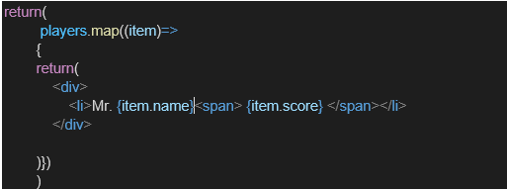

* Filter the players with scores below 70 using arrow functions of ES6.

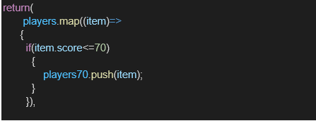

1. IndianPlayers
   1. Display the Odd Team Player and Even Team players using the Destructuring features of ES6
2. ListofPlayers

* Declare an array with 11 players and store details of their names and scores using the map feature of ES6



* Filter the players with scores below 70 using arrow functions of ES6.



1. IndianPlayers
   1. Display the Odd Team Player and Even Team players using the Destructuring features of ES6

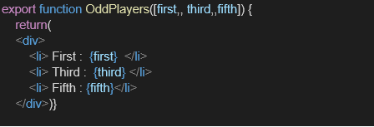

* 1. Declare two arrays T20players and RanjiTrophy players and merge the two arrays and display them using the Merge feature of ES6

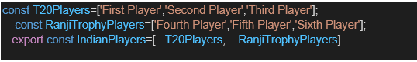

Display these two components in the same home page using a simple if else in the flag variable.

**Code:**

**ListofPlayers.js***// src/components/ListofPlayers.js*

**import** React **from** 'react';

**const** ListofPlayers **=** () **=>** {

**const** players **=** [

    { name: 'Rohit Sharma', score: 85 },

    { name: 'Virat Kohli', score: 95 },

    { name: 'Shubman Gill', score: 50 },

    { name: 'Suryakumar Yadav', score: 40 },

    { name: 'KL Rahul', score: 72 },

    { name: 'Ravindra Jadeja', score: 69 },

    { name: 'Hardik Pandya', score: 90 },

    { name: 'Mohammed Siraj', score: 65 },

    { name: 'Jasprit Bumrah', score: 80 },

    { name: 'Kuldeep Yadav', score: 30 },

    { name: 'Shami', score: 88 },

  ];

**const** below70 **=** players.filter(player **=>** player.score **<** 70);

**return** (

    <div>

      <h2>All Players</h2>

      <ul>

        {players.map((player, index) **=>** (

          <li *key***=**{index}>{player.name} - {player.score}</li>

        ))}

      </ul>

      <h3>Players with score below 70</h3>

      <ul>

        {below70.map((player, index) **=>** (

          <li *key***=**{index}>{player.name} - {player.score}</li>

        ))}

      </ul>

    </div>

  );

};

**export** **default** ListofPlayers;

**IndianPlayers.js:**

*// src/components/IndianPlayers.js*

**import** React **from** 'react';

**const** IndianPlayers **=** () **=>** {

**const** T20players **=** ['Rohit', 'Virat', 'Gill', 'SKY', 'Hardik'];

**const** RanjiTrophy **=** ['Jadeja', 'Bumrah', 'Siraj', 'Shami', 'Ashwin'];

**const** mergedPlayers **=** [**...**T20players, **...**RanjiTrophy];

**const** [oddTeam, evenTeam] **=** [

    mergedPlayers.filter((_, i) **=>** i **%** 2 **!==** 0),

    mergedPlayers.filter((_, i) **=>** i **%** 2 **===** 0)

  ];

**return** (

    <div>

      <h2>Merged Players</h2>

      <p>{mergedPlayers.join(', ')}</p>

      <h3>Odd Team</h3>

      <ul>{oddTeam.map((p, i) **=>** <li *key***=**{i}>{p}</li>)}</ul>

      <h3>Even Team</h3>

      <ul>{evenTeam.map((p, i) **=>** <li *key***=**{i}>{p}</li>)}</ul>

    </div>

  );

};

**export** **default** IndianPlayers;

**App.js**

**import** React **from** 'react';

**import** ListofPlayers **from** './components/ListofPlayers';

**import** IndianPlayers **from** './components/IndianPlayers';

**const** App **=** () **=>** {

**const** flag **=** **true**; *// Change to false to switch component*

**return** (

    <div *className***=**"App">

      <h1>🏏 Cricket App</h1>

      {flag **?** <ListofPlayers /> **:** <IndianPlayers />}

    </div>

  );

};

**export** **default** App;

**Output:**

