First of all we will import the necessary libraries  
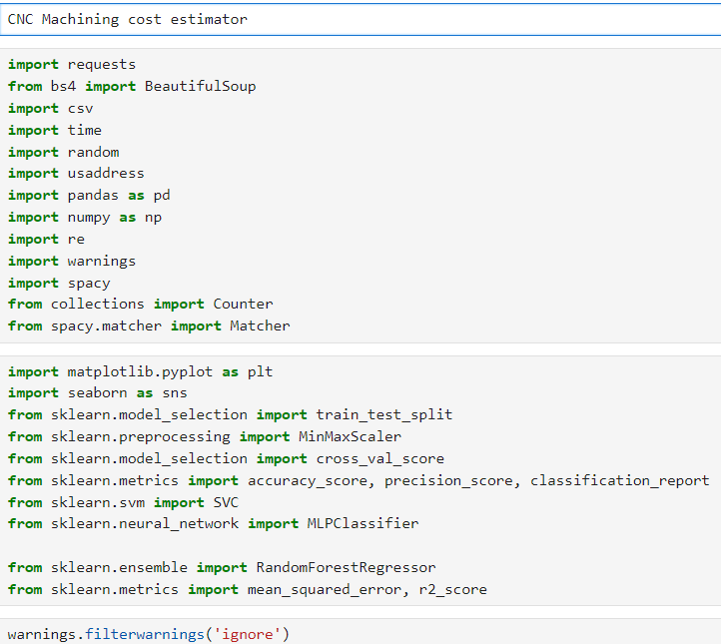

We bring a postal code zip data frame to separate location   


Function to get state, city data from a location

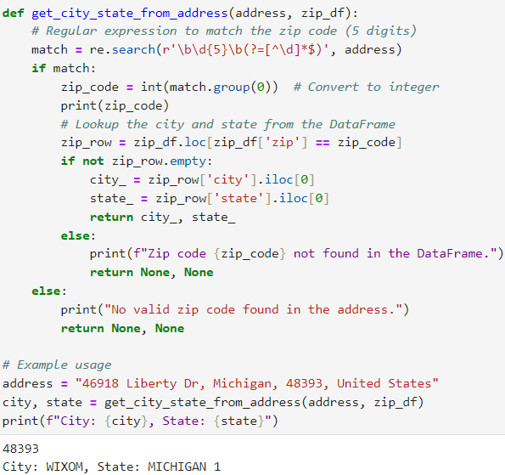

To get city and state 

Page scrapping logic  
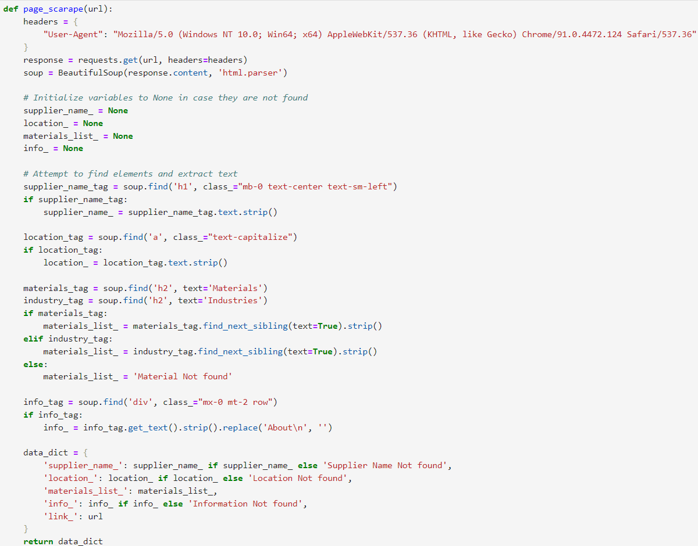

Code to scan each page and then scrape   
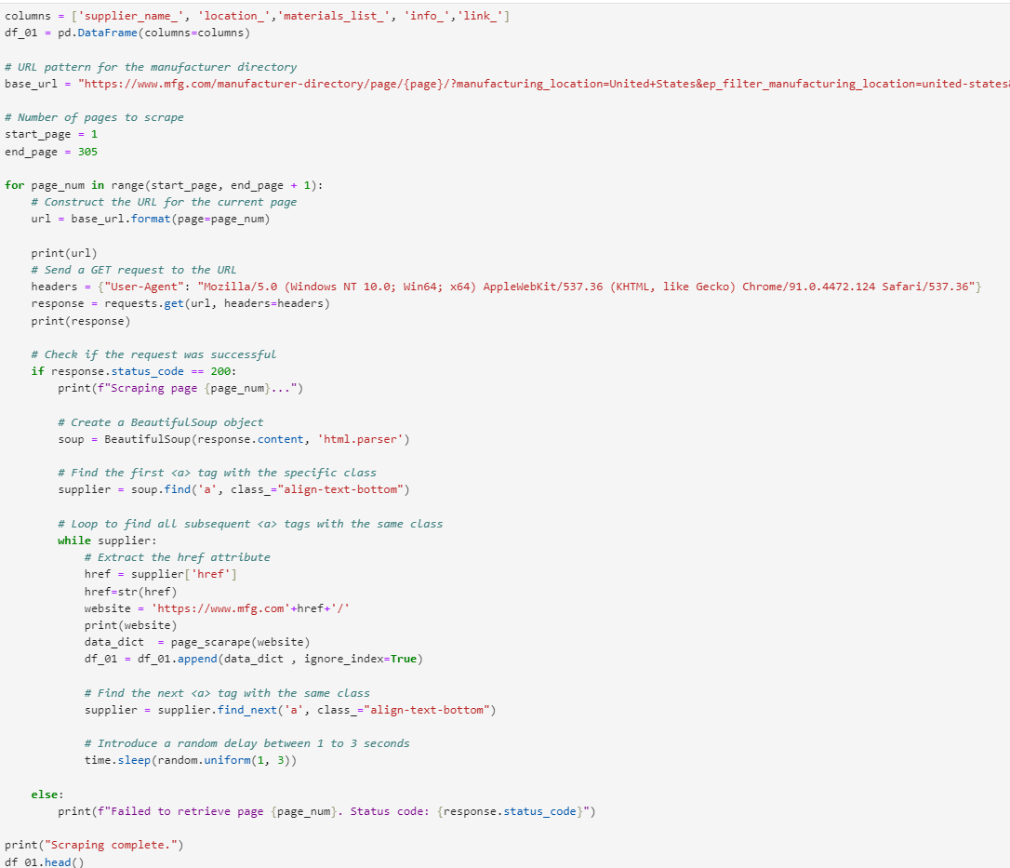

Spacy model to extract some additional info from info column, can be fine-tuned as per user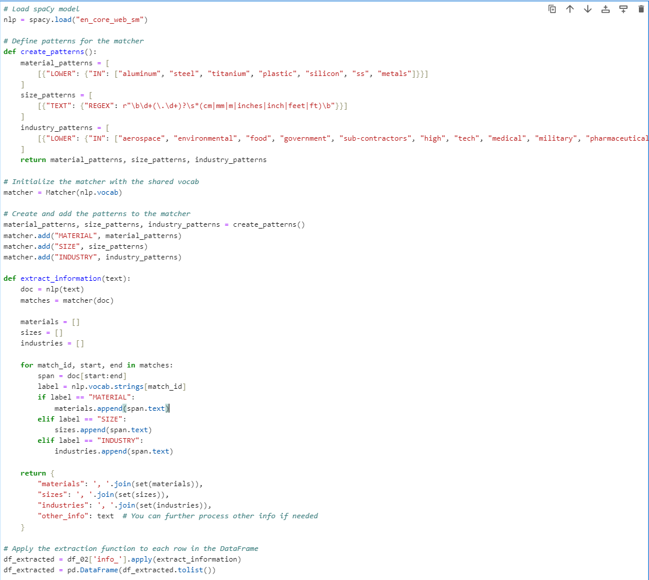

Few more data cleaning processes

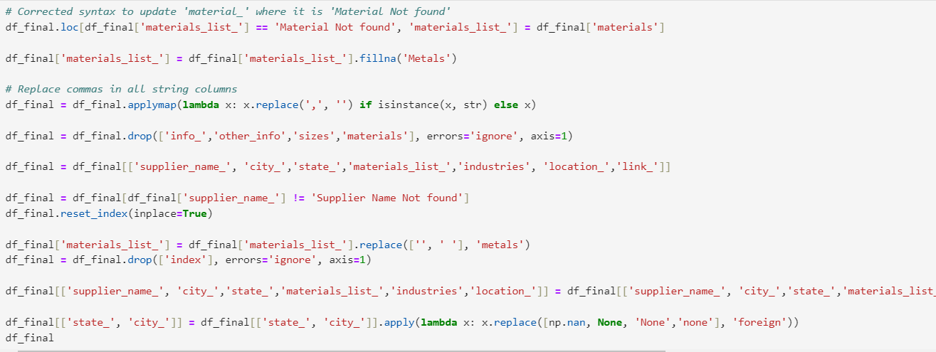

**NOTE:**

**The price and complexity of the machining, manufacturer was not been able to derived.  
So the data has been made manually, price ranging from 0 to 10 and complexity 0 to 5**

Preparing data for training, testing then apply model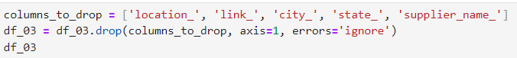



Vectorize the material and industry column 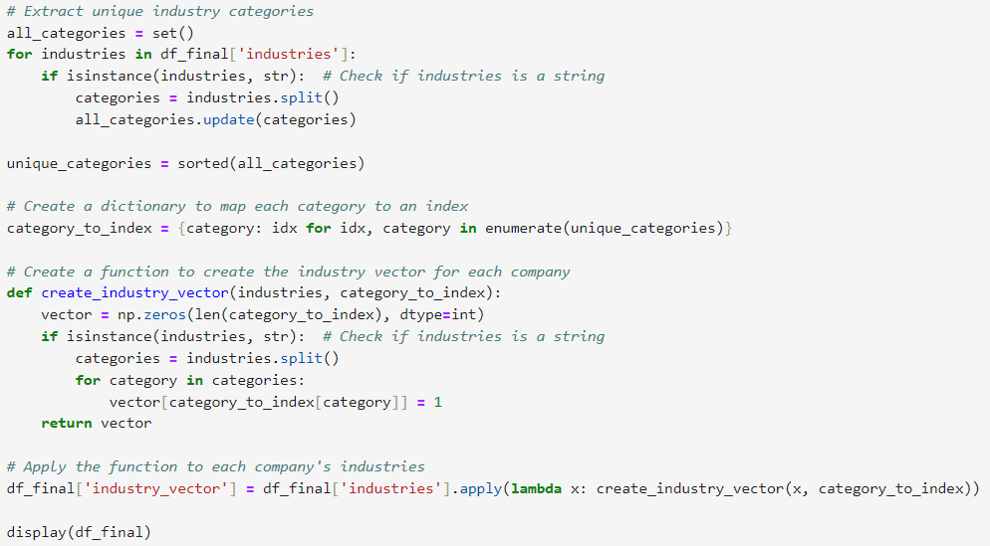 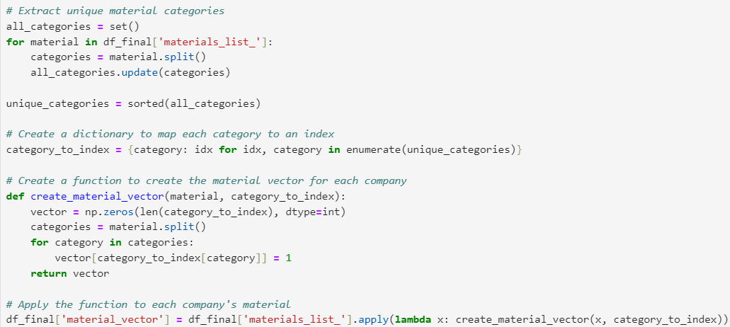

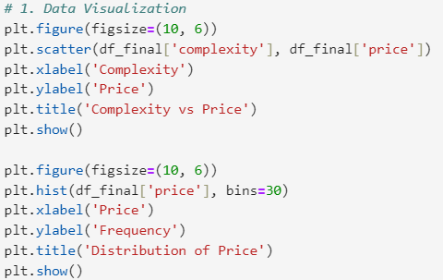

Final data prep then training it using random forest classifier  
At the end of the code there is another cell, having various other method to train the model, user can use them too   
