**WEATHER API TECHNICAL DOCUMENT**

**Objective:**

Our Objective is to get the Earthquake-related report from the internet using the website <http://earthquake.usgs.gov/earthquakes/feed/v1.0/summary/all_hour.geojson> . It will return a JSON file having the weather details.

**API Outputs:**

The website returns a file of JSON type file consisting of following parameters like: EntryId , CategoryId, EventType ,EventMessage , EventDateTime , Latitude ,Longitude ,Magnitude.

**How to Get the data:**

Steps:

1. Open Folder Earthquake_API from desktop.
2. Extract the Earthquake_API.zip on your PC, it consist of all the source code and Earthquake.XML which is required.
3. After opening Earthquake.XML, update the dependencies “SENDAPI” in the EARTHQUAKE.XML if you want to change the address where you need to send the adata .

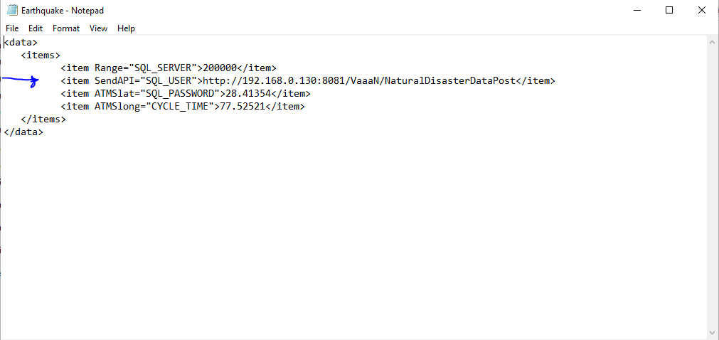

**Code Explanation:**

1. Import required Libraries
2. Parsing the Earthquake.xml data
3. We Fetch the data from website : <http://earthquake.usgs.gov/earthquakes/feed/v1.0/summary/all_hour.geojson>



1. This is how the Sample data would look like from the website.
2. We will preprocess data to get in DataFrame which is easy to use for a user.

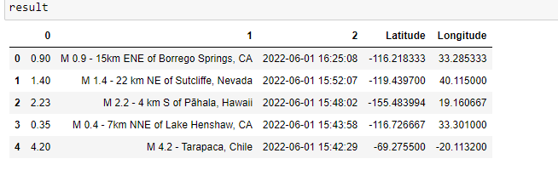

Hint : Here I used long process in Jupyter notebook which can be of one way to fetch the data but that is a long one we can also use the method in notepad (original code) to do the process ,so no need to process the long data.

1. We Created a Function to Check distance between our Latitude and Longitude with the affected Latitude and Longitude , we get data of our Latitude and Longitude from Earthquake.xml.
2. If distance < configdistance (Distance is less than Configdistance (mathematically)) then the function will return True else it will return False.
3. If distance< configdistance is True then we send the above data like Title, Time, Magnitude etc to the send API in the same JSON format.