GradeSense - Answer Sheet
Name: Ananya Rao Roll No: 24B

Q1. Science (5 marks)
An electric circuit is a close path in which electric current can flow. The battery gives the potentiall diffrence which push the current around the circuit. Switch is used for open and close the circuit, if switch is close then current will flow and bulb will glow, if switch is open then no current flow through the circuit.
In the circuit the battery, switch, resistor, bulb and ammeter is connected in series because current pass through all of them one by one. Ammeter is connected in series because it measure the current flowing in circuit. Voltmeter is also connected in the circuit to measure the potential diffrence, as shown in diagram below -
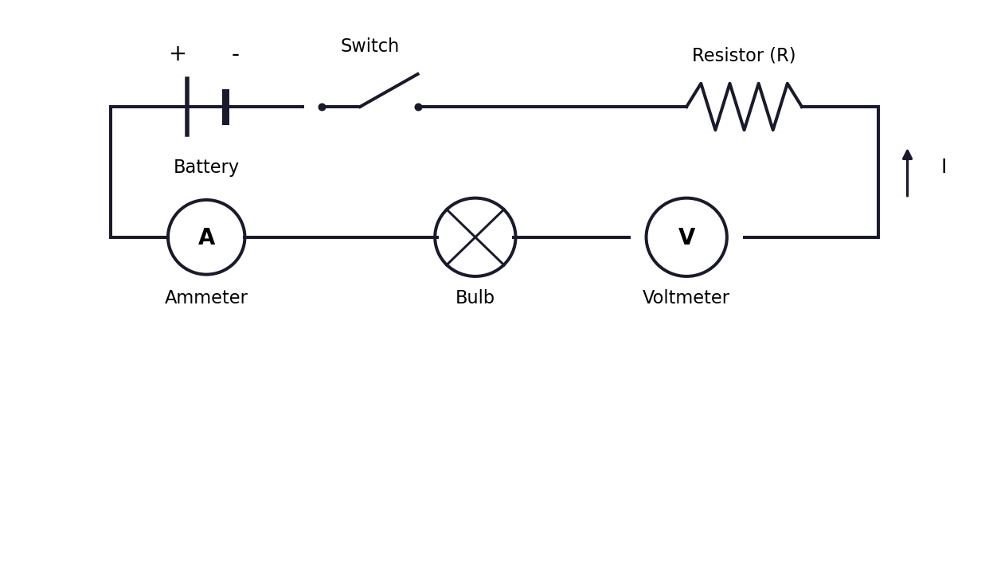
When current pass through the circuit some of the current get used up by the bulb and resistor, that is why the bulb glow and become hot.
As per Ohms law, V = IR. So if we increase the resistance then the current flowing in the circuit will also increase, because more resistance need more current to push through it. If the resistance is less then the bulb will glow dim.
Answer 2 - English
Technology have changed the way we learn in a big way. Now students can find information easily on internet, youtube videos, google etc. Before this student have to go library and read big books but now everything is on phone.
I think technology make learning better because student can learn at there own pace and explore different topic which interest them. For example a student can watch video on youtube to understand hard topic.
But sometime student became too dependent on technology and they dont try to think on their own, they just search google for answer.
In conclusion technology is good for learning but student should use it correctly.
Q.3 ECONOMICS
From the table we can make demand and supply graph, with quantity on x axis and price on y axis. Demand curve go downward because when price increase people buy less, and supply curve go upward because producer want to sell more when price is high.
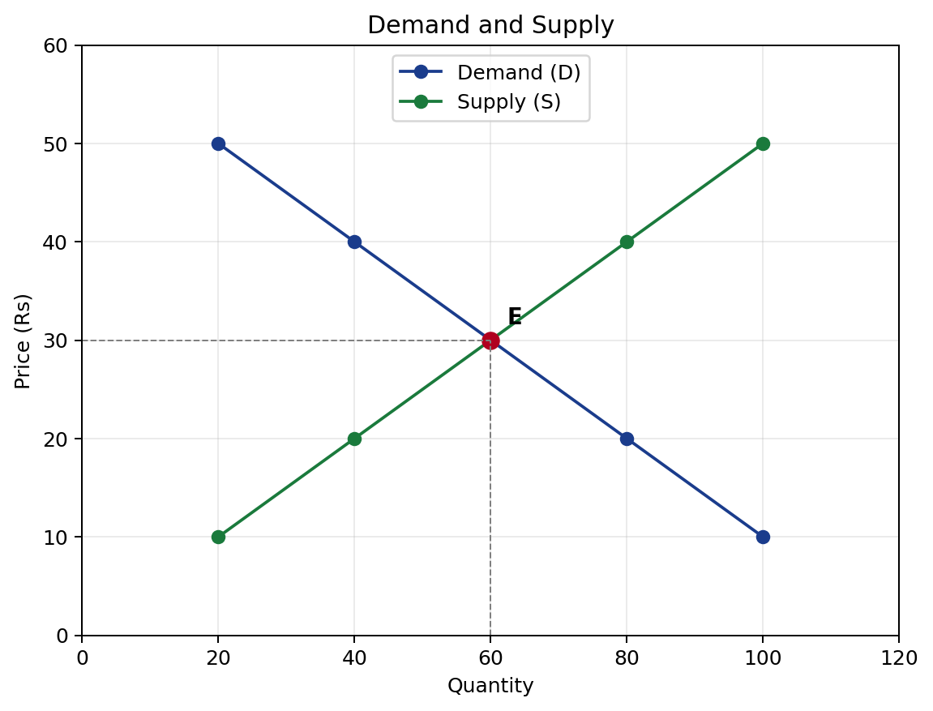
The two curve meet at price Rs 30 and quantity 60 unit, this is called eqilibrium point because at this price the qty demand and qty supply is same.
If price is below eqilibrium then demand is more than supply, this is called shortage, and price will start increasing due to this. If price is above eqilibrium also something will happen in the market.
If cost of production increase then producer will get more profit so they will supply more at the same price, so the supply curve will shift to the right/downward, and new eqilibrium will be at lower price and higher qty.

