->Start the application server using by running app.java  
->enter the url in the browser [http://localhost:8080](http://localhost:8080/)  
->Enter the Actual URL in the inputbox provide and click on submit

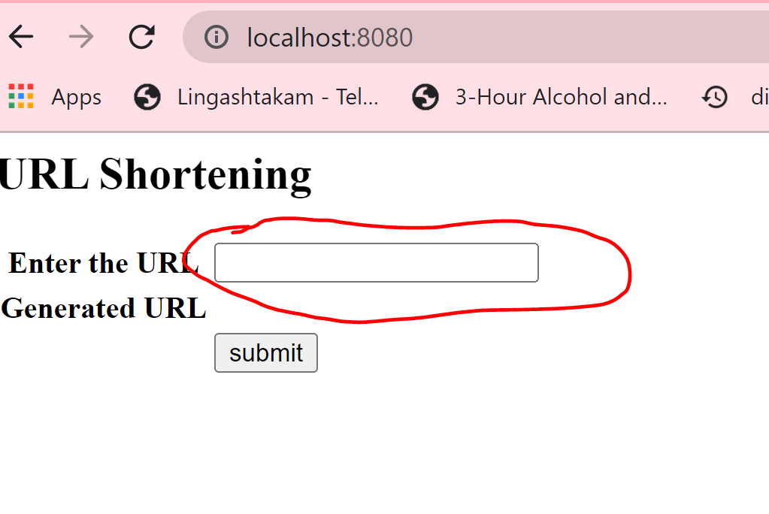  
->Observe the shorl URL being generated below.

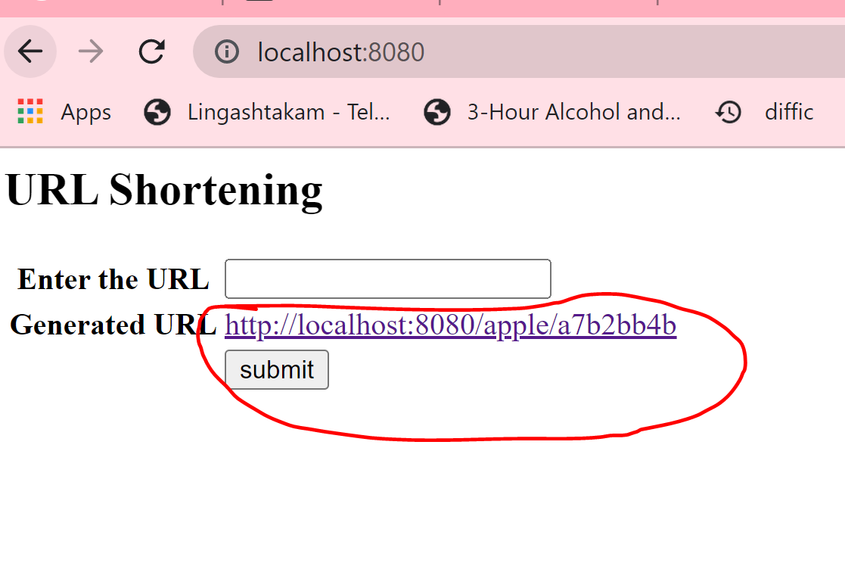  
-copy the short url to browser, observe it is being redirected to actual URL

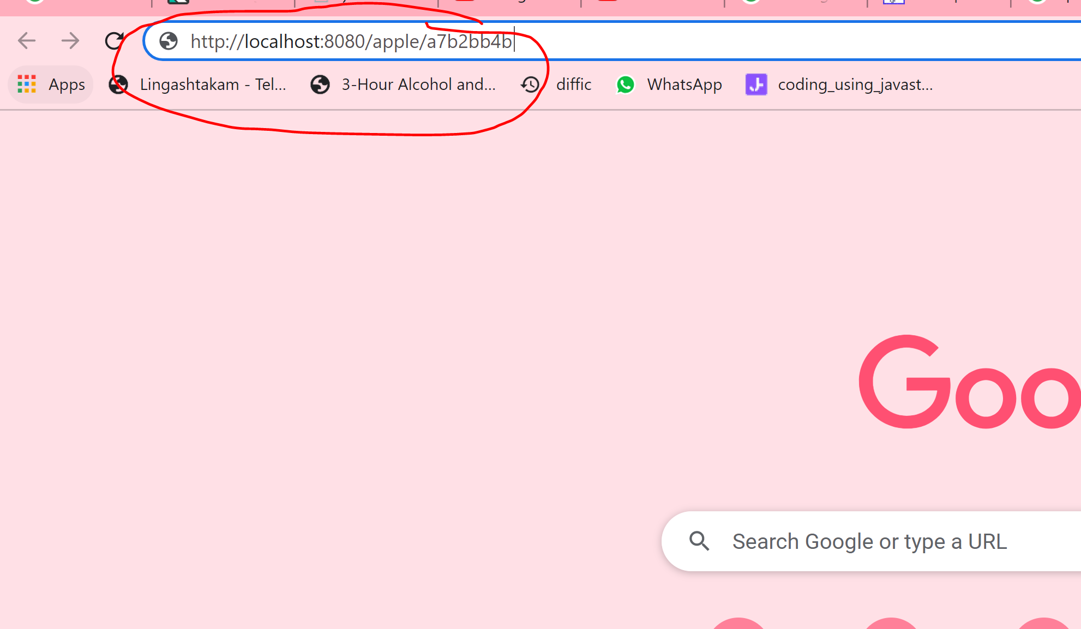

->Observe being redirected to longurl

