

JAYPEE INSTITUTE OF

INFORMATION TECHNOLOGY

SEC-62,NOIDA.

**Department of CSE & IT**

**Bachelor of Technology, III Semester**

**2020-2021**

**AUTO EVALUATION SYSTEM**

**Submitted by: Raghav Goyal (19103272)**

**Akash Jain (19103281)**

**Submitted to: Prantik Sir**

**PROBLEM STATEMENT**

To solve modern day problem of evaluating subjective and multiple option correct in less consuming time and without much of human labourer.

**RELEVANCE**

Generally Evaluating programs are slow and not that efficient because of the improper use of data structures.

As responses is evaluated with the use of hashing ,other friendly algorithms and stored in different files so the time in matching the responses is minimum..

The purpose of this project is to give a fast and efficient methodology of Evaluation without any complications.

**OUTPUT SCREENSHOT**

**1.**

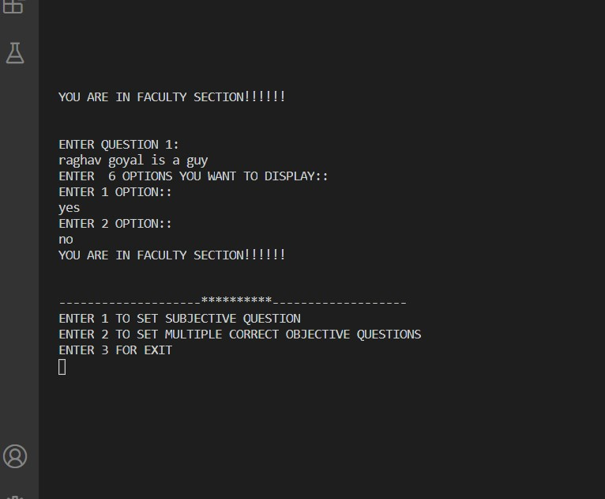**2.**

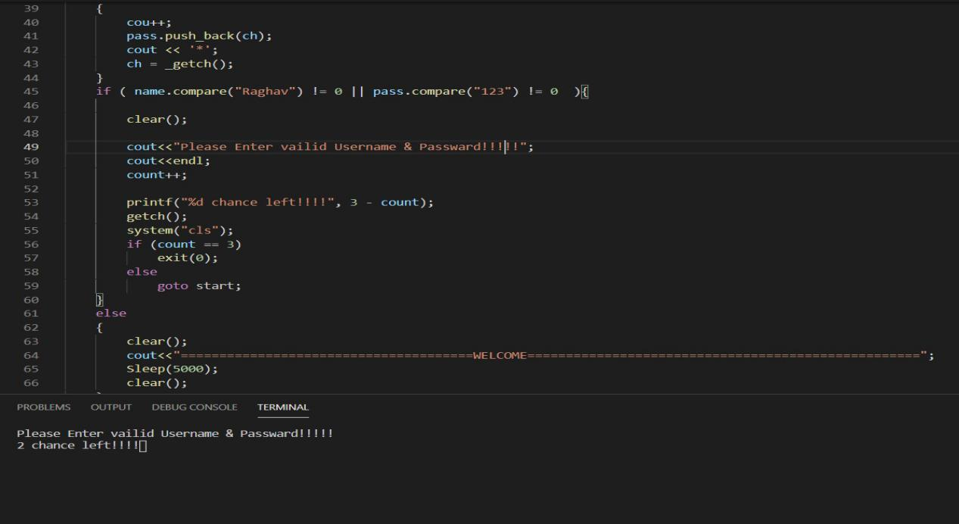

**3.**

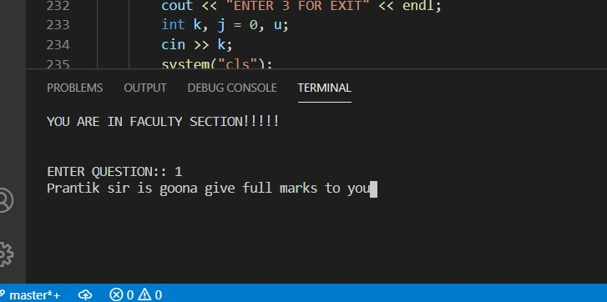

**4.**

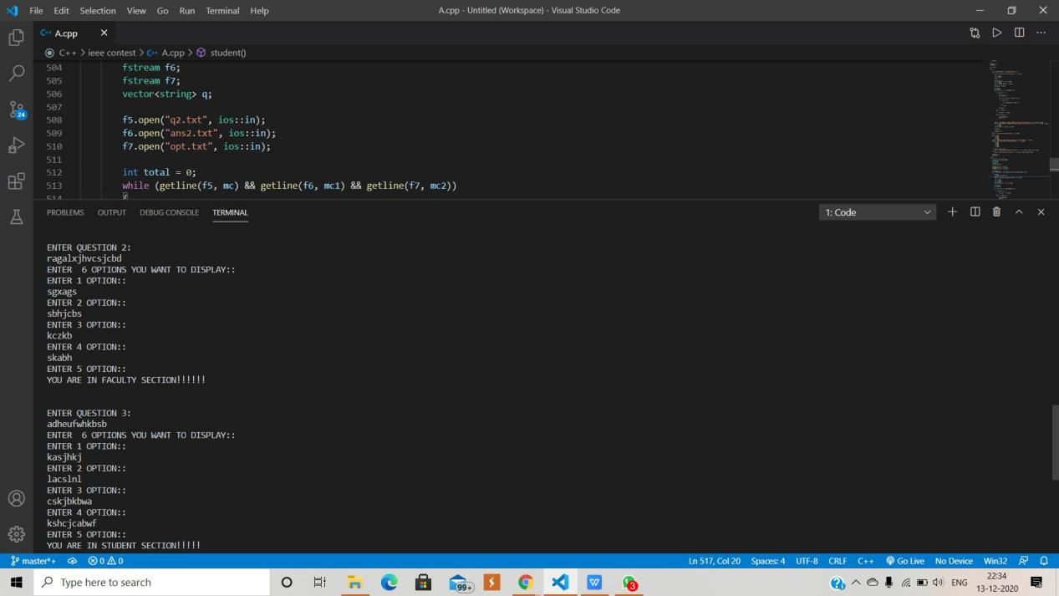

**LIST OF CONCEPTS AND DATA STRUCTURES USED**

The main Data structures which we are using in our project would be the concept of Hashing. Further in Hashing we are using the concept of linear probing to store the desired keywords.

In addition to it we are using the concept of file handling to store the information of questions to be answered and there answers.

We are also using the concept of KMP algorithm to search in most efficient manner.

We are also using the concept of STL.

In short we are using these many concepts:

Hashing(Linear probing), KMP Algorithm,STL, Array, File Handling.

**CORE FUNCTIONS**

The core functions in our program are:

* void login()
* FACULTY()
* student()
* search()
* match()
* ascii()
* compute()

**ALGORITHMS USED**

In computer science, the Knuth–Morris–Pratt string-searching algorithm (or KMP algorithm) searches for occurrences of a "word" W within a main "text string" S by employing the observation that when a mismatch occurs, the word itself embodies sufficient information to determine where the next match could begin, thus bypassing re-examination of previously matched characters.

The algorithm was conceived by James H. Morris and independently discovered by Donald Knuth "a few weeks later" from automata theory.Morris and Vaughan Pratt published a technical report in 1970. The three also published the algorithm jointly in 1977. Independently, in 1969, Matiyasevich discovered a similar algorithm, coded by a two-dimensional Turing machine, while studying a string-pattern-matching recognition problem over a binary alphabet. This was the first linear-time algorithm for string matching.

**REFERENCES**

* Geeksforgeeks
* Stackoverflow
* W3school