Deliverable 1 ( FR + NFR):
Category | ID | Type | Description | Priority | Acceptance Criteria | Rationale
Functional | FR-001 | Nearest-Rider Dispatch | The system shall match an outgoing courier request with the nearest active delivery rider within a 3 km radius using real-time GPS coordinates and rider availability status. | High | Pass: Rider receives dispatch notification with accurate pickup location, route preview, and estimated arrival time within 30 seconds of request submission. Fail: Order assigned to an offline rider, rider outside 3 km radius, or dispatch latency exceeds 60 seconds. | Minimizes pickup time and fuel cost, which directly improves customer satisfaction and rider earnings per hour. A 3 km cap prevents unreasonably long pickup legs that erode platform efficiency.
Functional | FR-002 | OTP Verification | The system shall generate a cryptographically unique 6-digit OTP for both package pickup and delivery handover, enforcing a 10-minute expiry window and a maximum of 3 validation attempts. | High | Pass: OTP verification succeeds with the correct code; fails and locks after 3 incorrect attempts; sender and rider both receive OTP via in-app notification and masked SMS. Fail: Package handed over without OTP validation, OTP accepted after expiry, or brute-force attempts not rate-limited. | Minimizes pickup time and fuel cost, which directly improves customer satisfaction and rider earnings per hour. A 3 km cap prevents unreasonably long pickup legs that erode platform efficiency.
Functional | FR-003 | Route Optimization | The system shall compute and push an optimized multi-stop delivery route to the assigned rider, factoring in real-time traffic, delivery time windows, package priority flags, and estimated stop durations. | High | Pass: Rider receives a route with total completion time, turn-by-turn navigation, and dynamic re-routing when traffic conditions change. Fail: Route distance exceeds the mathematically optimal path by more than 15%, or high-priority deliveries are sequenced after standard ones. | Reduces per-delivery time and distance, allowing a single rider to complete more orders per shift while ensuring time-sensitive packages are not delayed.
Functional | FR-004 | Live Tracking | The system shall stream live GPS telemetry and delivery status updates to the sender client at intervals not exceeding 5 seconds, displaying rider location, current stop, and estimated delivery time. | Medium | Pass: Sender client displays rider location within 10-meter accuracy; status transitions (picked up, in transit, arriving, delivered) reflect actual rider actions within 10 seconds. Fail: Location data is stale for more than 30 seconds, position drift exceeds 100 meters, or status updates are lost during network handoff. | Real-time visibility reduces customer anxiety and support ticket volume; it also builds trust in the platform, increasing repeat usage.
Functional | FR-005 | Order Cancellation | The system shall allow the sender client to cancel an active courier request any time before the pickup OTP is validated, automatically processing refunds per a time-based cancellation policy and notifying the rider in real time. | Medium | Pass: Cancellation succeeds instantly before pickup OTP verification; refund is initiated within 5 minutes; rider receives push notification and the order is removed from their queue. Fail: Cancellation is permitted after pickup OTP validation, refund is delayed beyond 24 hours, or rider is not notified of cancellation before reaching the pickup point. | Real-time visibility reduces customer anxiety and support ticket volume; it also builds trust in the platform, increasing repeat usage.
Non-Functional | NFR-001 | Performance & Security | Delivery status and live GPS telemetry updates from riders shall transmit to the sender client with under 2-second end-to-end latency using TLS 1.3 encrypted WebSocket connections with AES-256-GCM payload encryption. | High | Pass: Benchmarking under simulated peak load (1,000 concurrent riders, 5,000 active tracking sessions) confirms p95 latency ≤ 2s, p99 latency ≤ 3s, zero unencrypted data frames, and successful penetration test against OWASP Top 10. Fail: p95 latency exceeds 5 seconds, plaintext GPS coordinates detected in transit, or man-in-the-middle vulnerability confirmed. | Sub-2-second latency is the threshold where tracking feels "live" rather than delayed; strong encryption is mandatory because GPS traces are personally identifiable data subject to data-protection regulations.
Non-Functional | NFR-002 | Availability & Reliability | The dispatch engine shall maintain 99.9% uptime during declared operational hours (06:00–23:59 local time) and execute automatic failover to a hot-standby secondary region within 30 seconds of primary node failure, with zero unacknowledged order state loss. | High | Pass: 30-day availability measurement ≥ 99.9% (≤ 43 minutes cumulative downtime); failover completes within 30 seconds; all in-flight orders retain consistent state post-failover verified by chaos-engineering tests. Fail: Monthly downtime exceeds 43 minutes; failover exceeds 60 seconds; or any active order shows inconsistent status after recovery. | Dispatch is the revenue-critical path; any outage means zero order fulfillment and immediate financial loss. 99.9% uptime aligns with industry SLAs for on-demand logistics platforms.
Deliverable 2:
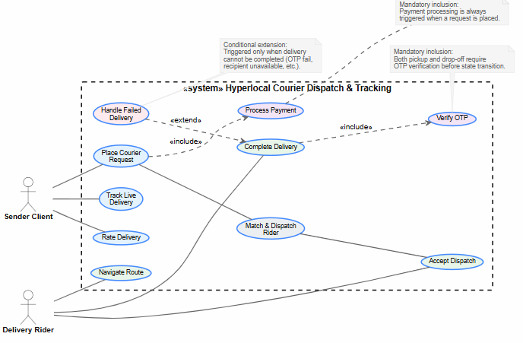

Deliverable 3:
Preconditions
- The Sender Client has successfully created an outgoing courier request, and the system has matched and assigned it to the nearest active Delivery Rider.
- The Delivery Rider is logged into the mobile application and currently set to an active status.
Postconditions
- The package status is updated to "Delivered" in the system database.
- The payment transaction is finalized, and the delivery metrics/logs are archived.
Main Success Scenario (MSS)
- The system sends a dispatch notification containing the pickup location to the assigned Delivery Rider's device.
- The Delivery Rider opens the app and taps Accept Order.
- The system updates the order status to "Accepted" and provides turn-by-turn navigation to the pickup location.
- The Delivery Rider arrives at the pickup location, collects the package from the Sender Client, and updates the status to "Picked Up" in the app.
- The system initiates live GPS telemetry streaming to transmit location updates to the Sender Client.
- The Delivery Rider navigates to the destination and arrives at the drop-off location.
- The system automatically triggers and sends a secure One-Time Password (OTP) to the recipient/Sender Client.
- The Delivery Rider requests the OTP from the recipient and enters it into the mobile application.
- The system validates the entered OTP against the generated code.
- The system marks the delivery as successfully completed, terminates live telemetry tracking, and logs the timestamp.
Alternate Flows
- A1. Rider Rejects or Misses Dispatch Notification:
  - 1a. At any point before acceptance, if the Delivery Rider rejects the notification or the 60-second acceptance timer expires:
  - 1b. The system revokes the dispatch assignment from the current rider.
  - 1c. The system triggers a re-matching algorithm to find the next nearest active delivery rider within the radius and loops back to step 1 of the Main Success Scenario.
- A2. Invalid OTP Entered:
  - 9a. If the OTP entered by the Delivery Rider does not match the system record:
  - 9b. The system displays an "Invalid OTP, please try again" error message on the rider's screen.
  - 9c. The Delivery Rider requests the correct OTP from the recipient and re-enters it (allows up to 3 attempts).
  - 9d. [Exceeding max attempts] If 3 consecutive invalid attempts occur, the system flags the order for manual customer support intervention and temporarily locks the delivery verification screen.

