Step 1: Install software

Step 2: Create working directory for storing database data

Step 3: Create environment variable PATH = C:\Program Files\MongoDB\Server\3.2\bin

Step 4: To run MongoDB just open cmd prompt and type mongod and enter

Step 5: To configure Intellij IDE follow below screen shot

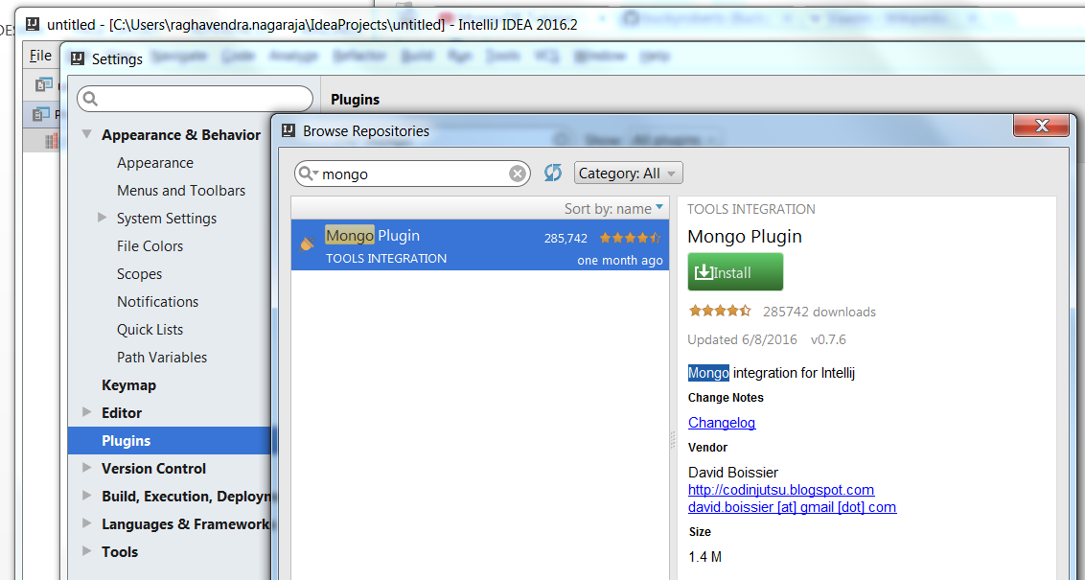

Other details,

**Component Set Binaries**

Server mongod.exe

Router mongos.exe

Client mongo.exe

MonitoringTools mongostat.exe, mongotop.exe

ImportExportTools mongodump.exe, mongorestore.exe, mongoexport.exe, mongoimport.exe

MiscellaneousTools bsondump.exe, mongofiles.exe, mongooplog.exe, mongoperf.exe

Open in web browser

mongod --rest –httpinterface

mongod –httpinterface

Reference link,

<https://docs.mongodb.com/manual/tutorial/install-mongodb-on-windows/>

MongoDB Atals

Features

* Monitoring
* Alerts
* Backups
* Settings
* Maintenance
* Infrastructure

Practice

* db.createCollection("userData")