Robotic hand

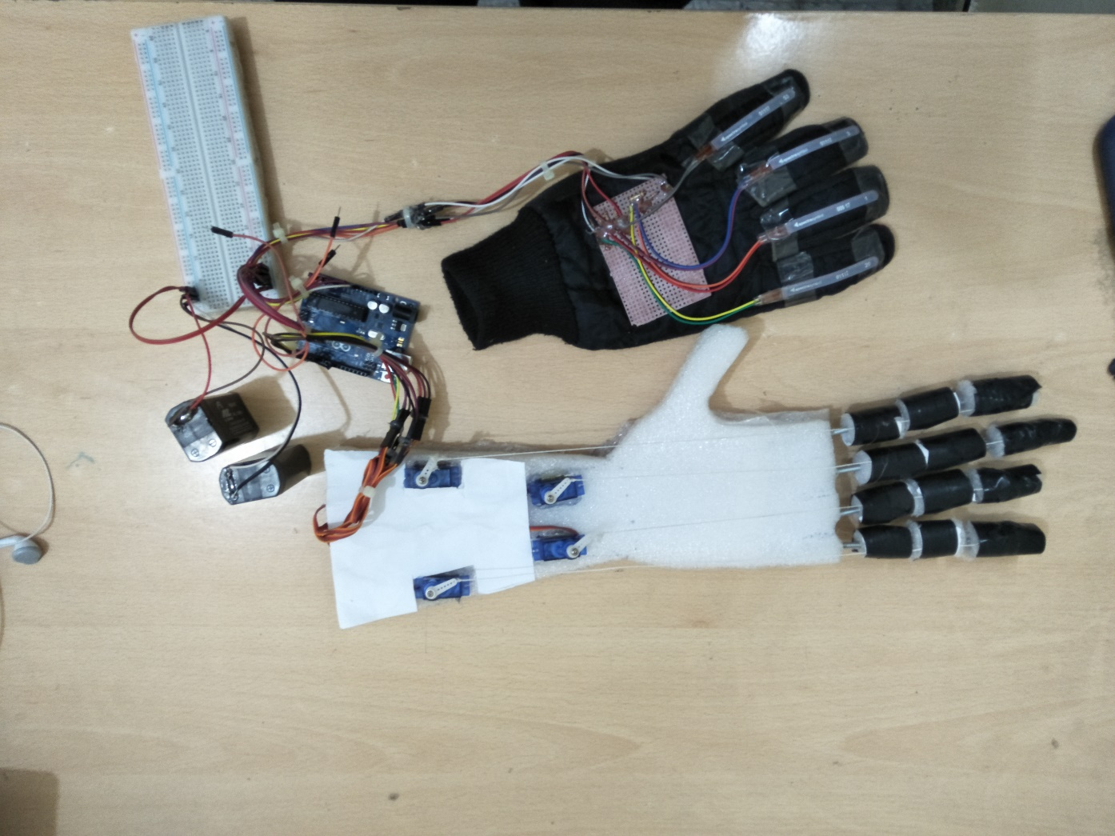

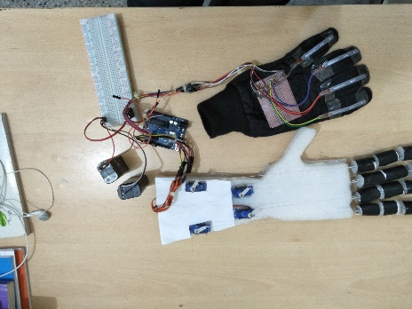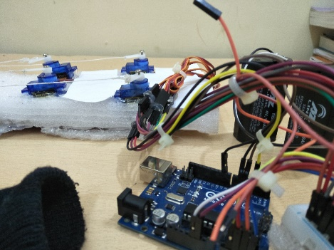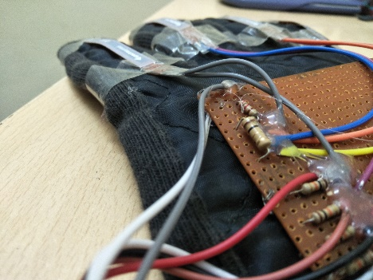

**MADE BY:-**

1.Naveen dugar-2107uec2142

2.Raghav -2017uec2144

INTRODUCTION :-

Robotics could easily be one of the most researched fields of modern technology. New inventions and innovations in the field have led to the whole new set of devices with intricate designs, a large number of degrees of freedom (DOF), pinpoint accuracy, rapid and reliable actuation and longer life span. One widely researched branch of robotics involves designing of biomimetic devices. The research in this area is driven by the clear goal of achieving design and control algorithms that will resemble those found in biological counterparts. In this research work, we are particularly interested in mimicking the motion of the human hand. The human hand is one of the most intricate mechanisms found in nature and possesses high complexity and utility. All the digits are required to act in unison to perform complex motions.

Amputees often suffer from psychological and physical difficulties due to their inability to use their extremities. To aid the amputees in acquiring a functional replacement hand at a feasible cost, a prototype prosthetic was created utilizing Flexy Hand, a hand model, and Arduino, an open source microprocessor. To avoid expensive and frustrating control methods associated with myoelectric prosthetics, an glove with sensor allows the user to select a gesture that he wishes the hand to perform. The sensors send this information to the Arduino, which powers certain servos to actuate each finger individually. The simple construction and low cost of materials, as well as the use of sensors, enables amputees to gain access to new prosthetics with ease.

Material Used :-

1.Arduino UNO

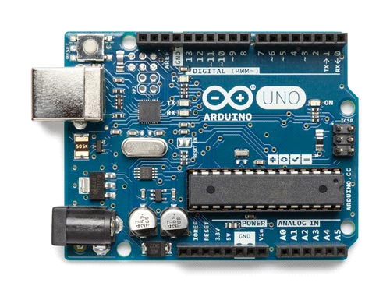

2.Flex Sensors

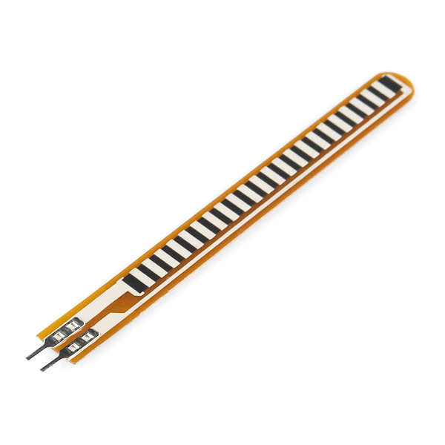

3.Servo

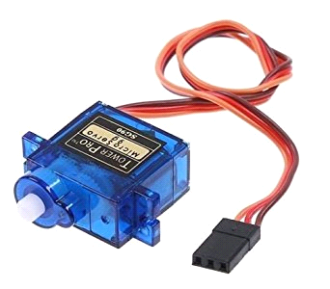

4.Steel coin spring

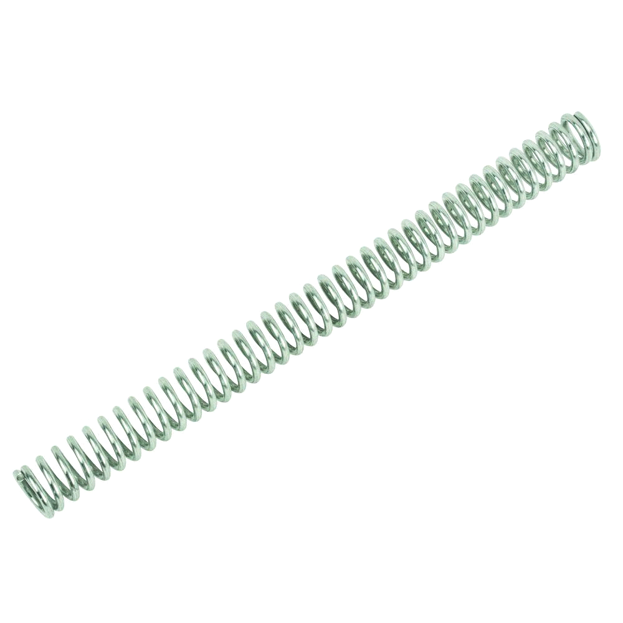

5.Jumper Wire

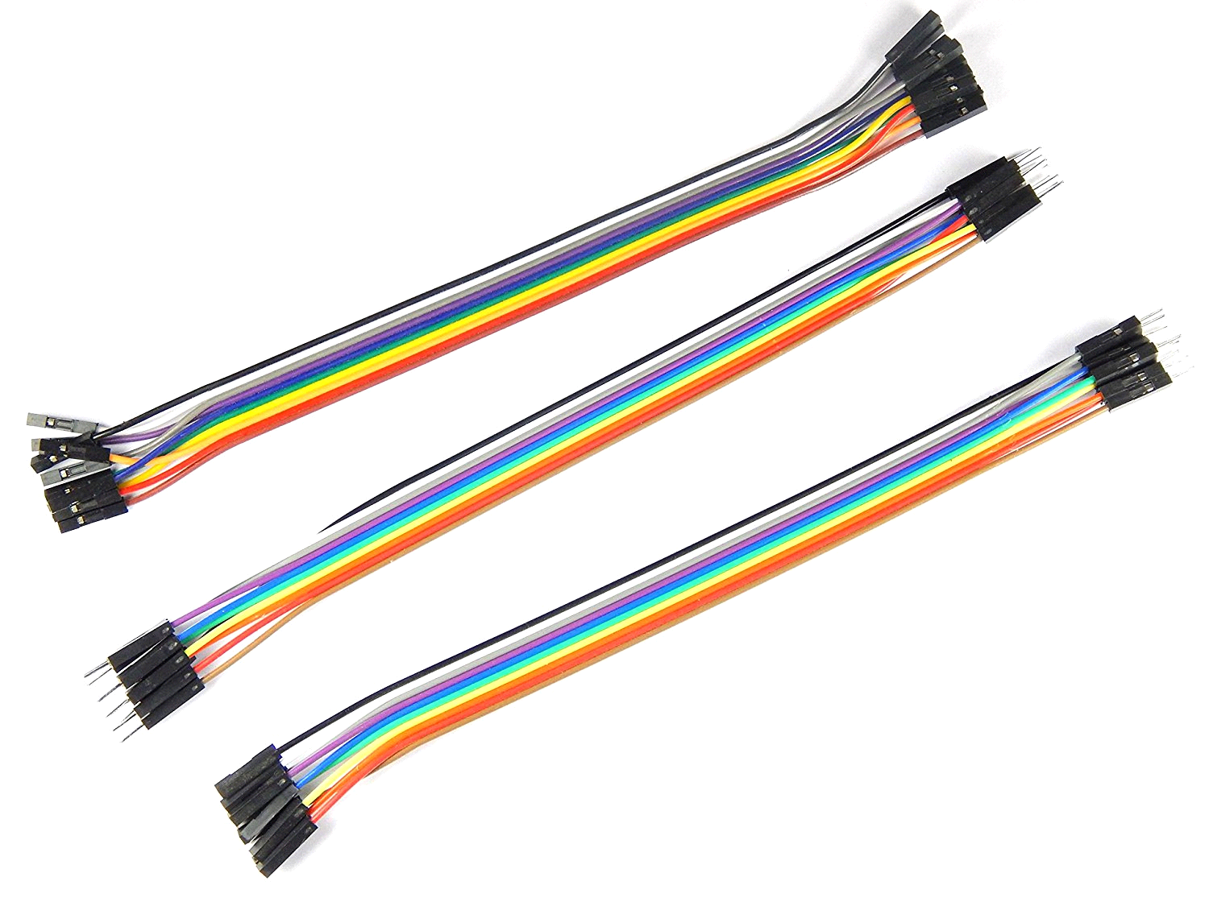

6.Bread Board

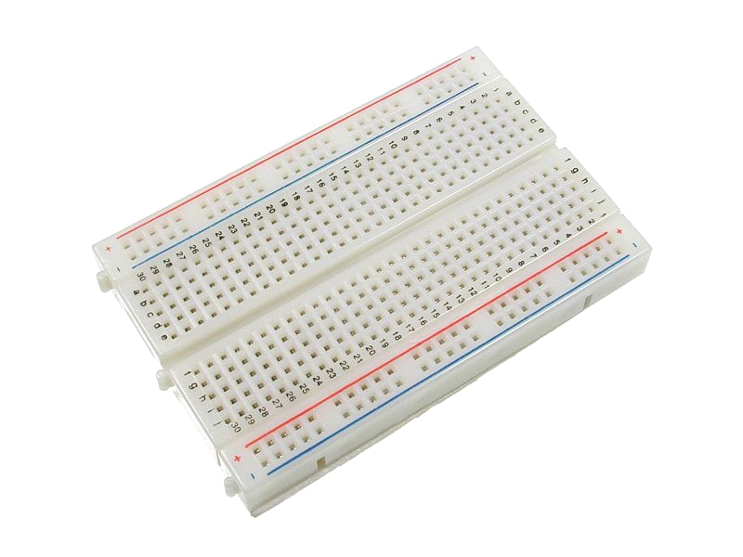

4.Resistance 10k ohm

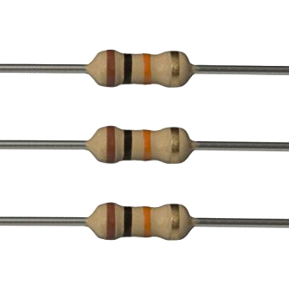

5.Battery 4V

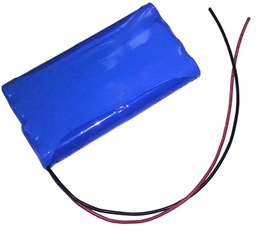

*CIRCUIT DIAGRAM*

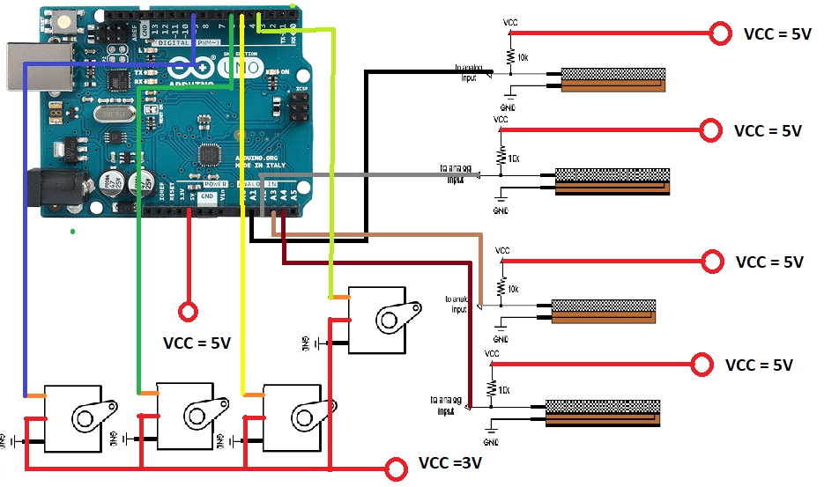

code

#include<Servo.h>

//defining servo name

Servo servo1;

Servo servo2;

Servo servo3;

Servo servo4;

void setup()

{

//set baudrate at 9600 btps

Serial.begin(9600);

//On Analog Pins

pinMode(A1,INPUT);

pinMode(A2,INPUT);

pinMode(A3,INPUT);

pinMode(A4,INPUT);

//defining servo pin

servo1.attach(3);

servo2.attach(5);

servo3.attach(6);

servo4.attach(9);

}

void loop()

{

int val1=analogRead(A1); //Read Analog Signal

int pos1=map(val1,600,800,0,180); //Map readed Analog Signal to 0-180

servo1.write(pos1); //Move Servo

delay(1); //Delay servo for 1millisec

int val2=analogRead(A2);

int pos2=map(val2,600,800,0,180);

servo2.write(pos2);

delay(1);

int val3=analogRead(A3);

int pos3=map(val3,600,800,0,180);

servo3.write(pos3);

delay(1);

int val4=analogRead(A4);

int pos4=map(val4,600,800,0,180);

servo4.write(pos4);

delay(1);

}