Steps to make the AWS Micorservices Up and Running

1. To start the AWS server, Navigate to <https://rc-lx854.ut.dentegra.lab:8443/rundeck/project/AWS_DEV/job/show/7656b880-b0ff-4a4b-8b40-b11bfbe71084> and enter the server name and click on “Run Job” as show below.

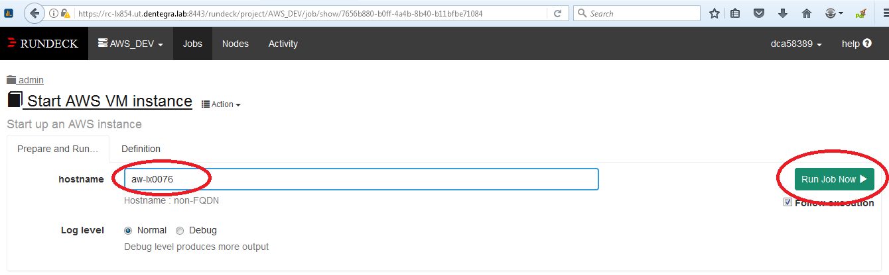

1. Run Jenkins job to deploy and run the micro services in MOCKING mode for AWS, Navigate to the following url <https://rc-lx850.ut.dentegra.lab:8443/view/CX%20Dashboard/job/DEV_Build_CX_MICROSERVICES/>

and click on the option “[Build with Parameters](https://rc-lx850.ut.dentegra.lab:8443/job/DEV_Build_CX_AWS/build?delay=0sec)” and then click the “Build” button as shown below.

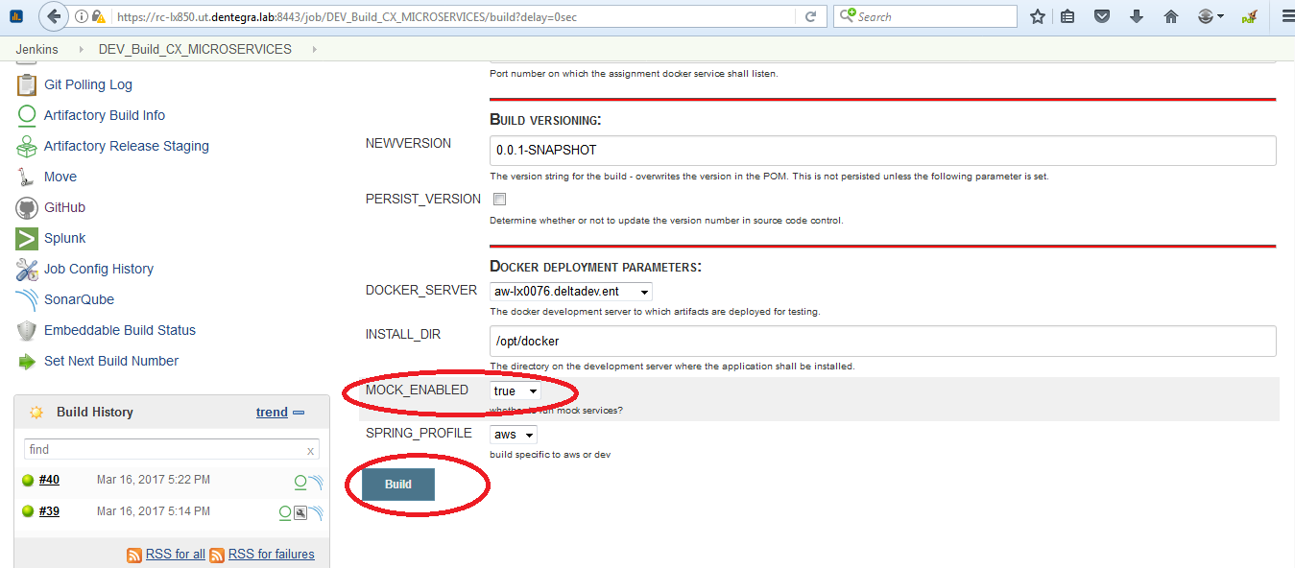

1. Run Jenkins job to deploy and run the micro services in regular mode for AWS, Navigate to the following url <https://rc-lx850.ut.dentegra.lab:8443/view/CX%20Dashboard/job/DEV_Build_CX_MICROSERVICES/>

and click on the option “[Build with Parameters](https://rc-lx850.ut.dentegra.lab:8443/job/DEV_Build_CX_AWS/build?delay=0sec)” and change the values for “MOCK_ENABLE=false” and click the “Build” button as shown below.

