**DATABASE EXERCISE**

**EMP ID - 4099**

**RAGHAV GUPTA**

**https://docs.google.com/document/d/1EmvtvZ0JaW9M6o4R4_Smm4k1Kut-MKeDx1FnJS-hc14/edit?usp=sharing**

1. Create Database

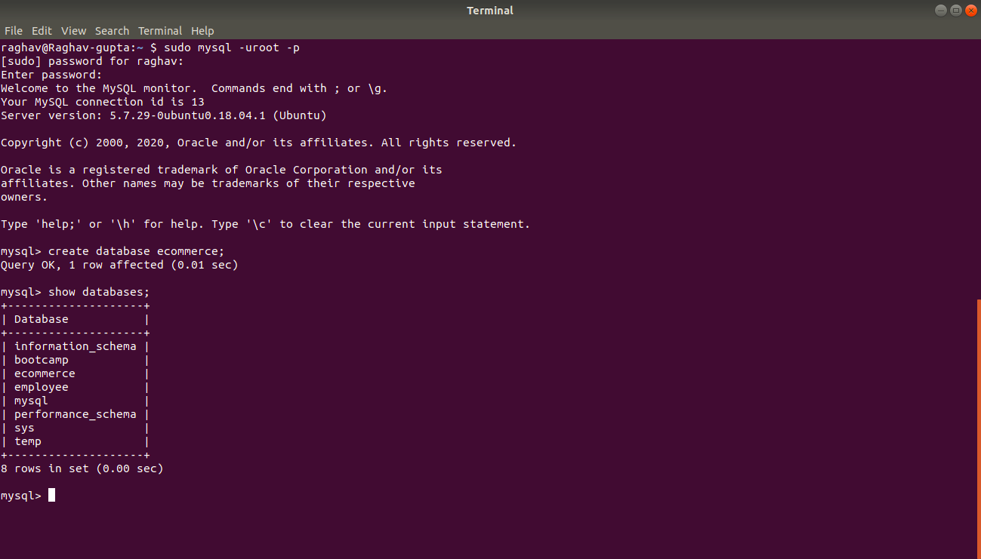

1. Design Schema
2. Create tables

2 and 3 answered together ----

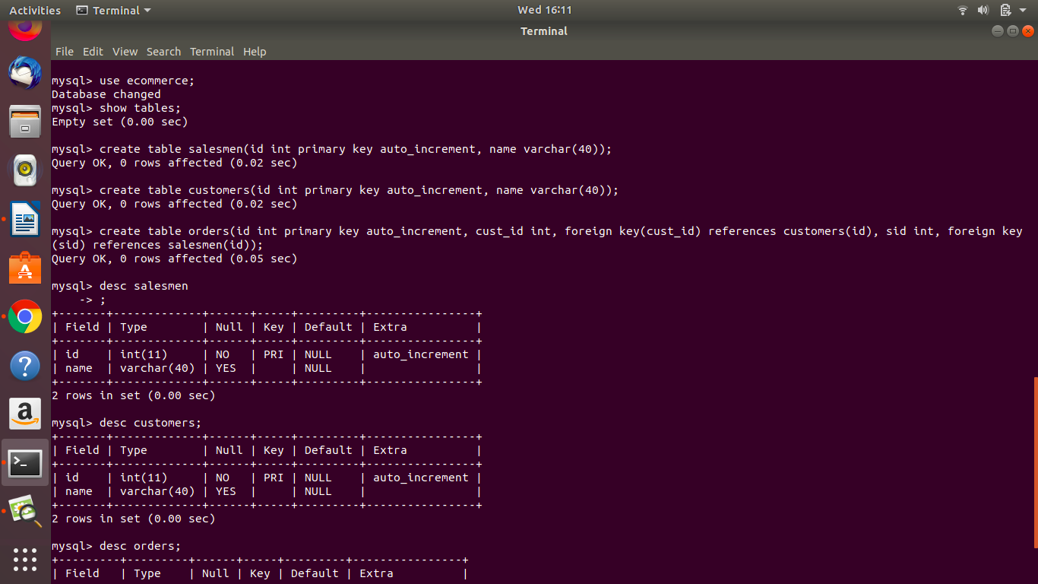





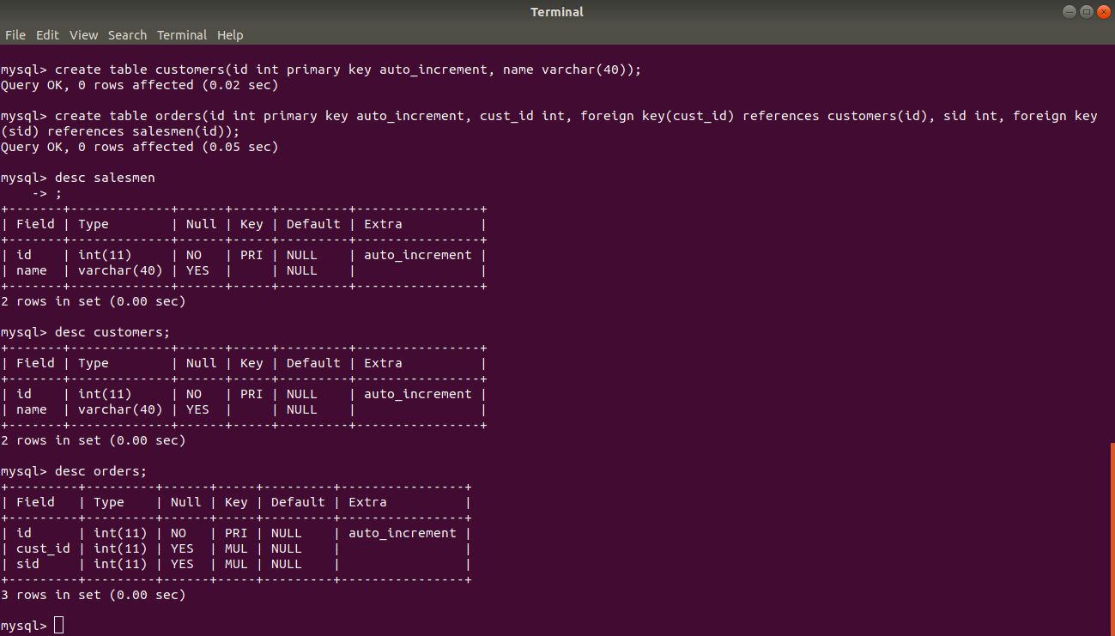

1. Insert sample data

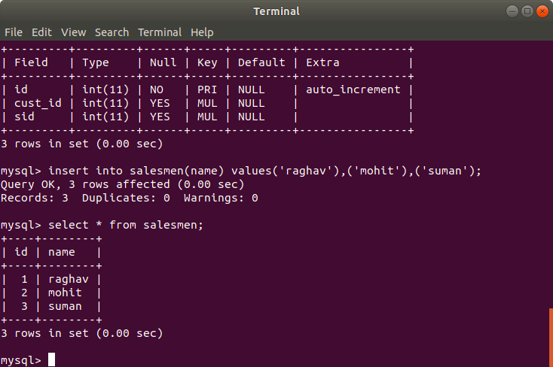

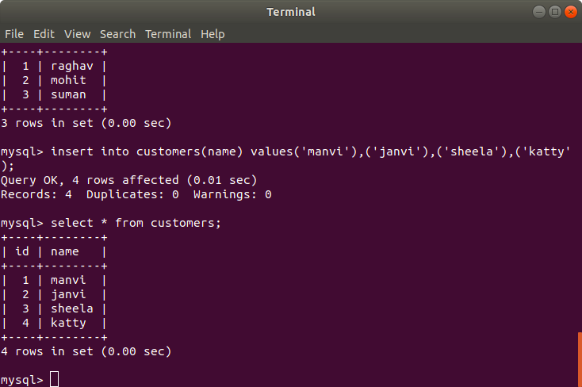

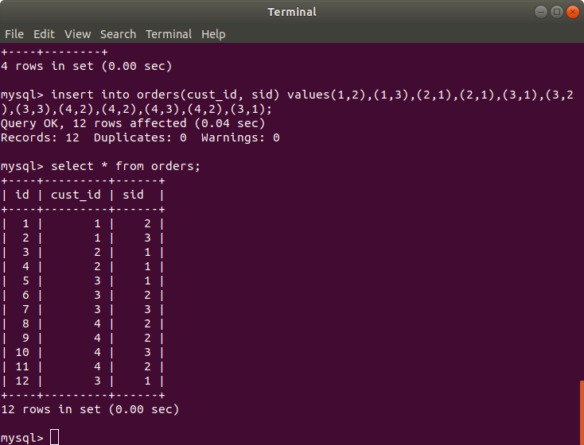

1. Find the sales person have multiple orders.

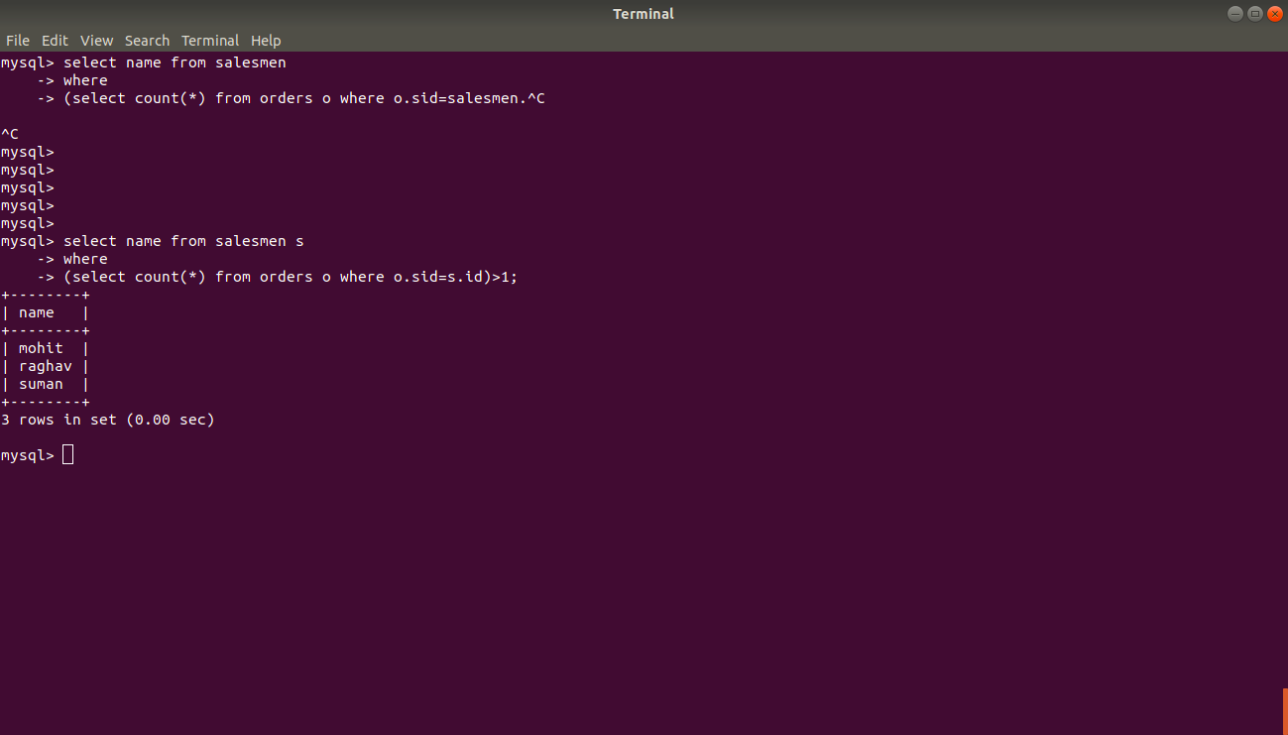

1. Find the all sales person details along with order details

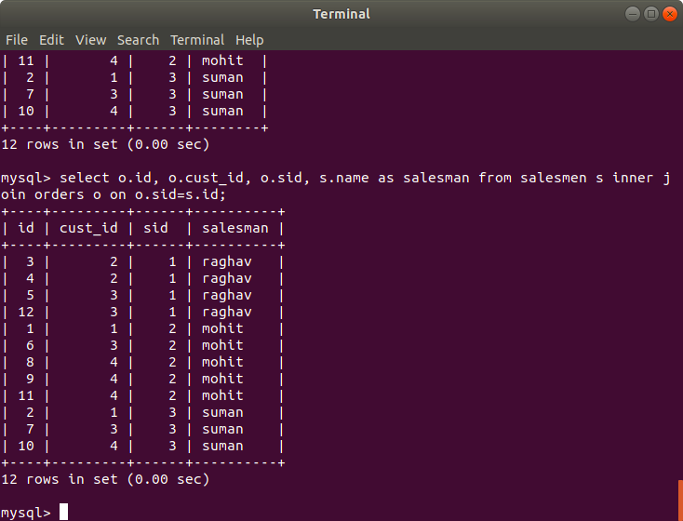

1. Create index
2. How to show index on a table

7 and 8 -- together answered

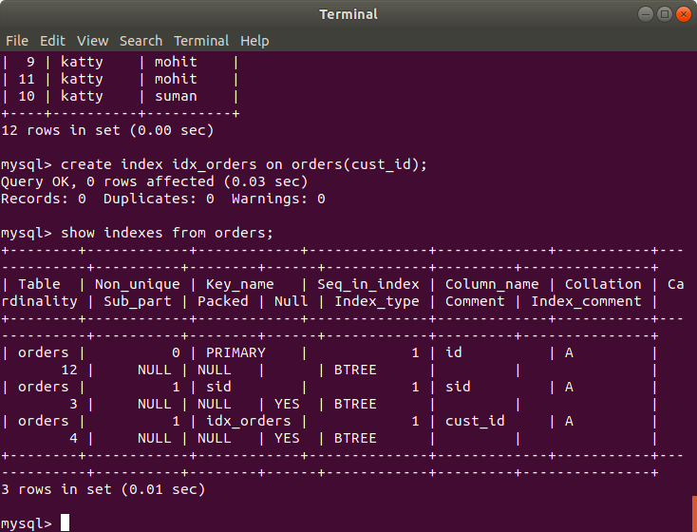

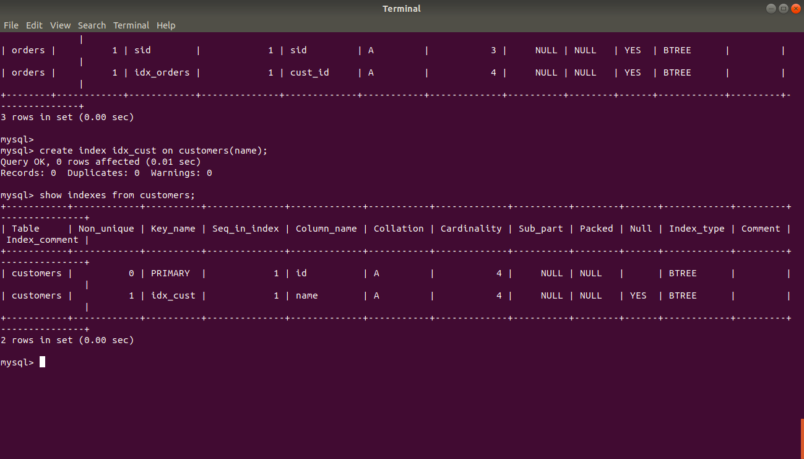

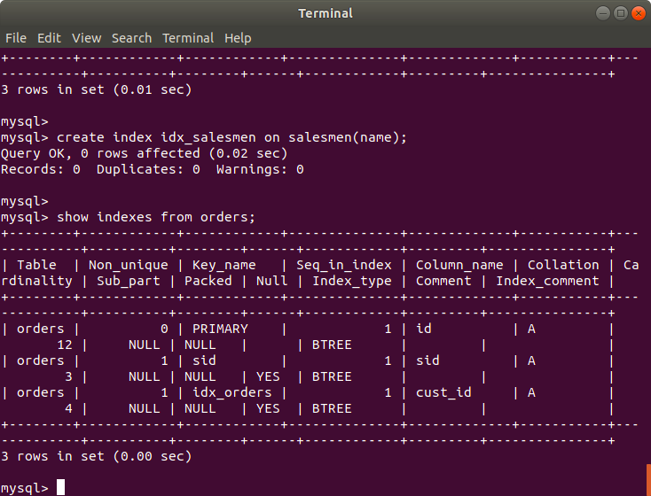

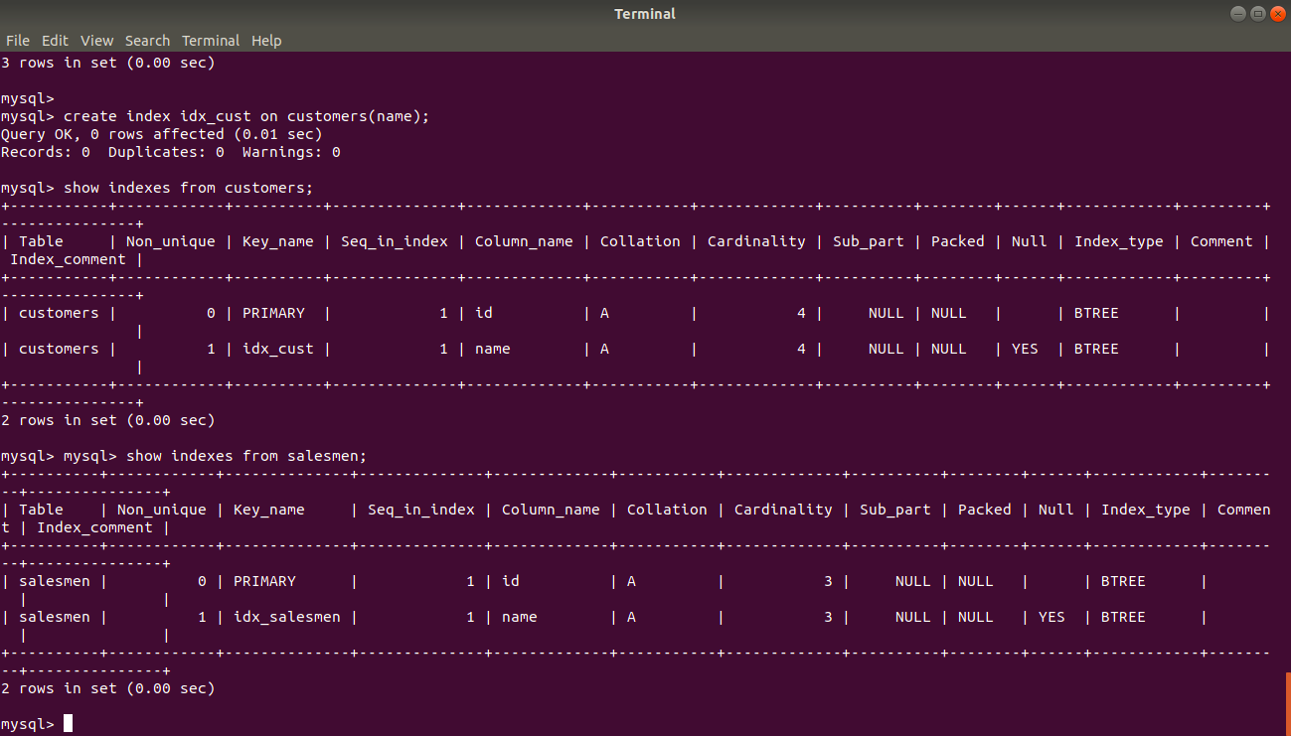

1. Find the order number, sale person name, along with the customer to whom that order belongs to

