**GIT EXERCISE SOLUTION**

**Empid - 4099 - raghav gupta**

**Question 1- Git Setup** [**https://confluence.atlassian.com/bitbucket/set-up-git-744723531.html**](https://confluence.atlassian.com/bitbucket/set-up-git-744723531.html)

Sudo apt-get update

Sudo apt-get install git

Git --version

Git config --global user.name raghavGuptaTTN

Git config --global user.email [raghav.gupta@tothenew.com](mailto:raghav.gupta@tothenew.com)

**Question 2. Initialize a Git Repository**

Create a repository on github.com

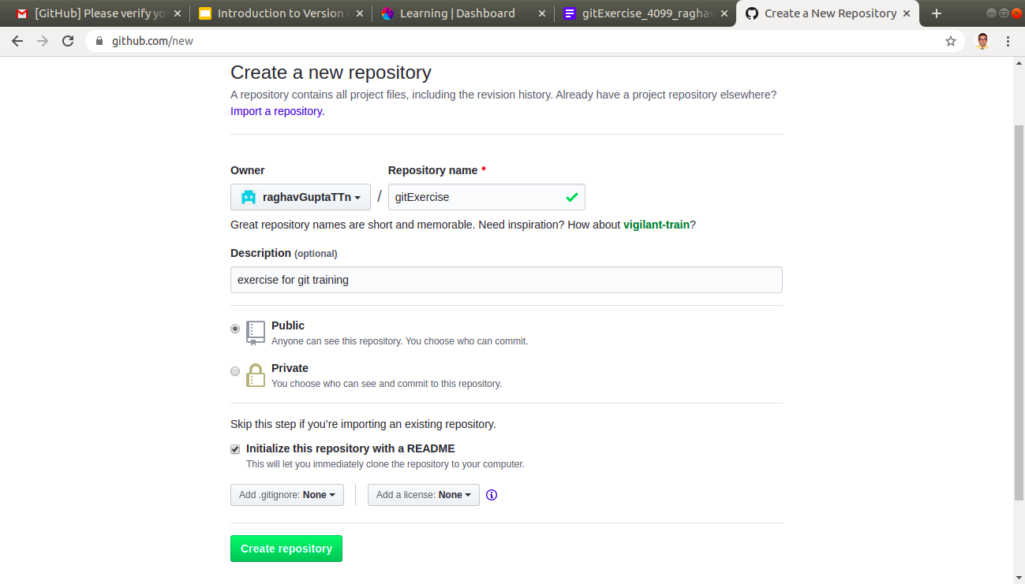

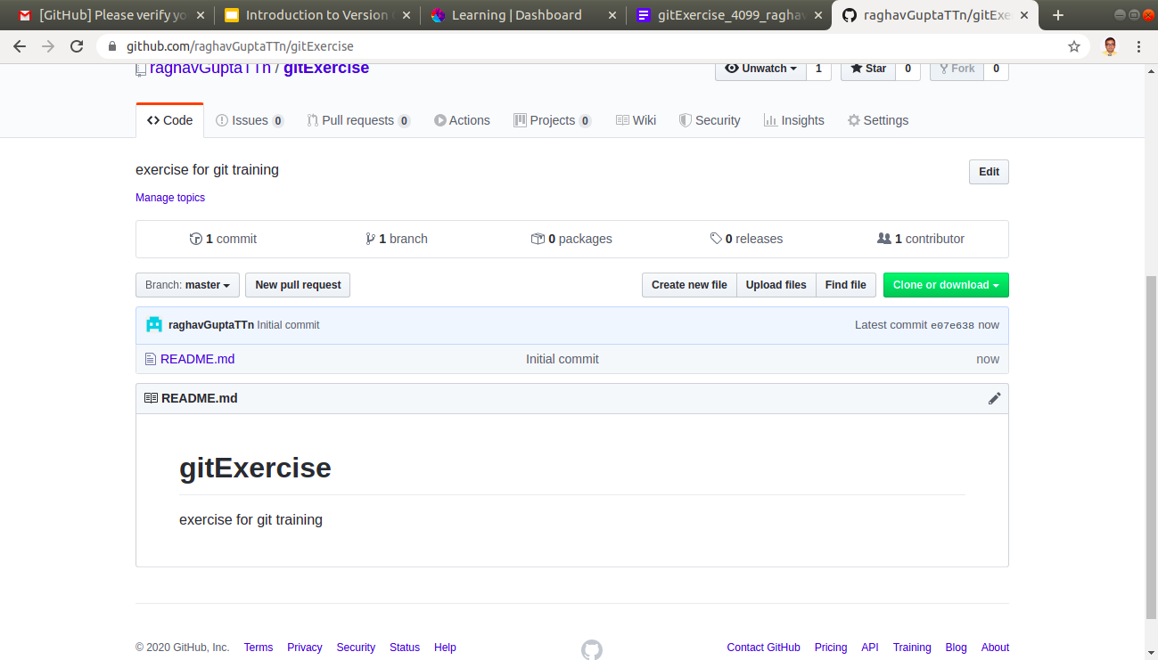

Now create a folder gitExercise and cd into that

Now, run git init

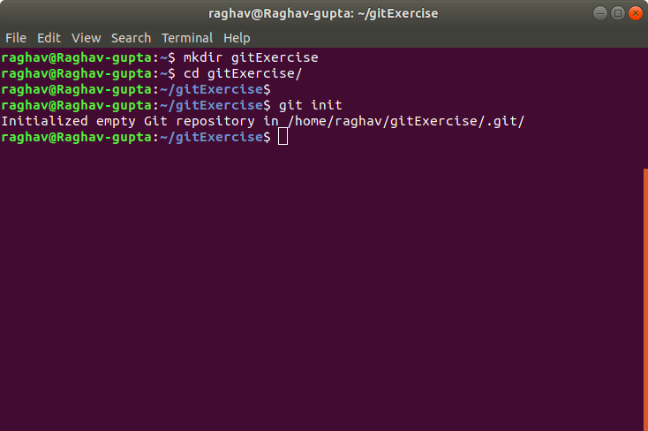

**Question 3. add files to the repository**

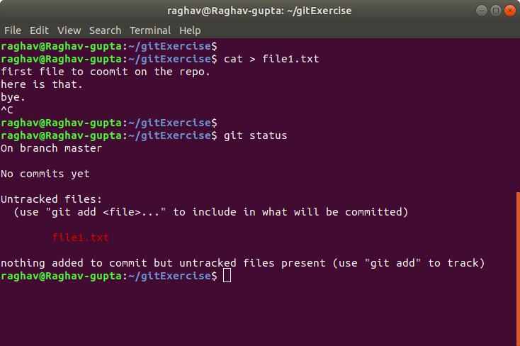

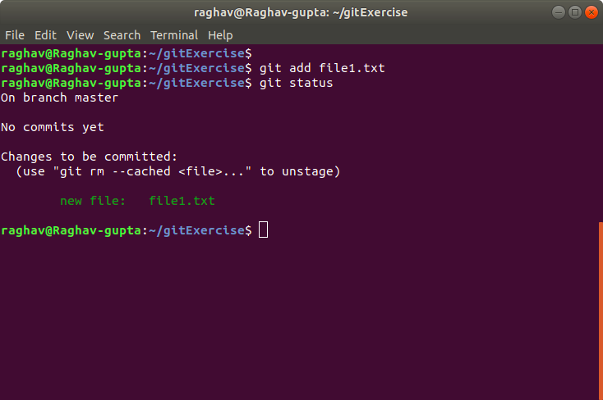

**Question 4. Unstage 1 file**

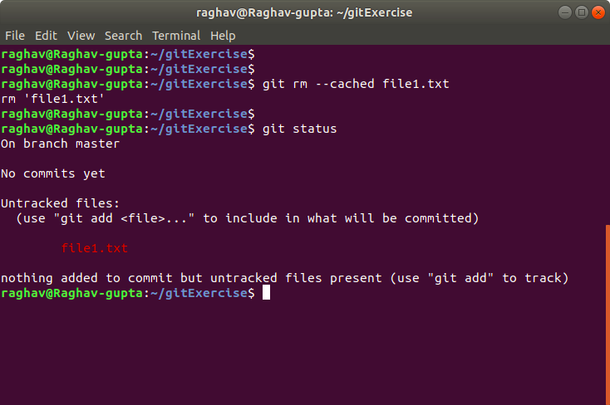

**Question 5. Commit the file**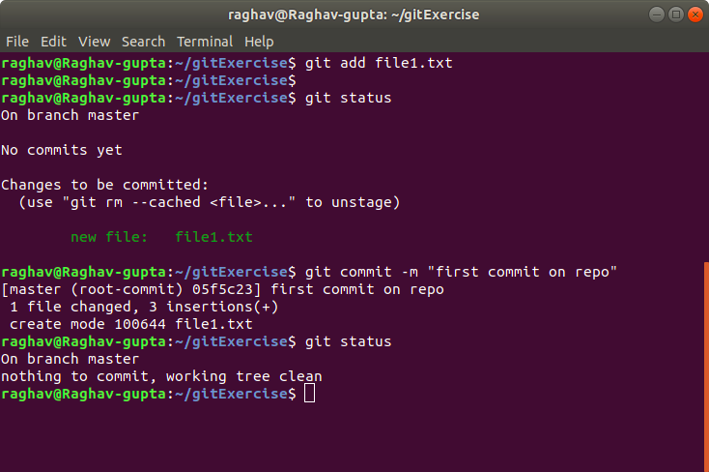

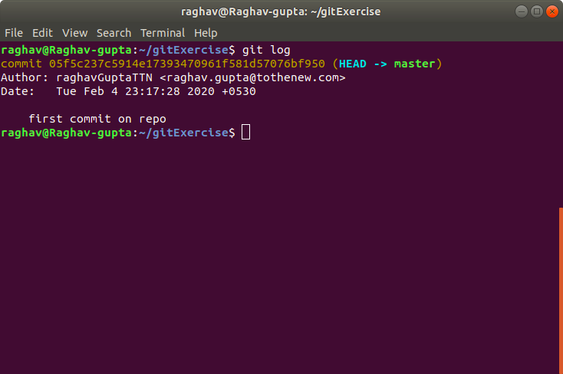

**Question 6. Add a remote**

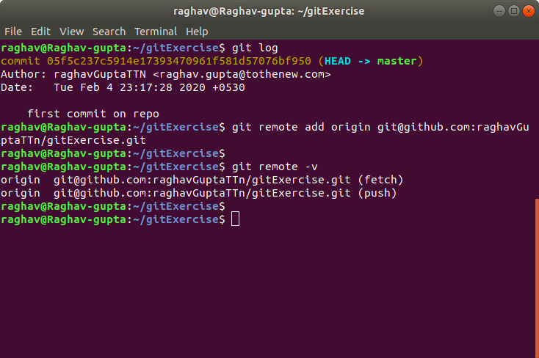

**Question 7. Undo changes to a particular file**

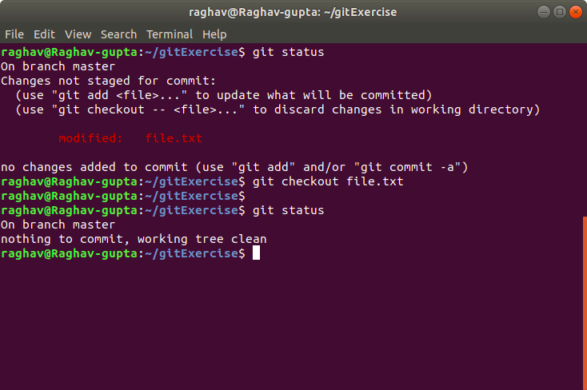

**Question 8. Push changes to Github**

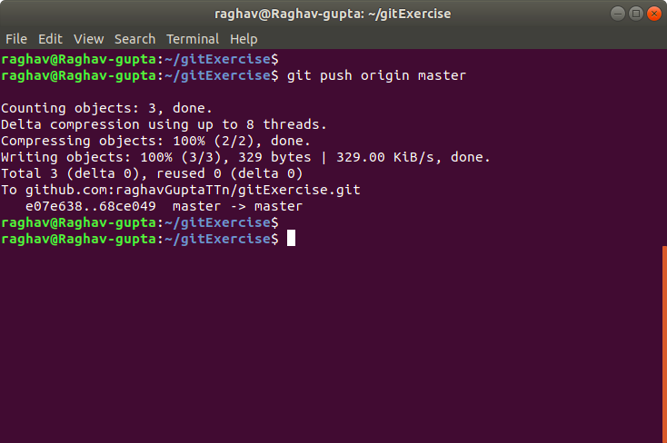

**Question 9. Clone the repository**

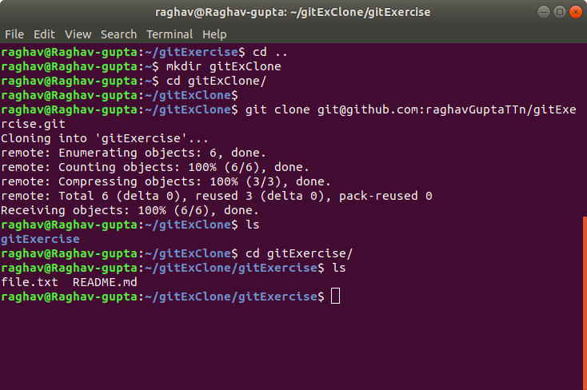

**Question 10. Add changes to one of the copies and pull the changes in the other.**

Go to the cloned repository folder.

Create a new file

Add, commit, and push it

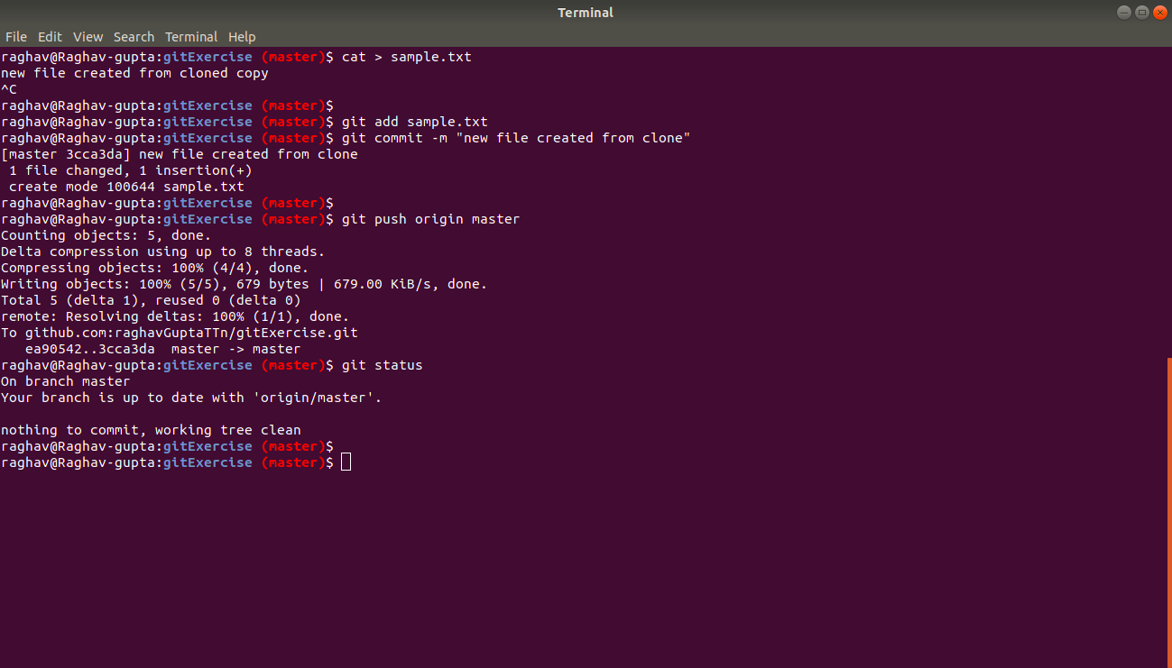

Then,

Now go to the actual initiallised repository

Pull the changes

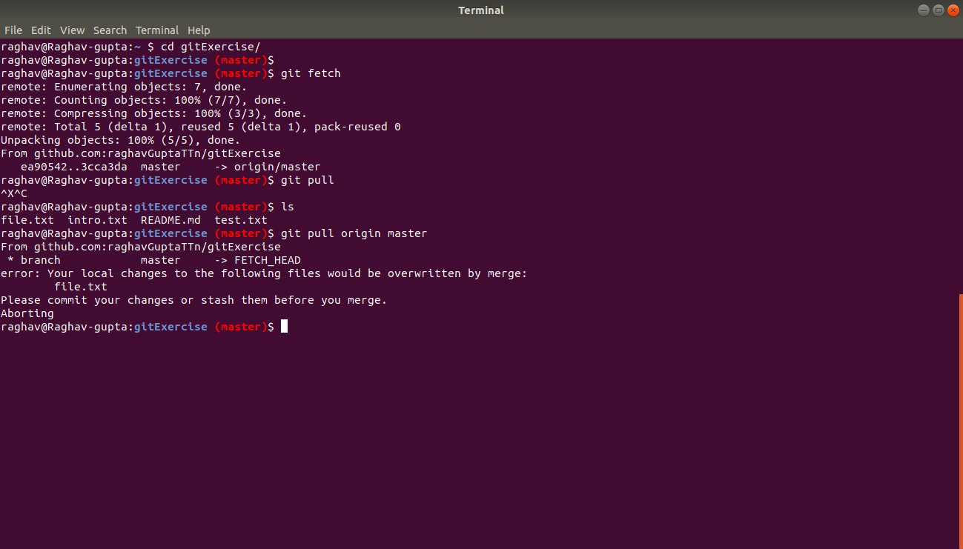

Intially pull failed, because of changes in the working directory.

I stashed them.

Try again then.

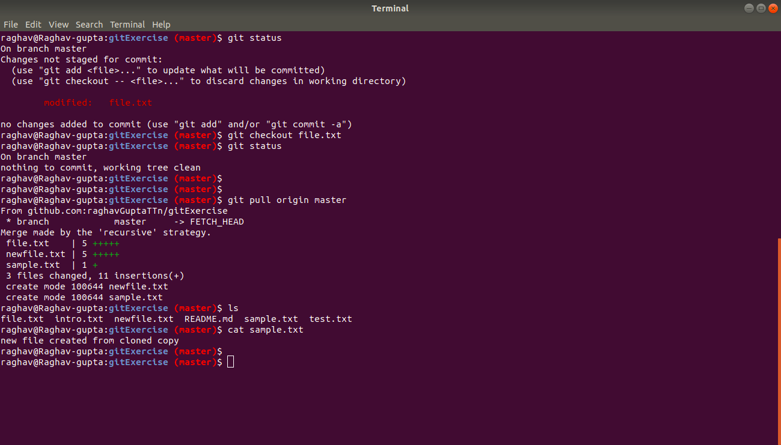

Now, we can see the sample.txt file here also.

Done..

**Question 11. Check differences between a file and its staged version**

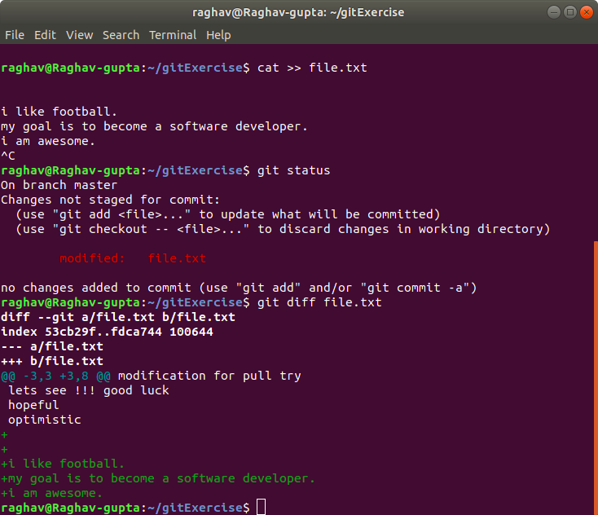

Now, do “git add file.txt” and then see below,

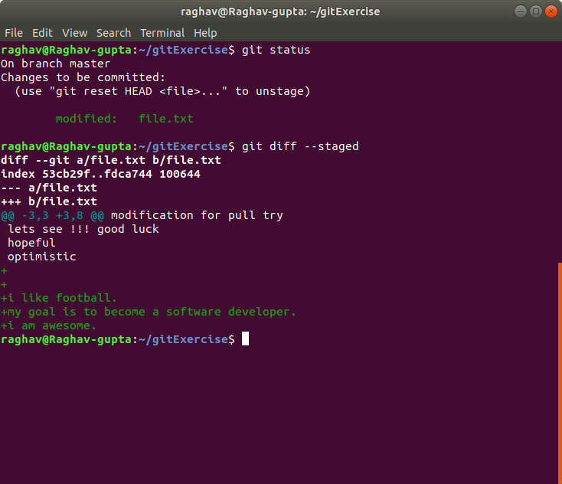

**Question 12. Ignore a few files to be checked in**

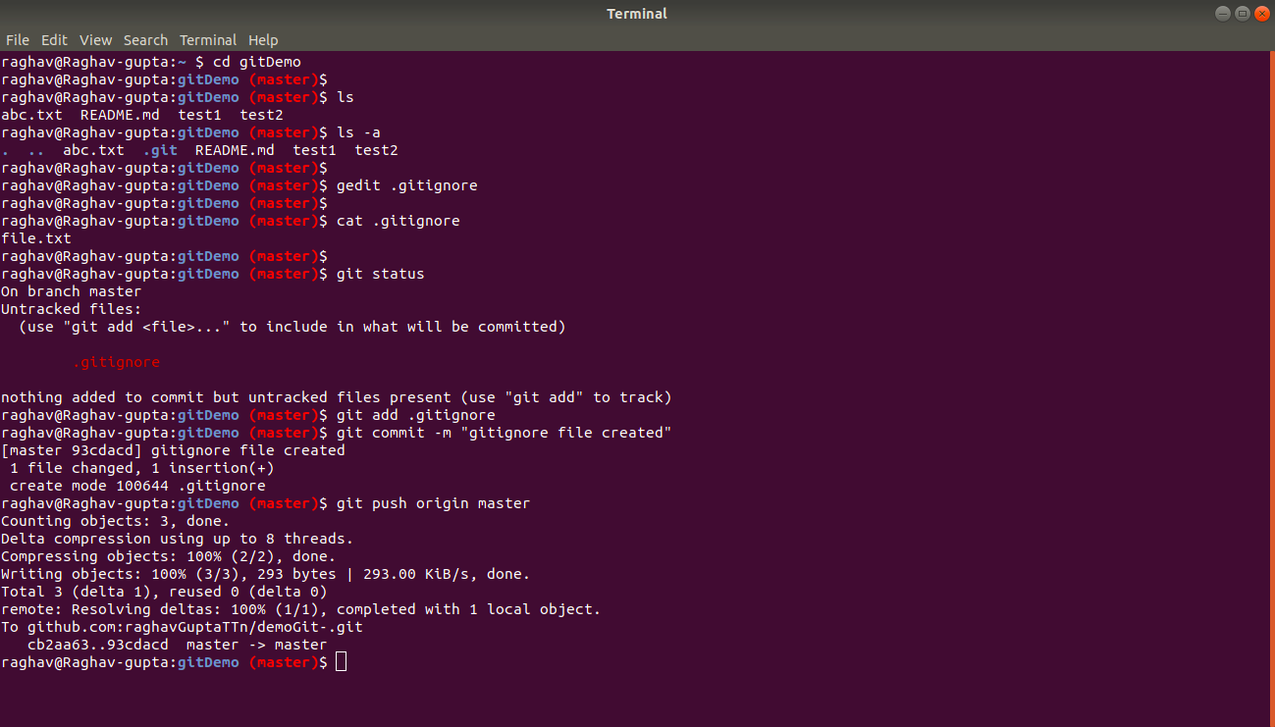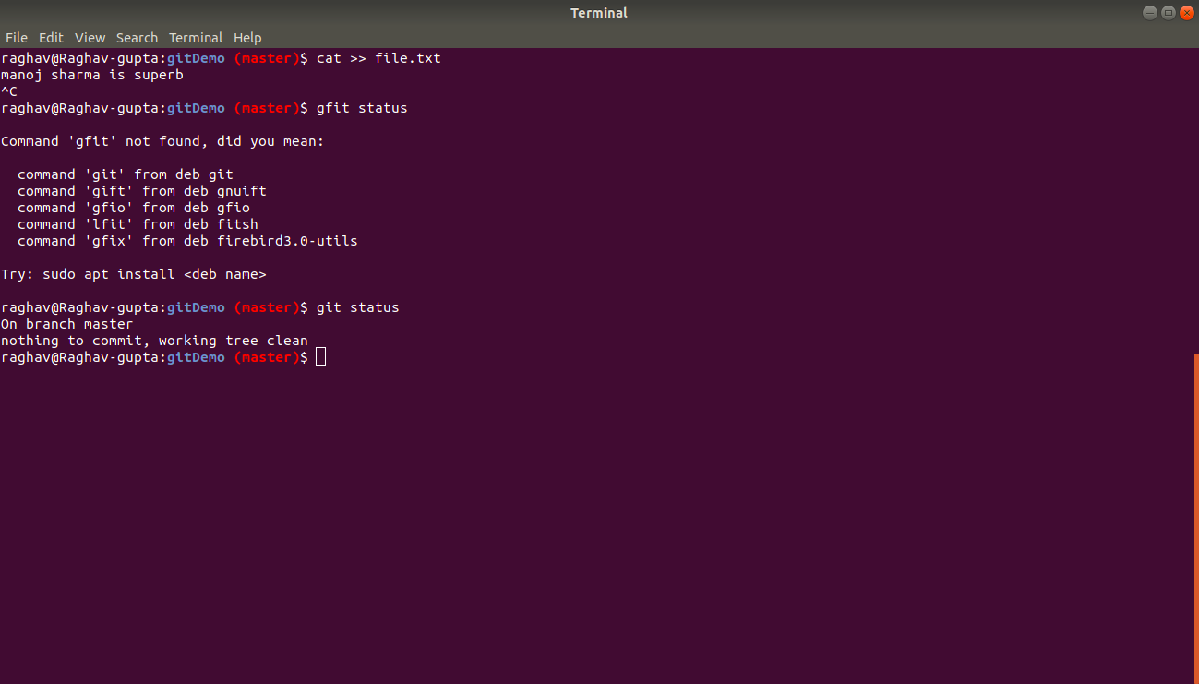

**Question 13. Create a new branch.**

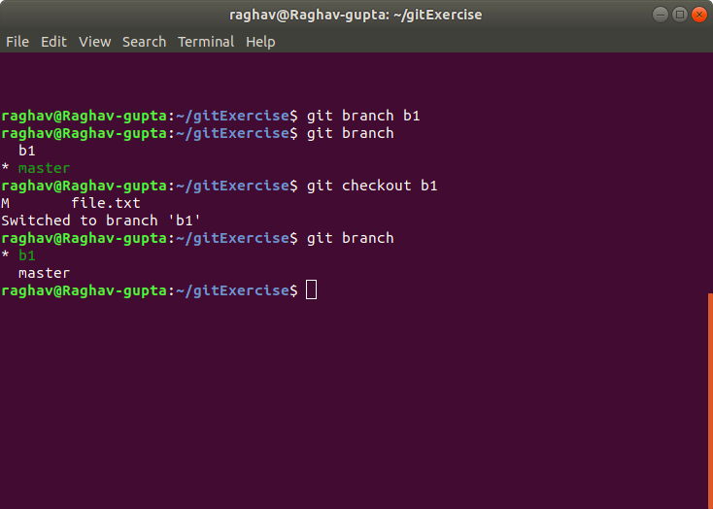

**Question 14. Diverge them with commits**

I made 2 commits in both the branches

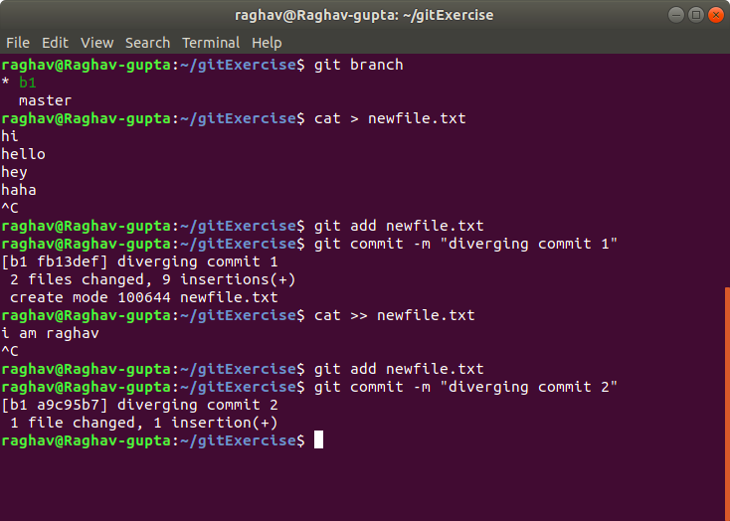

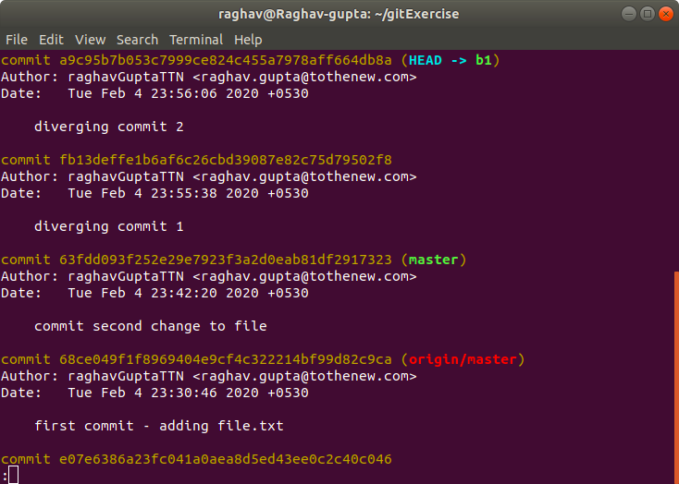

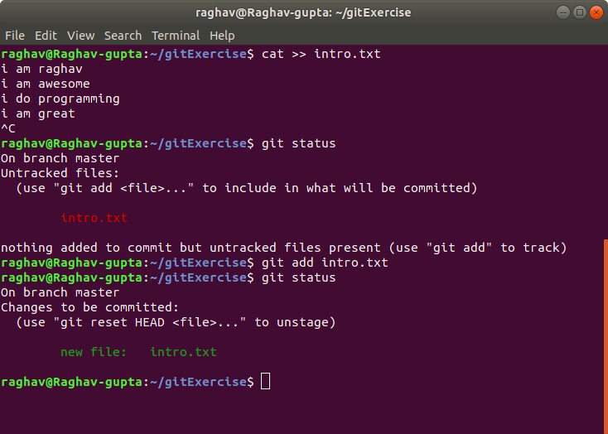

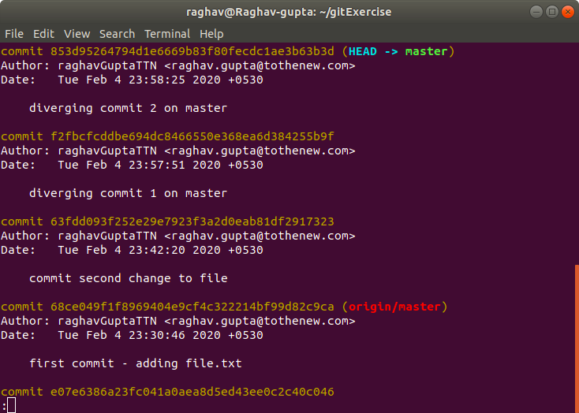

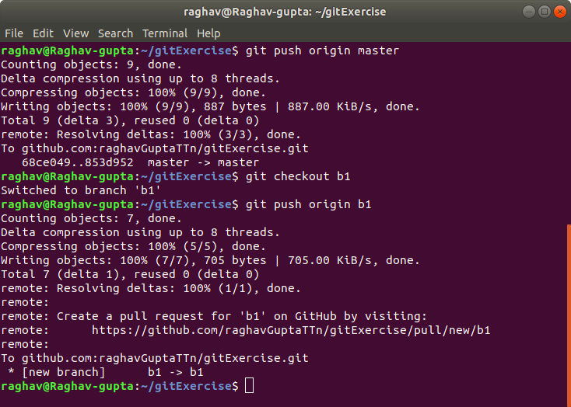











**Question 15. Edit the same file at the same line on both branches and commit**

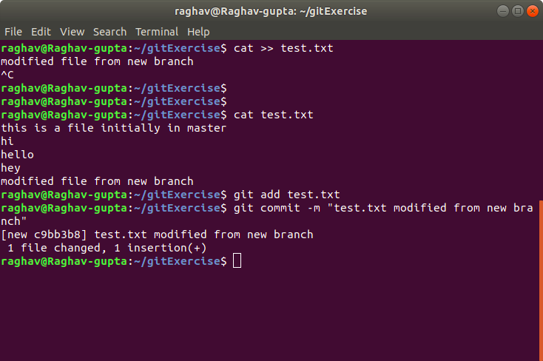

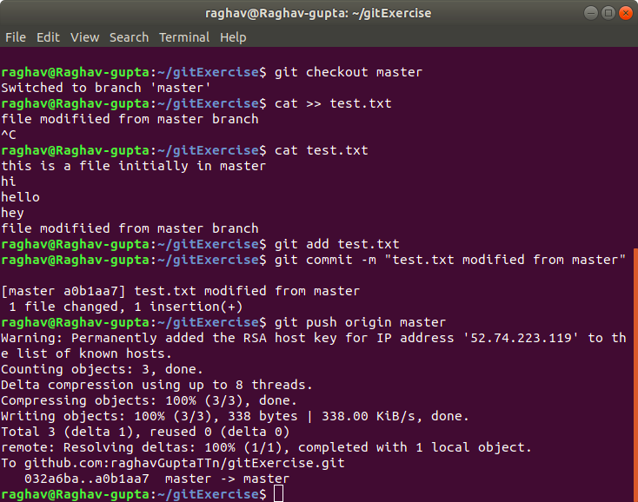

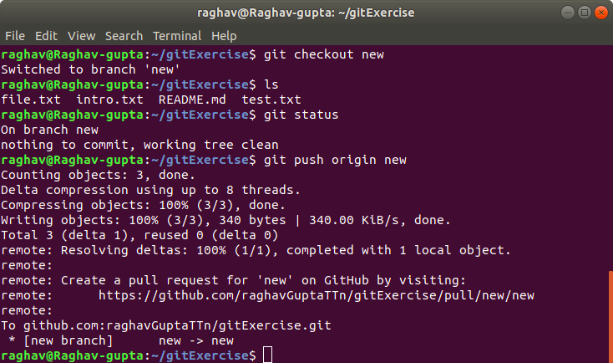

**Question 16. Try merging and resolve merge conflicts**

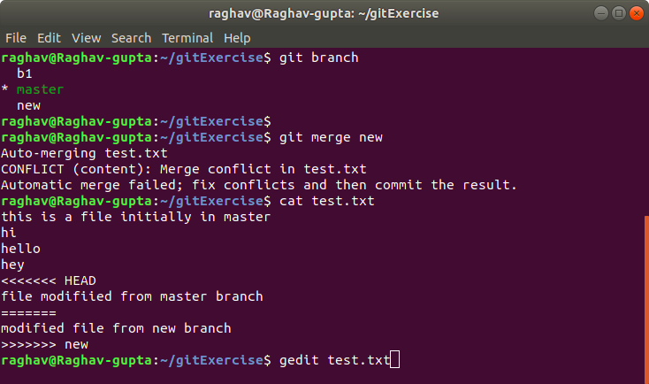

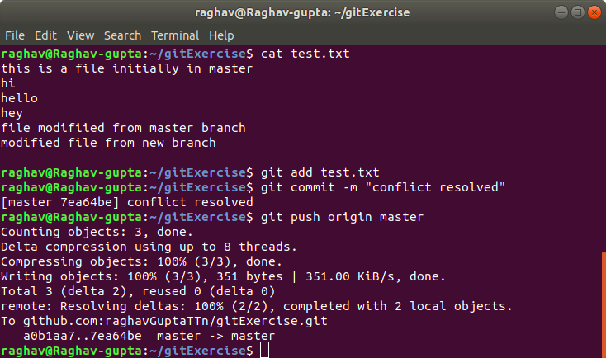

**Question 17. Stash the changes and pop them**

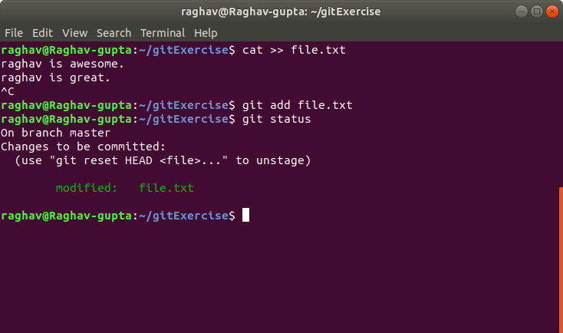

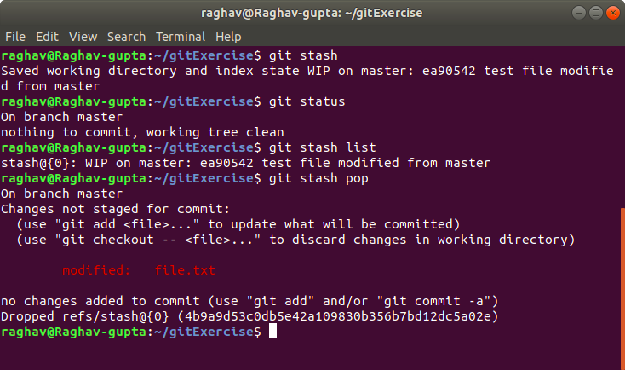

**Question 18. Add the following code to your .bashrc file**

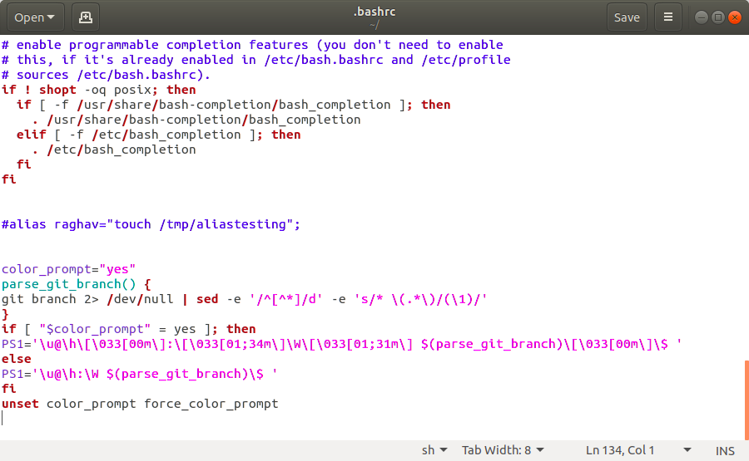

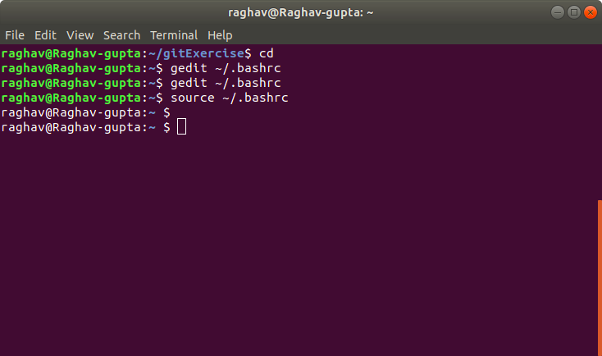

Color changed now in git.

