**HTML Exercise**

**4099 - Raghav Gupta**

**--------------------------------------------------------**

**1.How are inline and block elements different from each other?**

|  |  |
| --- | --- |
| Inline | Block |
| They don't take up a new line and can be placed within the same line as other previous elements. | They automatically take up a new line always even if there is empty space in the previous lines. |
| They are contained inside other elements normally.  They are used to format some part of the normal content.  Like to format a specific part of a paragraph. | They are used to contain other elements of the page to group them together. |
| Setting the width of inline elements doesn’t work.  Height, min-width, max-width, max-height, min-height also dont work. | We can set the width and height of block level elements. |
| They take up the space of the content inside. | They take up the entire width of the screen or parent. |
| Example - span, img, strong, a, input etc. | Example - h1-h6, p, div |
|  | Most of theHTML elements are block level elements. |
| Demo - question1.html | Demo - question1.html |

**2.Explain the difference between visibility:hidden and display:none**

Both are very useful properties but have a difference between them.

VISIBILITY:HIDDEN hides the element on the screen, makes it invisible but the element actually exists on the page and takes up the space but we cant see it.

DISPLAY : NONE - removes the element at all from the webpage and the space is freed for other elements.

3. **Explain the clear and float properties.**

The float property is used for positioning and formatting content e.g. let an image float left to the text in a container. Basically, it floats the element relative to the parent.

it can have one of the following values:

* left - The element floats to the left of its container
* right - The element floats to the right of its container
* none - The element does not float (will be displayed just where it occurs in the text). This is default
* inherit - The element inherits the float value of its parent

The clear property specifies what elements can float beside the cleared element and on which side.

It removes the effect of float for some element in the page.

It can have one of the following values:

* none - Allows floating elements on both sides. This is default
* left - No floating elements allowed on the left side
* right- No floating elements allowed on the right side
* both - No floating elements allowed on either the left or the right side
* inherit - The element inherits the clear value of its parent

The most common way to use the clear property is after we have used a float property on an element.

**4. explain difference between absolute, relative,fixed and static.**

## **position: static;**

HTML elements are positioned static by default.

Static positioned elements are not affected by the top, bottom, left, and right properties.

An element with position: static; is not positioned in any special way; it is always positioned according to the normal flow of the page:

## **position: relative;**

An element with position: relative; is positioned relative to its normal position.

Setting the top, right, bottom, and left properties of a relatively-positioned element will cause it to be adjusted away from its normal position. Other content will not be adjusted to fit into any gap left by the element.

If the element has a parent, we can position the element with respect to that.

## **position: fixed;**

An element with position: fixed; is positioned relative to the viewport, which means it always stays in the same place even if the page is scrolled. The top, right, bottom, and left properties are used to position the element.

A fixed element does not leave a gap in the page where it would normally have been located

An element with **position: absolute;** is positioned relative to the nearest positioned ancestor (instead of positioned relative to the viewport, like fixed).

However; if an absolute positioned element has no positioned ancestors, it uses the document body, and moves along with page scrolling.

**5. Write the HTML code to create a table in which there are 4 columns( ID , Employee Name, Designation, Department) and at least 6 rows. Also do some styling to it.**

**Question5.html**

**6. Why do we use meta tags?**

* Meta tags provide the metadata of the page.
* The content of meta tags is not displayed on the page but it provides useful information about the web page.
* It can be used to enhance the searchability of the page on the web through SEO.
* It provides information about the page to other designers and browsers like what is contained in the page, what is the source of the page, who is the author of the page, the date of creation of the page etc.
* In HTML5, it also allows the designer to take control over the viewport. It helps the page to open properly on screens of different sizes. Its is used to make responsive web pages.
* Example -
  + <meta name="viewport" content="width=device-width, initial-scale=1.0">
  + <meta name="keywords" content="HTML, CSS, XML, XHTML, JavaScript">
  + <meta name="description" content="Free Web tutorials on HTML and CSS">
  + <meta name="author" content="John Doe">

**7. Explain box model.**

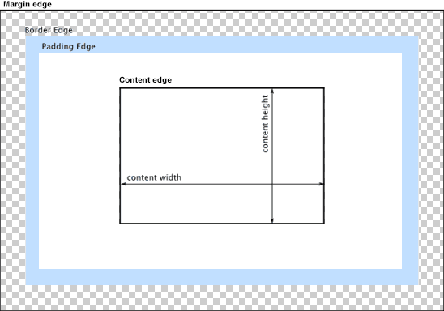

When laying out a document, the browser's rendering engine represents each element as a rectangular box according to the standard **CSS basic box model**. CSS determines the size, position, and properties (color, background, border size, etc.) of these boxes.

Every box is composed of four parts (or *areas*), defined by their respective edges: the *content edge*, *padding edge*, *border edge*, and *margin edge*.

**Content area** is bounded by the content edge, it denotes the bound of the actual content without any spaces.

**Padding edge** denotes the outer edge of the padding.

**Border edge** represents the outer boundary of the border of the content.

Finally, the **margin edge** represents the edge in touch with the adjacent elements. Its the outer edge of the margin.

**8. What are the different types of CSS Selectors?**

There are many types of CSS selectors like adjacent selector, star selector, sibling selector etc. bue the most important ones are

[**Type selector**](https://developer.mozilla.org/en-US/docs/Web/CSS/Type_selectors)

Selects all the similar elements in the document on the basis of tag name.

**Syntax:** elementname

**Example:** input will match any [<input>](https://developer.mozilla.org/en-US/docs/Web/HTML/Element/input) element.

[**Class selector**](https://developer.mozilla.org/en-US/docs/Web/CSS/Class_selectors)

Selects all elements that have the given class attribute.

**Syntax:** .classname

**Example:** .index will match any element that has a class of "index".

[**ID selector**](https://developer.mozilla.org/en-US/docs/Web/CSS/ID_selectors)

Selects an element based on the value of its id attribute. There should be only one element with a given ID in a document.

**Syntax:** #idname

**Example:** #toc will match the element that has the ID "toc".

**9. Define Doctype.**

A doctype or document type declaration is an instruction which tells the web browser about the markup language in which the current page is written. The Doctype is not an element or tag, it lets the browser know about the version of or standard of HTML or any other markup language that is being used in the document.

**Declaration** : A DOCTYPE declaration appears at the top of a web page before all other elements. According to the HTML specification or standards, every HTML document requires a document type declaration to ensure that the pages are displayed in the way they are intended to be displayed.

The DOCTYPE for HTML5 is case-insensitive.

<!DOCTYPE html>

**10. Explain 5 HTML5 semantic tags.**

HTML5 offers new semantic elements to define different parts of a web page:

* <article>
* <aside>
* <details>
* <figcaption>
* <figure>
* <footer>
* <header>
* <main>
* <mark>
* <nav>
* <section>
* <summary>
* <time>

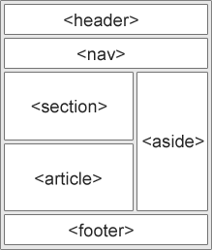

## **HTML5 <section> Element**

The <section> element defines a section in a document.

"A section is a thematic grouping of content, typically with a heading."

A home page could normally be split into sections for introduction, content, and contact information.

The **<article> element** specifies independent, self-contained content.

An article should make sense on its own, and it should be possible to read it independently from the rest of the web site.

Examples of where an <article> element can be used:

* Forum post
* Blog post
* Newspaper article

## **HTML5 <header> Element**

The <header> element specifies a header for a document or section.

The <header> element should be used as a container for introductory content.

we can have several <header> elements in one document.

## **HTML5 <footer> Element**

The <footer> element specifies a footer for a document or section.

A <footer> element should contain information about its containing element.

A footer typically contains the author of the document, copyright information, links to terms of use, contact information, etc.

We may have several <footer> elements in one document.

## **HTML5 <nav> Element**

The <nav> element defines a set of navigation links. Like we have in every website, a set of links like home, about us, contact us etc…

**11. Create HTML for web-page.jpg (check resources, highest weightage for answers)**

------------- see **page.html** file

**12. Create HTML for form.png (check resources, highest weightage for answers)**

---- see **form2.html** file