**JPA 3 ASSIGNMENT - some screen shots**

1. Create a class Address for Author with instance variables streetNumber, location, State.
2. Create instance variable of Address class inside Author class and save it as embedded object.
3. Introduce a List of subjects for author.
4. Persist 3 subjects for each author.
5. Create an Entity book with an instance variable bookName.

See answer 1-5 in

JPA3Assignments/normalquestions

1. Implement One to One mapping between Author and Book.

JPA3Assignments/onetoone

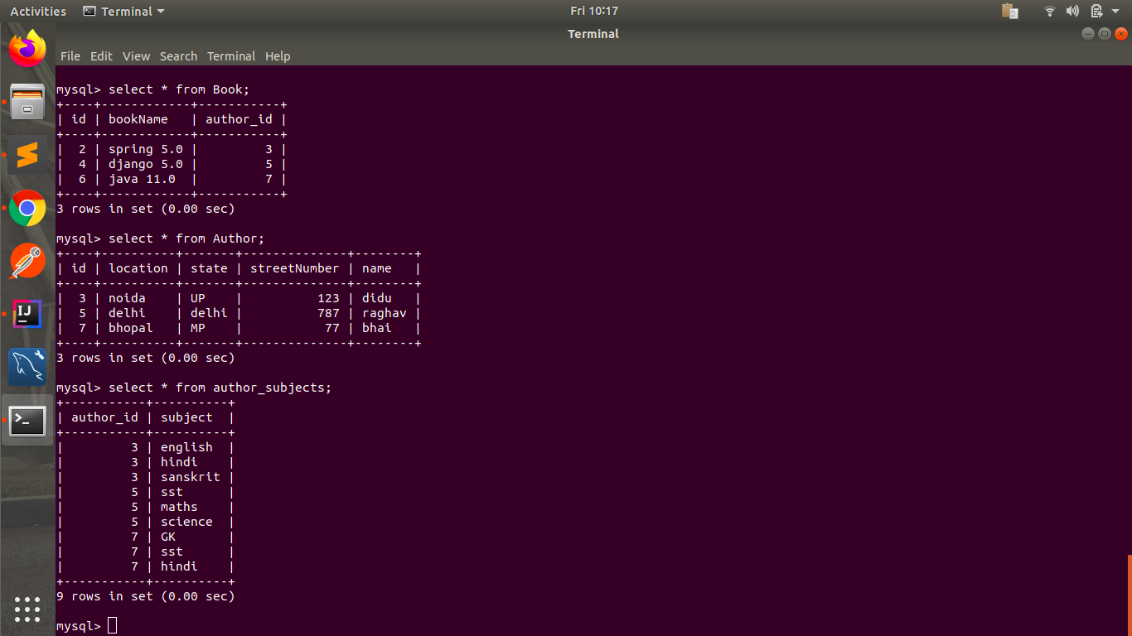

1. Implement One to Many Mapping between Author and Book(Unidirectional, BiDirectional and without additional table ) and implement cascade save.

UNIDIRECTIONAL -

JPA3Assignments/onetomany

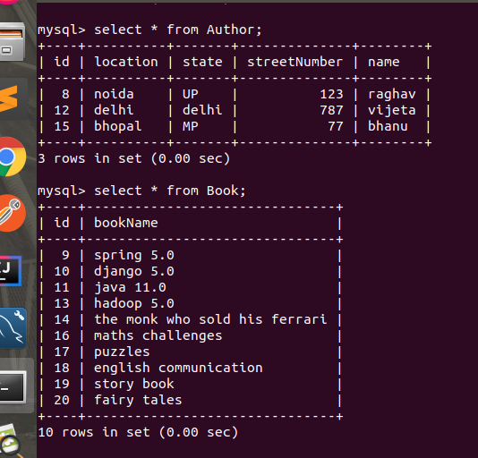

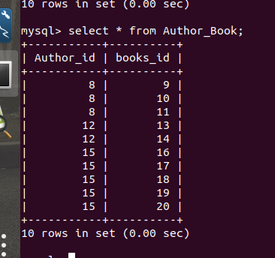

BIDIRECTIONAL and without additional table ----

JPA3Assignments/onetomanybidirectional

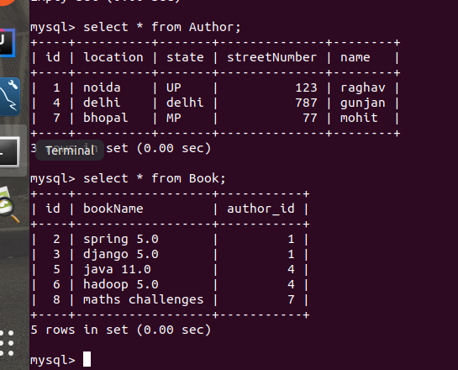

1. Implement Many to Many Mapping between Author and Book.

JPA3Assignments/manytomany

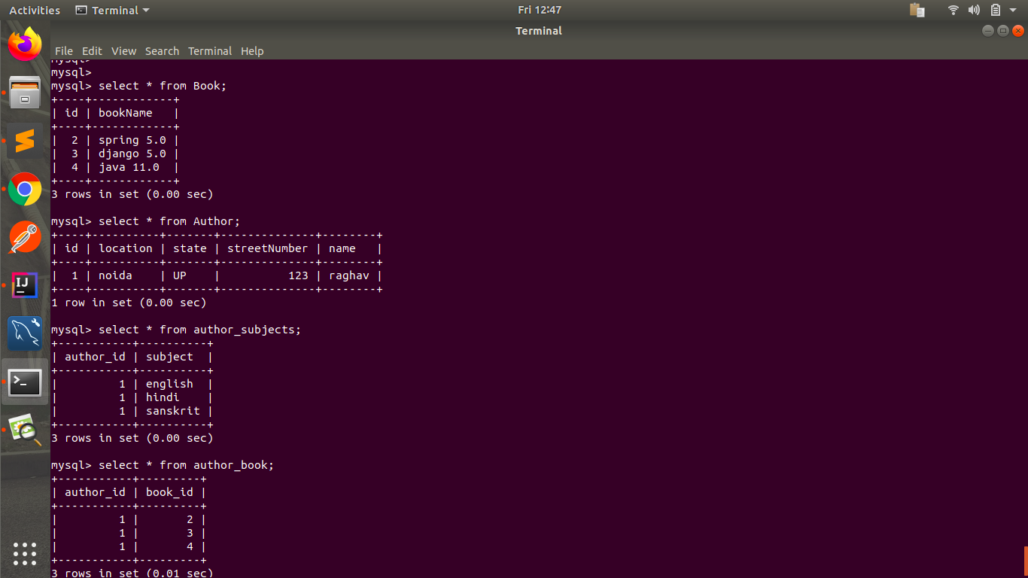

1. Which method on the session object can be used to remove an object from the cache?
2. What does @transactional annotation do?

See answers of these 2 questions in

JPA3Assignments/normalquestions