**LINUX EXERCISE SOLUTION**

**Question 1. Create a directory "exercise" inside your home directory and create nested(dir1/dir2/dir3) directory structure inside "excerise" with single command.**

By using -p flag with mkdir

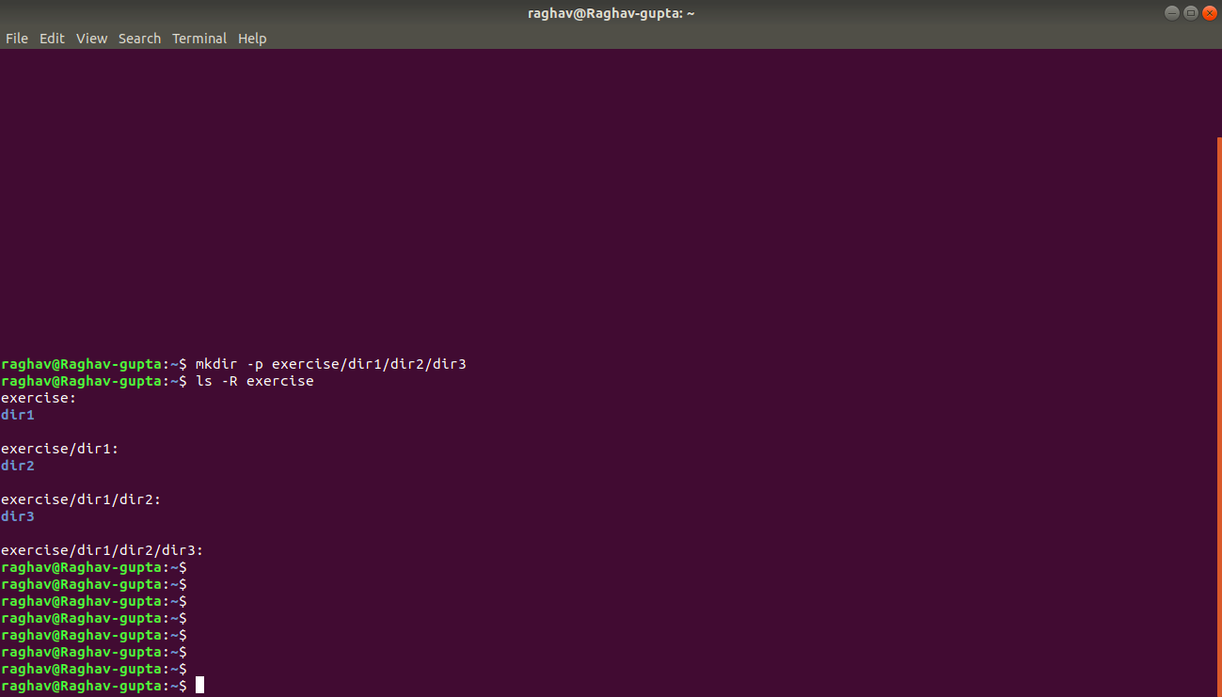

**Question 2. Create two empty files inside dir2 directory: emptyFile1,emptyFile2 in single command**

Using touch to create the files.

Using rm -r to remove a non empty directory

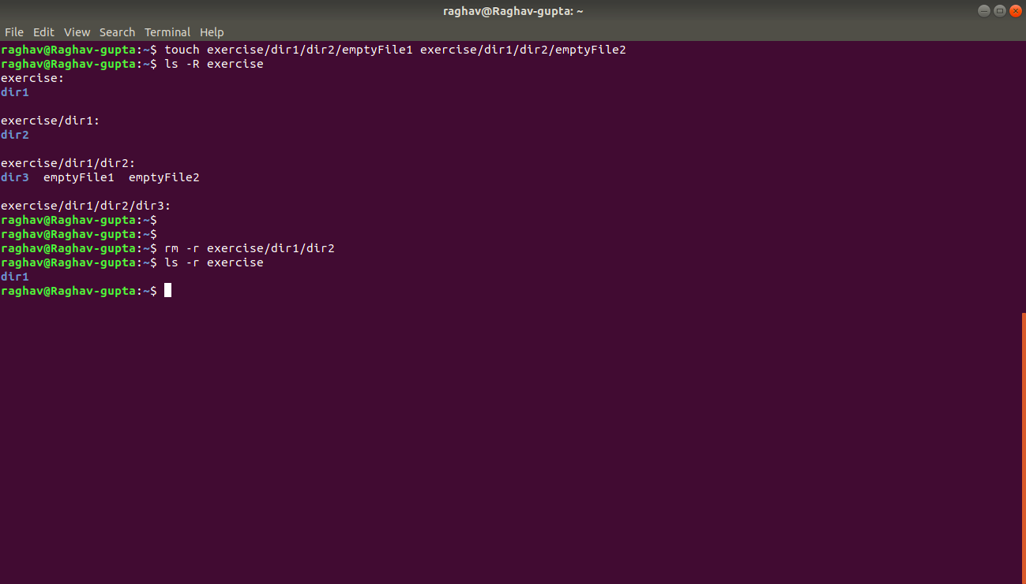

**Question 3. Create one file file1.txt containing text "hello world" and save it.**

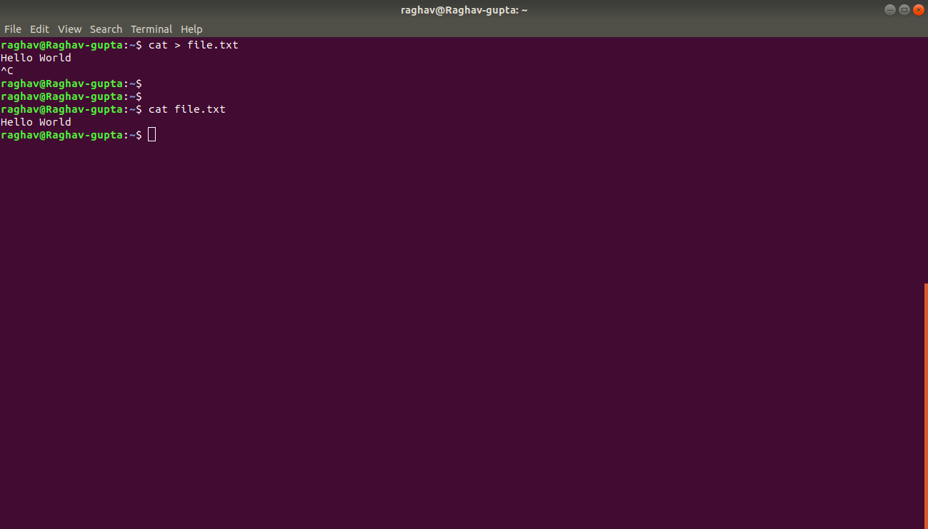

**Question 4. Find a "passwd" file using find command inside /etc. copy this files as passwd_copy and then rename this file as passwd_backup.**

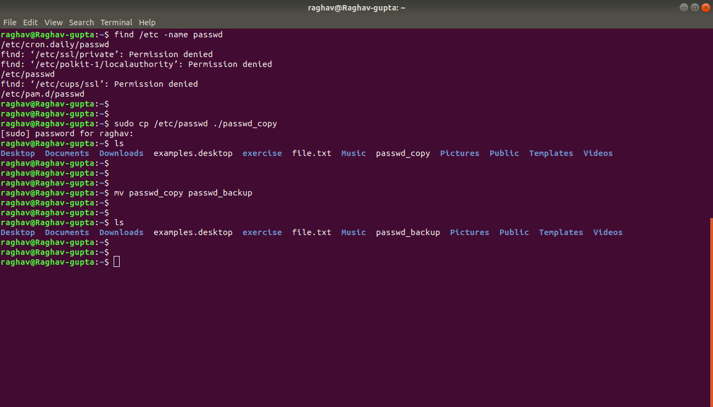

**Question 5. Try reading passwd_backup file in multiple tools: less,more,cat,strings etc and find the difference in their usage.**

less passwd_backup

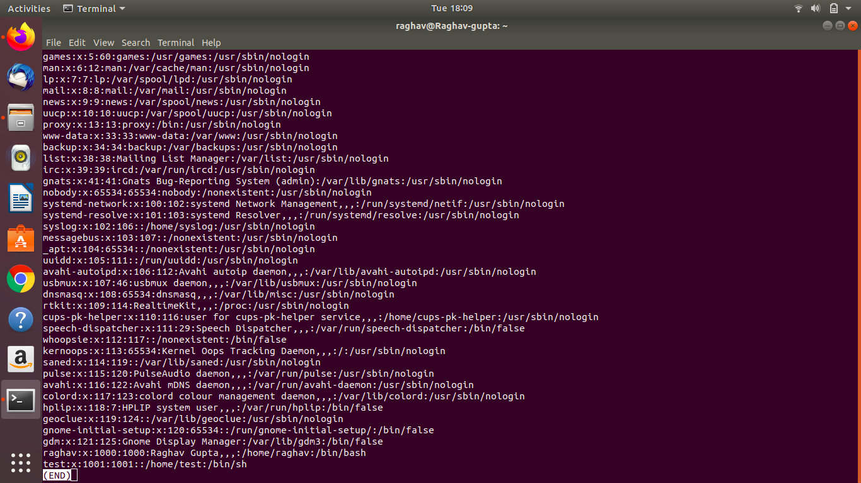

more passwd_backup

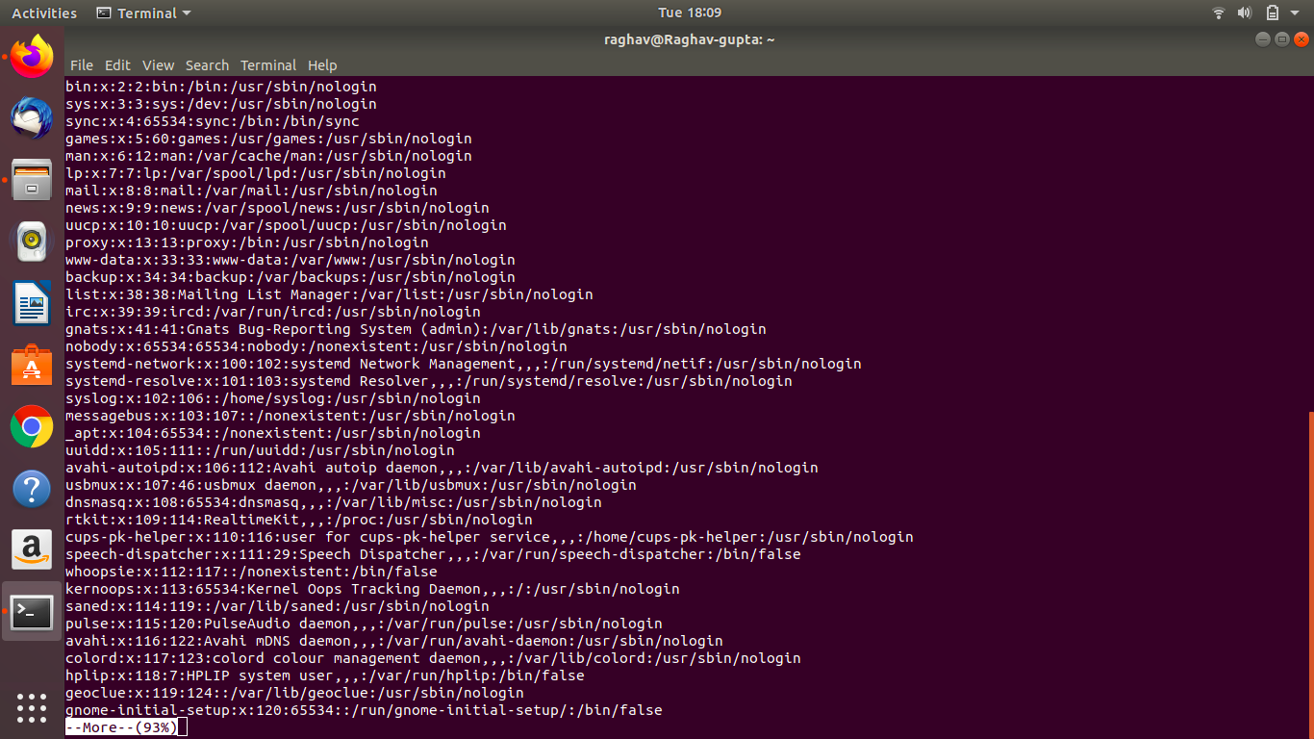

cat passwd_backup

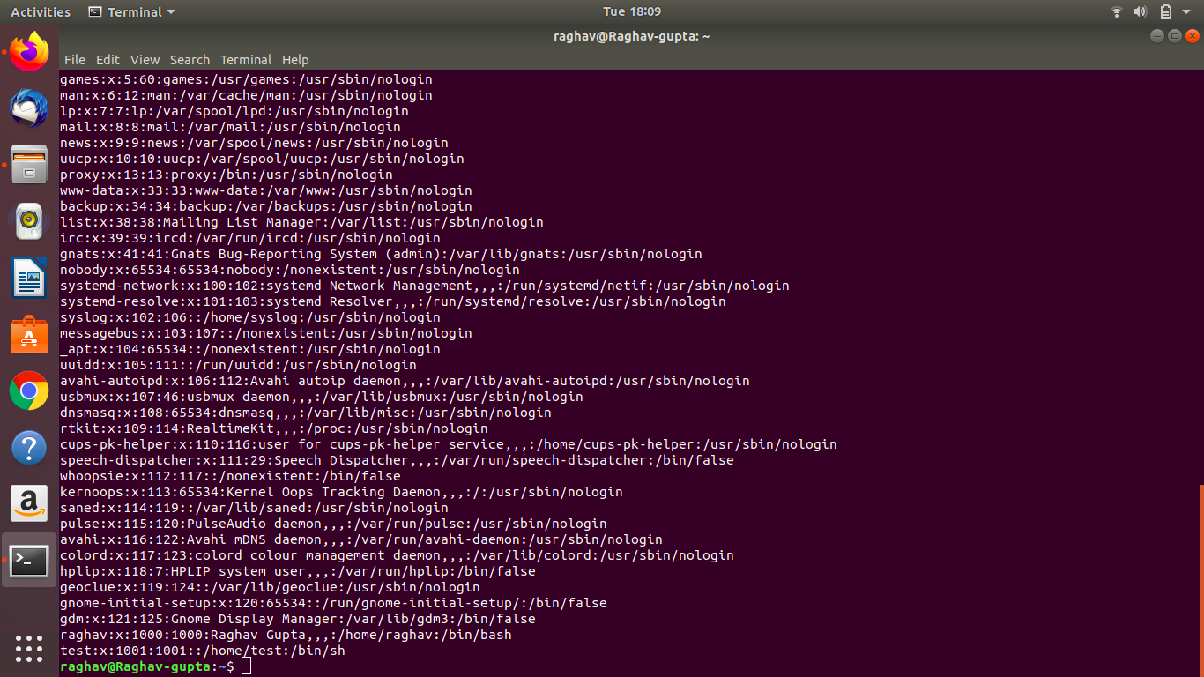

strings passwd_backup

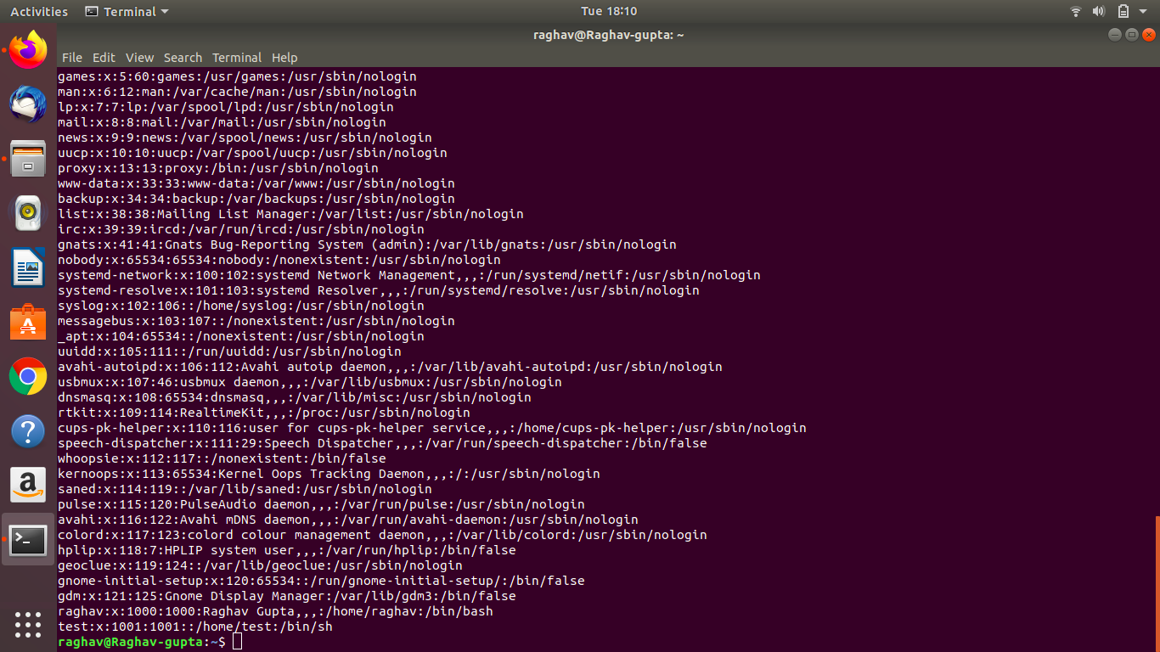

**Question 6. Find out the number of line in password_backup containing "/bin/false".**

Use -c flag with grep - to give count of lines

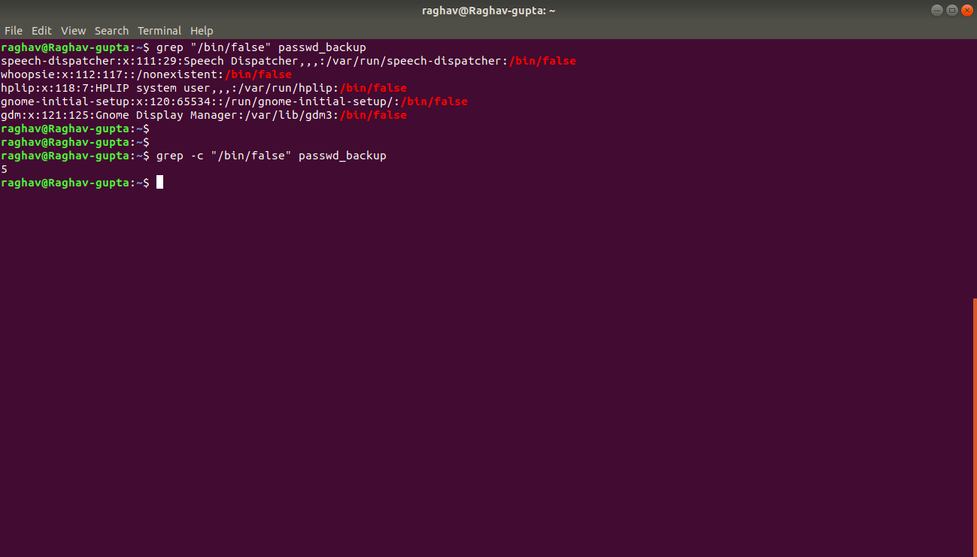

**Question 7. Get the first 5 lines of a file “password_backup” and Redirect the output of the above commands into file "output"**

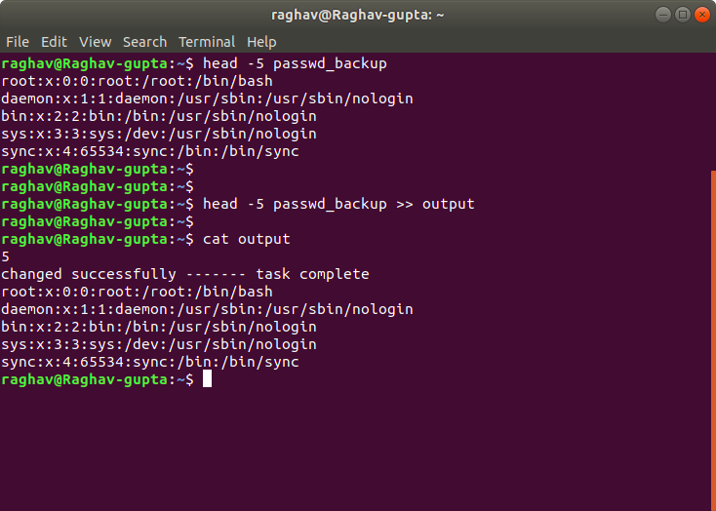

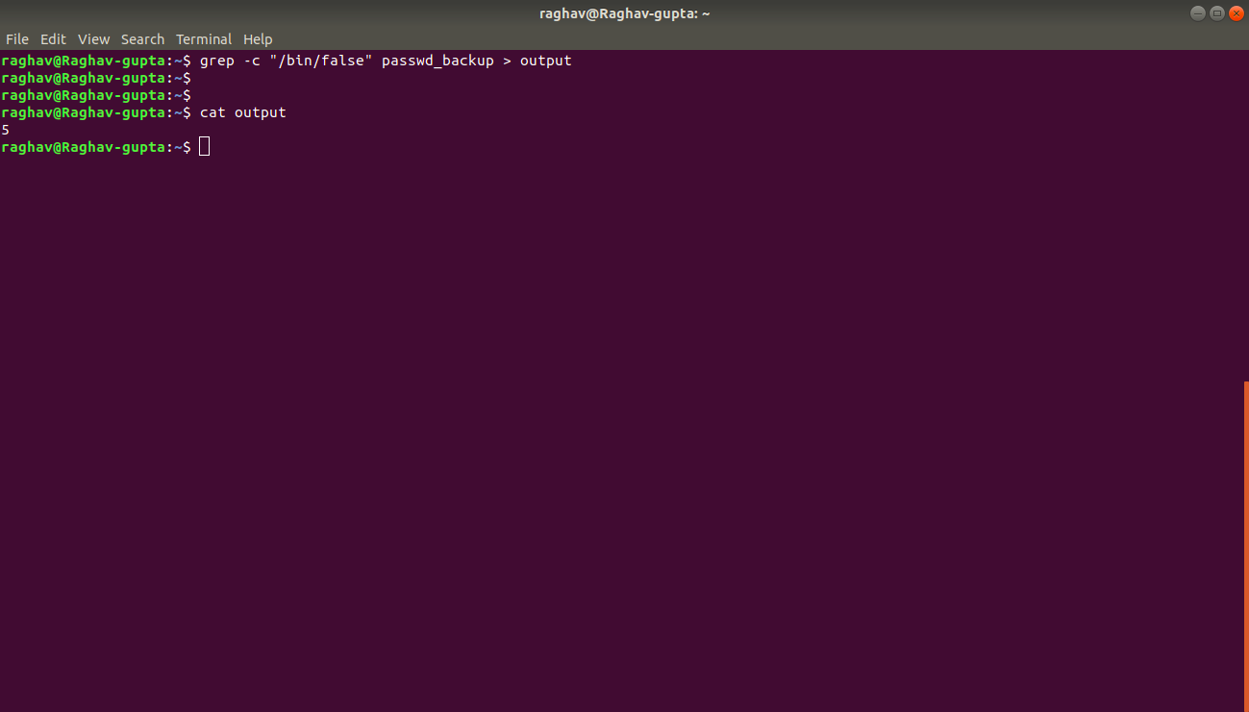

**Question 8. Create a "test" user,create its password and find out its uid and gid.**

I used

Useradd

Passwd

Id commands

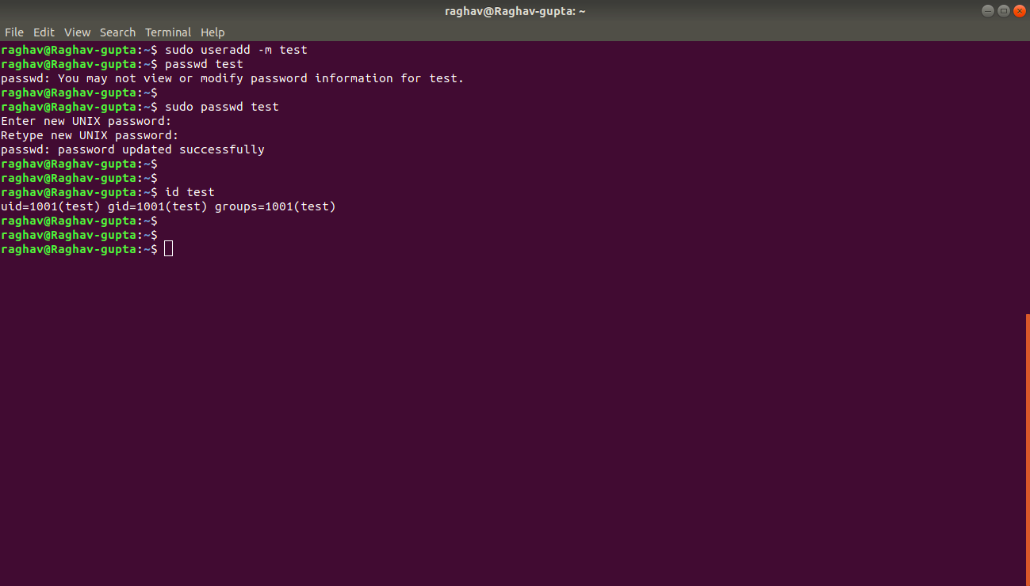

**Question 9. Change the timestamp of emptyFile1,emptyFile2 which are exist in dir2.**

I created the files, checked current time stamp, updated by touch and again checked.

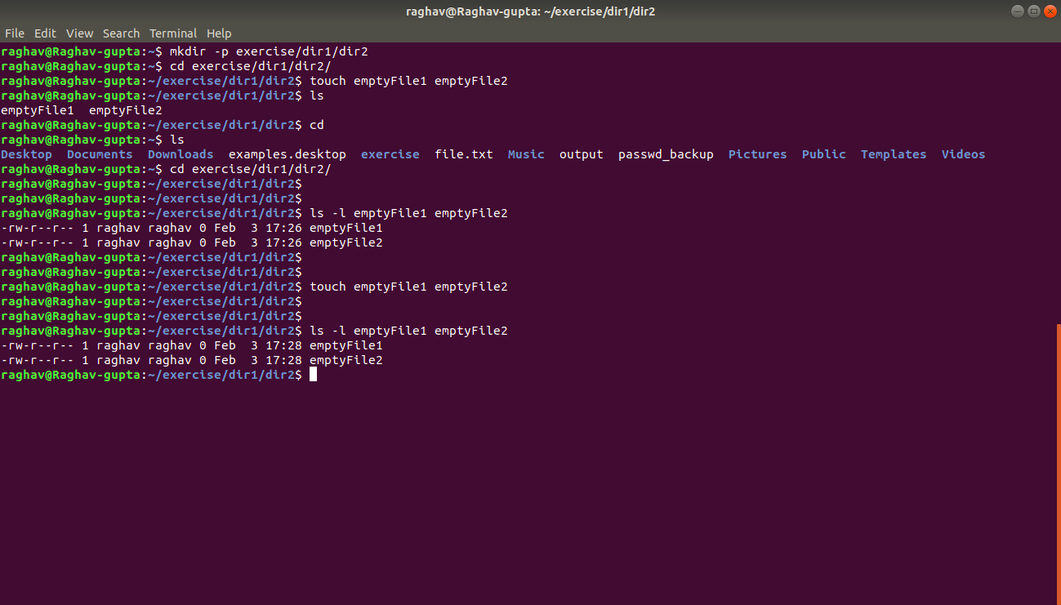

**Question 10. Login as test user and edit the "output" file created above. Since the permission wont allow you to save the changes. Configure such that test user can edit it.**

1. **Add group owner of the "output" file as the secondary group of testuser and check/change the "output" file permission if it is editable by group. Once done revert the changes**
2. **Make the file editable to the world so that test user can access it. Revert the changes after verification**
3. **Change the ownership to edit the file.**

Step 10.1 -

Check initial permission of output file

Check group owner of output file

Login to raju user

Try to edit the output file and it failed

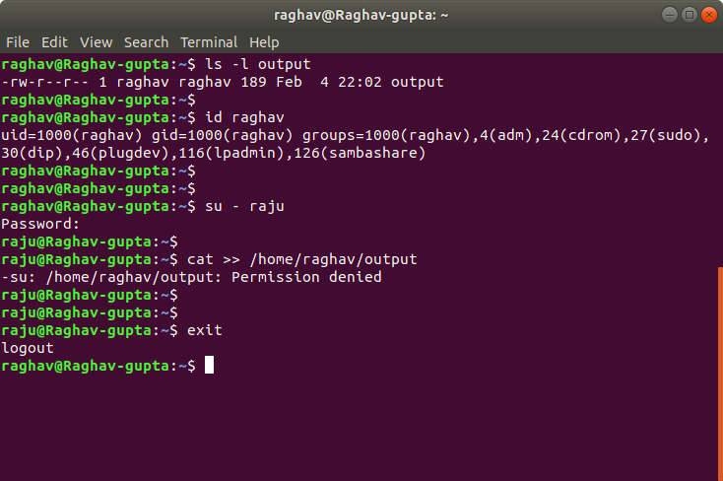

Now, Check the current group owner of use raju and user raghav

Add group owner of user raghav as the secondary group of user raju

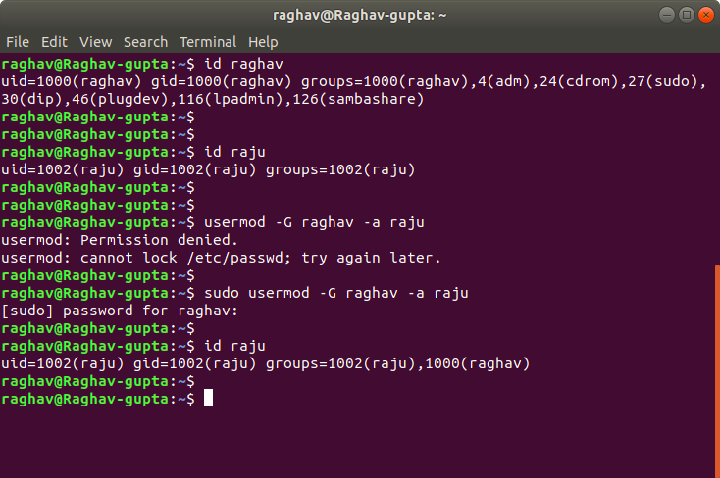

Change to user raju

Try editing output file - failed

Change the group permission of output file

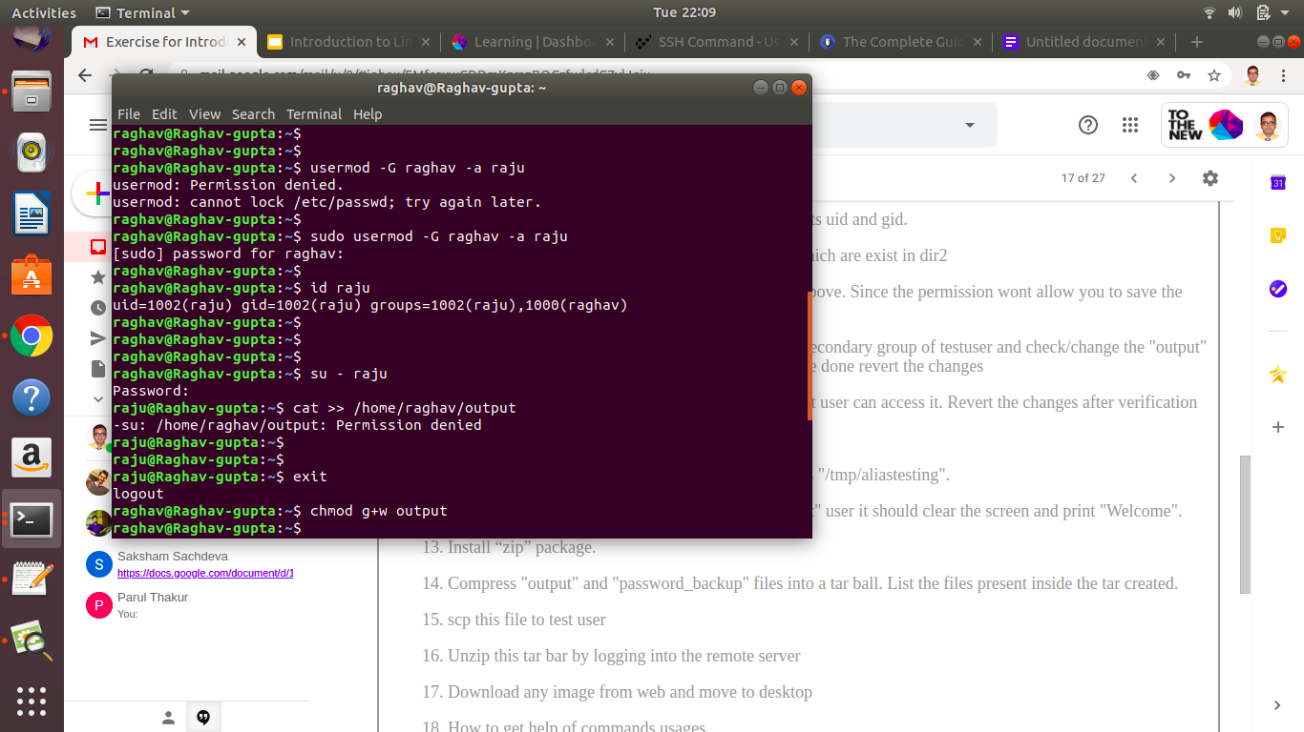

Now again try to update the output file - success

Revert the permission changes

Verify the permissions of output file.

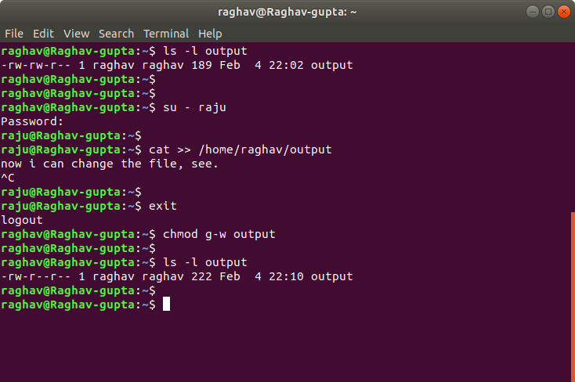

Step 10.2 -

Modify the file permissions of output file to be editable by all.

Verify

Revert the changes

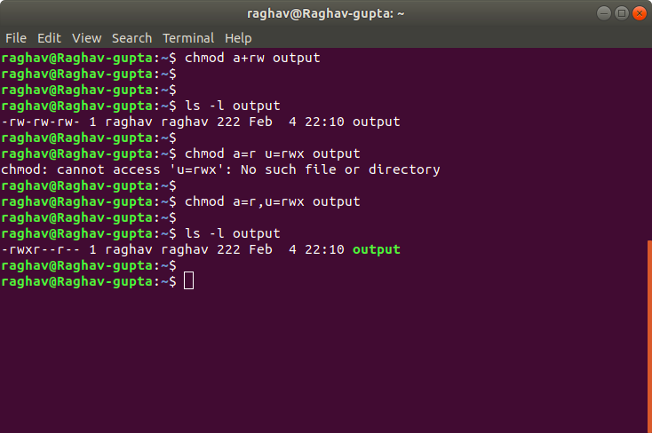

Step 10.3 -

Change the owner of output file to user raju.

Try editing the file now.

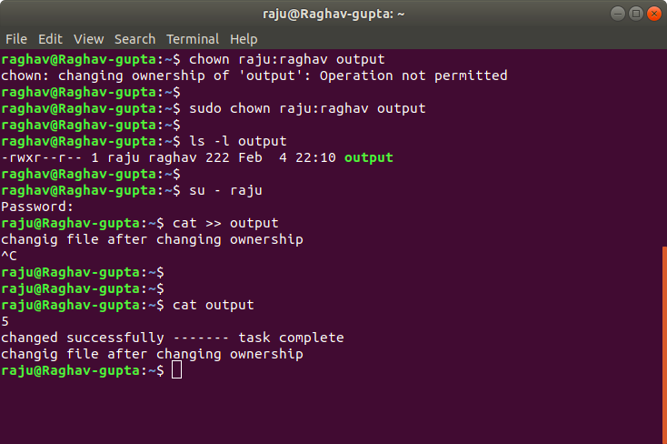

**Question 11. Create alias with your name so that it creates a file as "/tmp/aliastesting".**

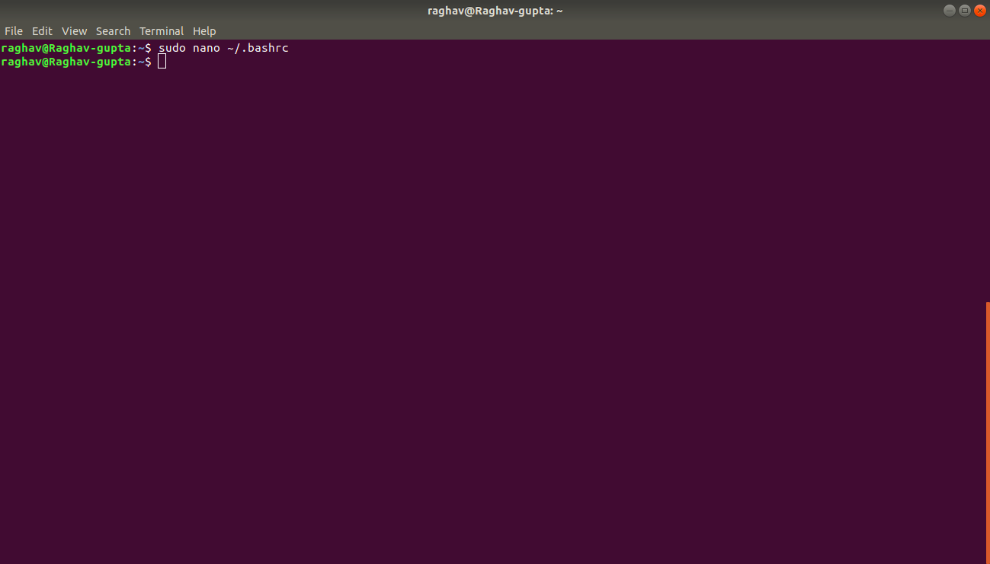

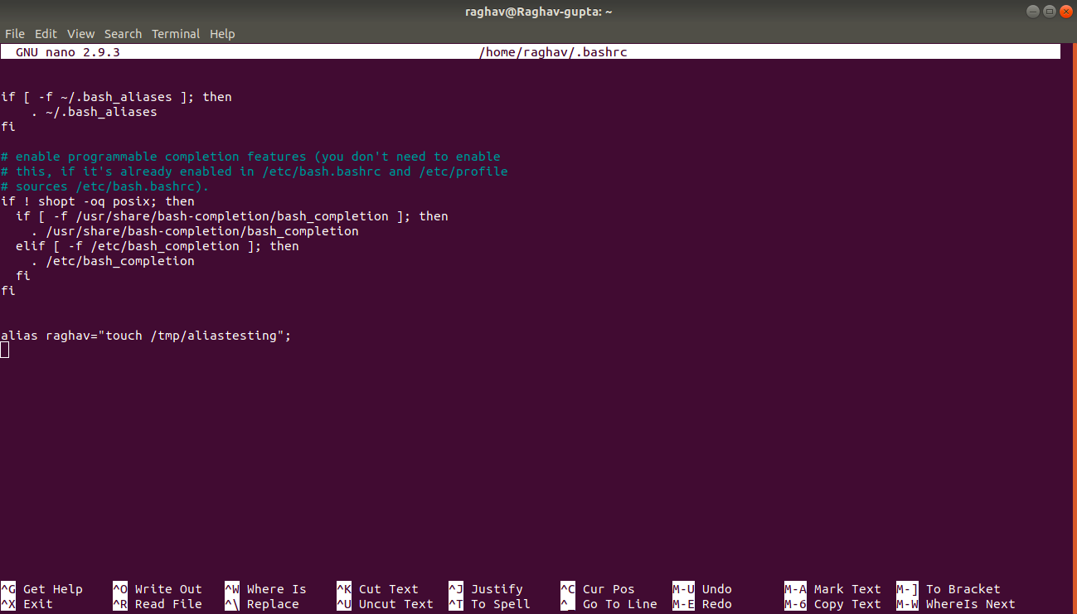

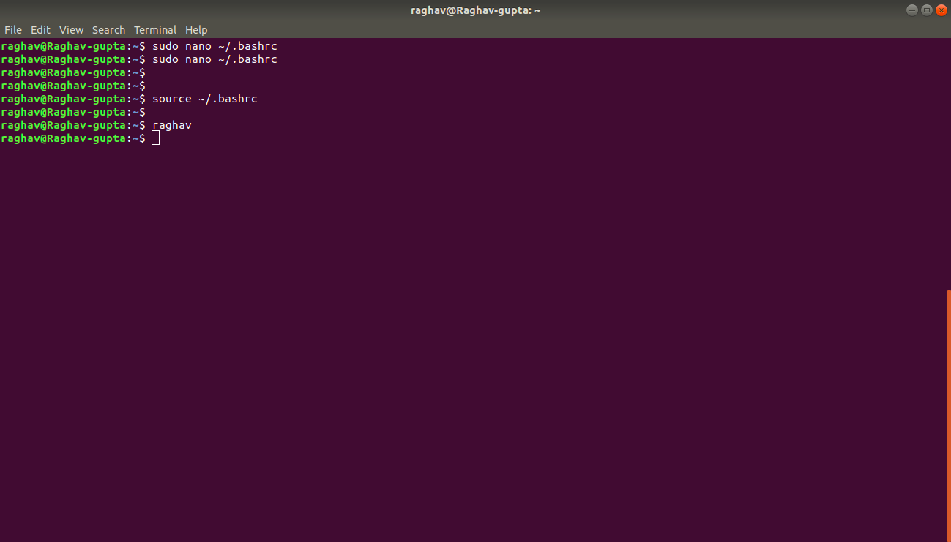

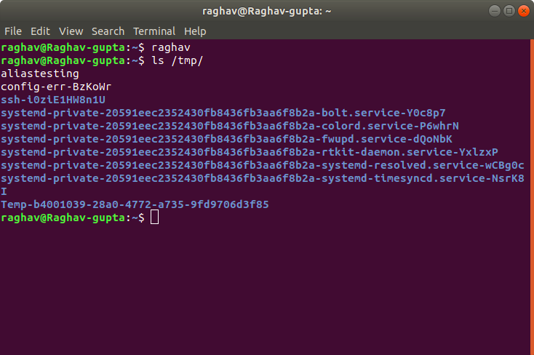

**Question 12.**

**Edit ~/.bashrc file such that when you change to "test" user it should clear the screen and print "Welcome".**

1. Change the user by su command
2. Edit its bashrc file
3. Change user to my normal account
4. Now, switch to test user by su command and u will see the welcome output

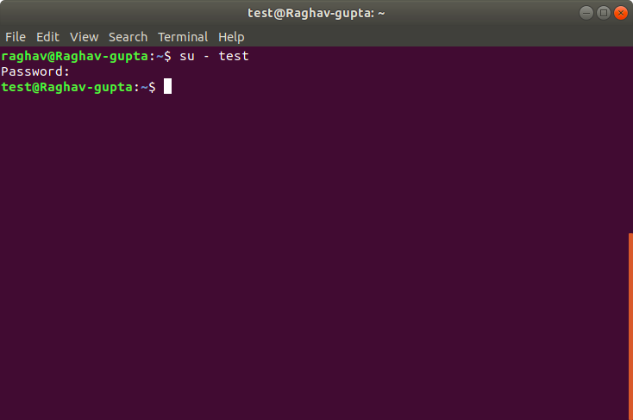

By

nano ~/.bashrc

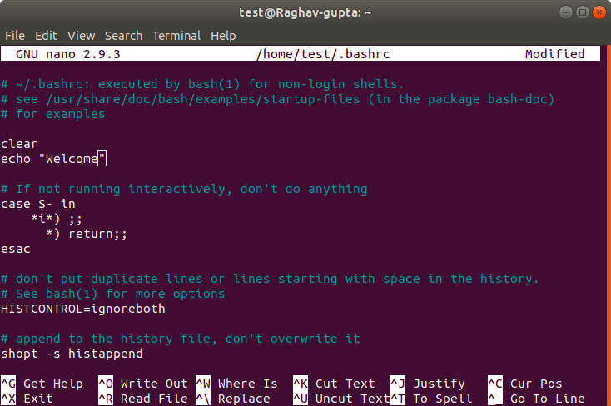

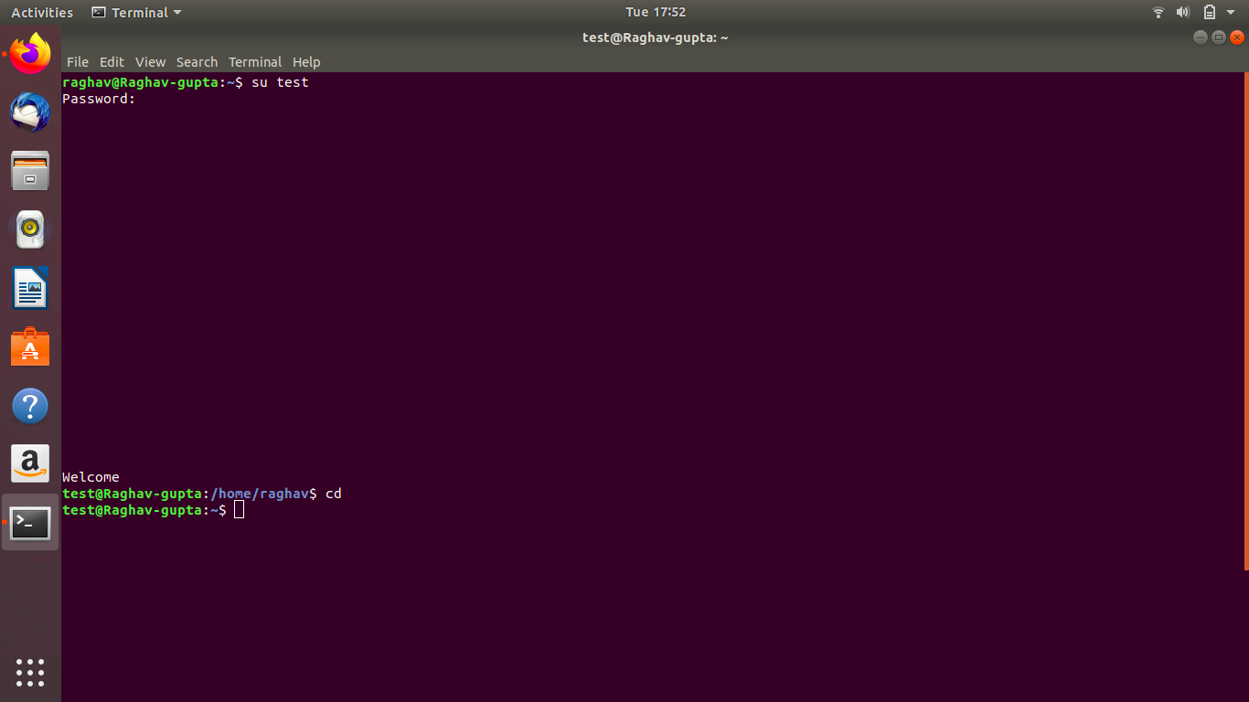

**Question 13. Install “zip” package.**

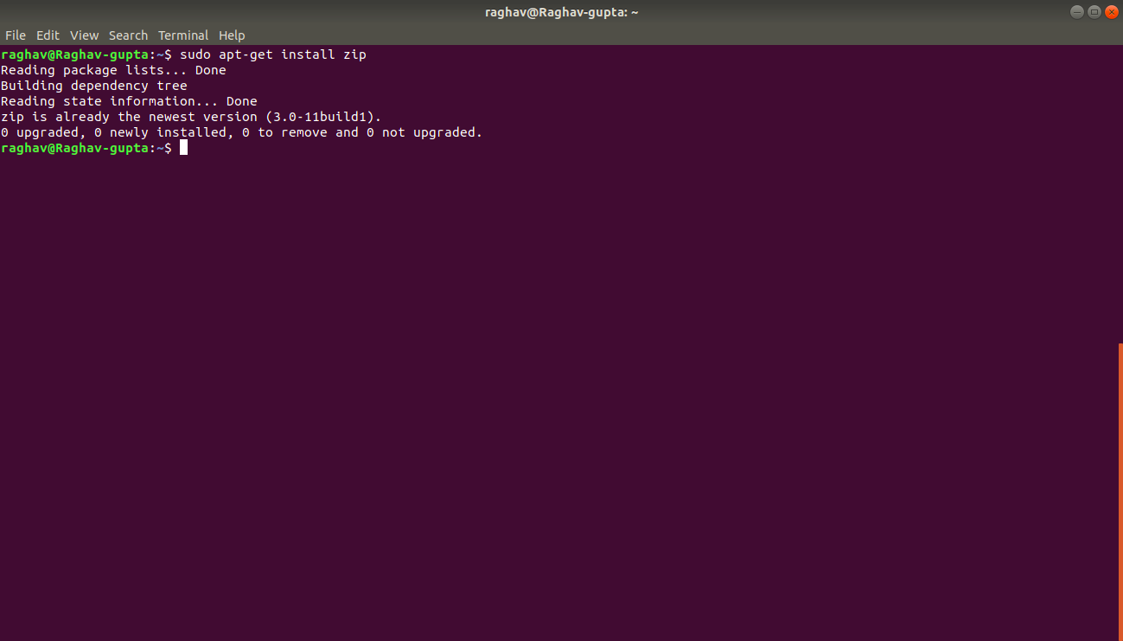

**Question 14. Compress "output" and "password_backup" files into a tar ball. List the files present inside the tar created.**

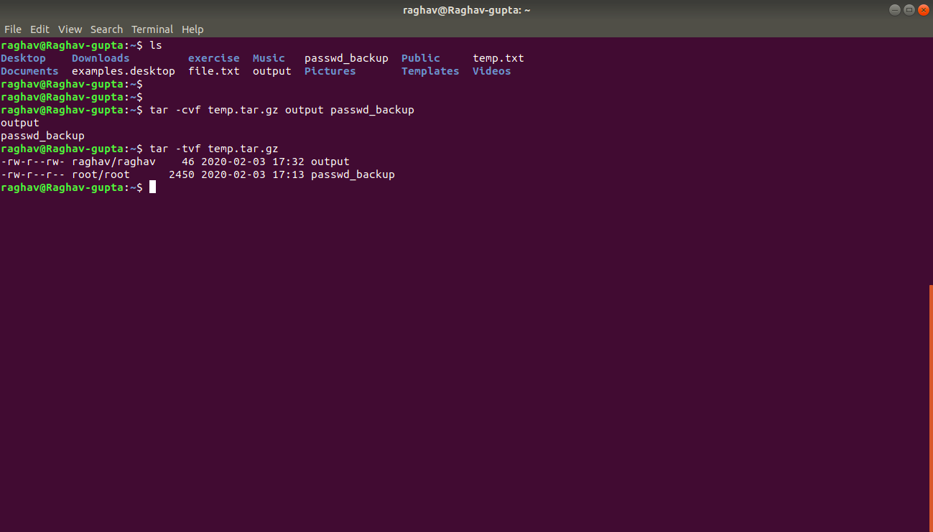

**Question 15. scp this file to test user**

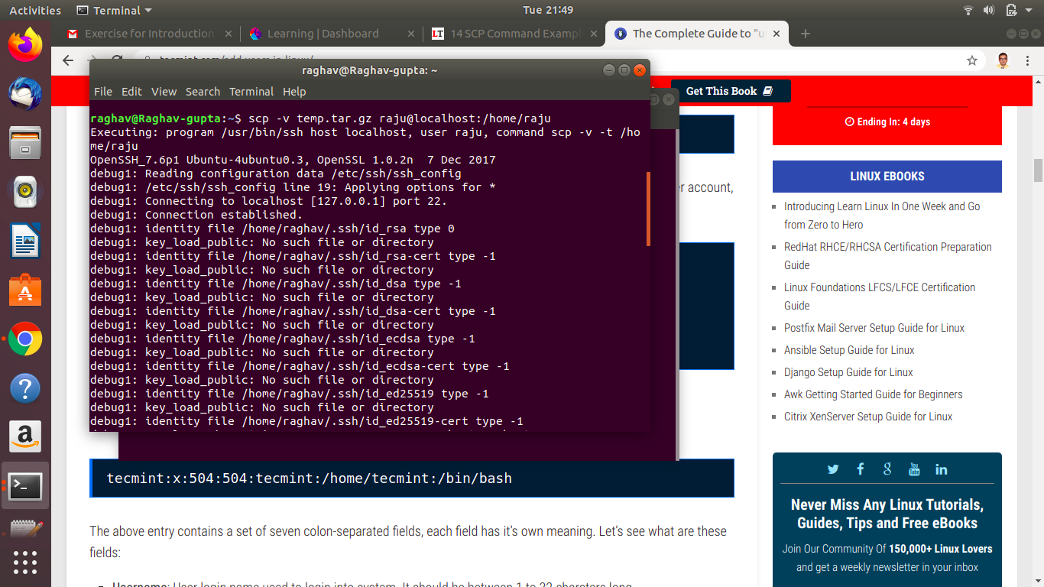

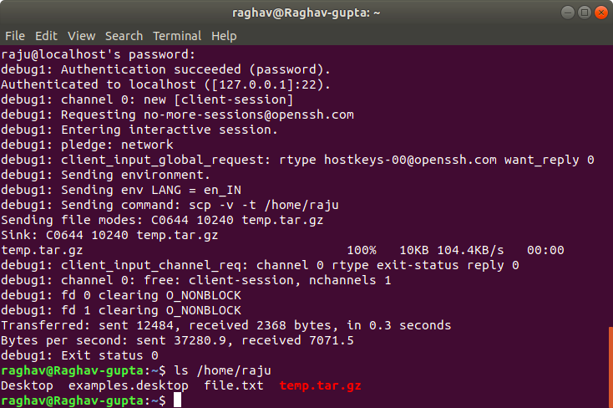

**Question 16. Unzip this tar bar by logging into the remote server**

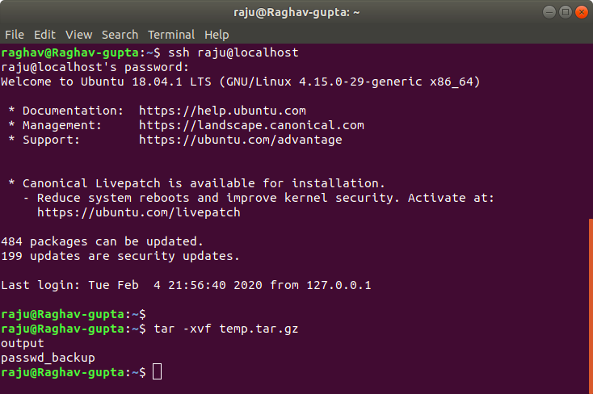

**Question 17. Download any image from web and move to desktop**

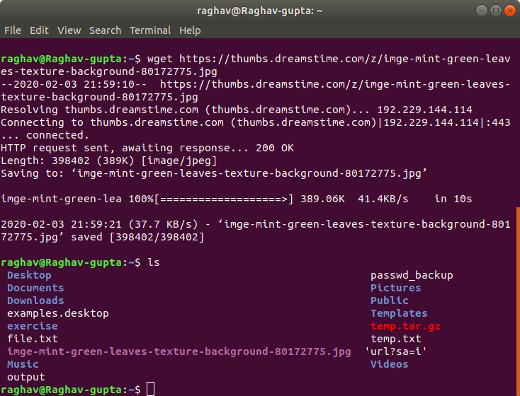

**Question 18. How to get help of commands usages.**

To get help of command usage, we have 3 options -

1. **man cmdName -**

**man grep**

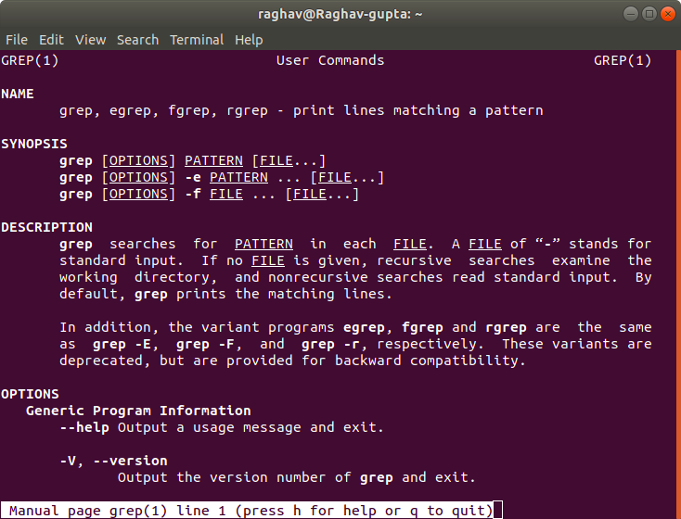

1. **cmdName --help**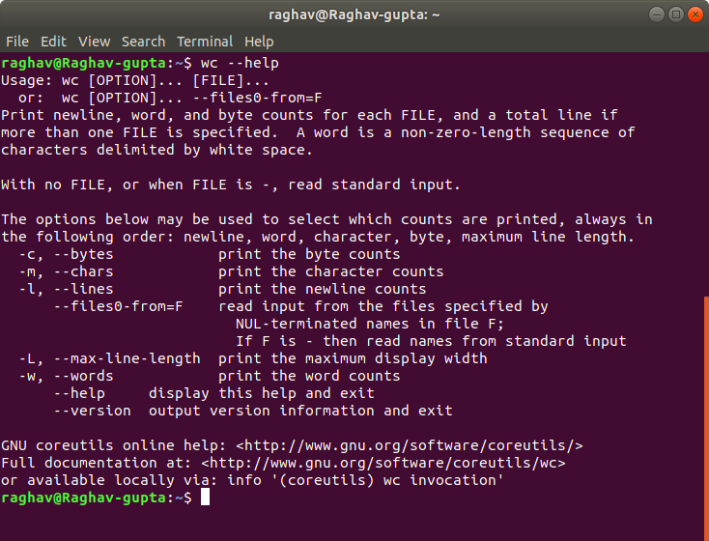
2. **cmdName -h**

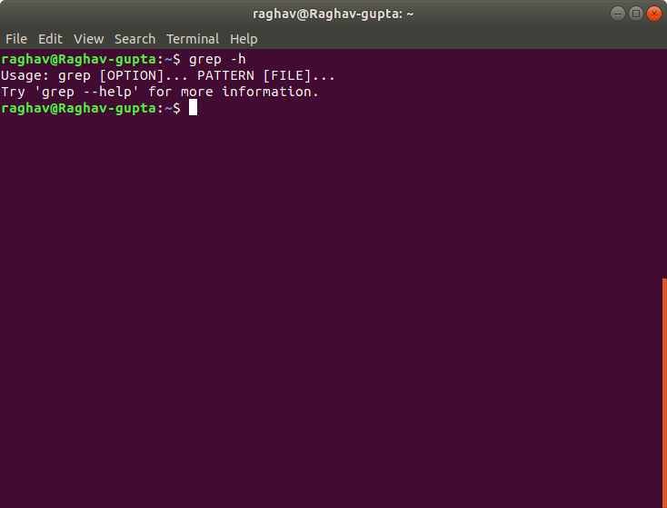

**Question 19. Create a symlink of /etc/services into /tmp/ports-info**

ln -s /etc/services /tmp/ports-info

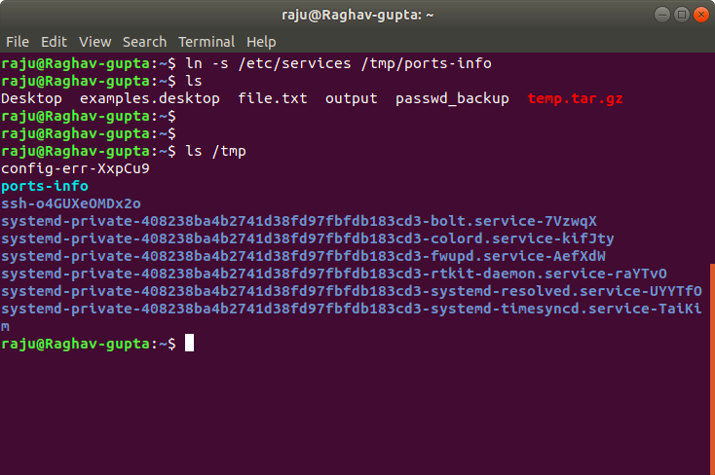

If we do cat /tmp/ports-info, it gives the same content of /etc/services file.

**Question 20. You are appointed as a Software/DevOps Engineer in ABC media services. On your first day you need to troubleshoot a problem. There is a command “xyz” somewhere installed in that linux system. But as a new joinee you do not have any idea about where is that Installed. How can you check that?**

whereis command is used to locate the binaries of a file.

