**REST WITH SPRING ASSIGNMENT**

**RAGHAV GUPTA**

**========================================**

|  |  |  |
| --- | --- | --- |
| 1. **Create a simple REST ful service in Spring Boot which returns the Response "Welcome to spring boot".** | | |

1. **Create an Employee Bean(id, name, age) and service to perform different operations related to employee.**
2. **Implement GET http request for Employee to get list of employees.**
3. **Implement GET http request using path variable top get one employee**
4. **Implement POST http request for Employee to create a new employee.**
5. **Implement Exception Handling for resource not found**
6. **Implement DELETE http request for Employee to delete employee**

**For QUESTION 2-7 ----------------**

**I have attached the complete porject.**

**Please see the Employee package for the API.**

**For exception handling - refer the ‘exceptions’ package.**

**Run by using DemoApplication.java**

1. **Implement PUT http request for Employee to update employee**

**Steps followed -**

Make a get request to check the initial value

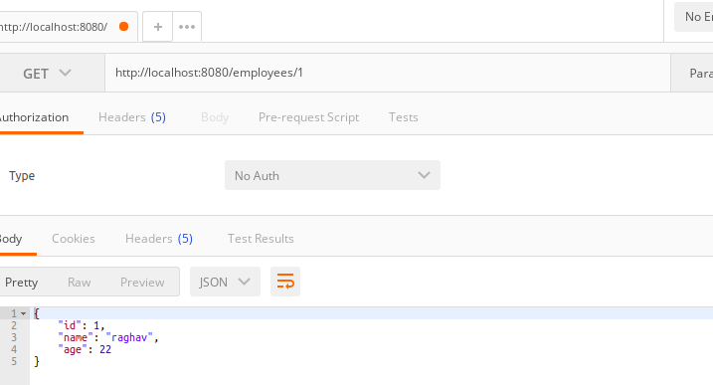

Make a put request to update the value

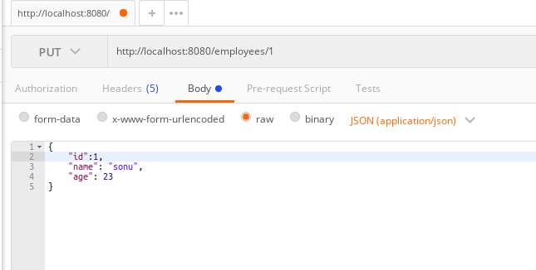

The request was fulfilled successfully

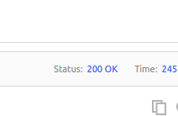

Check the data by making a get request

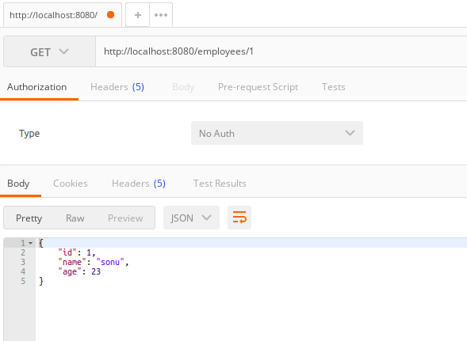

**Now, if I make a put request for a resource which is not present, then it will create the resource.**

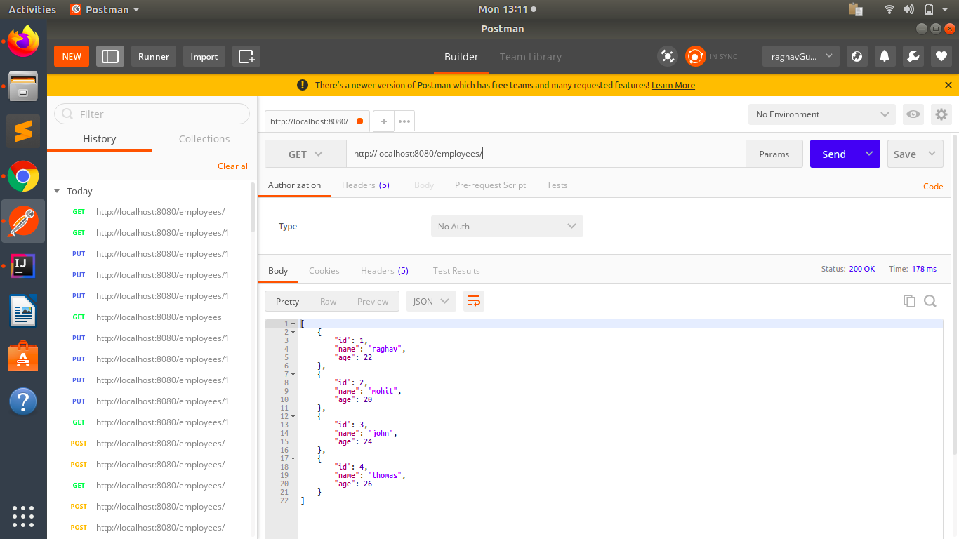

Now, make a put request

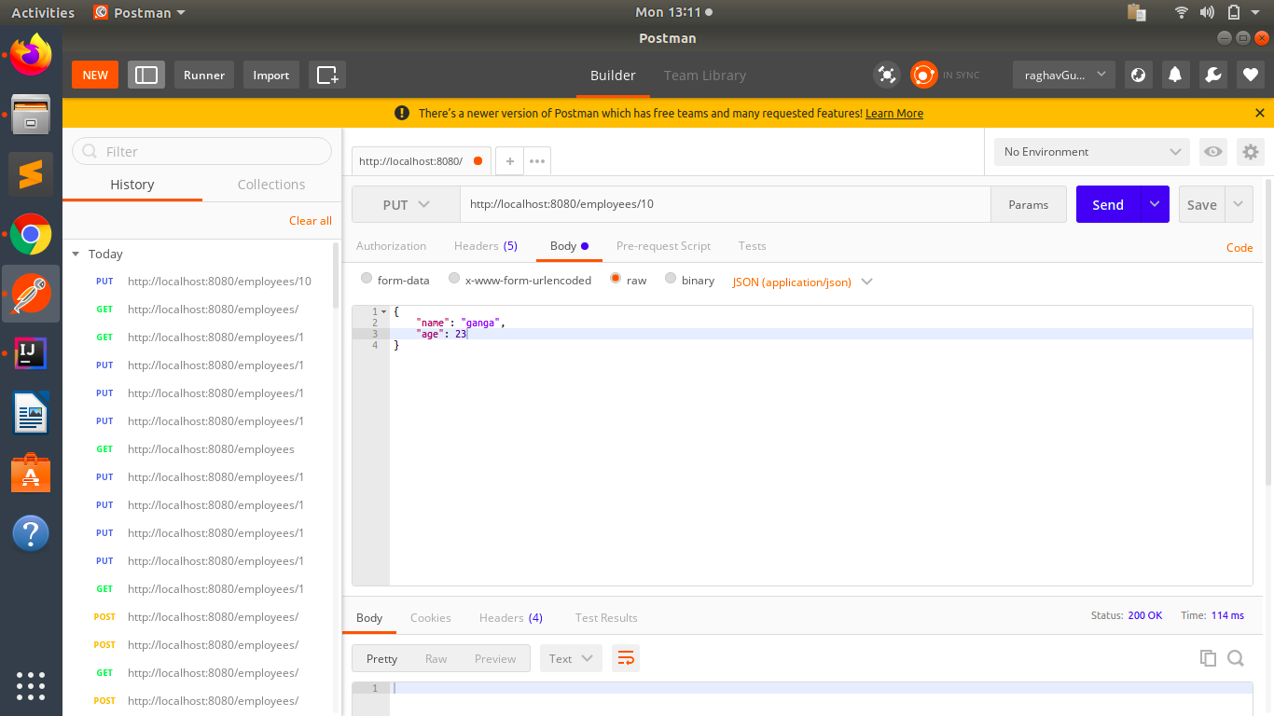

Now see that the resource has been created like a post request.

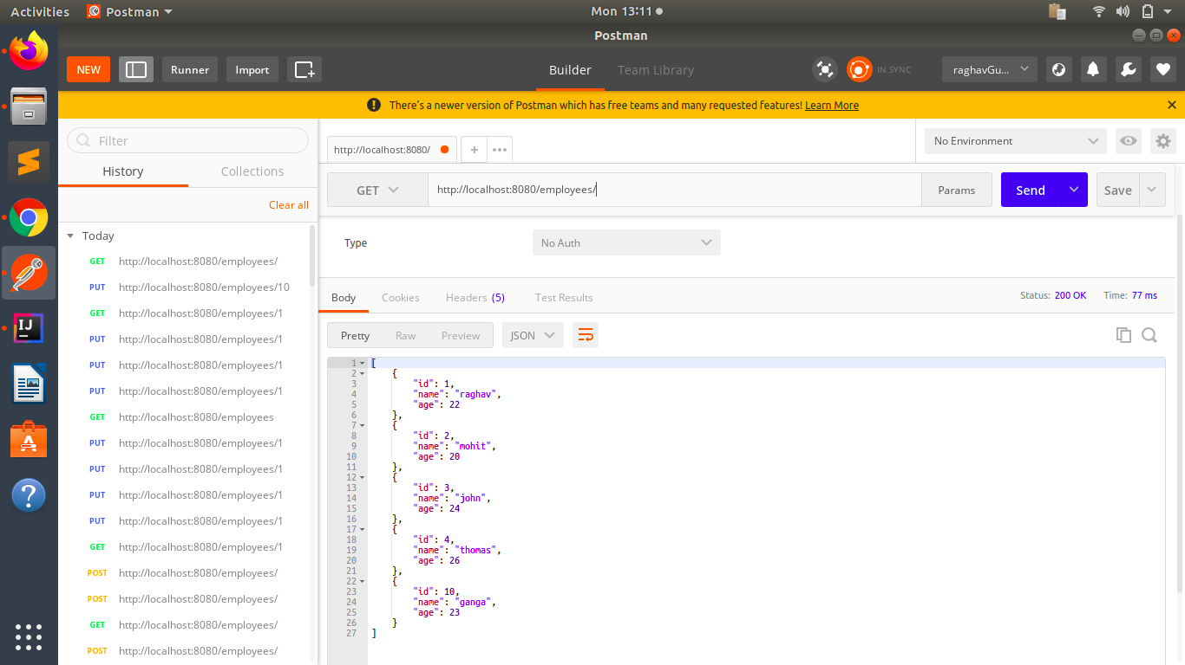

1. **Apply validation while create a new employee using POST http Request.**

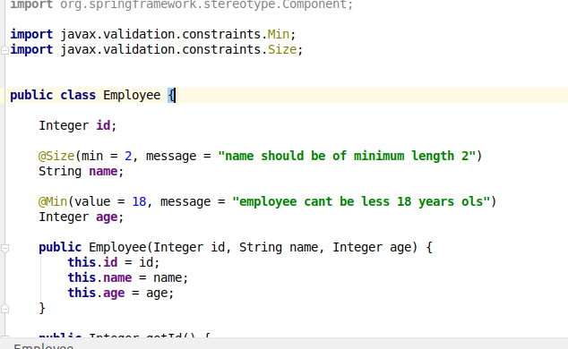

**For displaying correct message to user when validation fails.**

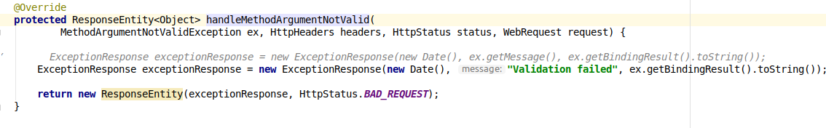

Apply @Valid in the controller also to indicate that this parameter has to be validated.

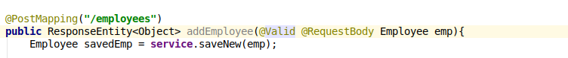

Now, if i make the request

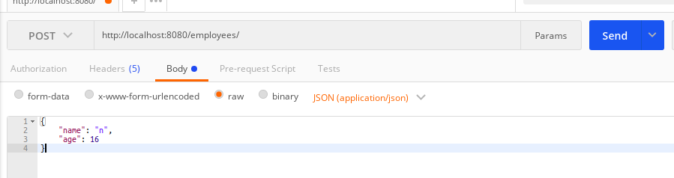

The output is -

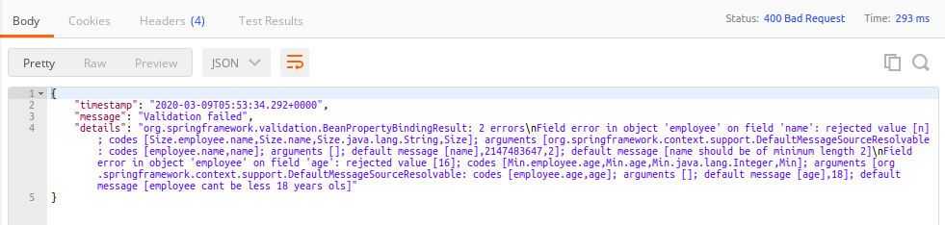

We can also see the validation error message we gave.

1. **Configure actuator in your project to check the health of application and get the information about various beans configured in your application**

actuator is a monitoring tool which is used to monitor the web appliction.

it tells details about the health, security, etc.... about the app. it may be used to know that whether my app is up or not immediately. In micro-service based architecture there are so many micro-services that monitoring is very important.

it can be accessed by /actuator

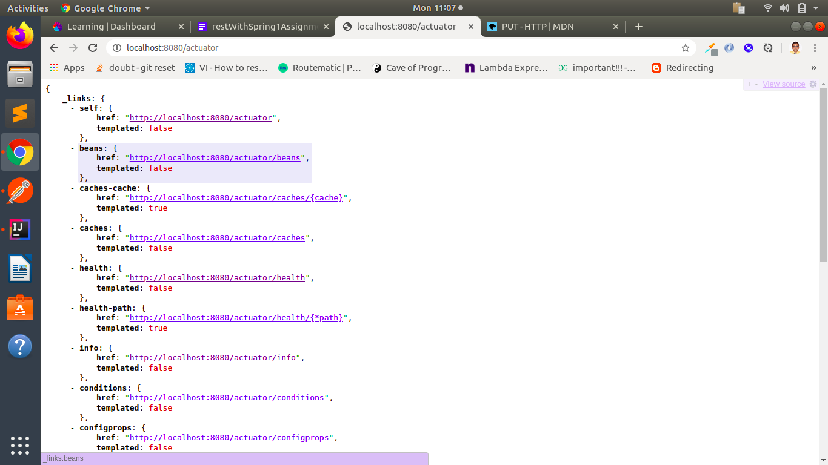

In applictation.properties file - write this line.

It enables all the features of actuator and exposes them to the web.

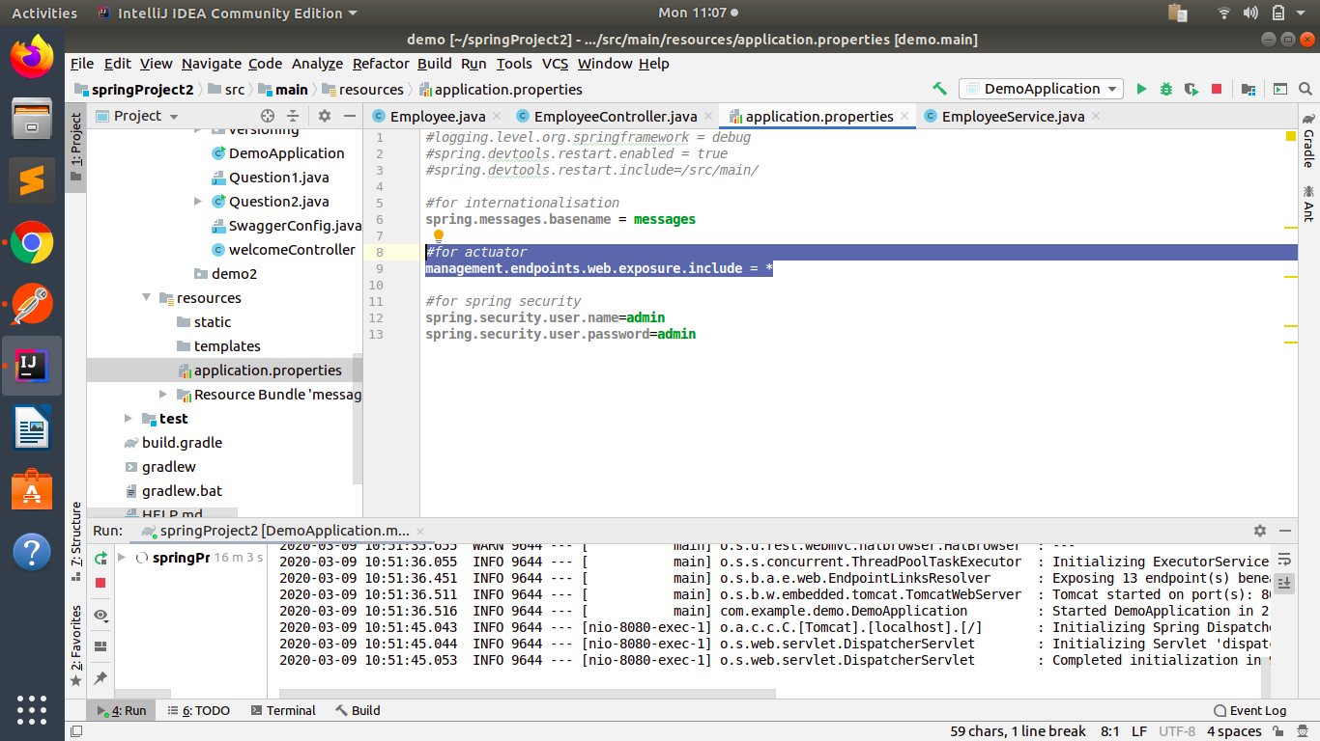

One feature is to see all the beans.

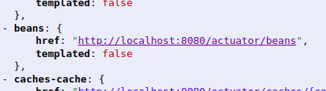

I can find my own created bean also.

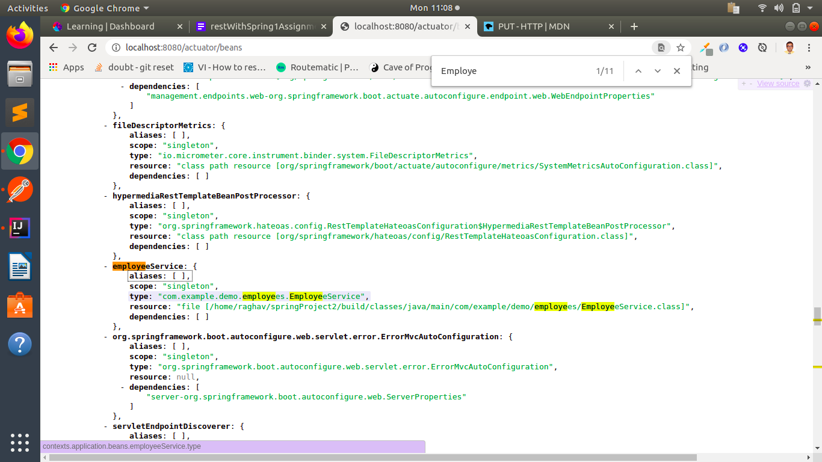

I can see the metrics also by

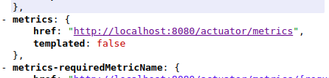

EXAMPLE -

<http://localhost:8080/actuator/metrics/jvm.memory.used> ------------------------------

