SPRING SECURITY

RAGHAV GUPTA

=================================

* Implement oauth 2 using spring security and authenticate a user which is saved in database using spring data jpa.

We generate the access token for the admin user which is used for authentication for the server.

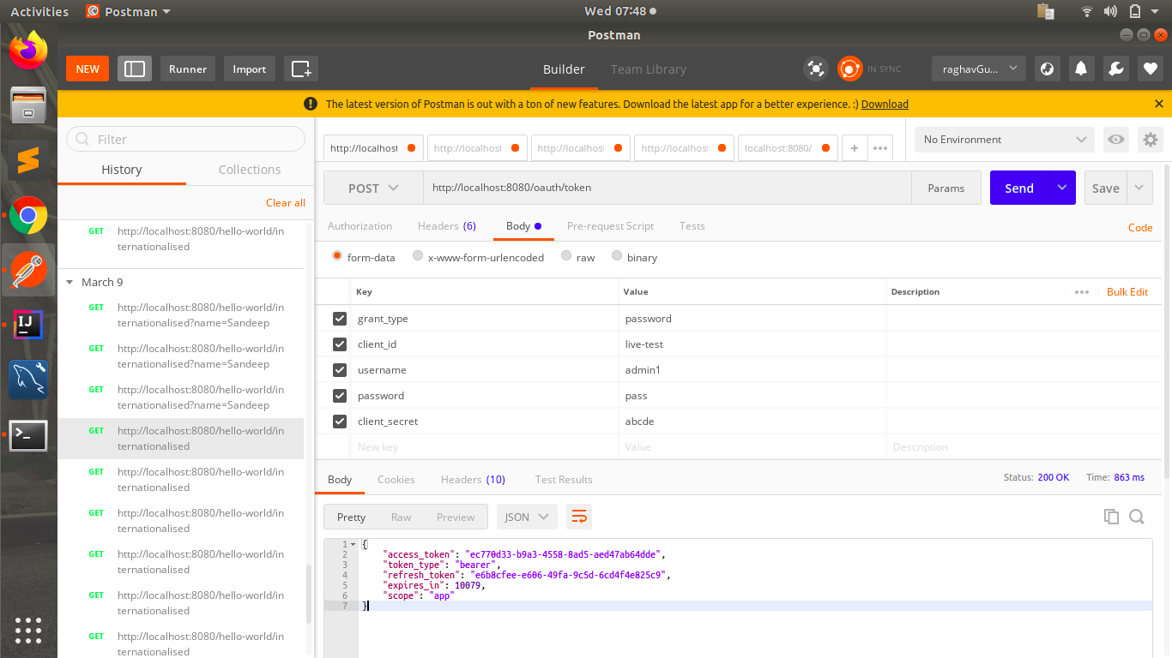

We can see that that admin user is authenticated and he can access the home page.

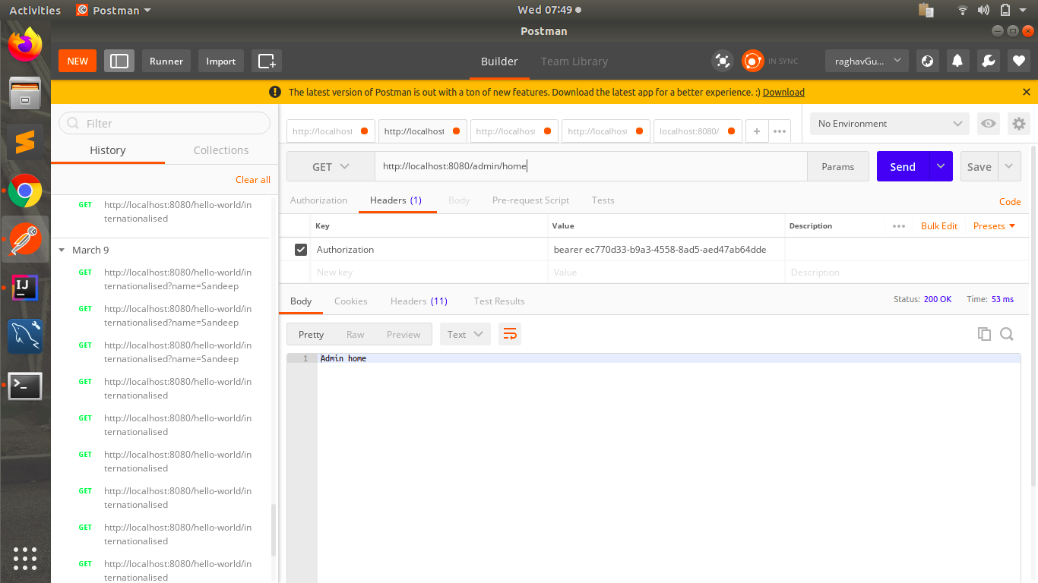

Same thing we do for the normal user - generate token and try to authenticate now.

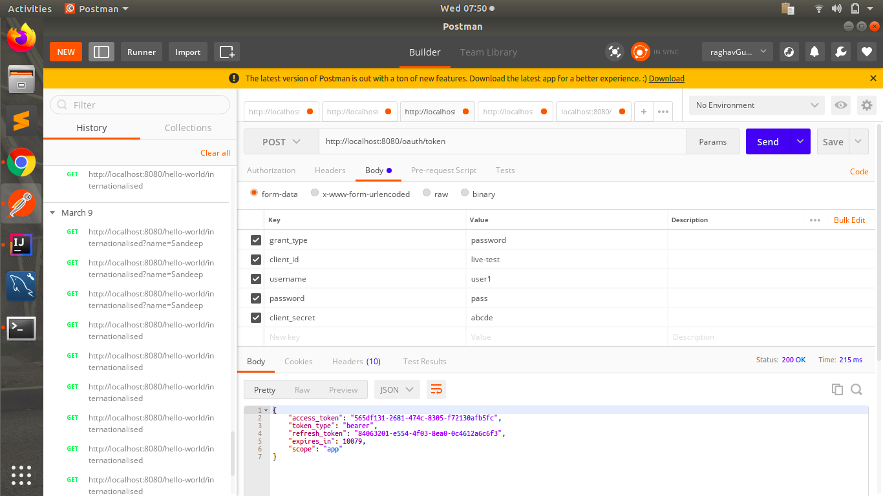

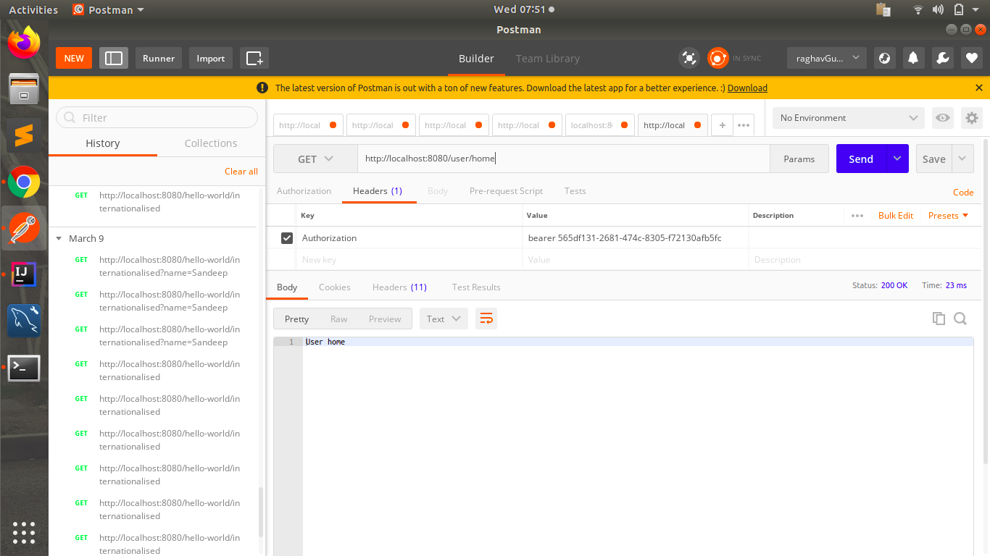

Now we try to logout and any kind of user can do that.

Here i added wrong token, so error was there.

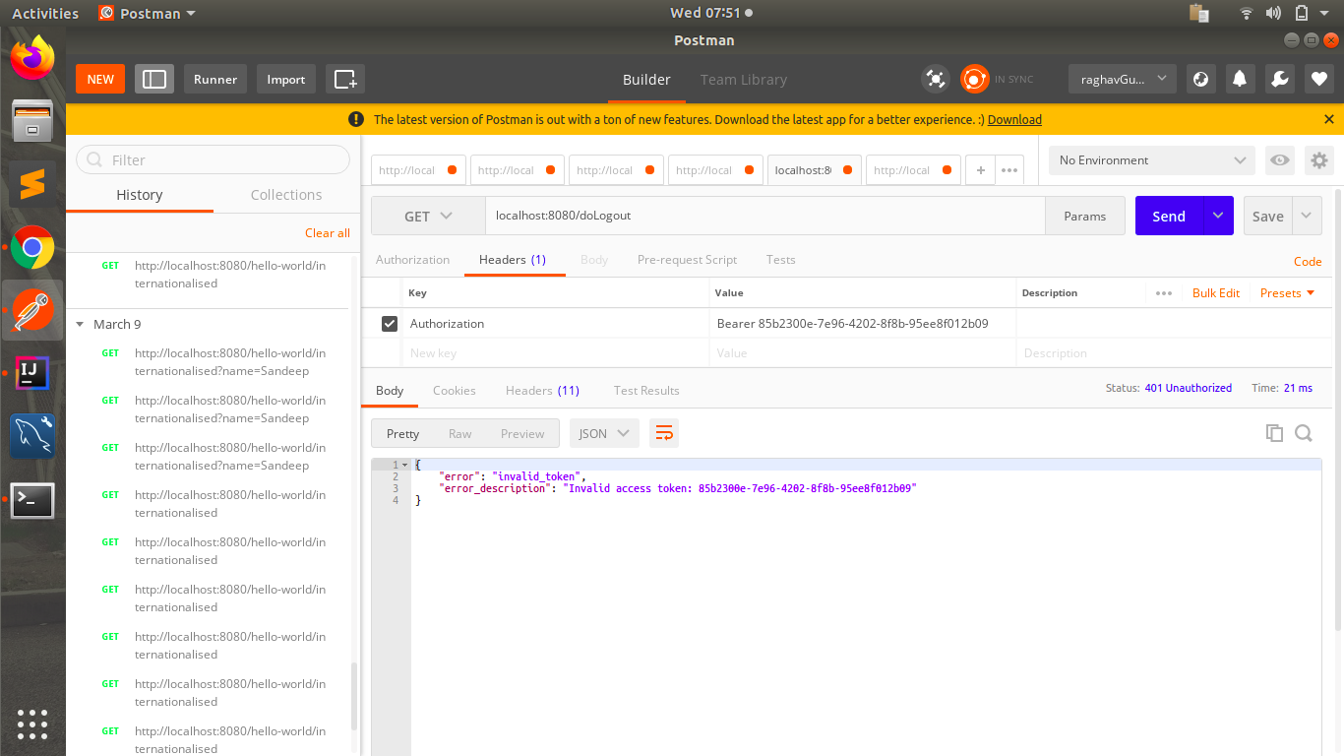

We need correct token to logout also.

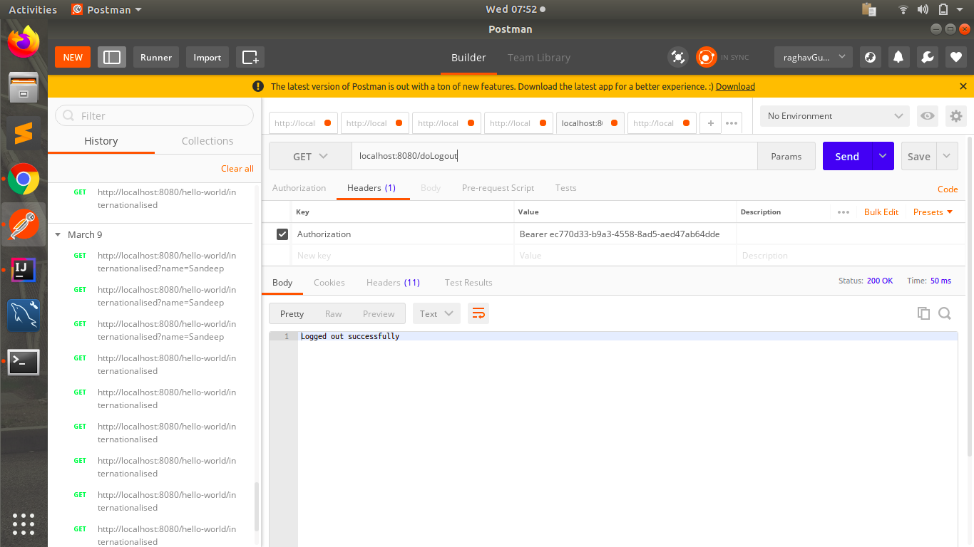

* Grant different Roles to different users and make sure that only authorized users of a given type can access the resource.

Its done as the admin cannot access user home and user cant access admin home.

If i pass user token while accessing admin home, it would not authenticate me.