Snowflake architecture

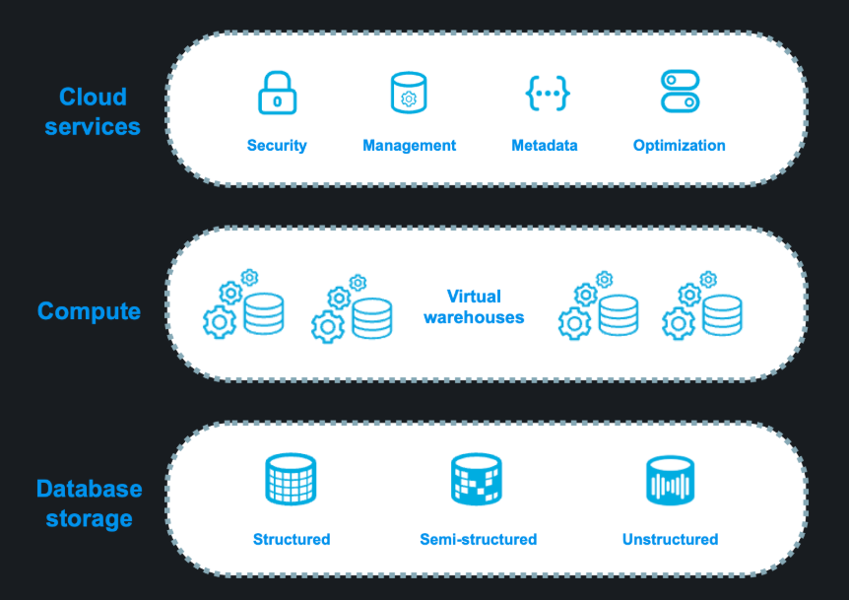
Snowflake’s unique architecture has the following key layers:
- Database storage
- Compute
- Cloud services

Database storage
Snowflake supports the following kinds of data:
- Structured data — such as rows and columns in a table — follows a strict tabular schema.
- Semi-structured data — such as a JSON file or an XML file — has a flexible schema.
- Unstructured data — such as a document, image, or audio file — has no inherent schema.
Snowflake supports several types of tables for data storage, including the following table types:
- Snowflake tables
- Apache Iceberg™ tables
- Hybrid tables
Snowflake tables
When data is loaded into a Snowflake table, Snowflake reorganizes that data into its internally optimized, compressed, columnar format. Snowflake stores this optimized data in cloud storage. Snowflake tables are ideal for data warehouses.
Snowflake manages all aspects of how this data is stored — including the organization, file size, structure, compression, metadata, and statistics. All data in Snowflake tables is automatically divided into micro-partitions, which are contiguous units of storage. Micro-partitions improve efficiency and provide other benefits.
You can use Snowflake tables to store structured and semi-structured data. You can also use the FILE data type for unstructured data.
For more information about Snowflake tables, see Understanding Snowflake Table Structures.
Apache Iceberg™ tables
Apache Iceberg™ tables for Snowflake combine the performance and query semantics of typical Snowflake tables with external cloud storage that you manage. They are ideal for existing data lakes and data lakehouses that you can’t, or choose not to, store in Snowflake.
Iceberg tables store their data and metadata files in an external cloud storage location; for example, Amazon S3, Google Cloud Storage, or Microsoft Azure Storage. The external storage isn’t part of Snowflake.
You can use Iceberg tables to store structured and semi-structured data.
For more information, see Apache Iceberg™ tables.
Hybrid tables
Hybrid tables are optimized for low latency and high throughput by using index-based random reads and writes. Hybrid tables support row locking and enforce unique and referential integrity constraints, which are critical for transactional workloads. You can use a hybrid table along with other Snowflake tables and features for Unistore workloads that bring transactional and analytical data together in a single platform.
You can use hybrid tables to store structured and semi-structured data.
For more information, see Hybrid tables.
Compute
A virtual warehouse is a cluster of compute resources in Snowflake. Virtual warehouses process SQL statements and, using Snowpark, run code in languages, such as Java, Python, and Scala. With Snowpark Connect for Spark, you can also run Apache Spark™ workloads on virtual warehouses.
Each virtual warehouse is an independent compute cluster that doesn’t share compute resources with other virtual warehouses. As a result, each virtual warehouse has no effect on the performance of other virtual warehouses.
For more information, see Virtual warehouses.
Cloud services
The cloud services layer is a collection of services that coordinate activities across Snowflake. These services tie together all of the different components of Snowflake in order to process user requests, from sign-in to query dispatch. The cloud services layer also runs on compute instances that are provisioned by Snowflake from the cloud provider.
Services managed in this layer include the following:
- Security, authentication, and access control
- Snowflake Horizon Catalog
- Infrastructure management with cloud platforms
- Metadata management, including the SNOWFLAKE database and the Snowflake Information Schema
- Query parsing and optimization
- Regulatory compliance
Integrated features for your workloads
Instead of moving data to different systems so that different teams can complete specific operations and tasks, you can bring all of your workloads directly to their data with an integrated set of features.
These features support the following broad areas of data integration and development:
- Data engineering
- Analytics
- AI and ML
- Applications and collaboration

Data engineering
Snowflake separates storage and compute, which simplifies some traditional challenges of data engineering, such as infrastructure management and performance tuning. Data engineers can focus on implementing pipelines that ingest, transform, and deliver data.
Snowflake provides several ways to ingest data, including the following options:
- COPY INTO <table> command — Loads data from files to a table.
- Snowpipe — Loads data from files as soon as they are available in a stage.
- Snowpipe Streaming — Loads row-level data continuously and with low latency, using the Snowflake SDKs or a REST API, directly into Snowflake tables and Snowflake-managed Iceberg tables, instead of loading data from files.
- Openflow connectors — Ingest data from specific sources by using connectors built on Apache NiFi, such as Microsoft Sharepoint and Google Drive.
- Snowflake Connectors — Connect from external applications and systems and stream data into Snowflake.
Snowflake also provides several ways to transform data, including the following options:
- Dynamic tables — Define tables that automatically refresh based on target freshness and a query that performs data transformations.
- Streams and tasks — Capture changes made to base objects with streams and define tasks to perform data transformations.
- Snowpark — Perform more complex transformations by using programming languages, such as Python, Java, and Scala.
- dbt — Use an open-source data transformation tool and framework to define, test, and deploy SQL transformations.

