Existing HRMS Applcation Screenshots :

Dashboard from Fresh Team:

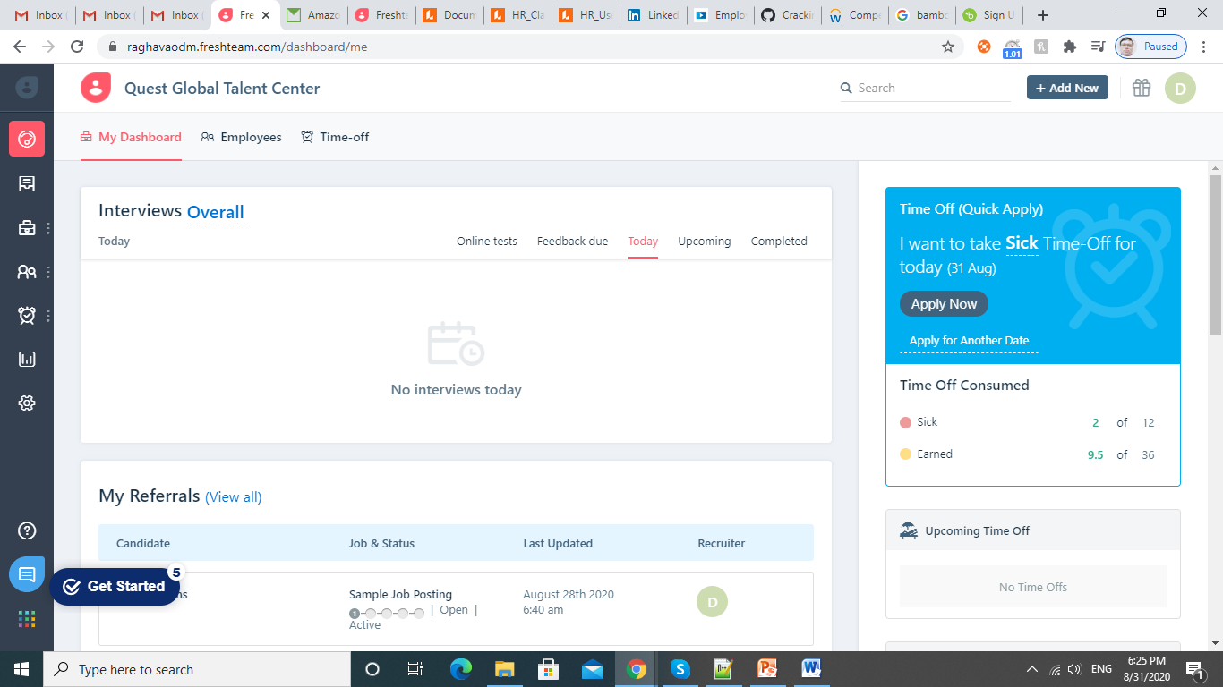

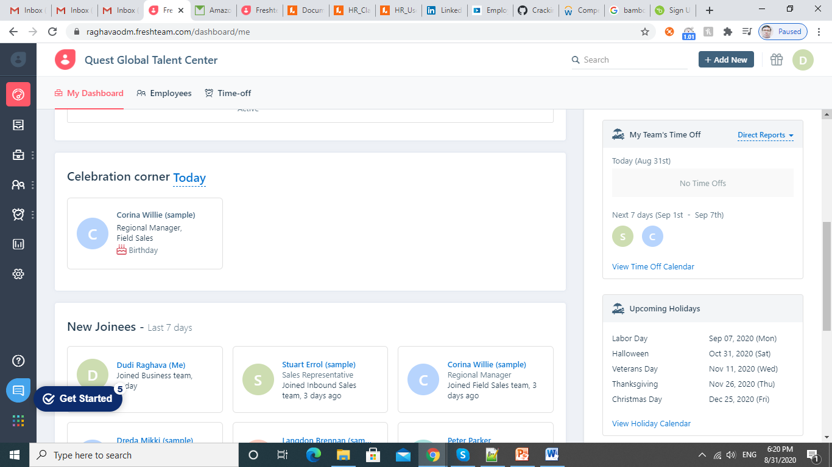

Employees Dashboard:

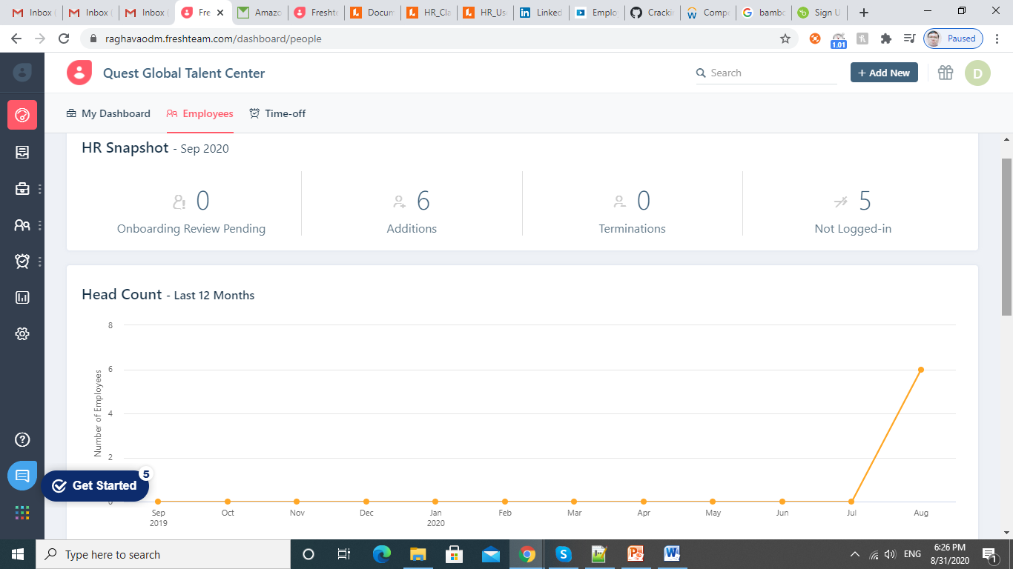

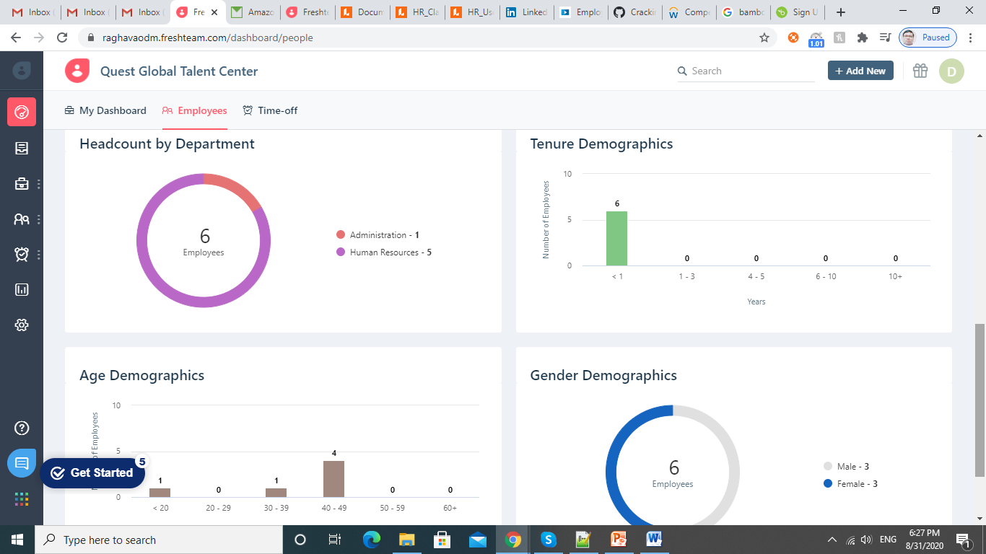

Time-off Dashboard:

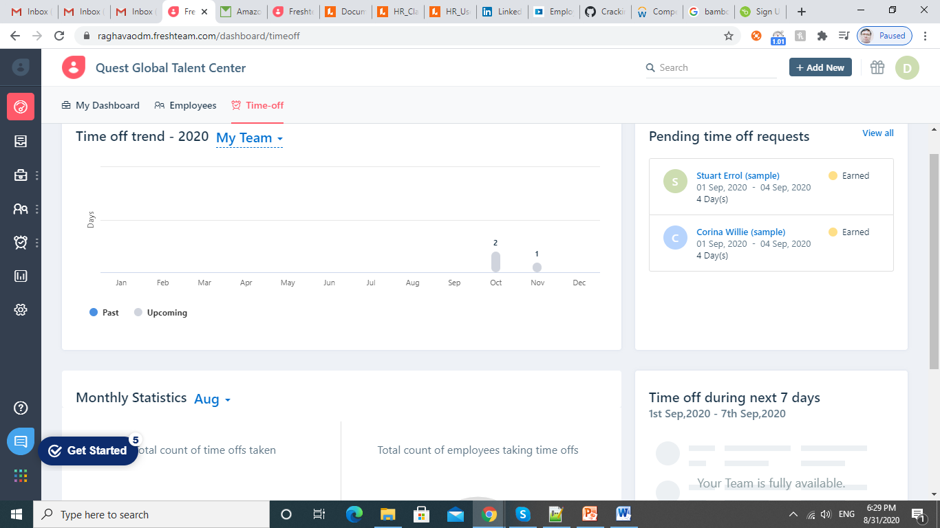

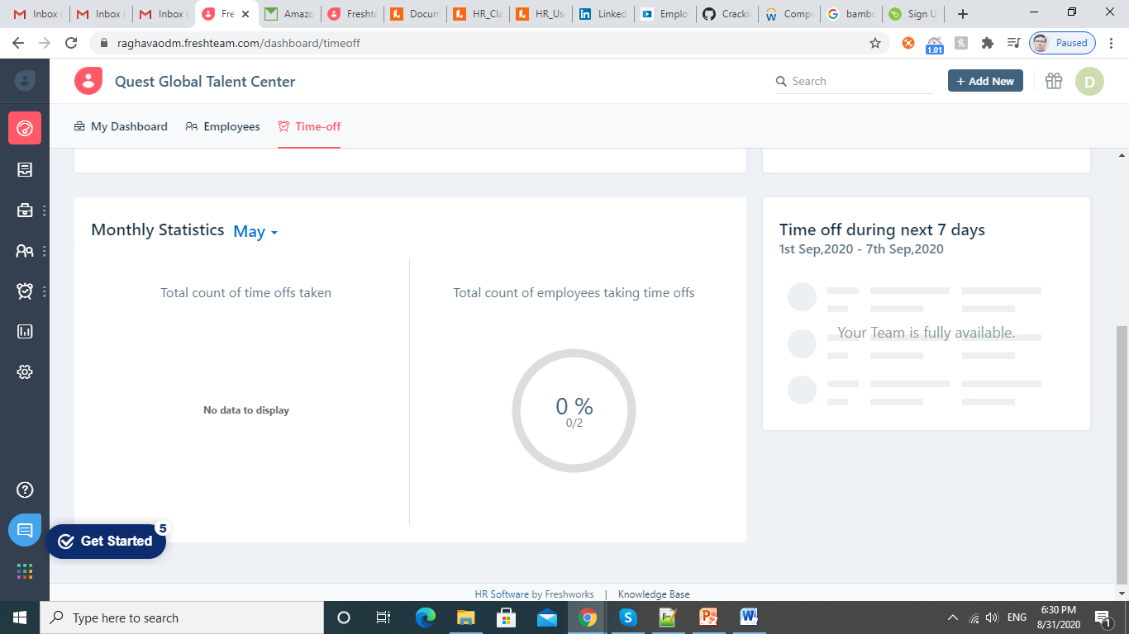

HRMS Benefits for Hiring Applicants:

* Store Job Description
* Request for new hires
* Manage job boards
* schedule and track interviews
* Background check
* Testing and assessments
* Immigration documentation

**Job Opening Page:**

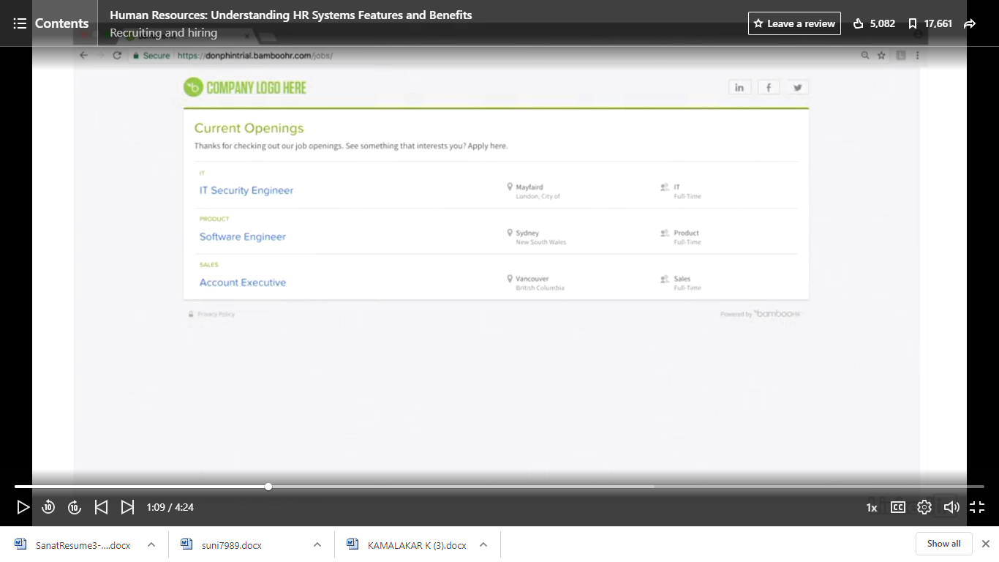

Applicant Tracking System:

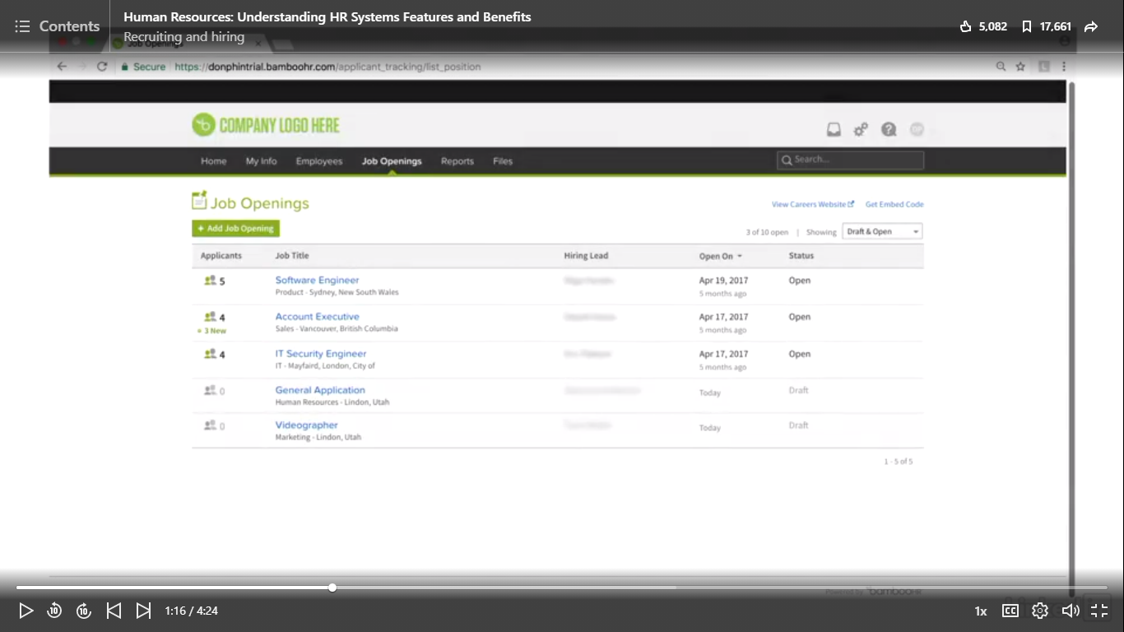

More information about the Openings:

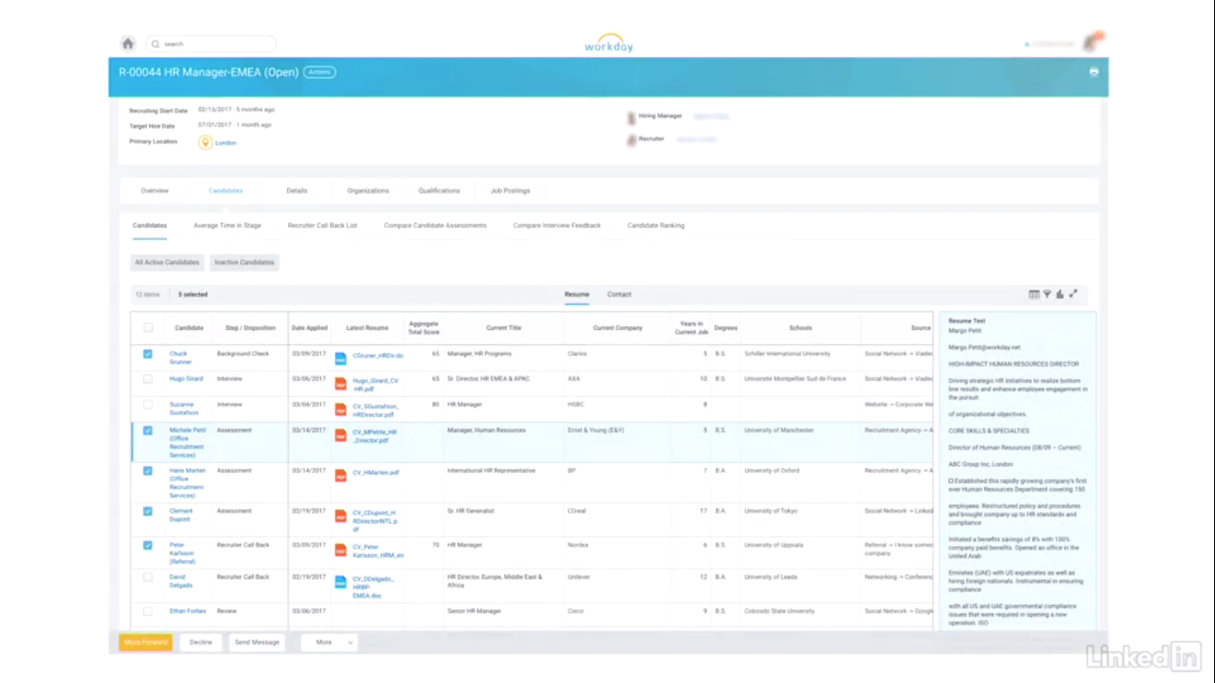

Posting the Job on Linked-In from System:

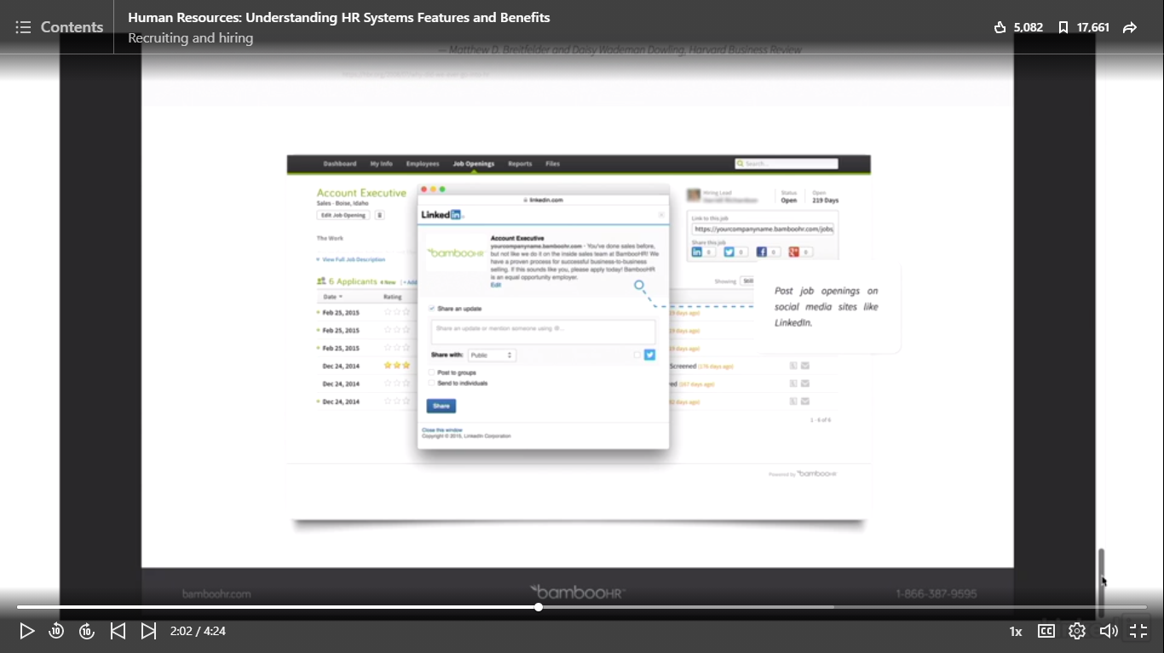

Dashboard for specific Job Applicant:

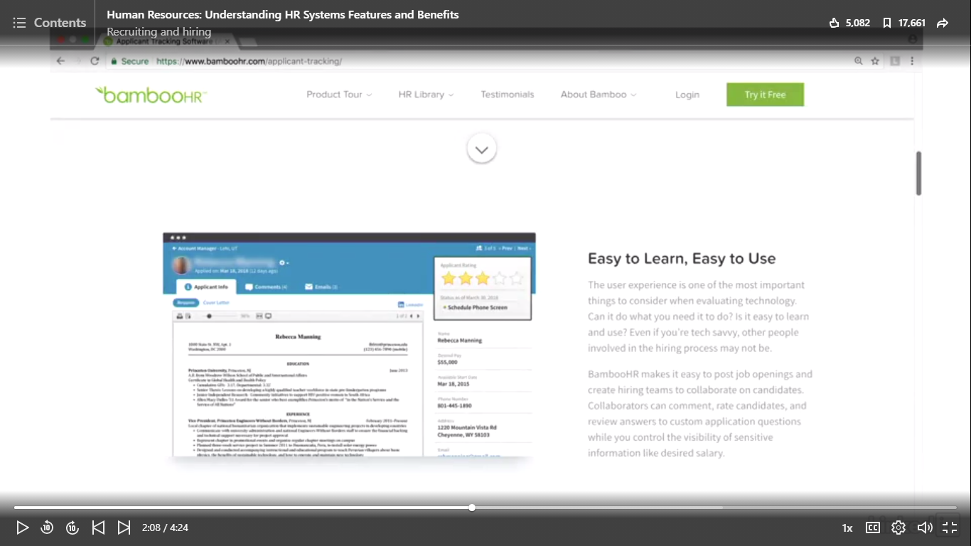

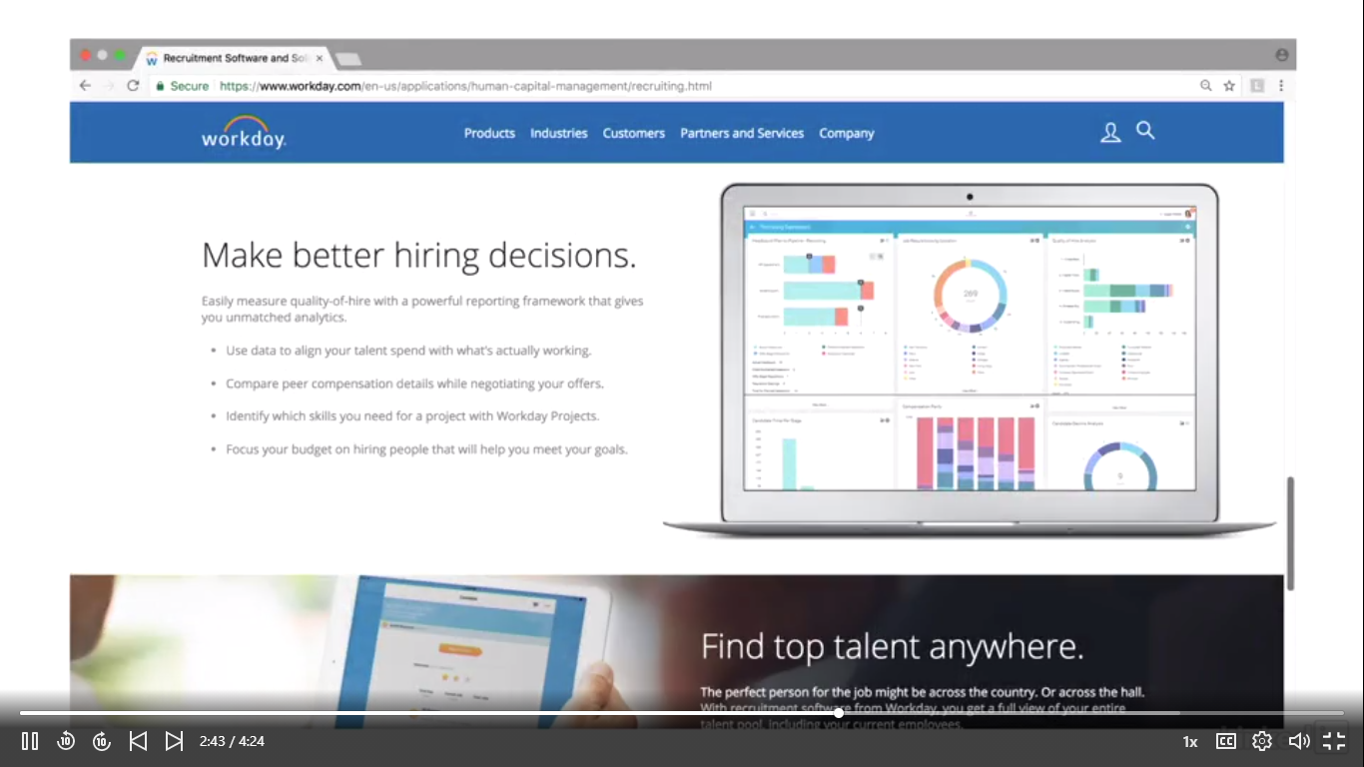

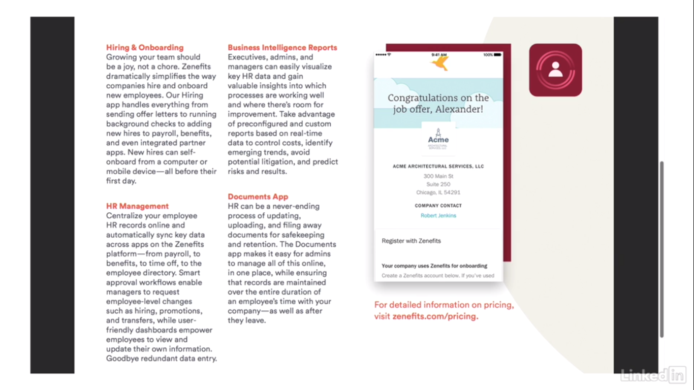

Employee on Boarding:

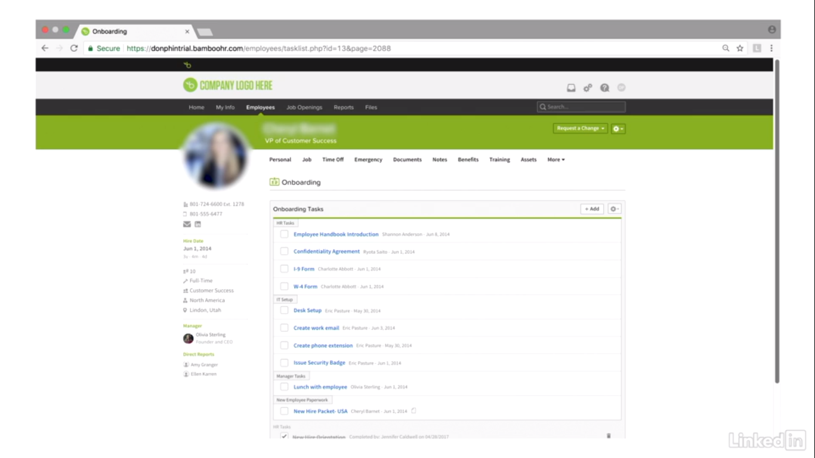

Payroll Integration:

* Electronic time and Attendance
* Comply with wage and hour requirements
* Understand Paycheck, benefits and total compensation.

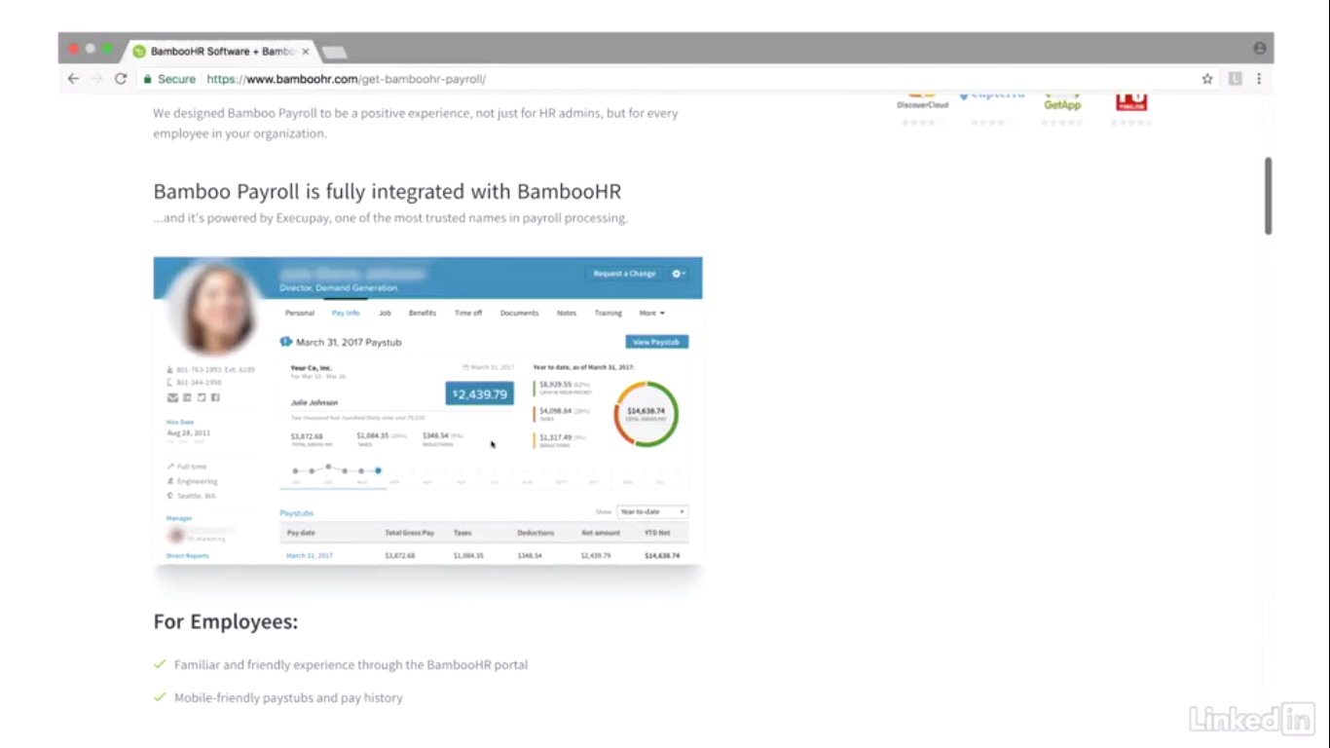

Total Paycheck:

* Pay
* Healthcare
* Social Security
* Medicare
* Workers Compensation
* And More

HRMS has the ability to integrate payroll data into workers compensation billing.

Compensation Management is designed to maximize the return on the investment.

Goal: Reward the right people to greatest extent, for most relevant reasons.

Compensation Management:

* Proper wage and salary levels
* Managing rise and bonuses.
* Determine overall compensation levels.

<https://www.workday.com/en-us/products/human-capital-management/human-resource-management/compensation.html>