**HRMS Application Design Document**

**What is HRMS?**

A Human Resource Management System is comprehensive software that integrates core and strategic HR functions into one solution. It’s typical features will be Employee self-service portal, Manager self-service portal and a Central database. It should mainly reduce the paperwork for the HR by having all the information available in one secured place.

**Requirements of the System:**

**Functional Requirements:**

**Employee:**

1. Employee’s can view their personal information.
2. Employees can view basic information of other employees in his department.
3. Employees can login Time-In and Time-Out.

**Admin:**

1. Admin teams should be able to add individual employees, view all employee’s and update individual records.
2. Admin team should add Department information.
3. Can view Timesheet for all employees.

**Manager:**

1. Can view their personal information.
2. Can view all Employees reported to him.
3. Can view the Timesheet for the employees reported to him.

**Non-Functional Requirements:**

1. Same login for Employees, Admin and Manager. But based on authorization, we will provide access.
2. Normal Employee shouldn’t be able to access other employees' information.
3. Manager should be able to access only his profile and employees reporting to him.
4. Proper error handling and Progress bar while retrieving any information.

**System API:**

1. Following method would be used to add employee information:

**createEmployee(name, gender, date_of_birth, joining_date, primary_contact_information, permanent_contact_information, telephone_numbers, email-ids, Location, department_id, photo_path, manager_id)**

Parameters:

name (string) : Name of the employee.

gender (character) : M for Male and F for Female

date_of_birth (date) : Date of Birth of the employee

joining_date (date) : Date of joining.

primary_contact_information (string) : Current Address details of the employee.

permanent_contact_information (string) : Permanent Address details of the employee, copy of primary contact if both are the same.

telephone_numbers (string) : Comma separated contact details, with at least one Primary contact.

email-ids (string) : OnPassive Official email ID.

Location (string) : Bangalore or Hyderabad or US.  
photo_path (string) : Location of the employee’s image where it’s located.

manager_id(number) : Manager's employee Id

1. Following is the method for getting all employee :

**getAllEmployees() : return employee_info**

Return:

employee_info(Employee): All Employees information will be returned by this method.

1. Following is the method for Adding Department information:

**addDepartment(department_name, department_description)**

Parameter:

department_name(string) : Name of the department.

department_description(string) : Description of the department.

1. Following is the method for adding Time sheet:

**addTimeSheet(time_in, time_out, task_description:optional)**

Parameter:

time_in(time_stamp): Current Timestamp.

time_out(time_stamp) : Current Timestamp.

task_description (string) : what task has been performed today.

**Use Case Diagram :**

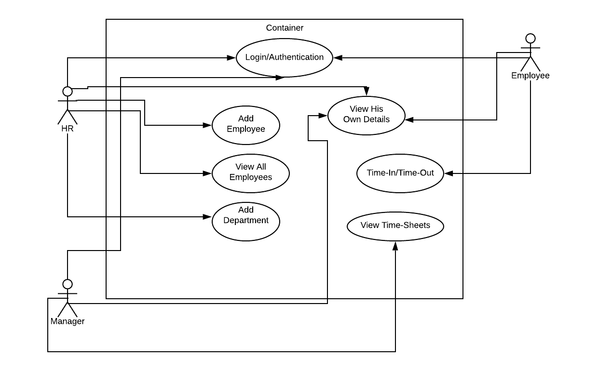

**Class Diagram :**

Here are the main classes of Human Resource Management System:

User Class : This class will contain the user login information.

Role Class : This class will contain role information.

Employee Class : This class contains the information of all employees.

Timesheet Class: This class contains the information of all Timesheets.

Department Class: This class contains the information of all Departments.

Permission Class: This class contains the information of all Permissions.

ContactDetails Class: This class contains the contact information of the Employee

AddressDetails Class: This class contains the information of the Address of the Employee.

PhoneDetails Class: This class contains the information of the Phone of the Employee.

HRAdmin Class: This class contains the functionality of HRAdmin.

Manager Class: This class contains the functionality of Manager.

