Low Pressure Testing
Tech Writer  Approved by: | Document # | Revision Draft

A. | Objective

B. | Safety

  Note | Safety is our #1 priority. If you are unsure of a procedure or require MSDS information, contact your PII Coordinator or Safety Team Representative.

  Warning | Always wear an approved ESD wrist strap connected to a suitable earth point when handling the electronic insert

B.1 | Hazardous Chemicals
- Some chemicals in this procedure may be hazardous under certain conditions. Review MSDS information before proceeding.
- Always work in a well-ventilated area.
- Always wear protective eyewear when working with aerosol spray solvents.
- Never use aerosol sprays near open flames or under high temperatures.
- Use protective gloves to avoid prolonged skin contact with solvents.
- Wash hands thoroughly before eating, drinking, smoking or using the toilet.

B.2 | Personal Protective Equipment
- Wear steel toed boots with full foot protection. If working with circuit boards, ensure that your footwear is ESD (electrostatic dissipating).
- Wear back support belts and use proper lifting techniques at all times.
- Employees are encouraged not to lift more than 30 to 50 pounds depending on the bulkiness of the equipment/materials and their body size. Mechanical assistance shall be used otherwise.
- Wear appropriate heat resistant gloves when exposure to high temperature is present.

C. | References

C.1 Drawings
Drawing No. | Description

D. | Consumable Items

E. | Tooling & Equipment

E.1 Tooling and Equipment

F. | Prerequisites

Please review this document and the Quality Plan documents before proceeding to familiarize yourself with the required actions.

G. | Assembly Procedures

G.1 | Compensator Housing Air Test

- Slide o-ring guide ring onto shaft up to inner actuator bearing race.  - Apply a thin layer of API modified thread compound Air Test Plug threads.  - Wrap teflon tape around sealing shoulder of Air Test Plug.  - Install Air Test Plug into Compensator Housing, torque to approximately 200 ft-lbs.  - Install a 3/8”-18 fill adapter into the Air Test Plug.  - Connect the Low Pressure Gauge assembly to the Fill Adapter.  - Attach the regulator to the Low Pressure Gauge assembly.  - Turn the regulator fully counter clockwise (zero pressure).  - Attach the Air line to the Pressure Regulator to 10 psi maximum.  - Close the valve on the Pressure Gauge assembly and remove the Air Line.  - Leave for one hour to ascertain that there is zero drop in pressure.  - Record the results in the pull-out section at the end of this document. | 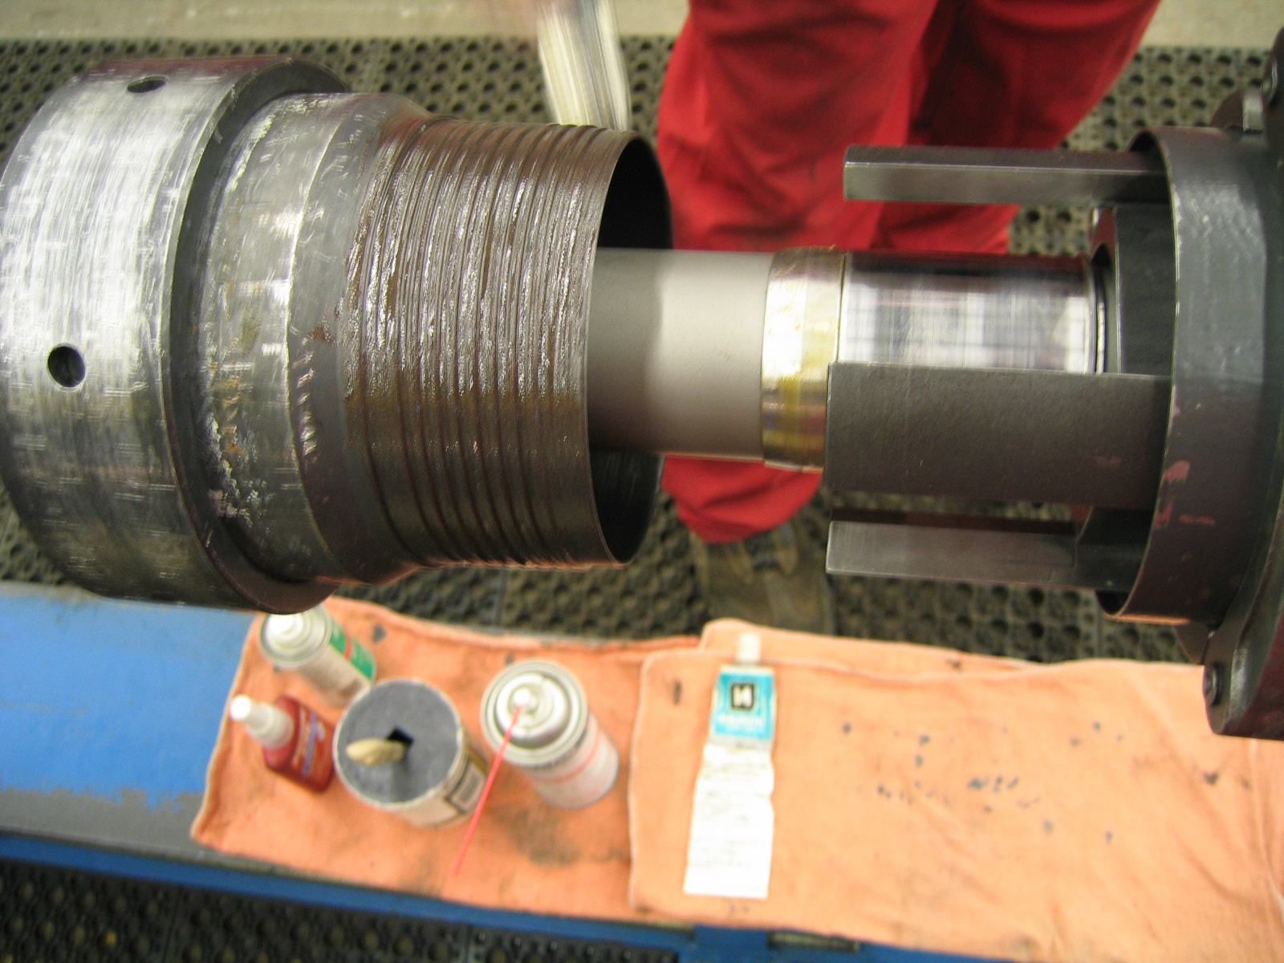  Figure 1: Air Test Plug  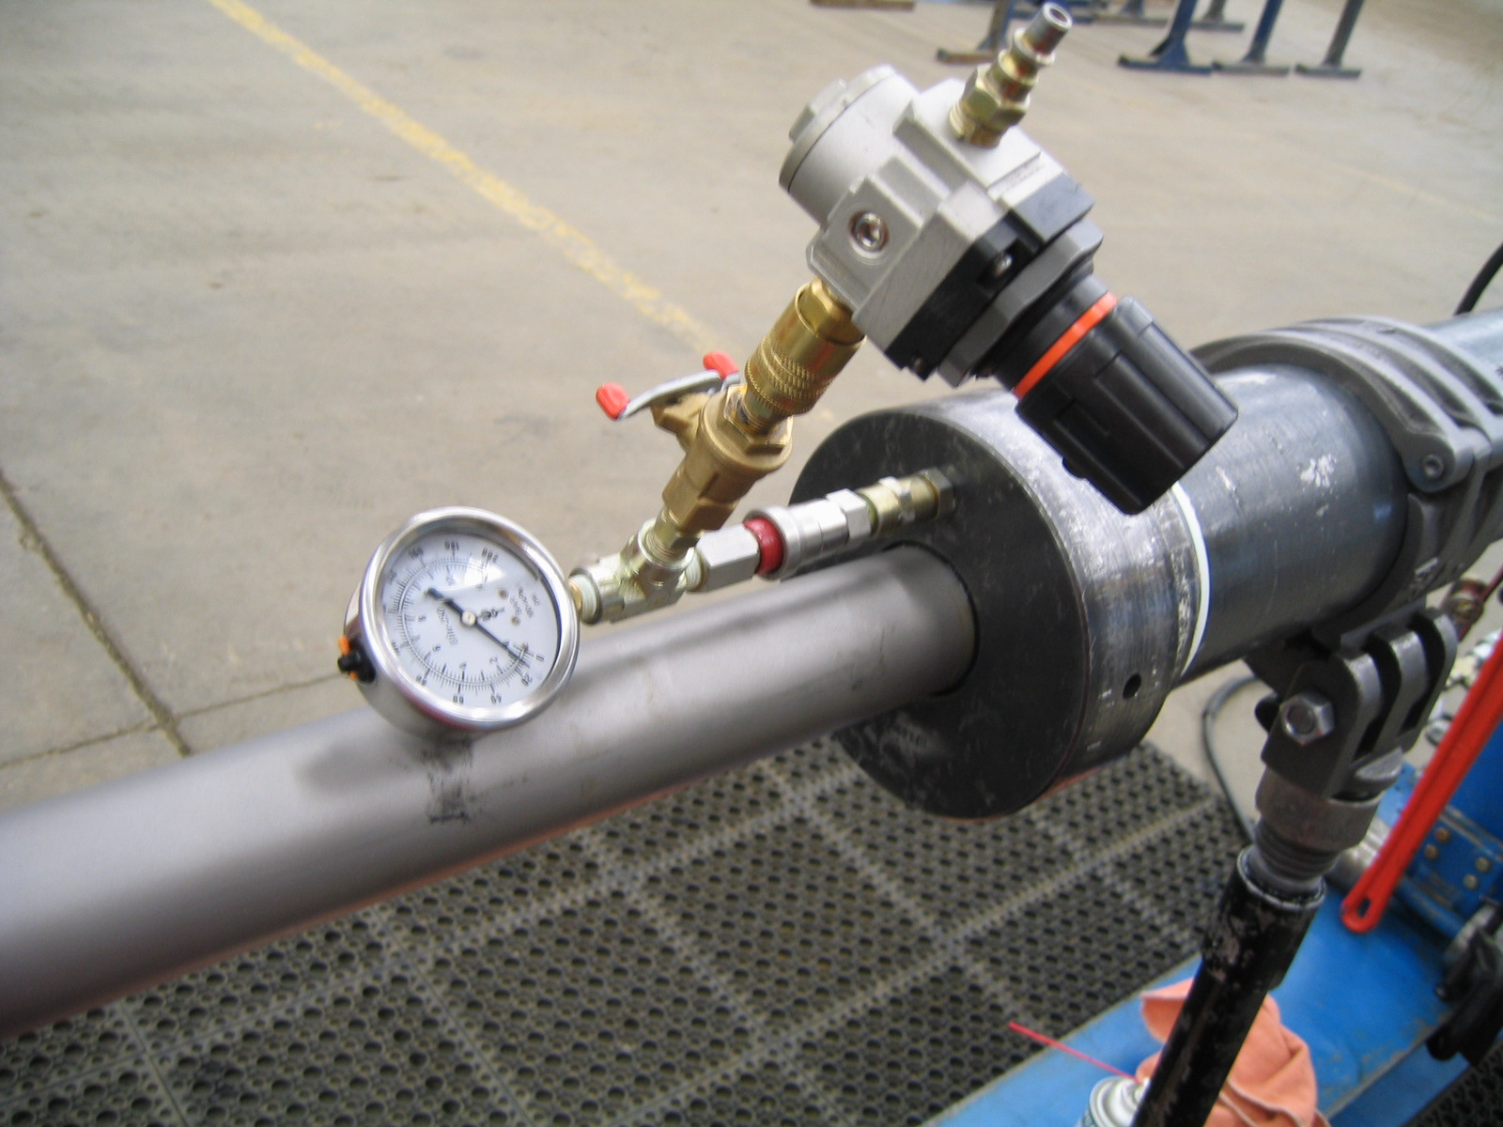  Figure 2: Compensator Housing Air Test

  Note | Bleed the air pressure back to zero before removing any test adapters!

G.2 | Driver Air Test

- Install Air Test Plug Top into the box end of the Driver.  - Install the Air Test Plug Bottom into the bottom of the Anti-Rotation Housing c/w lubricated o-ring.  - Apply a thin layer of API thread compound to the Anti-Rotation Housing.  - Thread the Air Test Cap onto the AR Housing.  - Install a 3/8”-18 fill adapter into the Air Test Plug Top.  - Connect the Low Pressure Gauge assembly to the Fill Adapter.  - Attach the regulator to the Low Pressure Gauge assembly.  - Turn the regulator fully counter clockwise (zero pressure).  - Attach the Air line to the Pressure Regulator to 10 psi maximum.  - Close the valve on the Pressure Gauge assembly and remove the Air Line.  - Leave for one hour to ascertain that there is zero drop in pressure.  - Record the results in the pull-out section at the end of this document. | 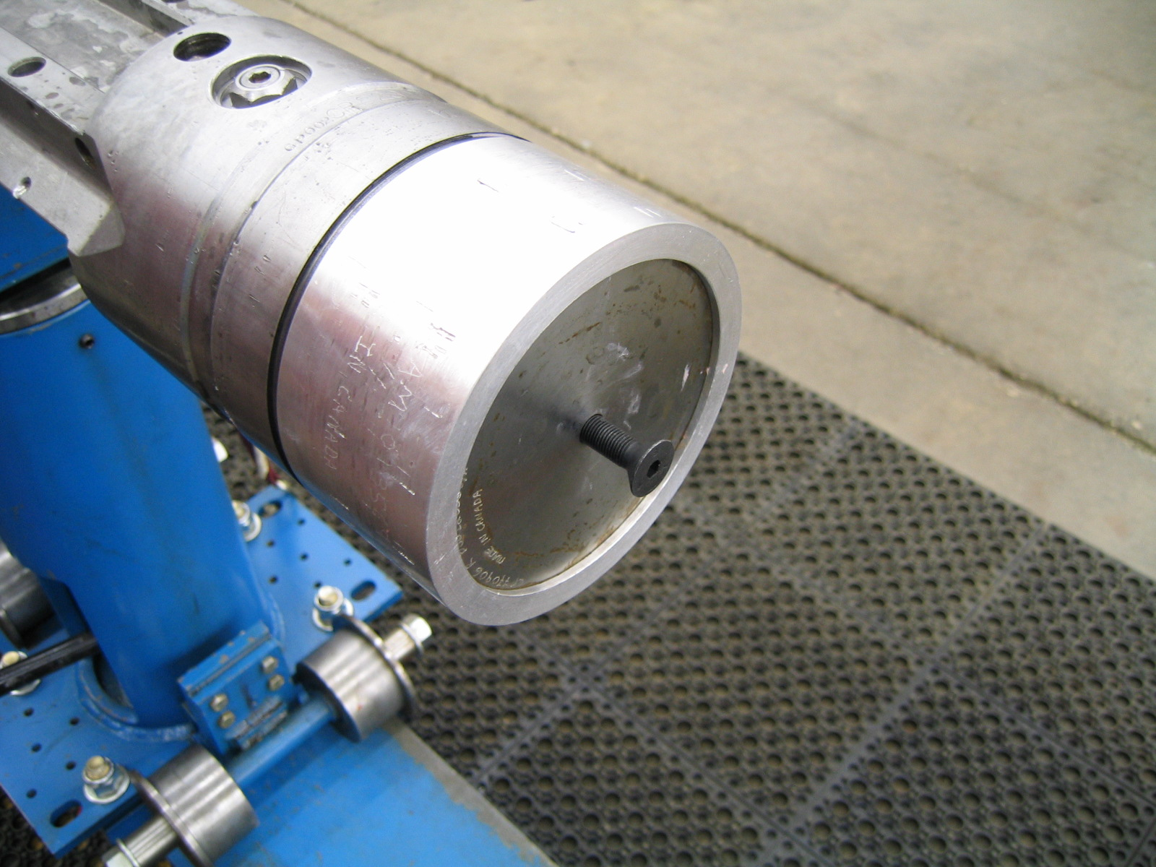  Figure 3: Air Test Plug Bottom and Cap  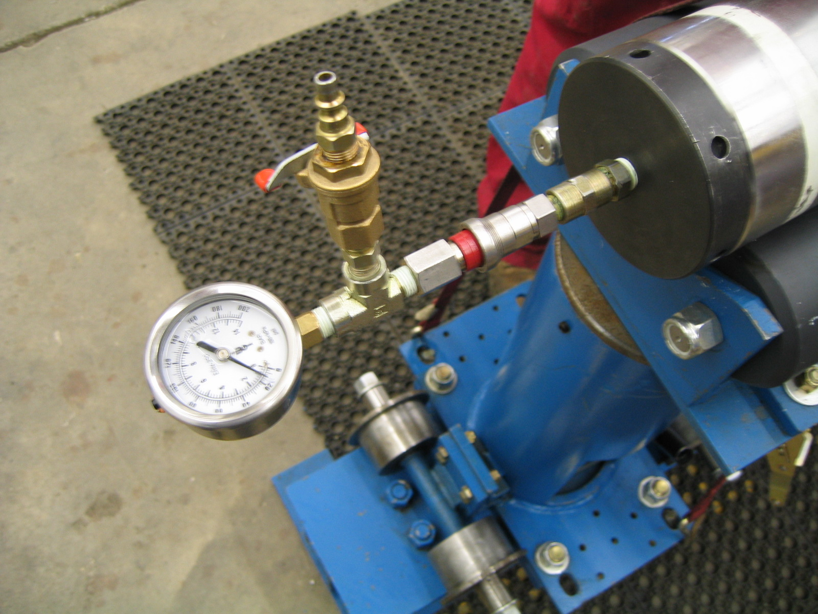  Figure 4: Driver Air Test

  Note | Bleed the air pressure back to zero before removing any test adapters!

G.3 | Complete Tool Air Test

- Install .0625” NPT pipe plug into the lower rotary seal housing and .3125” NPT pipe plugs into the Driver housing.  - Fit the Fill Adapter into the Upper Rotary Seal.  - Connect the Low Pressure Gauge assembly to the Fill Adapter.  - Attach the regulator to the Low Pressure Gauge assembly.  - Turn the regulator fully counter clockwise (zero pressure).  - Attach the Air line to the Pressure Regulator to 10 psi maximum.  - Close the valve on the Pressure Gauge assembly and remove the Air Line.  - Leave for one hour to ascertain that there is zero drop in pressure.  - Record the results in the pull-out section at the end of this document. | Figure 5: Air Test Plug Bottom and Cap  Figure 6: Driver Air Test

  Note | Bleed the air pressure back to zero before removing any test adapters!

Main Assembly Pressure Testing
Tech Writer:  Approved by: | Document # | Tool Serial No: | Revision (Draft)

G.1 Compensator Housing Air Test
1 Hour Pressure Test @ 10 PSI | Pass | Fail | Tested By | Date

G.2 Driver Air Test
1 Hour Pressure Test @ 10 PSI | Pass | Fail | Tested By | Date

G.3 Complete Tool Air Test
1 Hour Pressure Test @ 10 PSI | Pass | Fail | Tested By | Date

