Problem :

In 2010, the ACLU presented a report on jury selection in Alameda County, California. The report concluded that certain ethnic groups are underrepresented among jury panelists in Alameda County, and suggested some reforms of the process by which eligible jurors are assigned to panels. In this section, we will perform our own analysis of the data and examine some questions that arise as a result.

Null Hypothesis:

Assuming that the jury selected was random from population.

Alternative Hypothesis:

The jury was selected in random

So to prove this we will find a test statistic. To find test statistic First We change our data into a data frame. After that we are setting ethnicity column as index to know which ethnic group is assigned.

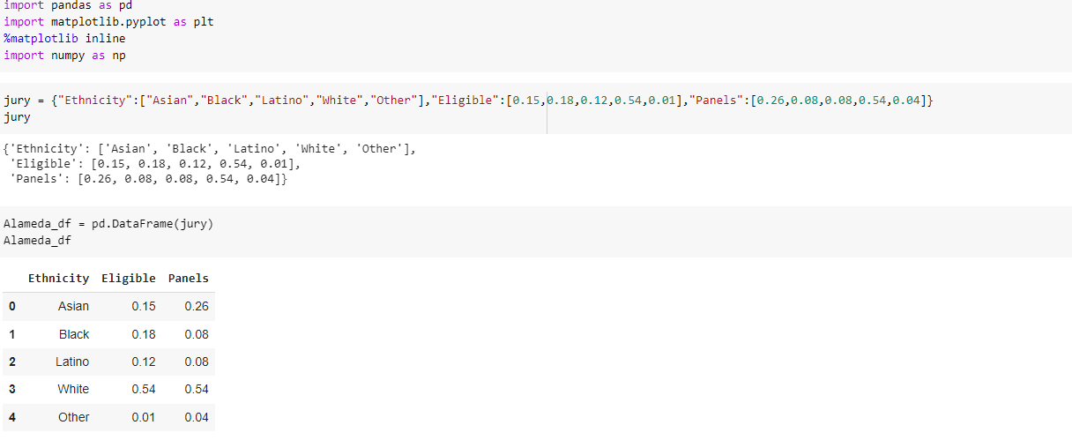

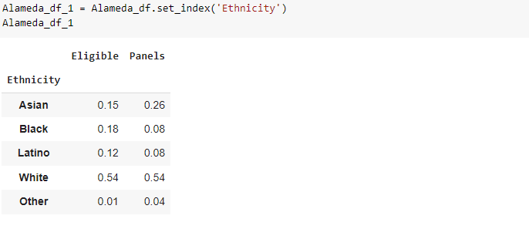

For every ethnic group we are finding the difference between the panel and eligible. Then we get differences for all the ethnic groups. In those differences we find some negative values. So if we calculate the sum of those differences we will get zero because it contains negative values.

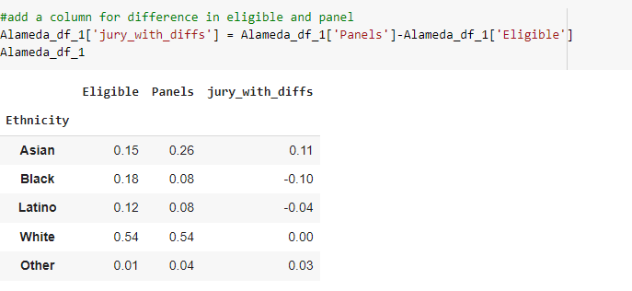

Hence we are finding sum of positive values of differences and absolute values of negative values. Because we are using absolute values the sum will get doubled of original values so we calculate sum/2. The sum/2 value is our test statistic which is equal to 0.14

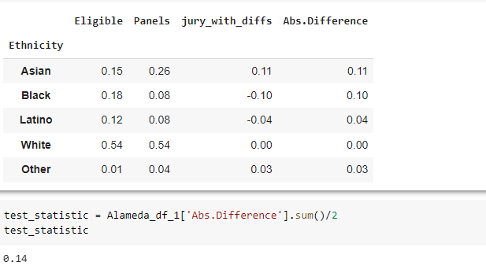

To test this we are taking a random sample using multinomial distribution because we have different ethnic groups. For that random samples also we are finding difference between those samples and eligibility=0.009.

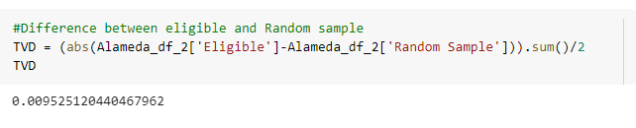

We will be repeating the same process for 5000 times for 1453 people. We will get 1453 such kind of differences . We will take 5 among them and we plot a histogram.

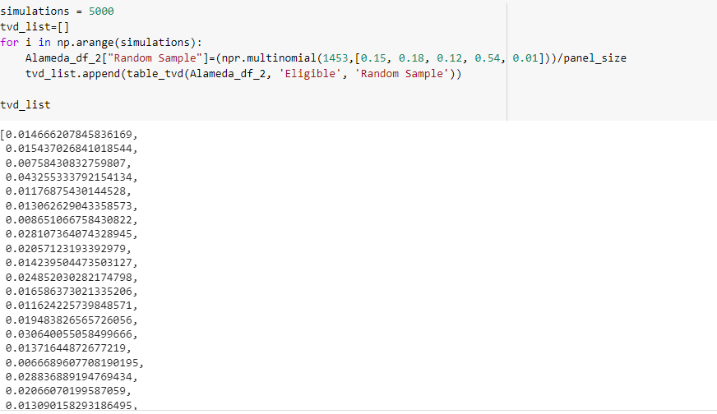

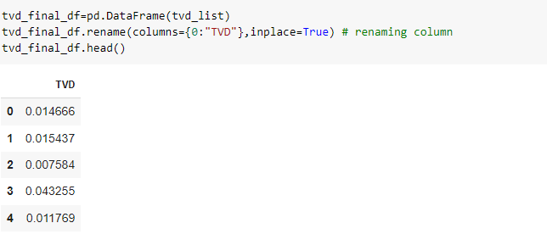

After plotting the histogram we understood that the differences of these 5 will be far away from the test statistic value 0.14.

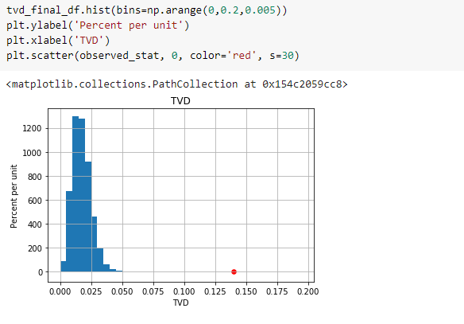

So we can conclude that the jury is not selected in random order.

Hence we are rejecting Null hypothesis.