How to setup Jfrogg container registry using docker?

1. Create Docker volume name as registry
2. Create Docker container using following command

sudo docker run -itd -p 8081:8081 -p 8082:8082 --name artifactory-jcr -v registry://var/opt/jfrog/artifactory --restart=always docker.bintray.io/jfrog/artifactory-jcr:latest

1. After this you need go on browser and type

IP:8082

By default username and password would be

admin and password

change password option will come after you entered first time by default username and password.

Select Repo for docker

1. Create local-repo in jfrog

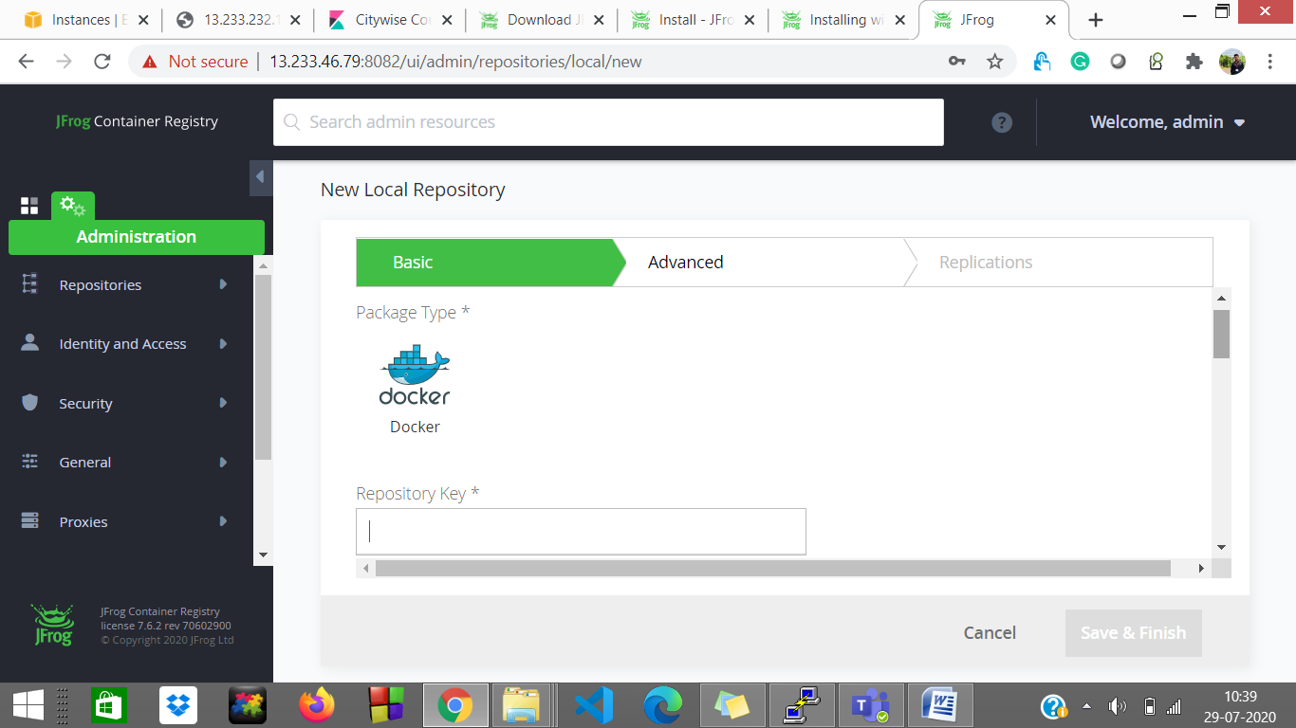

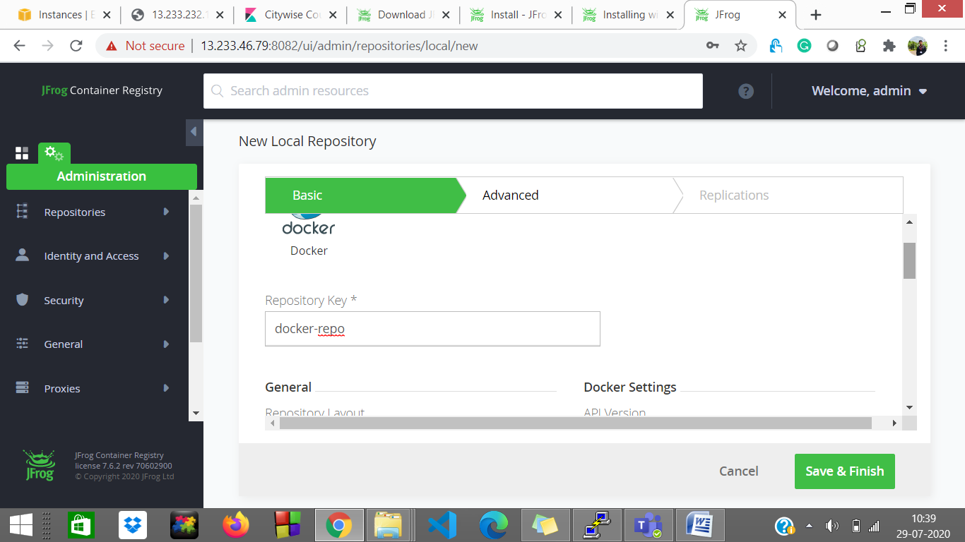

After this just do save and finish

Now got to command line

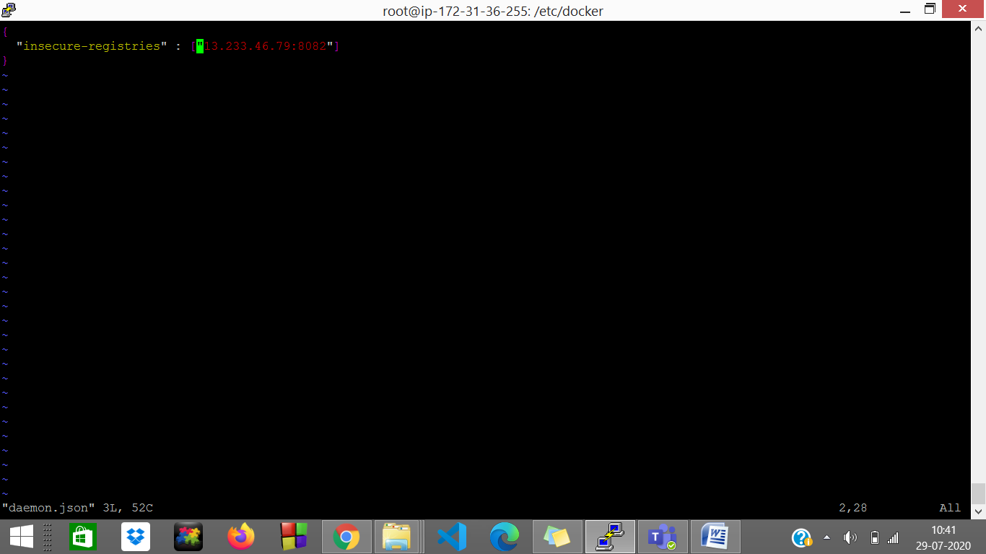

Add this line by changing your ip

Now do

* service docker restart
* systemctl daemon-reload

Now login with following command

sudo docker ip:8082

if you get login succeed then it would be okay

Now try to push or pull the image in repo which you created.

In my case i have one httpd image is there

I will push this image to my registry

But for pushing we need to change the tag

* sudo docker tag httpd:latest ip:8082/<repo-name>/<image-name>:<version>

for ex

sudo docker tag httpd:latest 13.233.46.79:8082/docker-repo/httpd:v1

as soon you push automatically you can see on jcr

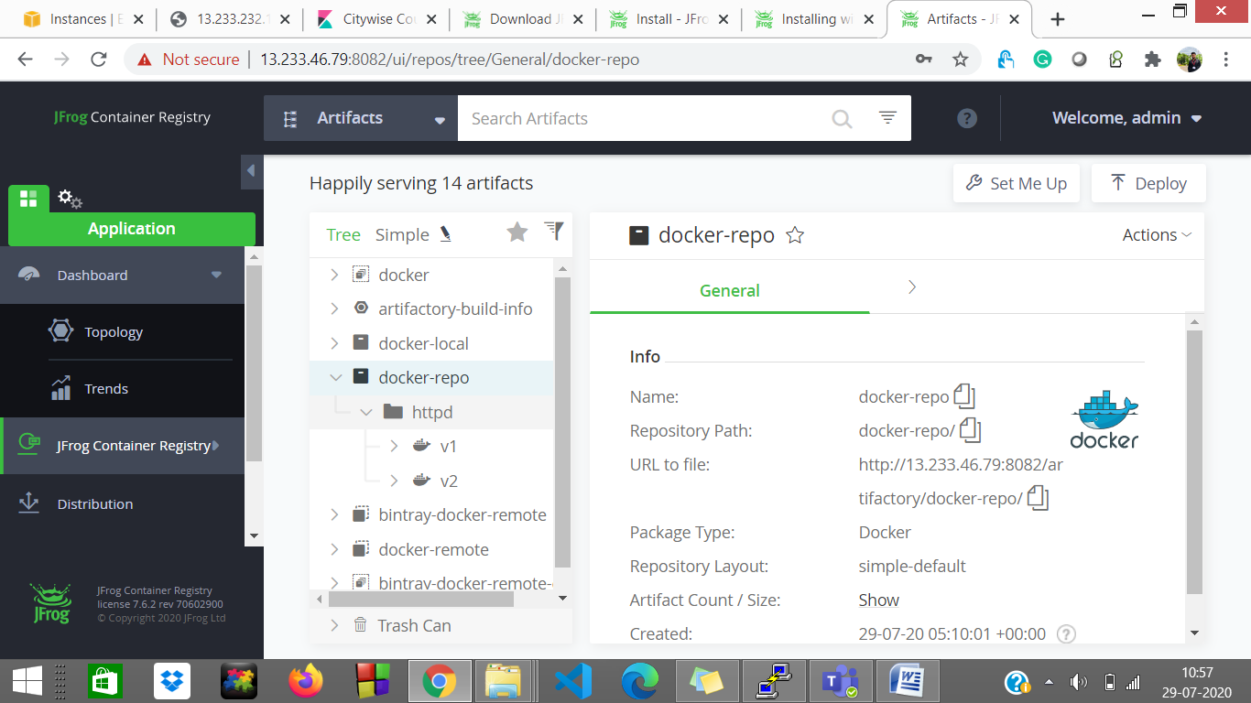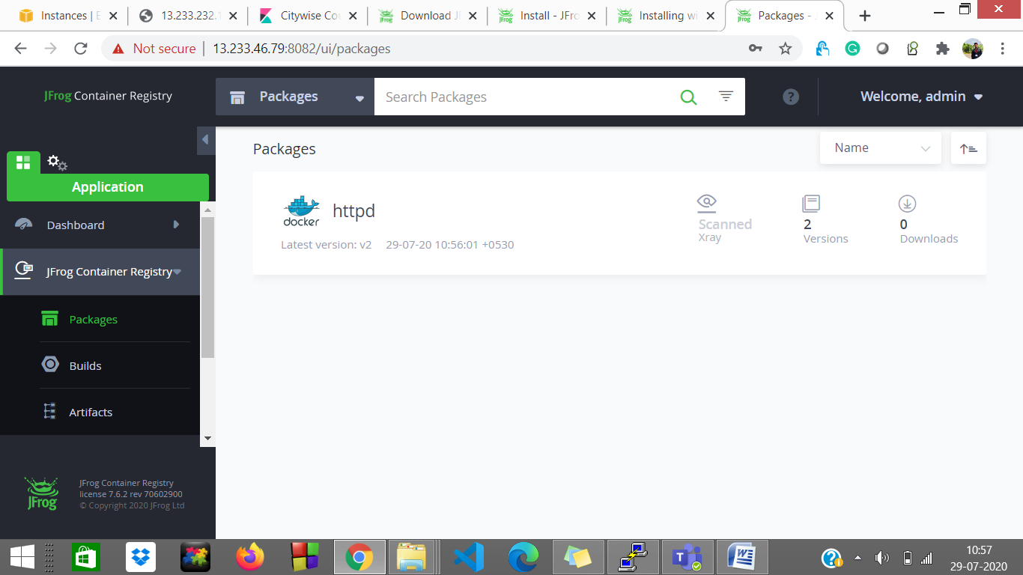

In one repo you can push multiple images of different flavours and different version also.

For ex httpd having v1 and v2 and same for nginx in one repositiory only.

This part of jcr Now jcr done

For more information:

<https://www.jfrog.com/confluence/display/JCR6X/Installing+with+Docker>